
There were an estimated 8,510 total social housing sales to sitting tenants in England in 2009-10, an increase of 16 per cent on 2008-09. The increase contrasts with falls in social housing sales in recent years and was due to an increase in sales of Registered Provider properties.
There were an estimated 3,100 Right to Buy sales in England in 2009-10 (36 per cent of all sales), a 20 per cent decrease from 2008-09. Around three-quarters of Right to Buy sales were of Local Authority properties.
The average market value of Local Authority properties purchased through Right to Buy in 2009-10 was £101,260. This produced average capital receipts of £74,610 and an average discount of £26,660 per property.
Registered Provider sales included 90 properties sold through the Right to Acquire scheme (compared to 180 in 2008-09) and 80 through Social HomeBuy (compared to 100 in 2008-09).
A further 2,940 sales (35 per cent of total sales) were disposals of Registered Provider properties to the private sector. Other shared equity and outright sales to sitting tenants accounted for the remaining sales.

Housing
Statistical Release

Rev 23 September 2010
using
Research
Summary
Number 239, 2007

Social Housing Sales to sitting tenants, England, 2009-10

Contents
1. Introduction ………………… 2
2. Total social housing sales to sitting tenants in England …… 2
3. Total Right to Buy sales in England ……………………….. 5
4. Local Authority Right to Buy sales in England ……………... 6
5. Registered Provider Right to Buy sales in England………… 8
6. Right to Acquire sales in England ………………………. 9
7. Social HomeBuy sales in England …………….……….. 10
8. Accompanying tables ........10
9. Notes to Tables……………11
10. Data Sources………….. ..11
11. Data Quality……….……..11
12. Related Statistics………..12
13. Revisions Policy………....13
14. Background notes .…......13
15. User Consultation …..…. 15

Responsible statistician:
Jane Hinton

Press Enquiries:
office hours: 0303 444 1201
out of hours: 0303 444 1201

press@communities.gov.uk

Statistical Enquiries:
office hours: 0303 444 4066
housing.statistics@communities.gov.uk

Introduction
This Statistical Release presents official statistics on the number of social housing sales to sitting tenants in England and its regions for 2009-10.
Social housing sales include sales through Right to Buy, Preserved Right to Buy, Right to Acquire, Social HomeBuy and other outright or shared equity sales to sitting tenants. They exclude Low Cost Home Ownership sales through shared ownership schemes to non-social tenants.
Figures on the number of social housing sales are collected from Local Authority returns to Communities and Local Government and Registered Provider returns to the Tenant Services Authority (TSA). These returns are supplemented by data from the Investment Management System managed by the Homes and Communities Agency.

Total Social housing sales to sitting tenants in England
Table 1: Total social housing sales in England
Year | Local Authority social housing sales |  | Registered Provider social housing sales¹ |  | Total social housing sales
 | Number | % Change | Number | % Change | Number | % Change
2000-01 | 53,010 |  | . |  | .
2001-02 | 52,460 | -1% | 9,890 | . | 62,350 | .
2002-03 | 64,150 | 22% | 12,570 | 27% | 76,720 | 23%
2003-04 | 69,990 | 9% | 18,340 | 46% | 88,330 | 15%
2004-05 | 50,370 | -28% | 14,900 | -19% | 65,270 | -26%
2005-06 | 26,940 | -47% | 11,260 | -24% | 38,200 | -41%
2006-07 | 17,390 | -35% | 10,260 | -9% | 27,650 | -28%
2007-08 | 12,250 | -30% | 7,110 | -31% | 19,360 | -30%
2008-09 ^{R} | 3,150 | -74% | 4,160 | -41% | 7,310 | -62%
2009-10 | 2,640 | -16% | 5,870 | 41% | 8,510 | 16%
1. Figures on total Registered Provider's social housing sales to sitting tenants are not available prior to 2001-02.
R = Revised
A total of 8,510 social homes were sold by Local Authorities and Registered Providers (RPs) to sitting tenants in England in 2009-10. This was a 16 per cent increase over the year and contrasts with consecutive annual falls in social housing sales since 2003-04. The latest level is around a tenth of the peak in sales of 88,330 in 2003-04.
Until 2008/9 local authority sales accounted for the majority of social housing sales. In 2009/10, sales of Local Authority properties accounted for 31 per cent of all social housing sales. Figure 1 shows the annual trend in total social housing sales since 1991-92. Data on total RP sales to sitting tenants were not collected prior to 2001-02; Figure 3 provides estimates of their sales under Preserved Right to Buy and Right to Acquire.
Figure 1: Total social housing sales¹ in England

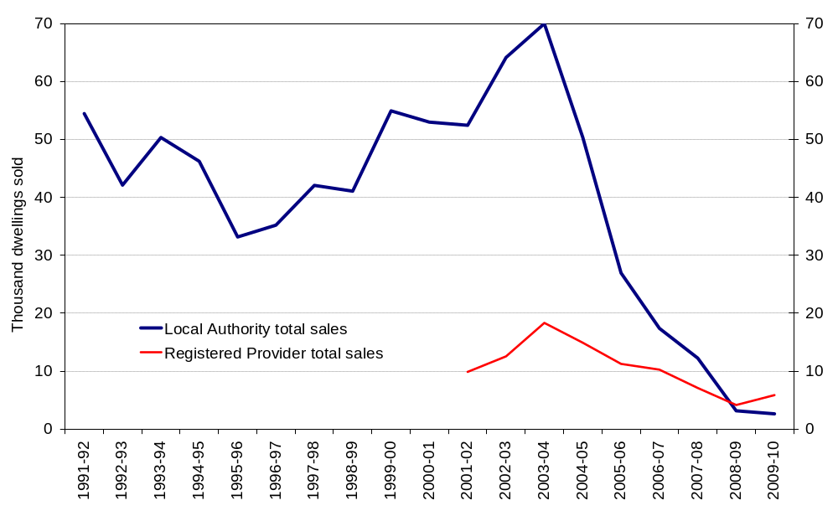
1. Figures on total Registered Provider's social housing sales to sitting tenants are not available prior to 2001-02.
Right to Buy (RTB) sales were the largest individual component of social housing sales to sitting tenants in 2009-10, accounting for 36 per cent of all sales. The major share of Local Authority sales continues to be through RTB (87 per cent in 2009-10). There were 2,940 disposals of Registered Provider (RP) properties to the private sector, representing the next largest component of social sales (35 per cent). Other shared equity and outright sales to sitting tenants made up 27 per cent of all sales, increasing by just over a third to 2,300 in 2009-10 (Figure 2). Prior to 2008-09 Preserved Right to Buy sales had been the largest component of total RP sales (Figure 3).
Figure 2: Components of social housing sales in England
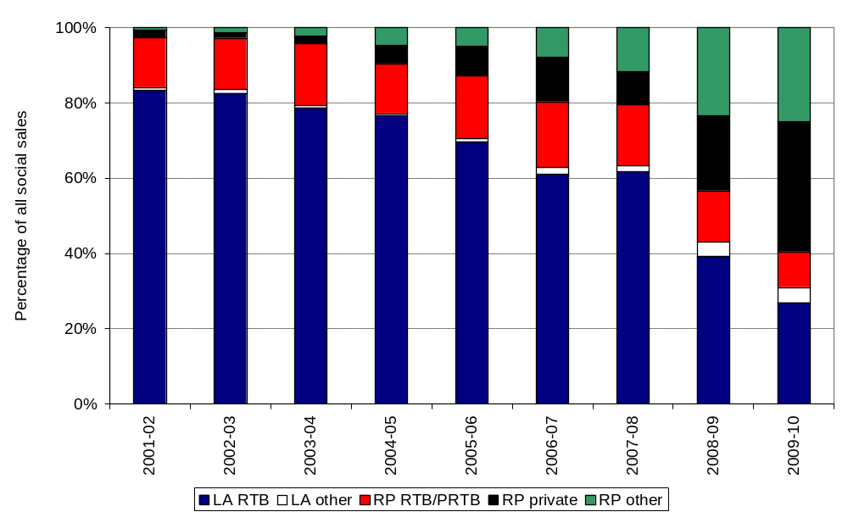

Figure 3: Registered Provider social housing sales in England¹
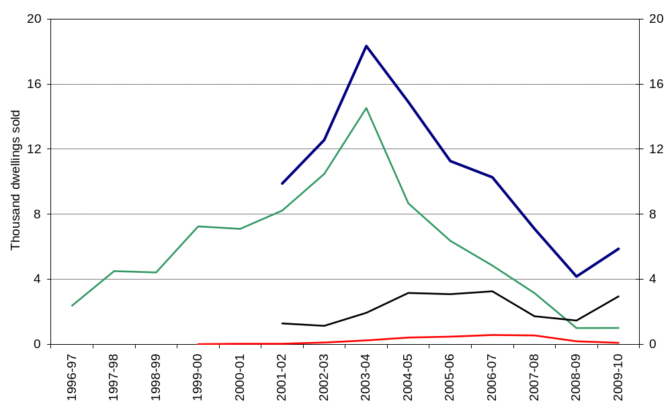
1. Prior to 2001/2 data returns by Registered Provider's did not separately identify sales to sitting tenants other than those through the Preserved Right to Buy and Right to Acquire schemes.

Total Right to Buy sales in England
Table 2: Right to Buy sales in England
Year | Local Authority RTB sales |  | Registered Provider RTB and Preserved RTB sales |  | Total RTB and Preserved RTB Sales
 | Number | % Change | Number | % Change | Number | % Change
2000-01 | 52,380 |  | 7,100 |  | 59,480
2001-02 | 51,970 | -1% | 8,220 | 16% | 60,190 | 1%
2002-03 | 63,390 | 22% | 10,470 | 27% | 73,870 | 23%
2003-04 | 69,580 | 10% | 14,530 | 39% | 84,100 | 14%
2004-05 | 49,980 | -28% | 8,670 | -40% | 58,650 | -30%
2005-06 | 26,660 | -47% | 6,360 | -27% | 33,010 | -44%
2006-07 | 16,900 | -37% | 4,840 | -24% | 21,730 | -34%
2007-08 | 11,960 | -29% | 3,150 | -35% | 15,110 | -30%
2008-09 ^{R} | 2,880 | -76% | 1,000 | -68% | 3,870 | -74%
2009-10 | 2,290 | -20% | 800 | -20% | 3,100 | -20%
R = Revised
A total of 3,100 homes were sold through the Right to Buy (RTB) scheme in England in 2009-10. This was 20 per cent lower than in 2008-09 and continues the downward trend in RTB sales since the recent peak of 84,100 sales in 2003-04. Three-quarters of RTB sales in 2009-10 were Local Authority properties. Figure 4 shows total RTB sales since the start of the scheme in 1980.

Figure 4: Right to Buy sales in England
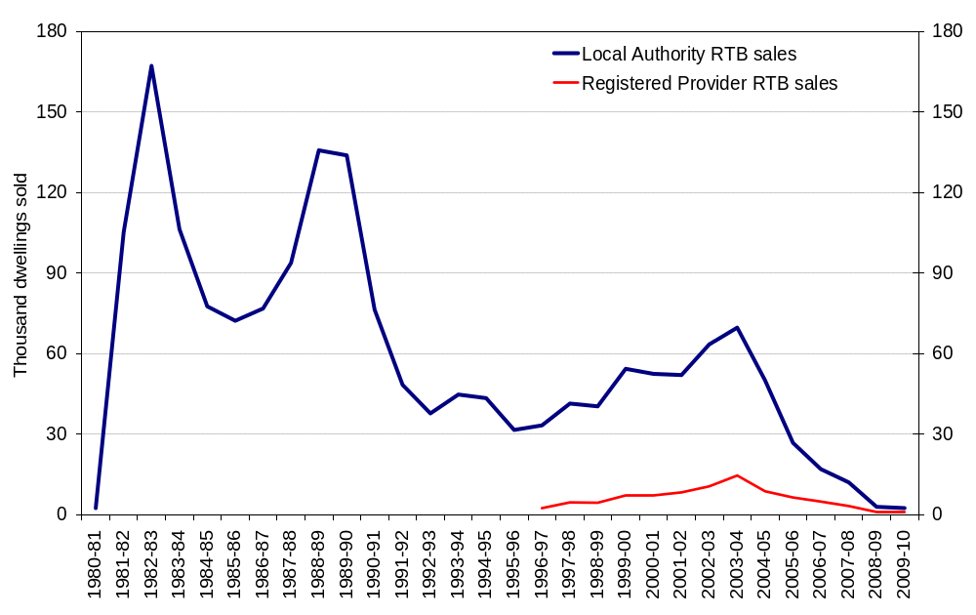
In 2009-10, 22 per cent of Local Authority homes and 13 per cent of Registered Provider homes sold through the RTB scheme were flats. This is a lower proportion of sales than observed in recent years (Figure 5).
Figure 5: Flats as percentage of Right to Buy sales in England
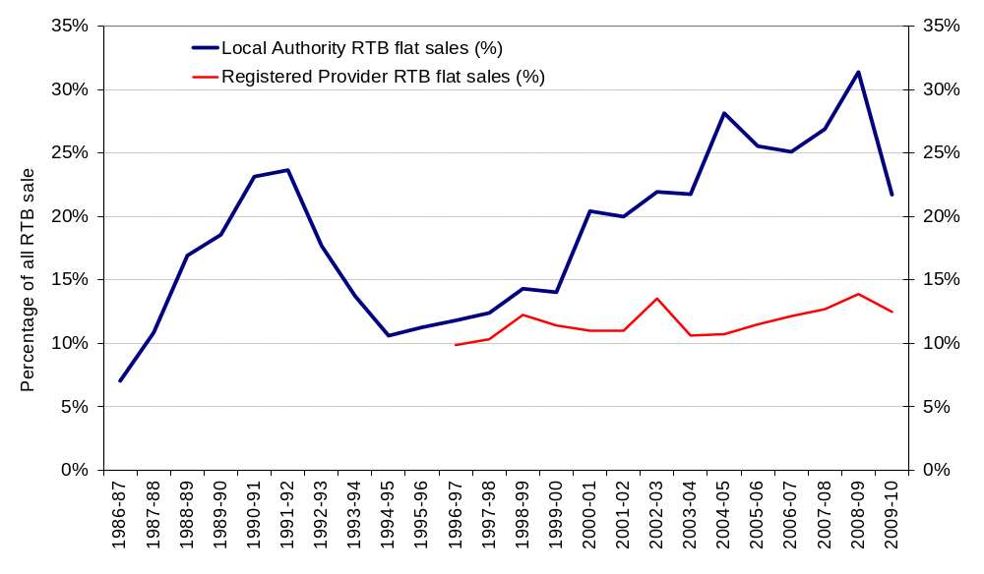

Local Authority Right to Buy sales in England
Table 3: Local Authority Right to Buy sales: financial data¹
Year | Number of applications(Note 2) | Number of Sales | Sales as  % of applications | Capital Receipts |  | Discount |  |  | Market Value
 |  |  |  | Total Value (£m) | Average per property (£) | Total Value (£m) | Average per property (£) | % of market value | Total Value (£m) | Average per property (£)
2000-01 | 92,930 | 52,380 | 56% | 1,426 | 27,220 | 1,251 | 23,880 | 47% | 2,676 | 51,090
2001-02 | 108,440 | 51,970 | 48% | 1,566 | 30,140 | 1,215 | 23,380 | 44% | 2,781 | 53,520
2002-03 | 186,410 | 63,390 | 34% | 2,210 | 34,860 | 1,508 | 23,790 | 41% | 3,718 | 58,660
2003-04 | 109,060 | 69,580 | 64% | 2,936 | 42,200 | 1,714 | 24,640 | 37% | 4,651 | 66,840
2004-05 | 89,930 | 49,980 | 56% | 2,575 | 51,520 | 1,282 | 25,650 | 33% | 3,857 | 77,180
2005-06 | 64,700 | 26,660 | 41% | 1,545 | 57,910 | 681 | 25,550 | 31% | 2,225 | 83,460
2006-07 | 62,060 | 16,900 | 27% | 1,145 | 67,800 | 422 | 24,970 | 27% | 1,567 | 92,770
2007-08 | 35,280 | 11,960 | 34% | 934 | 78,130 | 303 | 25,340 | 24% | 1,237 | 103,470
2008-09^{R} | 11,010 | 2,880 | 26% | 221 | 76,850 | 73 | 25,400 | 25% | 294 | 102,250
2009-10 | 10,350 | 2,290 | 22% | 171 | 74,610 | 61 | 26,660 | 26% | 232 | 101,260
R = Revised
1. All financial data are shown in nominal prices and do not take account of inflationary changes.
2. A small number of applications are not successful at the initial stage; successful applications represent around 90% of all applications. Tenants who meet the RTB qualifying criteria are entitled to purchase their homes if they can secure finance to do so. This column previously showed successful applications. However, only total applications are available after 2008-09.
There were 10,350 Right to Buy (RTB) applications for Local Authority stock in 2009-10, which was 6 per cent lower than in 2008-09. Although there is a time lag between making an application and completing a sale, 2,290 sales equates to 22 per cent of RTB applications. This percentage is lower than in earlier years where between 26 per cent and 64 per cent of all applications led to a future sale.
The average market value of Local Authority properties purchased through the RTB scheme in 2009-10 was £101,260 (one per cent lower than in 2008-09). Discounts averaged £26,660, a 5 per cent increase on 2008-09. On average, discounts in 2009-10 equated to 26 per cent of the market value. This is a small increase on 2008-09 (25 per cent) but below levels seen in earlier years. Capital receipts averaged £74,610 (3 per cent lower than in 2008-09), whilst total capital receipts fell by almost a quarter to £171 million mainly due to a lower number of sales. Note the financial data shown in Table 3 do not take account of inflationary changes.
Figure 6 below shows the distribution of Local Authority RTB sales by region for selected years (full data are available in Live Table 670). In 1999-00 London had the largest proportion of Local Authority RTB sales in England (21 per cent of all sales) with West Midlands the next largest (13 per cent). In 2004-05 London again had the largest share (21 per cent), followed by Yorkshire and the Humber (19 per cent) and the North West (17 per cent). In 2009-10, Yorkshire and the Humber (16 per cent), West Midlands (14 per cent) and East Midlands (14 per cent) saw the largest share of RTB sales.
Figure 6: Local Authority Right to Buy sales by region
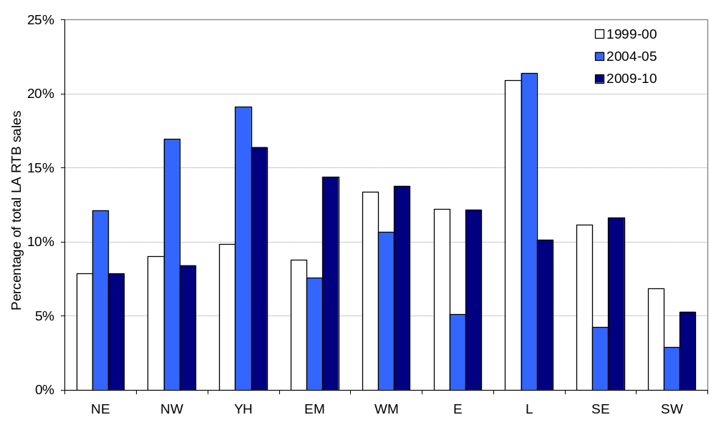

Registered Provider Right to Buy sales in England
Table 4: Registered Provider Right to Buy sales: financial data¹
Year | Number of sales | Average Capital Receipts per property (£) | Average Discount per property (£) | Average discount (%) | Average Market Value per property (£)
2000-01 | 7,100 | 27,400 | 24,860 | 47% | 52,520
2001-02 | 8,220 | 26,690 | 23,600 | 46% | 50,780
2002-03 | 10,470 | 32,500 | 26,300 | 44% | 59,370
2003-04 | 14,530 | 33,200 | 25,420 | 43% | 58,640
2004-05 | 8,670 | 37,600 | 26,590 | 41% | 64,210
2005-06 | 6,360 | 45,010 | 27,150 | 38% | 72,160
2006-07 | 4,840 | 53,460 | 28,390 | 35% | 81,960
2007-08 | 3,150 | 62,630 | 27,120 | 30% | 89,750
2008-09 | 1,000 | 72,230 | 26,940 | 27% | 99,170
2009-10 | 800 | 62,720 | 28,010 | 31% | 91,530
1. All financial data are shown in nominal prices and do not take account of inflationary changes.
There were 800 Registered Provider (RP) sales through Right to Buy (RTB), including Preserved Right to Buy, in 2009-10. The estimated average market value of RP properties purchased was £91,530, 8 per cent lower than in 2008-09. Discounts on sales averaged £28,010 (4 per cent higher) which was 31 per cent of the average market value. Capital receipts averaged £62,720 in 2009-10 (13 per cent lower than in 2008-09).
Figure 7 below shows the distribution of RP RTB sales by region for selected years (full data are available in Live Table 675). In 1999-00 the largest proportion of RP RTB sales were in the South East (30 per cent) and the South West (28 per cent). In 2004-05 by far the largest share of sales were in the North West region (36 per cent). The North West (25 per cent) and Yorkshire and the Humber (19 per cent) had the largest proportion of sales in 2009-10.
Figure 7: Registered Provider Right to Buy sales by region
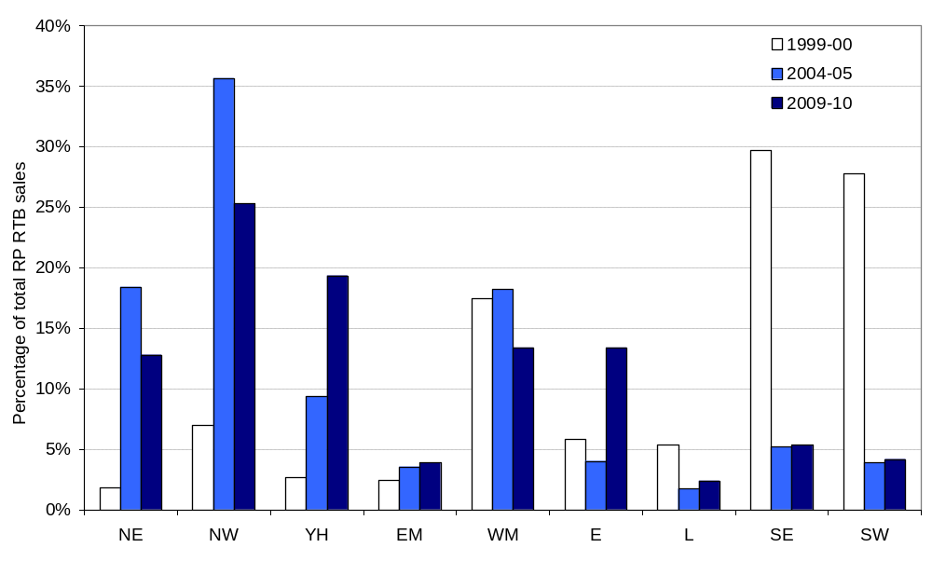

Right to Acquire sales in England
Table 5: Right to Acquire sales
 | Right to Acquire sales
 | Number | % Change
2000-01 | 20
2001-02 | 40 | 111%
2002-03 | 110 | 192%
2003-04 | 240 | 113%
2004-05 | 410 | 74%
2005-06 | 470 | 15%
2006-07 | 570 | 21%
2007-08 | 540 | -5%
2008-09 | 180 | -66%
2009-10 | 90 | -53%

In 2009-10 90 Registered Provider homes were sold through the RTA scheme in England, compared to 180 the previous year. Since its introduction in 1997-98 2,670 homes have been sold through the RTA scheme. Regional figures are not presented due to the low number of sales.

Social HomeBuy sales in England
Table 6: Social HomeBuy sales
 | Local Authority Social HomeBuy sales | Registered Provider Social HomeBuy sales | Total Social HomeBuy sales
 | Number | Number | Number | % Change
2006-07 | - | 50 | 50
2007-08 | - | 160 | 160 | 234%
2008-09 | 10 | 90 | 100 | -41%
2009-10 | 10 | 70 | 80 | -23%
The Social HomeBuy scheme was introduced in 2006-07, since when almost 400 homes have been sold - the majority being Registered Provider properties. In 2009-10 a total of 80 Social HomeBuy homes were sold compared to 100 in the previous year.

Accompanying tables
Accompanying tables are available to download alongside this release at http://www.communities.gov.uk/housing/housingresearch/housingstatistics/housingstatisticsby/socialhousingsales/livetables/
Table 643: Financial data on Local Authority homes sold through the Right to Buy scheme, by region.
Table 648: Local Authority stock sold through Right to Buy and other council house sales by district and region.
Table 670: Local Authority stock sold through the Right to Buy scheme, by region.
Chart 671: Local Authority and Registered Provider stock sold through the Right to Buy scheme.
Table 672: Local Authority stock sold through the Right to Buy scheme, by region (quarterly).
Table 674: All sales of Local Authority stock (including transfers to Registered Providers), by region.
Table 675: Registered Provider stock sold through the Right to Buy scheme, by region.
Chart 676: All sales of Local Authority stock (including transfers to Registered Providers).
Table 677: Registered Provider stock sold through the Right to Acquire scheme.
Table 678: Total social housing sales to sitting tenants.
Chart 679: Total social housing sales to sitting tenants.
Chart 680: All sales of Registered Provider stock.
Chart 681: Percent of Right to Buy sales that were flats.
Table 682: Financial data on Registered Provider homes sold through Right to Buy, by region.
Table 683: All Social HomeBuy sales.

Notes to the tables
The following conventions have been used in the tables:
. Not available
.. Not applicable
- Nil or less than half the final digit shown
^{R} Revised from previous release
Totals may not equal the sum of component parts due to rounding to the nearest 10.

Data sources
Local Authority social housing sales figures are collected from the P1B Quarterly Housing Monitoring returns supplied by Local Authorities to Communities and Local Government. This gives information at district level for all Local Authority council house sales as well as housing capital expenditure.
Registered Provider social housing sales figures are from Regulatory and Statistical Returns (RSR) and Continuous Recording (CORE) returns supplied to the Tenant Services Authority (TSA) by Registered Providers.
Registered Provider Right to Acquire sales are from the Homes and Communities Agency (HCA) Investment Management System (IMS).
Social HomeBuy figures are from a combination of P1B returns (for Local Authority Social HomeBuy sales) and IMS (for Registered Provider Social HomeBuy sales).
All data are rounded to the nearest 10 units with the exception of the aggregate financial data where the totals are shown in millions.

Data quality
Local Authority returns (P1B form):
Some Local Authorities do not own any stock and so cannot make any social housing sales. Only stock holding authorities are requested to make a P1B return. In 2009-10 there were 178 authorities with at least 100 units of stock, of which 175 made a complete P1B return. The level of social housing sales is estimated for non-responding authorities who own more than 100 units. Estimates are made by applying the average ratio of sales to stock in each region for responding authorities to the level of stock held by missing authorities in that region. Sales were estimated for three Local Authorities in 2009-10 and this estimated data accounted for one per cent of total estimated sales.
Registered Provider returns:
All social landlords that are registered with the Tenant Services Authority make an annual Regulatory and Statistical Return (RSR) which includes data on all their sales. The RSR sales data is not reported by geographical area and therefore the regional distribution of these sales needs to be estimated. This is done by using information from the Continuous Recording (CORE) returns. CORE returns are only required from Registered Providers (RPs) with at least 250 units or bedspaces. Regional proportions are taken from CORE sales and applied to the total number of sales reported through the RSR. This method assumes that the regional distribution of any sales not reported on CORE, such as those by small RPs, is the same as those for larger RPs. In 2009-10 approximately 42 per cent of Right to Buy and Preserved Right to Buy sales made by RPs were recorded on the CORE returns.
The RSR does not ask RPs to provide financial information on their sales of stock. However, CORE returns do include financial data on social housing sales. As CORE does not provide complete coverage of all sales, and there are no estimates made for the sales not covered by CORE, the financial information from CORE are shown as simple average values.
Regional figures and financial data are not shown for either Right to Acquire or Social HomeBuy sales due to a small number of sales under each scheme.
The Homes and Communities Agency (HCA) Investment Management System (IMS) contains information provided by RPs that have applied to receive grant and this shows the number of Right to Acquire and RP Social HomeBuy figures. These are also reported through the RSR but the IMS figures are used here because they are based on grant funded completions.

Related statistics
Statistics for the devolved administrations can be found at:
- Northern Ireland: http://www.dsdni.gov.uk/index/publications/housing_stats.htm (Tables 3.16 and 4.8)
- Scotland: http://www.scotland.gov.uk/Topics/Statistics/Browse/Housing-Regeneration/HSfS/SalesSittingTenants
- Wales: http://wales.gov.uk/topics/statistics/headlines/housing2010/100915/?lang=en

The Tenants Service Authority (TSA) publishes annual statistics collected through its Regulatory and Statistical Return (RSR) on stock size, location, type, provider characteristics and rents relating to Registered Providers (RPs) in England. Data from the RSR is the main source of RP data used in the social housing sales statistics.
http://www.tenantservicesauthority.org/server/show/ConWebDoc.20659/changeNav/14567

The TSA also publish data on low cost home ownership sales collected through the Continuous Recording (CORE) returns. Annual statistics for 2009/10 were published by the TSA on 10 September at https://core.tenantservicesauthority.org/ and further reports and analysis can be downloaded from the CORE website. CORE data is used in this release for financial data on RP sales and to inform regional distributions of sales that cannot be obtained from the RSR data.

Affordable housing statistics are published annually by CLG and can be found at:
http://www.communities.gov.uk/housing/housingresearch/housingstatistics/housingstatisticsby/affordablehousingsupply/

These statistics show the gross annual new supply of affordable housing units for social rent and low cost home ownership. The Housing and Communities Agency’s IMS system is an important data source for the affordable housing statistics and is also the preferred source for Right to Acquire and Social HomeBuy sales used in the social housing sales statistics.

Revisions policy
This policy has been developed in accordance with the UK Statistics Authority Code of Practice for Official statistics and the Communities and Local Government Revisions Policy.

Revisions to previous years data are generally incorporated in the next release. However if a substantial error was identified as a result of the data collected, compilation, imputation or dissemination process, then the statistical release, live tables and other accompanying releases would be updated with a correction notice as soon as is practical. Figures are not published in these statistics with a provisional status and the component data are reported as final annual figures. Revised figures are labelled “R”.

Small revisions have been made in this release to estimates of local authority sales in 2008-9 due to a correction to the imputation procedure. A correction to the data for 2009-10 in Figure 7 was made shortly following the first release of this data.

Background notes
- Figures on social housing sales only include the number of outright sales to sitting tenants. These include sales under Right to Buy (RTB), Preserved Right to Buy (PRTB), Right to Acquire (RTA), Social HomeBuy (SHB), Voluntary Purchase Grant (VPG), and other outright or shared equity sales to sitting tenants. Sales of other kinds, such as shared ownership sales, stock transfers to Registered Providers, either from Local Authorities or other RPs, and demolitions are not included in the total social housing sales figures.
- The old definition of registered social landlord (“RSL”) has been replaced with the concept of registered providers of social housing. All providers of social housing will now be listed on a register and will become a “Registered Provider” (RP). A distinction between this system and the old system of RSLs is that a provider of social housing can now be either a non-profit organisation or a profit-making organisation. Each body will be designated as one or the other upon being entered on to the register. RSLs automatically became non-profit registered providers under the new system.
- The Right to Buy scheme (RTB) was introduced by the 1980 Housing Act with effect from October 1980. RTB is available to:
  - secure tenants of Local Authorities and RPs
  - RP assured tenants who have been transferred with their homes as part of a stock transfer from a Local Authority to a RP – these tenants have a Preserved RTB
Qualifying tenants may purchase the home they rent from their social landlord at a discount.
- The Right to Acquire (RTA) scheme was introduced by the Housing Act 1996 with effect from 1 April 1997. The scheme enables eligible housing association tenants living in qualifying properties to buy their rented home at a discount. RTA only applies to properties built or acquired by housing associations, both charitable and non charitable, with public funds from 1 April 1997 onwards. Properties transferred from a Local Authority to a housing association after 1 April 1997 are also eligible. Some properties are exempt from RTA including sheltered housing and homes located in small rural settlements.
- Social HomeBuy (SHB) is a voluntary scheme which was introduced in April 2006. It enables tenants of participating Local Authorities and housing associations to buy a share of between 25% and 100% in their rented home. SHB helps in particular housing association tenants who do not have the Right to Buy or Right to Acquire, and social tenants who cannot afford outright purchase. Tenants receive a discount on the initial share purchased and on any additional shares they buy. This is equivalent to the Right to Acquire discount (between £9,000 and £16,000 - depending upon the Local Authority area in which the property is located) pro-rata to the share purchased.
- Voluntary Purchase Grant (VPG) was a voluntary scheme which enabled tenants of participating housing associations to buy their rented home outright at a discount. The scheme helped tenants who did not have the Right to Buy or Right to Acquire. VPG was replaced by Social HomeBuy in April 2006.
- The figures do not include sales and transfers between LAs and Registered Providers. The 23,760 Large Scale Voluntary Transfers (LSVTs) of Local Authority stock to RPs and 11,890 sales and transfers between RPs in 2009-10 are not included in the figures.
- These statistics relate to England only. Please see the Related Statistics section for links to the devolved administrations.
- The next release is expected to be published in September 2011 covering social housing sales during 2010-11. Feedback provided on this release will be reflected in the next release.

User consultation
Prior to 2008-09 Communities and Local Government published regular statistics on Right to Buy sales in their Live Tables. In line with the new Code of Practice for Official Statistics these data have since been presented in a Statistical Release and brought together with other data on social housing sales.
Users are encouraged to provide feedback on this release to the statistical enquiries contact shown below.

Enquiries

Media Enquiries:
office hours: 0303 444 1201
out of office hours: 0303 444 1201
email: press@communities.gov.uk

Statistical enquiries:
office hours: 0303 444 4066
email: housing.statistics@communities.gov.uk

Department for Communities and Local Government. © Crown Copyright, 2010

If you require this publication in an alternative format please email: alternativeformats@communities.gsi.gov.uk. Please note that the nature of content means that we may not be able to provide the Statistical series of publications in all requested formats.

September 2010

ISBN: 978-1-4098-2572-2

