

Housing
Statistical Release

20 September 2011
using
Research
Summary
Number 239, 2007

Social Housing Sales, England, 2010-11


Contents
1. Introduction ………………… 2
2. Total social housing sales in England ……………………….. 2
3. Geographical breakdown of LA sales …………………………… 4
4. Total Right to Buy sales in England ……………………….. 5
5. Local Authority Right to Buy sales in England ……………... 6
6. Registered Provider Right to Buy sales in England………… 8
7. Right to Acquire sales in England ………………………. 9
8. Social HomeBuy sales in England …………….……….... 9
9. Accompanying tables ......... 9
10. Demolitions & Transfers ..10
11. Data scope and sources.. 10
12. Data quality……….………11
13. Related statistics……….. 12
14. Revisions policy……….... 14
15. Background notes .…...... 14
16. User consultation …..…. 16

Responsible statistician:
Jane Hinton

Press Enquiries:
office hours: 0303 444 1201
out of hours: 0303 444 1201

press@communities.gov.uk

Statistical Enquiries:
office hours: 0303 444 2276
housing.statistics@communities.gov.uk
There were an estimated 8,410 total social housing sales in England in 2010-11. This is a decrease of 2 per cent on 2009-10 and continues the low level of sales seen in the previous two years. A decrease in Private Registered Provider sales was partly offset by an increase in Local Authority sales.
There were an estimated 3,690 Right to Buy sales in England in 2010-11 (44 per cent of all sales), a 16 per cent increase from 2010-11. Most (74 per cent) Right to Buy sales were of Local Authority properties.
The average market value of Local Authority properties purchased through Right to Buy in 2010-11 was £103,970. Average capital receipts were £77,470 and the average discount was £26,510 per property.
Registered Provider sales included 200 properties sold through the Right to Acquire scheme (compared to 90 in 2009-10) and 100 through Social HomeBuy (compared to 70 in 2009-10).
A further 3,340 sales (40 per cent of total sales) were disposals of Registered Provider properties to the private sector. Other shared equity and outright sales of existing stock accounted for the remaining sales.

Introduction
This Statistical Release presents official statistics on the number of sales of existing social housing stock in England and its regions for 2010-11.
Social housing sales include sales under Right to Buy, Preserved Right to Buy, Right to Acquire, Social HomeBuy, other outright or shared equity sales to tenants, and sales of existing stock to the private sector. The figures exclude sales through low cost home ownership schemes where these do not relate to existing social stock, i.e. sales of newly built homes for shared ownership or acquisitions of private sector homes for affordable home ownership. Intra-tenure transfers between social housing providers are also excluded.
Figures are collected from Local Authority returns to the Department for Communities and Local Government and Registered Provider returns to the Tenant Services Authority (TSA). These returns are supplemented by data from the Investment Management System managed by the Homes and Communities Agency.

Total social housing sales in England
Table 1: Total social housing sales in England
Year | Local Authority social housing sales |  | Registered Provider social housing sales¹ |  | Total social housing sales
 | Number | % Change | Number | % Change | Number | % Change
2001-02 | 52,460 |  | 9,890 |  | 62,350
2002-03 | 64,150 | 22% | 12,570 | 27% | 76,720 | 23%
2003-04 | 69,990 | 9% | 18,340 | 46% | 88,330 | 15%
2004-05 | 50,370 | -28% | 14,900 | -19% | 65,270 | -26%
2005-06 | 26,940 | -47% | 11,260 | -24% | 38,200 | -41%
2006-07 | 17,390 | -35% | 10,260 | -9% | 27,650 | -28%
2007-08 | 12,250 | -30% | 7,110 | -31% | 19,360 | -30%
2008-09 | 3,150 | -74% | 4,160 | -41% | 7,310 | -62%
2009-10^{R} | 2,730 | -13% | 5,870 | 41% | 8,600 | 18%
2010-11 | 3,090 | 13% | 5,320 | -9% | 8,410 | -2%
R = Revised
A total of 8,410 social homes were sold by Local Authorities and Registered Providers (RPs) in England in 2010-11. This was a 2 per cent decrease over the year and is around a tenth of the peak in sales of 88,330 in 2003-04. The relatively low level of sales in recent years reflects a number of factors including the general low levels of activity in the housing market following the 2007 credit crunch, and the value of discounts available under some schemes compared with house prices.
Until 2008/9 local authority sales accounted for the majority of social housing sales. In 2010/11, sales of Local Authority properties accounted for 37 per cent of all social housing sales. Figure 1 shows the annual trend in total social housing sales since 1991-92. The decrease in local authority stock sales primarily reflects the lower number of applications for purchase under the Right to Buy scheme.
Figure 1: Total social housing sales¹ in England

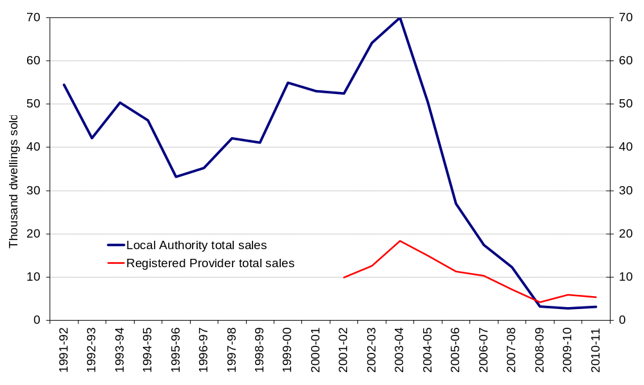
1. Figures on total Registered Provider's social housing sales are not available prior to 2001-02.
Figure 2 shows the breakdown of the main components of social housing sales since 2001-02. Whilst Right to Buy (RTB) no longer accounts for the majority of social housing sales, this is still the largest individual component of social housing sales in 2010-11, accounting for 44 per cent of all sales. The major share of Local Authority sales continues to be through RTB (89 per cent in 2010-11). Most disposals of Registered Provider (RP) properties were to the private sector (3,340 sales), representing the next largest component of social sales (40 per cent). Other RP sales, including under Right to Acquire, Social Homebuy and other shared equity and outright sales made up 12% of all sales (1,020), a decrease from 25% (2,120) observed in 2009-10.
Figure 2: Components of social housing sales in England
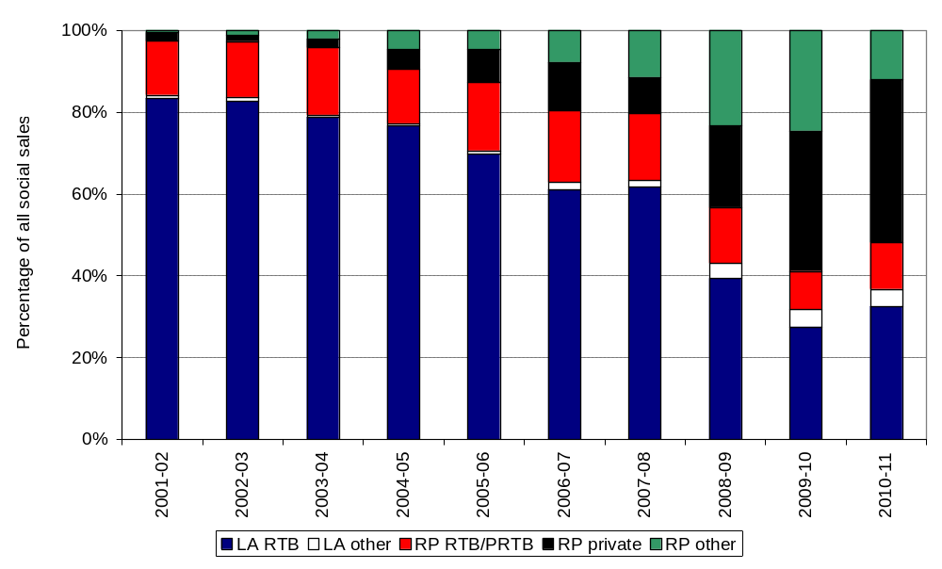

Geographical distribution of Local Authority sales
The map below shows the rate of all sales of local authority stock in 2010/11. To show the level of sales in proportion to the amount of stock owned by each local authority we have divided the number of sales by the total LA owned dwelling stock at the start of the year. This is then multiplied by 1000 to give a figure that is easier to interpret. It shows the rate of sales per thousand of existing stock. Local authorities who do not own any stock are shown as blank (white) in the map. Generally the rate of sales is low, at an average of around 2 properties per 1000 stock.
Figure 3: Sales of local authority stock by local authority district, England
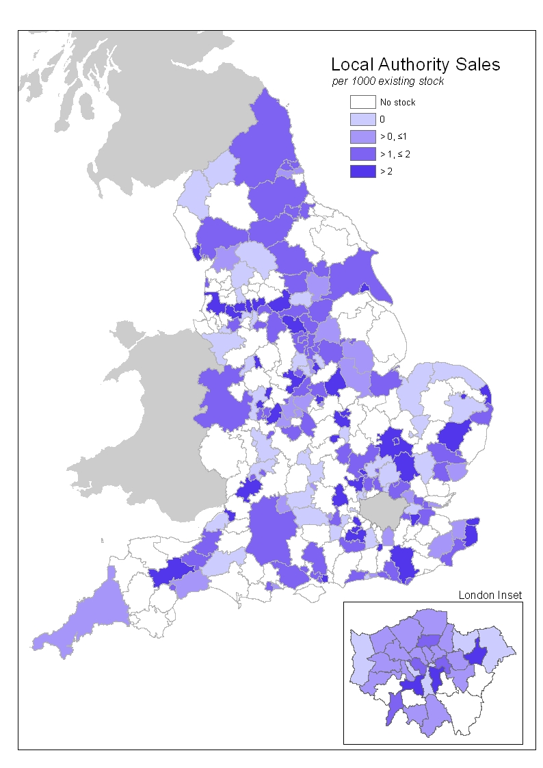
Further data on local authority sales can be found in Live Table 648. Registered Provider sales cannot be presented at local authority level as data are not available to this geographical breakdown.

Total Right to Buy sales in England
Table 2: Right to Buy sales in England
Year | Local Authority RTB sales |  | Registered Provider RTB and Preserved RTB sales |  | Total RTB and Preserved RTB Sales
 | Number | % Change | Number | % Change | Number | % Change
2001-02 | 51,970 |  | 8,220 |  | 60,190
2002-03 | 63,390 | 22% | 10,470 | 27% | 73,870 | 23%
2003-04 | 69,580 | 10% | 14,530 | 39% | 84,100 | 14%
2004-05 | 49,980 | -28% | 8,670 | -40% | 58,650 | -30%
2005-06 | 26,650 | -47% | 6,360 | -27% | 33,010 | -44%
2006-07 | 16,900 | -37% | 4,840 | -24% | 21,730 | -34%
2007-08 | 11,960 | -29% | 3,150 | -35% | 15,110 | -30%
2008-09 | 2,880 | -76% | 1,000 | -68% | 3,870 | -74%
2009-10^{R} | 2,370 | -18% | 800 | -19% | 3,170 | -18%
2010-11 | 2,730 | 15% | 960 | 19% | 3,690 | 16%
R = Revised
A total of 3,690 homes were sold through the Right to Buy (RTB) scheme in England in 2010-11. This was 16% per cent higher than in 2009-10 and whilst this contrasts with consecutive annual falls in RTB sales since 2003-04, the overall level of sales is still small in the context of historic levels. The majority (74 per cent) of RTB sales in 2010-11 were Local Authority properties. Figure 4 shows total RTB sales since the start of the scheme in 1980. The trends in the data primarily reflect interest at the start of the scheme and then historic changes to the discount levels offered and general activity in the housing market.

Figure 4: Right to Buy sales in England
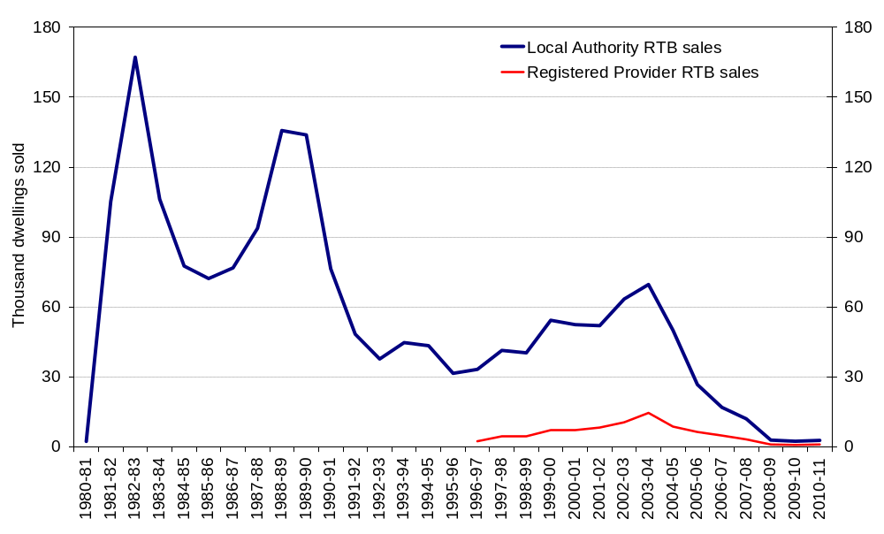

In 2010-11, 26 per cent of Local Authority homes and 15 per cent of Registered Provider homes sold through the RTB scheme were flats. This is a slight increase on the decreased share of sales observed last year (Figure 5) but the historic upward trend in the share of flat sales, reflecting the higher discount rates available on flats, may be stabilising.
Figure 5: Flats as percentage of Right to Buy sales in England 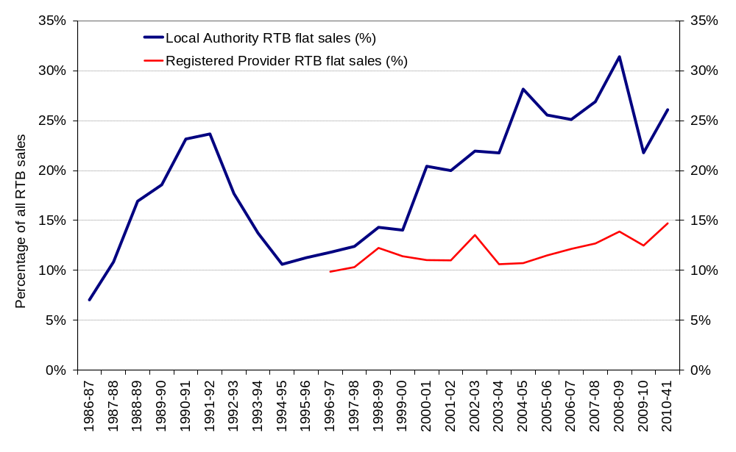

Local Authority Right to Buy sales in England
Table 3: Local Authority Right to Buy sales: financial data¹
Year | Number of applications(Note 2) | Number of Sales | Sales as  % of applications | Capital Receipts |  | Discount |  |  | Market Value
 |  |  |  | Total Value (£m) | Average per property (£) | Total Value (£m) | Average per property (£) | % of market value | Total Value (£m) | Average per property (£)
2001-02 | 108,440 | 51,970 | 48% | 1,566 | 30,140 | 1,215 | 23,380 | 44% | 2,781 | 53,520
2002-03 | 186,410 | 63,390 | 34% | 2,210 | 34,860 | 1,508 | 23,790 | 41% | 3,718 | 58,660
2003-04 | 109,060 | 69,580 | 64% | 2,936 | 42,200 | 1,714 | 24,640 | 37% | 4,651 | 66,840
2004-05 | 89,930 | 49,980 | 56% | 2,575 | 51,520 | 1,282 | 25,650 | 33% | 3,857 | 77,180
2005-06 | 64,700 | 26,650 | 41% | 1,545 | 57,950 | 680 | 25,530 | 31% | 2,225 | 83,480
2006-07 | 62,060 | 16,900 | 27% | 1,145 | 67,800 | 422 | 24,970 | 27% | 1,567 | 92,770
2007-08 | 35,280 | 11,960 | 34% | 934 | 78,130 | 303 | 25,340 | 24% | 1,237 | 103,470
2008-09 | 11,010 | 2,880 | 26% | 221 | 76,850 | 73 | 25,400 | 25% | 294 | 102,250
2009-10^{R} | 10,860 | 2,370 | 22% | 178 | 75,200 | 63 | 26,580 | 26% | 241 | 101,780
2010-11 | 9,930 | 2,730 | 28% | 212 | 77,470 | 72 | 26,510 | 25% | 284 | 103,970
R = Revised
1. All financial data are shown in nominal prices and do not take account of inflationary changes.
2. A small number of applications are not successful at the initial stage; successful applications represent around 90% of all applications. Tenants who meet the RTB qualifying criteria are entitled to purchase their homes if they can secure finance to do so. This column previously showed successful applications. However, only total applications are available after 2008-09.
There were 9,930 Right to Buy (RTB) applications for Local Authority stock in 2010-11, which was 9 per cent lower than in 2009-10. Although there is a time lag between making an application and completing a sale, 2,730 sales equates to 28 per cent of RTB applications. Whilst this percentage is slightly higher than the previous two years it is still low compared to the historic conversion rate where between 34 per cent and 64 per cent of all applications led to a sale. The lower conversion rate of applications into sales in recent years may reflect general constraints on mortgage lending following the credit crunch.
Average market value and discount value remain similar to those observed since 1997/8. The average market value of Local Authority properties purchased through the RTB scheme in 2010-11 was £103,970 (two per cent higher than in 2009-10). Discounts averaged £26,510, almost the same as in 2009-10. On average, discounts in 2010-11 equated to 25 per cent of the market value. This is nearly the same as in 2009-10 but below levels seen prior to 2007-08. Capital receipts averaged £77,470 (3 per cent higher than in 2009-10), whilst total capital receipts increased by 19% to £212 million. Note the financial data shown in Table 3 do not take account of inflationary changes.
Figure 6 below shows the distribution of Local Authority RTB sales by region for selected years (full data are available in Live Table 670). The regional distribution of RTB sales has changed over time, moving away from London in recent years: In 2000-01 London had the largest proportion of Local Authority RTB sales in England (22 per cent of all sales) with West Midlands the next largest (13 per cent). In 2010-11, West Midlands (16 per cent) and Yorkshire and the Humber (15 per cent), saw the largest share of RTB sales and only 13 per cent of sales were in London. The South West has consistently had the lowest share of RTB sales.
Figure 6: Local Authority Right to Buy sales by region
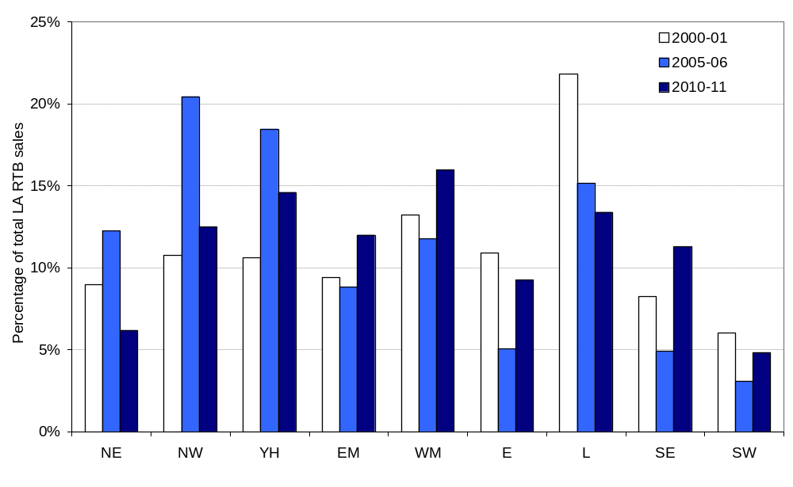

Registered Provider Right to Buy sales in England
Table 4: Registered Provider Right to Buy sales: financial data¹
Year | Number of sales | Average Capital Receipts per property (£) | Average Discount per property (£) | Average discount (%) | Average Market Value per property (£)
2001-02 | 8,220 | 26,690 | 23,600 | 46% | 50,780
2002-03 | 10,470 | 32,500 | 26,300 | 44% | 59,370
2003-04 | 14,530 | 33,200 | 25,420 | 43% | 58,640
2004-05 | 8,670 | 37,600 | 26,590 | 41% | 64,210
2005-06 | 6,360 | 45,010 | 27,150 | 38% | 72,160
2006-07 | 4,840 | 53,460 | 28,390 | 35% | 81,960
2007-08 | 3,150 | 62,630 | 27,120 | 30% | 89,750
2008-09 | 1,000 | 72,230 | 26,940 | 27% | 99,170
2009-10 | 800 | 62,720 | 28,010 | 31% | 91,530
2010-11 | 960 | 64,860 | 28,130 | 30% | 95,330
1. All financial data are shown in nominal prices and do not take account of inflationary changes.
There were 960 Registered Provider (RP) sales through Right to Buy (RTB), mainly Preserved Right to Buy, in 2010-11. The estimated average market value of RP properties purchased was £95,330, up slightly (4 per cent) on 2009-10. Discounts on sales averaged £28,130 (virtually unchanged on last year) which was 30 per cent of the average market value. Capital receipts averaged £64,860 in 2010-11 (3 per cent higher than in 2009-10).
Figure 7 below shows the distribution of RP RTB sales by region for selected years (full data are available in Live Table 675). In 2000-01 the largest proportion of RP RTB sales were in the South West (25 per cent) and the West Midlands (24 per cent). In 2005-06 by far the largest share of sales was in the North West region (35 per cent). The North West (28 per cent) continued to have the largest proportion of RP RTB sales in 2010-11.
Figure 7: Registered Provider Right to Buy sales by region
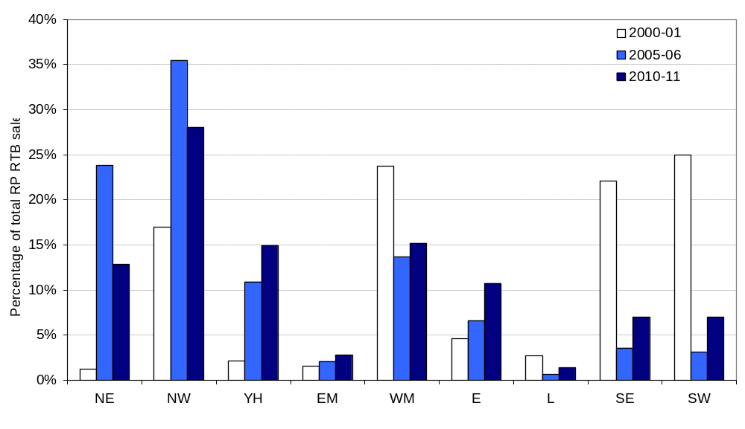

Right to Acquire sales in England
Table 5: Right to Acquire sales
 | Right to Acquire sales
 | Number | % Change
2001-02 | 40
2002-03 | 110 | 192%
2003-04 | 240 | 113%
2004-05 | 410 | 74%
2005-06 | 470 | 15%
2006-07 | 570 | 21%
2007-08 | 540 | -5%
2008-09 | 180 | -66%
2009-10 | 90 | -53%
2010-11 | 200 | 134%
In 2010-11 200 Registered Provider homes were sold through the RTA scheme in England, compared to 90 the previous year. Since its introduction in 1997-98 2,870 homes have been sold through the RTA scheme. Regional figures are not presented due to the low number of sales.

Social HomeBuy sales in England
Table 6: Social HomeBuy sales
 | Local Authority Social HomeBuy sales | Registered Provider Social HomeBuy sales | Total Social HomeBuy sales
 | Number | Number | Number | % Change
2006-07 | - | 50 | 50
2007-08 | - | 160 | 160 | 240%
2008-09 | 10 | 90 | 100 | -38%
2009-10 | 10 | 70 | 80 | -23%
2010-11 | 10 | 100 | 110 | 42%
The Social HomeBuy scheme was introduced in 2006-07, since when 490 homes have been sold - the majority being Registered Provider properties. In 2010-11 a total of 110 Social HomeBuy homes were sold compared to 80 in the previous year.

Accompanying tables
Accompanying tables are available to download alongside this release at http://www.communities.gov.uk/housing/housingresearch/housingstatistics/housingstatisticsby/socialhousingsales/livetables/
Table 643: Financial data on Local Authority homes sold through the Right to Buy scheme, by region.
Table 648: Local Authority stock sold through Right to Buy and other council house sales by district and region.
Table 670: Local Authority stock sold through the Right to Buy scheme, by region.
Chart 671: Local Authority and Registered Provider stock sold through the Right to Buy scheme.
Table 674: All sales of Local Authority stock (including transfers to Registered Providers), by region.
Table 675: Registered Provider stock sold through the Right to Buy scheme, by region.
Chart 676: All sales of Local Authority stock (including transfers to Registered Providers).
Table 677: Registered Provider stock sold through the Right to Acquire scheme.
Table 678: Total social housing sales.
Chart 679: Total social housing sales.
Chart 680: All sales of Registered Provider stock.
Chart 681: Percent of Right to Buy sales that were flats.
Table 682: Financial data on Registered Provider homes sold through Right to Buy, by region.
Table 683: All Social HomeBuy sales.
Table 684: Social housing: Demolitions of Registered Provider and Local Authority stock

Notes to the tables
The following conventions have been used in the tables:
. Not available
.. Not applicable
- Nil or less than half the final digit shown
^{R} Revised from previous release
Totals may not equal the sum of component parts due to rounding to the nearest 10.

Demolitions and transfers

Changes in the amount of social housing stock can also arise due to demolitions. Whilst outside the scope of this release, in response to user feedback, a new Live Table that brings together demolitions of local authority and registered provider stock has been published (Live Table 684).

Changes to stock can also arise due to the transfer of stock from local authorities to registered providers (through Large Scale Voluntary Transfers, LSVTs) and between registered providers. Information on local authority LSVTs is reported by the Homes and Communities Agency at http://www.homesandcommunities.co.uk/ourwork/existing-stock##lsvt and is included in our Live Tables 648 and 674. Transfers between registered providers are published by the Tenant Services Authority in their supporting tables for the Regulatory Statistical Return (https://rsr.tenantservicesauthority.org/ )

Data scope and sources
The social housing sales in England presented in this release cover sales of local authority and private registered provider existing stock. This includes sales under the Right to Buy, Preserved Right to Buy, Right to Acquire, Social HomeBuy, other outright or shared equity sales to tenants, and sales of existing stock to the private sector. Shared equity sales to tenants are recorded at the point of initial sale. The figures exclude sales through low cost home ownership schemes where these do not relate to existing social stock, i.e. sales of newly built homes for shared ownership or acquisitions of private sector homes for affordable home ownership. Intra-tenure transfers between social housing providers are also excluded.
Sales of local authority stock are collected from the P1B Housing Monitoring returns supplied by Local Authorities to Department for Communities and Local Government (DCLG). This gives information at district level for all Local Authority council house sales as well as housing capital expenditure. From 2010-11 the frequency of this return has been reduced from quarterly to annual. Consideration is currently being given to combining this form with the annual Housing Strategy Statistical Return for 2011-12.
Registered Provider social housing sales figures are from Regulatory and Statistical Returns (RSR) and Continuous Recording (CORE) returns supplied to the Tenant Services Authority (TSA) by Registered Providers. The TSA are in the process of reviewing their requirements for annual data provision from private registered providers.
Registered Provider Right to Acquire sales are from the Homes and Communities Agency (HCA) Investment Management System (IMS), a system for administering grant.
Social HomeBuy figures are from a combination of P1B returns (for Local Authority Social HomeBuy sales) and IMS (for Registered Provider Social HomeBuy sales).
All data are rounded to the nearest 10 units with the exception of the aggregate financial data where the totals are shown in millions.

Data quality
Local Authority returns (P1B form):
Some Local Authorities do not own any stock and so cannot make any social housing sales. Only stock holding authorities are requested to make a P1B return. As at 1 April 2010 there were 174 authorities with at least 100 units of stock, of which 164 made a complete P1B return. The level of social housing sales is estimated for non-responding authorities who own more than 100 units. Estimates are made by applying the average ratio of sales to stock in each region for responding authorities to the level of stock held by missing authorities in that region. Sales were estimated for 10 Local Authorities in 2010-11 and this estimated data accounted for around 5 per cent of total sales.
Registered Provider returns:
All social landlords that are registered with the Tenant Services Authority make an annual Regulatory and Statistical Return (RSR) which includes data on all their sales. The RSR sales data is not reported by geographical area and therefore the regional distribution of these sales needs to be estimated. This is done by using information from the Continuous Recording (CORE) returns. CORE returns are only required from Registered Providers (RPs) with at least 250 units or bedspaces. Regional proportions are taken from CORE sales and applied to the total number of sales reported through the RSR. This method assumes that the regional distribution of any sales not reported on CORE, such as those by small RPs, is the same as those for larger RPs. In 2010-11 approximately 45 per cent of Right to Buy and Preserved Right to Buy sales made by RPs were recorded on the CORE returns.
The RSR does not ask RPs to provide financial information on their sales of stock. However, CORE returns do include financial data on social housing sales. As CORE does not provide complete coverage of all sales, and there are no estimates made for the sales not covered by CORE, the financial information from CORE are shown as simple average values.
Regional figures and financial data are not shown for either Right to Acquire or Social HomeBuy sales due to a small number of sales under each scheme.
The Homes and Communities Agency (HCA) Investment Management System (IMS) contains information provided by RPs that have applied to receive grant and this shows the number of Right to Acquire and RP Social HomeBuy figures. These are also reported through the RSR but the IMS figures are used here because they are based on grant funded completions.

Related statistics
Affordable housing supply
The DCLG publishes statistics showing the total additional supply of affordable housing each year. This release includes additional social rented stock and the provision of low cost home ownership at the point of build completion or acquisition of the property. The Homes and Communities Agency’s IMS system is an important data source for the affordable housing statistics and is also the preferred source for Right to Acquire and Social HomeBuy sales used in the social housing sales statistics. They can be found at the following link:
http://www.communities.gov.uk/housing/housingresearch/housingstatistics/housingstatisticsby/affordablehousingsupply/.
Low cost home ownership sales
The Tenants Service Authority collects data from Private Registered Providers through the Continuous Recording (CORE) logs. A CORE log is completed for each sale of a registered provider home, including all low cost home ownership products and outright sales. CORE data is used in this release for financial data on RP sales and to inform regional distributions of sales that cannot be obtained from the RSR data. CORE data for 2010-11 can be found at the following link:
https://core.tenantservicesauthority.org/
Private Registered Provider stock
The Tenants Service Authority (TSA) publishes annual statistics collected through its Regulatory and Statistical Return (RSR) on stock size, location, type, provider characteristics and rents relating to Registered Providers (RPs) in England. Data from the RSR is the main source of RP data used in the social housing sales statistics.
http://www.tenantservicesauthority.org/server/show/ConWebDoc.21453/changeNav/14567
Dwelling stock estimates
DCLG also publishes statistics showing the total dwelling stock in England each year and estimates of stock by local authority district and tenure. They can be found at the following link:
http://www.communities.gov.uk/housing/housingresearch/housingstatistics/housingstatisticsby/stockincludingvacants/livetables/
Estimates in other UK countries
Statistics relating to sales of social housing stock in the other UK countries are published by the devolved administrations. In all countries, data are collected from returns made by the stock owning authority (local authority, housing association or equivalent). The scope of these statistics is therefore similar across the UK, but there are some differences in the treatment of shared ownership dwellings.
Data for Wales can be found at http://wales.gov.uk/topics/statistics/headlines/housing2011/110615/?lang=en
Social housing sales in Wales are covered by the same legislation as England. The statistics published by the Welsh Government cover sales of stock owned by local authority and registered social landlords under Right to Buy, Preserved Right to Buy, Right to Acquire, and voluntary and other sales. The voluntary and other sales category includes sales under the range of low cost home ownership schemes that operate in Wales. From January-March 2010 onwards, shared ownership sales are counted only when they are completed and the landlord no longer owns a share. Prior to this they only counted these sales when the initial share was sold.
The scope of social housing sales statistics in Wales is therefore slightly wider than that reported here for England which does not include shared ownership sales for non-social tenants.
Scotland’s publications on social housing sales can be found at
http://www.scotland.gov.uk/Topics/Statistics/Browse/Housing-Regeneration/HSfS/Sales
Social housing sales in Scotland are governed by different legislation to England and Wales, but the principles are similar. The tables presented cover sales of public authority stock including local authorities, new towns and Scottish Homes. Some tables include some housing associations sales where these have tenants with a preserved Right to Buy (by dint of stock transfers from LAs). Sales included are those under Right to Buy, Rent to Mortgage (prior to 2003), and other public authority sales which include sales to other individuals as well as block sales and transfers. Sales to other individuals involve the sale of council house property on the open market to non-sitting tenants. Other housing association sales included are initial shared ownership sales and other sales of dwellings. Including shared ownership sales at the point of the sale of the initial share is different to the approaches taken in Wales.
In Northern Ireland, social tenants have the right to a statutory house sale, which is similar to a “Right to Buy”. Data for Northern Ireland can be found at http://www.dsdni.gov.uk/index/stats_and_research/stats-publications/stats-housing-publications/housing_stats.htm
The statistics cover sales by the Northern Ireland Housing Executive (Northern Ireland’s strategic housing authority) to sitting tenants, sales by Housing Associations to sitting tenants and other sales. Separate tables also show full equity sales under the Co-ownership schemes (the equivalent of the HomeBuy schemes in Great Britain).

Revisions policy
This policy has been developed in accordance with the UK Statistics Authority Code of Practice for Official statistics and the DCLG Revisions Policy.

Revisions to previous years data are generally incorporated in the next release. However if a substantial error was identified as a result of the data collected, compilation, imputation or dissemination process, then the statistical release, live tables and other accompanying releases would be updated with a correction notice as soon as is practical. Figures are not published in these statistics with a provisional status and the component data are reported as final annual figures. Revised figures are labelled “R”.

Revisions have been made in this release to estimates of local authority sales in 2009-10 due to a correction to the imputation procedure. This resulted in returns for an additional four local authorities being imputed and increasing the total local authorities housing sales by 93 or 3.5%.

Background notes
- Figures on social housing sales only include the number of sales where these sales result in existing stock leaving the social sector. These include sales under Right to Buy (RTB), Preserved Right to Buy (PRTB), Right to Acquire (RTA), Social HomeBuy (SHB), Voluntary Purchase Grant (VPG), other outright or shared equity sales to tenants and disposals of existing stock to the private sector.
- Sales of other kinds, such as shared ownership sales of newly built social stock or of private sector stock, stock transfers to Registered Providers, either from Local Authorities or other RPs, and demolitions are not included in the total social housing sales figures.
- The Right to Buy scheme (RTB) was introduced by the 1980 Housing Act with effect from October 1980. RTB is available to:
  - secure tenants of Local Authorities and RPs
  - RP assured tenants who have been transferred with their homes as part of a stock transfer from a Local Authority to a RP – these tenants have a Preserved RTB. Qualifying tenants may purchase the home they rent from their social landlord at a discount.
- The Right to Acquire (RTA) scheme was introduced by the Housing Act 1996 with effect from 1 April 1997. The scheme enables eligible housing association tenants living in qualifying properties to buy their rented home at a discount. RTA only applies to properties built or acquired by housing associations, both charitable and non charitable, with public funds from 1 April 1997 onwards. Properties transferred from a Local Authority to a housing association after 1 April 1997 are also eligible. Some properties are exempt from RTA including sheltered housing and homes located in small rural settlements.
- Social HomeBuy (SHB) is a voluntary scheme which was introduced in April 2006. It enables tenants of participating Local Authorities and housing associations to buy a share of between 25% and 100% in their rented home. SHB helps in particular housing association tenants who do not have the Right to Buy or Right to Acquire, and social tenants who cannot afford outright purchase. Tenants receive a discount on the initial share purchased and on any additional shares they buy. This is equivalent to the Right to Acquire discount (between £9,000 and £16,000 - depending upon the Local Authority area in which the property is located) pro-rata to the share purchased.
- Voluntary Purchase Grant (VPG) was a voluntary scheme which enabled tenants of participating housing associations to buy their rented home outright at a discount. The scheme helped tenants who did not have the Right to Buy or Right to Acquire. VPG was replaced by Social HomeBuy in April 2006.
- The figures do not include sales and transfers between LAs and Registered Providers. The 52,260 Large Scale Voluntary Transfers (LSVTs) of Local Authority stock to RPs and 13,670 sales and transfers between RPs in 2010-11 are not included in the figures.
- These statistics relate to England only. Please see the Related Statistics section for links to the devolved administrations.
- The review of local authority data collection as cited in the Department’s draft Statistics Plan (consulted on in April to June 2011) is considering merging the collection of LA sales (through P1b) into the (revised) Housing Strategy Statistical Appendix. If agreed, this would be implemented for 2011-12 data collection and could affect the timing of the release of the next annual statistics. The publication window will be announced on the National Statistics Publication Hub and the Department’s release calendar when this is clearer, but we will aim to publish to a similar time period as for this year (autumn 2012). Feedback provided on this release will be reflected in the next release.

User consultation
In response to recommendations made by the UK Statistics Authority in their assessment report on housing statistics in England (see http://www.statisticsauthority.gov.uk/assessment/assessment/assessment-reports/assessment-report-117---statistics-on-housing-in-england.pdf), DCLG have carried out a short questionnaire on users requirements. This asked for user feedback on the scope of the categories of different types of sales they would like to see covered in this statistical release. Based on this, the title of the release has been revised to remove the reference to sitting tenants, and the coverage has been retained as all sales of existing stock, irrespective of whether this was to a sitting tenant or the private sector. Additionally, a new section on local authority statistics has been included along with reference to where information on demolitions and intra-tenure transfers can be found.

Enquiries

Media Enquiries:
office hours: 0303 444 1201
out of office hours: 0303 444 1201
email: press@communities.gov.uk

Statistical enquiries:
office hours: 0303 444 2276
email: housing.statistics@communities.gov.uk

Department for Communities and Local Government. © Crown Copyright, 2011

If you require this publication in an alternative format please email: alternativeformats@communities.gsi.gov.uk. Please note that the nature of content means that we may not be able to provide the Statistical series of publications in all requested formats.

September 2011

ISBN: 978-1-4098-3166-2

http://www.communities.gov.uk/publications/corporate/statistics/plan201112consultation

