- There were 262,527 new social lettings in 2011/12 by Private Registered Providers. This is a 1% increase on 2010/11 and equates to 10% of their social stock.
- A further 100,083 social lettings (28% of the total) were reported by local authorities. Overall, 67% lettings were for general needs social housing.
- The average weekly social rent was £76 in 2011/12. Private registered provider rent was £81, an increase of 6% on the previous year.
- The most common type of household taking up a general needs letting was single adults aged under 60, either with or without children (over 50% lettings).
- In the first year of collection, 4,612 affordable rent lettings were reported by private registered providers. Average weekly general needs affordable rent was £110, equating to 68% of average market rent.
- There were 10,356 social housing sales by Private Registered Providers during 2011/12, an increase of 4% on 2010/11.
- The average initial share purchased was 42% across all types of social housing sale, with 50% being the most typical initial share.

Housing
Statistical Release

21 September 2012
using
Research
Summary
Number 239, 2007

Social Housing Lettings & Sales in England, 2011/12: Continuous Recording (CORE) Data

Contents
1. | Annual social lettings….…… | 2
2. | Social letting characteristics | 4
3. | Household characteristics of social lettings | 6
4. | Affordable rent lettings.......... | 8
5. | Social housing sales.………. | 10
6. | Data quality ……....………… | 12
7. | Uses of lettings and sales data………………………….. | 15
8. | Related statistics…………… | 16
9. | Revisions policy…. ………… | 17
10. | Definitions…………............... | 18
11. | Accompanying tables………. | 19
12. | Background notes…………... | 19
13. | User consultation…………… | 20
14. | Enquiries…………………….. | 21

Responsible statistician:
Hazel Grace

Statistical enquiries:
office hours: 0303 44 42272
housing.statistics@communities.gov.uk

Media Enquiries:
office hours: 0303 44 41136
out of hours: 0303 44 41201

press@communities.gov.uk

Introduction

This release provides information on new lettings in England by local authorities (LAs) and private registered social housing providers (PRPs), and on sales of social housing in England by PRPs. Information about the tenancy or sale, the tenants or buyers, and the property, are collected each time there is a new letting or sale transaction. Lets of general needs and supported social housing are collected, and, from 2011/12, providers have also been asked to report on affordable lettings. All data are submitted through the on-line Continuous Recording system (CORE). Definitions of the main terms used in this release are given on page 18.
All information included in this release reflects data given by providers for the year ending 31 March 2012. It is important to note that whilst CORE captures all Private Registered Provider lettings in England, it is estimated to capture approximately 78% of Local Authority lettings for 2011/12 due to some local authorities not yet providing any data, and due to others providing incomplete data for the year. Information on data quality and advice on interpretation is given on page 12.

Annual social lettings

In 2011/12, there were 262,527 social lettings by private registered providers (PRPs). This is a 1% increase over 2010/11 consistent with the broad upward, but fluctuating, longer term trend (see Figure 1a). Between 2004/5 and 2011/12 PRP social lettings increased by 19% whilst the number of private providers decreased by 8%. PRP lettings in 2011/12 equated to 10% of their social stock.

Stock-holding local authorities were invited to supply lettings data from 2004/5 on a voluntary basis. In April 2009, the new regulatory requirements of the social housing regulator were applied to local authorities. Provision of CORE data is now a requirement on the Single Data List. The rise in participation over time accounts for the upward trend in local authority lettings. In 2011/12, 97% of stock-holding local authorities reported 100,083 social lettings, and we are working closely with the remaining non-participating local authorities on more complete data supply.
Figure 1a: Number of lettings and providers from 2004/05 to 2011/12
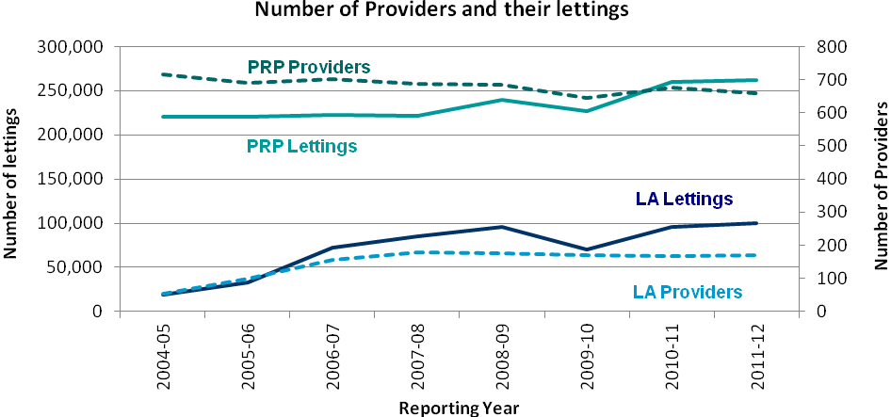
1. Due to changes in participation rates, care should be taken when comparing LA data over time.
2. 2009/10 data are estimated to reflect 90% of PRP and 50% of LA’s total lettings. The dip in provision in 2009/10 is likely to be in part due to a change of contractors collecting the data.
3. Number of LA Providers for 2005/06 is estimated between the levels known for 2004/05 and 2006/07.

Provider type
In 2011/12, 80% of social housing providers (659) were PRPs, supplying 72% of the social lettings recorded. The remaining 20% of providers (169) were local authorities, supplying 28% of social lettings. On average, local authorities operate on a larger scale than private providers, letting an average of 592 lettings per provider compared to 398 lettings per private provider in 2011/12. Figures on numbers of social providers and their lettings over time is given in Accompanying Table 1b.

Housing type
The social lettings relate to either general needs housing or supported housing, which is defined as housing with special design facilities or features targeted at a specific client group requiring support (for example, housing designed for older people). Around two-thirds of social lettings are for general needs housing. Most supported lettings are made by PRPs, who accounted for 91% of supported lettings in 2011/12. There has been a larger increase in supported housing lets over time, with PRP supported lettings increasing by 43% between 2004/5 and 2011/12 compared with a 7% increase in general needs lettings.

Table 1a: Social lettings by housing type and provider, 2004/05 to 2011/12
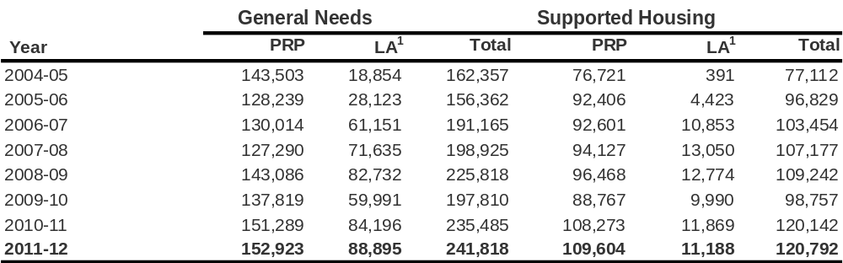
1. Due to changes in participation rates, care should be taken when comparing LA data over time.
2. 2009/10 data are estimated to reflect 90% of PRP and 50% of LA’s total lettings. Collection was likely to have been affected by a change in contractors collecting the data.

Details of the number of reported PRP and local authority lets by region are shown in Accompanying Table 1c; a breakdown of social stock and lettings turnover by region in Accompanying Table 1e; and a breakdown of lets by local authority area in Accompanying Table 1f.
- Social lettings characteristics
Tenancy type
The majority of general needs tenancies were starter tenancies, both for PRPs and local authorities. Most starter tenancies will convert to assured or secure tenancies after the introductory period, subject to conditions. Most supported housing tenancies were licence agreements in PRP housing, and secure tenancies in local authority housing.

Table 2a: Social lettings by tenancy type, 2011/12
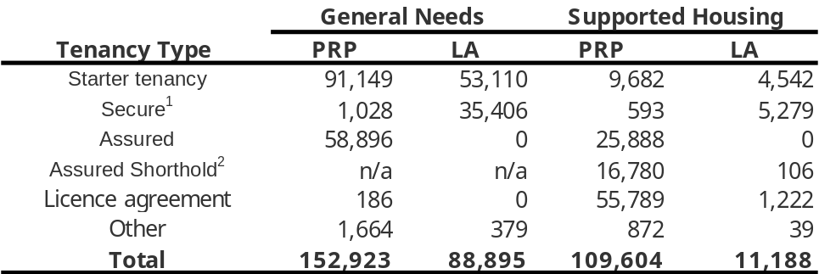
- For PRPs, these are commonly known as “fair rent-secure tenancies”
- Assured shorthold tenancies are not applicable for general needs lets. Local authorities could not provide fixed term tenancies until enactment of provisions in the Localism Act from April 2012.

Average rent
The average weekly social rent was £76 in 2011/12. Private registered provider rent was £81, an increase of 6% on the previous year.

The average weekly rent of general needs properties being let in 2011/12 was higher in PRP properties than local authority properties and this differential tends to increase with property size: one-bedroom property rent was on average 14% higher, whilst rents for three-plus bedroom properties were 18% higher.

As expected, London had the highest average weekly rent for all bedroom sizes across England, and properties in the north have the lowest average weekly rent.

Table 2b: Average weekly social rent¹ (£) of new general needs lettings, 2011/12
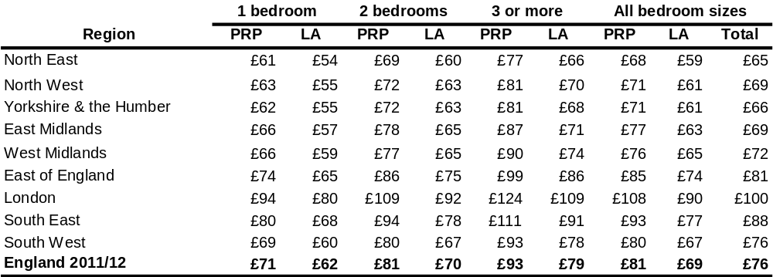
1. Weekly rent excludes service charges

Referral route
Over half of PRP general needs tenants were nominated by their local authority for housing. An additional 30% applied directly to the PRP. PRP supported housing shows a more even split of tenants applying directly compared to those with LA nominations; however, the most common route for lettings of PRP supported housing was referral by a range of agencies, schemes and public sector services.

Figure 2: Source of referral by provision type for PRP & LA social lettings, 2011/12
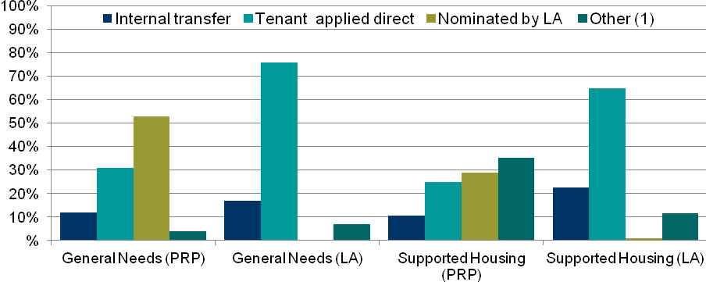
1. Other includes: voluntary agency, housing mobility scheme, social services, other social landlord, police probation prison, youth offending team, community mental health, health service.

Other key letting characteristics
On average, re-let times are longer for supported housing than for general needs properties, and local authority properties tend to be vacant for longer than PRP properties. Re-let times were similar to the previous year, except for local authority supported housing where re-let times increased from 42 days in 2010/11 to 50 days in 2011/12. Re-let times by region are shown in Accompanying Table 2d.
The majority of properties in all types of provision were let on the first offer. Most general needs lettings were taken up through Choice Based Lettings (CBL) schemes, with PRPs letting 77% of general needs properties via CBL schemes in 2011/12 compared to 34% in the 2007/08, which was the first year that CBL schemes were rolled out; and LAs letting 85% in 2011/12 compared to 46% in 2007/08.

Table 2f: Key social lettings characteristics, 2011/12
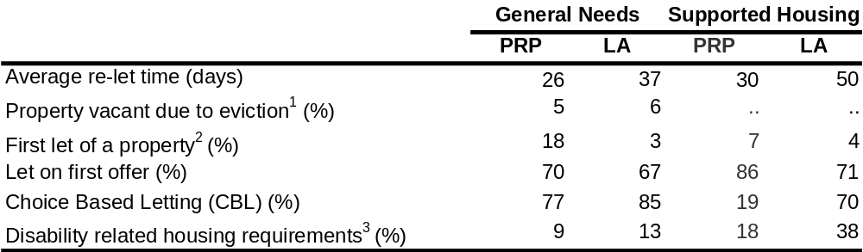
1. Where the property became vacant due to the previous tenant being evicted.
2. The property or supported housing unit/bedspace was newly built, converted or newly acquired.
3. Lettings where anyone in the household requires a disability related housing design or adaptation. The proportion of missing data excluded from the analyses is 12% for GN PRP, 37% for GN LA, 15% for SH PRP and 24% for SH LA.
.. Data not collected

- Household characteristics of social lettings

Household composition
The most common type of household taking up a general needs letting in 2011/12 was single adults aged under 60 without children (over 30%), with a further 20% to single adults aged under 60 with children. The majority of supported housing is assigned to single adults, with local authority lettings tending to be let to older people aged over 60.

Figure 3a: Household composition by provision type for social lettings, 2011/12
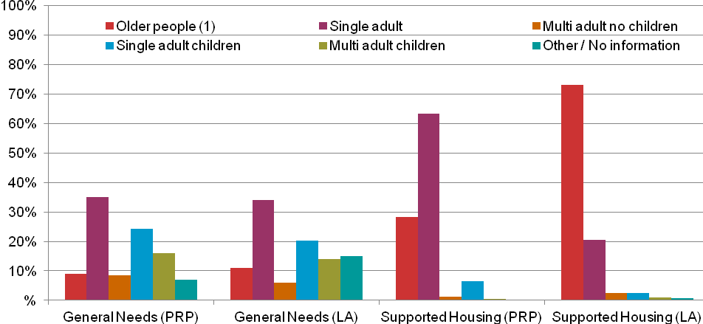
1. Older people are defined as any household where either the main occupier or their partner is aged 60 years or over.
2. % for “Other/No Information” values, 7% for GN_PRP, 15% for GN_LA, 0% for SH_PRP and 1% for SH_LA.

Economic status
In 2011/12, a third of general needs lettings were to tenants (head of household only) in employment, compared with 23% of local authority lets; this is similar to the previous year. Around a further 20% of general needs tenants were unemployed and another 20% not seeking work. Most supported housing lets were to tenants that were retired or unemployed.

Table 3b: Economic status of head of household, social lettings, 2011/12
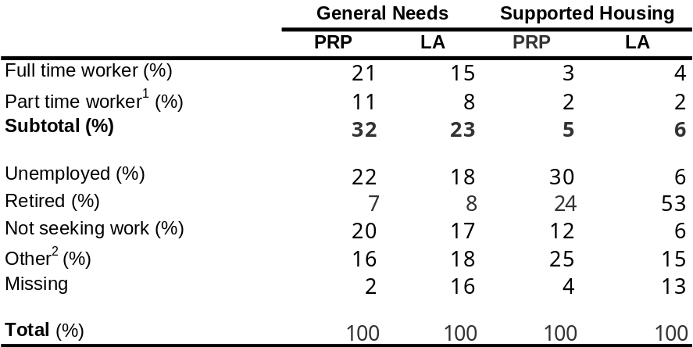
1. Defined as working less than 30 hours per week.
2. Other includes: Government training/New deal, full time student, unable to work because of long term sickness or disability, child under 16.

Other key household characteristics
Table 3d presents a range of other key characteristics of the households taking up social tenancies in 2011/12. In general, the patterns observed are similar to those in 2010/11. These percentages are based on reported data and the proportion of missing data is described in the footnotes.
Around a sixth (15%) of general needs lettings were made to those who were statutorily homeless. This was an increase of around 1% on 2010/11.
Nationality data are recorded for around 95% of lettings to PRP tenants. Where known, the majority (94%) are UK nationals, with the remainder split between the European Economic Area (EEA) countries and non-EEA countries. More details can be found in Accompanying Table 3c.
The majority of households in PRP lettings were eligible for housing benefit. Most households were new to social housing, based on their tenure immediately before this letting being in non-social housing.
Whilst the majority of lettings were made within the same local authority area, around twice the proportion of new supported lettings were assigned to households moving from a different local authority to the one providing the housing, when compared to those moving into general needs housing. This indicates that it is more likely that tenants need to move further to find appropriate supported housing.

Table 3d: Key household characteristics of social lettings, 2011/12
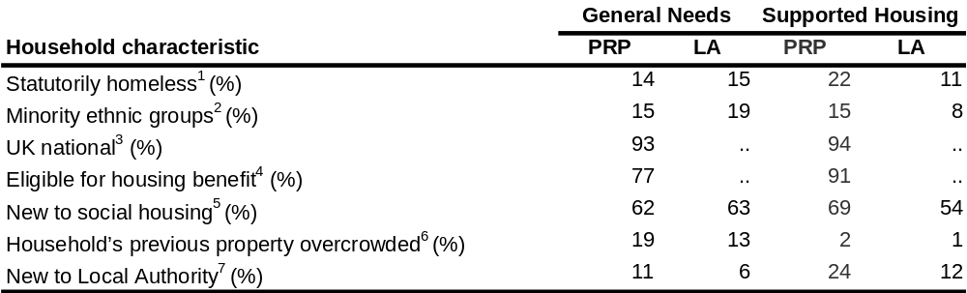
- Those found ‘statutorily homeless’ by a housing authority and either owed a main homelessness duty or not
- Includes all non-white head of households. The proportion of missing data excluded from the analyses is 4% for GN PRP, 14% for GN LA, 4% for SH PRP and 12% for SH LA.
- The proportion of missing data excluded from the analysis is 4% for GN PRP and 5% for SH PRP. Local authority estimates are excluded due to high levels of missing data (19%).
- The proportion of missing data excluded from the analyses is 18% for GN PRP and 15% for SH PRP. Local authority estimates are excluded due to high levels of missing data (38% ).
- Tenants whose tenure immediately before this letting was not social housing (including social housing other than general needs and supported housing).
- Defined as the tenants’ last settled home being unsuitable because of overcrowding, in their view. The proportion of missing data excluded from the analyses is 1% for GN PRP, 13% for GN LA, 3% for SH PRP and 10% for SH LA.
- Where the household lived in a different LA immediately before the letting (including in temporary accommodation).
- .. Data not included due to the levels of missing local authority data

Affordable Rents
Affordable rented housing is defined by the Homes and Communities Agency as:
“Rented housing let by registered providers of social housing to households who are eligible for social rented housing. Affordable Rent is not subject to the national rent regime but is subject to other rent controls that require a rent of no more than 80 per cent of the local market rent.”
Information about affordable rent lettings has been collected since providers started to sign contracts with the Homes and Communities Agency to deliver affordable rent properties during 2011/12. This is the first year of affordable rent data, and data relates to September 2011 to end of March 2012. During this period, only PRPs were able to deliver affordable rent; from April 2012, local authorities are able to offer lettings on an affordable rent basis.
During 2011/12, information on 4,612 affordable general needs lettings and 67 affordable supported lettings were provided by 146 providers. It is estimated that this comprises 78% of all Affordable Rent lettings made in the period when compared to the Homes and Communities Agency’s annual aggregate figures published on 20th August 2012 (see ‘Related statistics’).
Given that we have information on the majority of lettings, we consider the data sufficient to provide some exploratory analysis, however the partial nature of the dataset should be borne in mind when considering these statistics. Comparisons are made to PRP social lettings where appropriate.

Lettings and household characteristics
Around a third (35%) of new affordable rent lettings were the first lets of new build, converted or acquired properties. Discussion with individual providers confirmed that many of these were in new build properties, which due to the timeframe, were built intended for use as social rented properties and then assigned for affordable rent lettings.

Table 4a: Proportion of first lets for general needs lettings (PRPs only), 2011/12
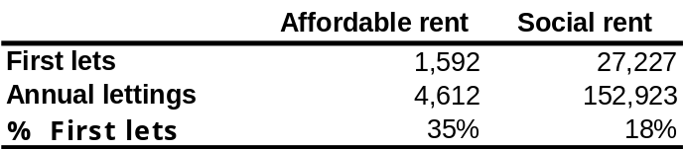
1. ‘First let’ is the first let of new build, conversion, or acquired property

The majority of affordable rent lettings in 2011/12 were starter / introductory tenancies (56%).

Table 4b: General needs lettings by tenancy type (PRPs only), 2011/12
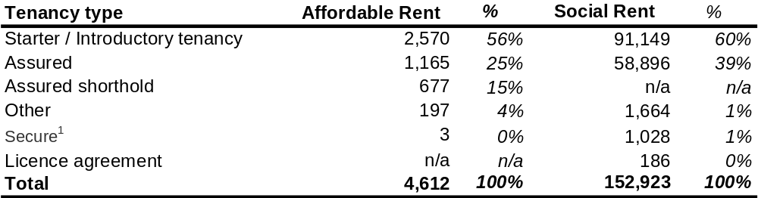
1. For PRPs, these are commonly known as “fair rent-secure tenancies”
2. Totals may not sum due to rounding

Average weekly affordable rents for reported lettings made in this period equated to around two-thirds of average market rents. Affordable rents were, on average, 36% higher than social rents for lettings in 2011/12. There will of course be local variation in rent levels.

Table 4c: Average weekly rent by number of bedrooms for general needs lettings (PRPs only), 2011/12
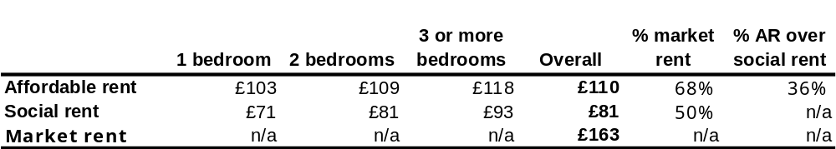
1. Average weekly market rent figure is for all property types for the year to end of June 2012 and is taken from the Valuation Office Agency publication: http://www.voa.gov.uk/corporate/statisticalReleases/120823_PrivateResidentialRentalMarketStatistics.html (table 1.7). Data are available by the number of bedrooms but not using a consistent categorisation to CORE.

- Sales

Sales are only recorded for private registered providers. Information on local authority sales can be found in the Department’s publication on social housing: http://www.communities.gov.uk/publications/corporate/statistics/socialhousingsales201011

Registered providers are asked to report data for all sales made under low cost home ownership, outright sales and other sales of their social stock. No details are recorded of sales of additional equity shares purchased by existing shared owners (known as ‘staircasing’). More details on the scope of sales data collected is set out in the Data Quality section.

The number of social sales has reduced over the last few years to around 10,000 per year, having been fairly steady for the few years previously at around 16k-17k per year. The reduction in sales reflects the change in the housing and mortgage market following the 2007 credit crunch.

Figure 5a: Social housing sales by year (PRPs only), 2011/12
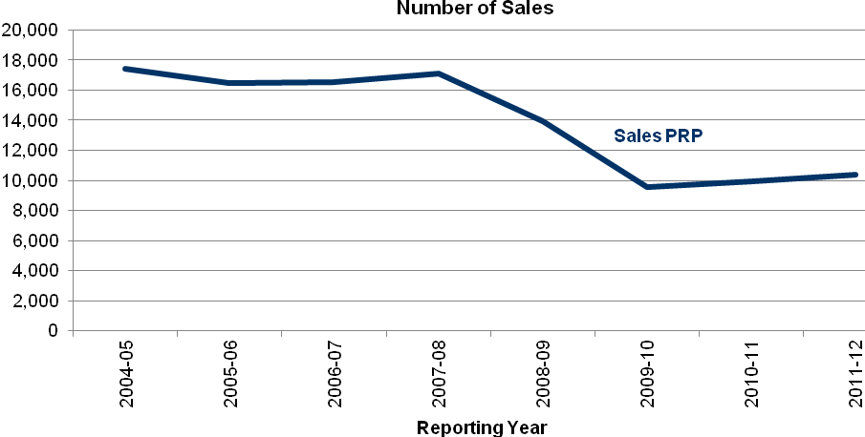

The 4% increase in sales for 2011/12 to 10,356 may reflect additional sales by new social housing providers; a comparison in the number of sales submitted from providers who reported data in 2010/11 shows a 3.9% decrease from 2010/11.

Table 5a: Social housing sales by year (PRPs only), 2011/12
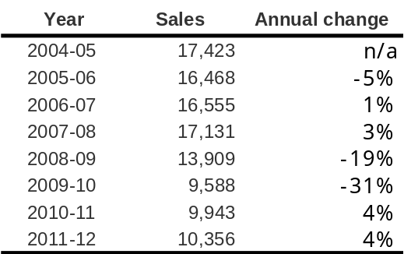

Shared ownership schemes accounted for the majority of sales during the year (86%). Under these schemes, buyers purchase a share in a property and pay rent (usually to a PRP) on the remainder. Of these sales, 60% were Shared Ownership and 17% New Build HomeBuy.

Table 5b: Types of sale during 2011/12 (PRPs only)
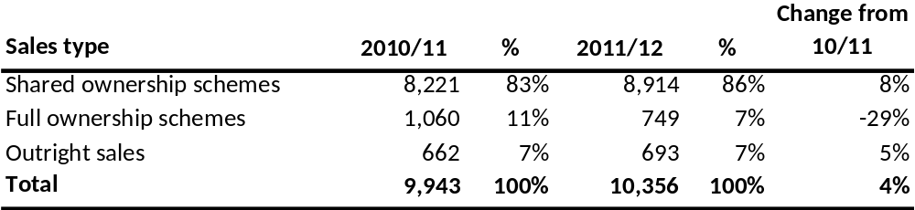

Full ownership schemes (7% of all sales in 2011/12) are either where the whole property is bought outright (at a discount, such as Right To Buy), or where the property is part-financed through an equity loan. Preserved Right to Buy accounted for 3% of all sales. The number of sales under full ownership schemes has fallen by 29% over the previous year, which probably reflects the cessation of the HomeBuy Direct scheme, which accounted for 4% of all sales and 36% of full ownership sales in 2010/11.

Across the shared ownership schemes, the most typical initial share purchased in 2011/12 was 50%, compared to 25% in 2010/11. The most typical share purchased in New Build HomeBuy increased from 25% in 2010/11 to 40%. The most typical share for Shared Ownership for the Elderly and Leasehold schemes for the Elderly remained the same at 70% and 75% respectively.

Most properties were sold to single adults (43%) and multi-adult households with no children (32%). This pattern is very similar to that observed in 2010/11.

Figure 5b: Household composition of social housing buyers of PRP stock, 2011/12
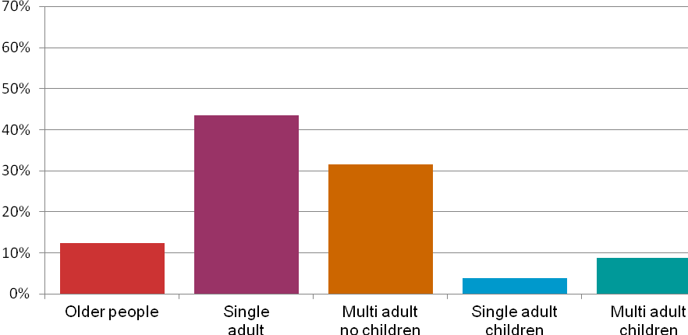
1. Older people are defined as any household where either the main occupier or their partner is aged 60 years or over. Percentages may not add due to rounding.
2. 12% recorded for “Other/No Information” and have been excluded from the analyses.

In 2011/12, most buyers (41%) of social housing were previously renting from the private sector and another 31% were living with family or friends. Only 7% of buyers were previously renting from a local authority or private registered provider. This is a similar pattern to 2010/11.

Figure 5c: Previous accommodation of buyers immediately before their purchase (PRPs only), 2011/12
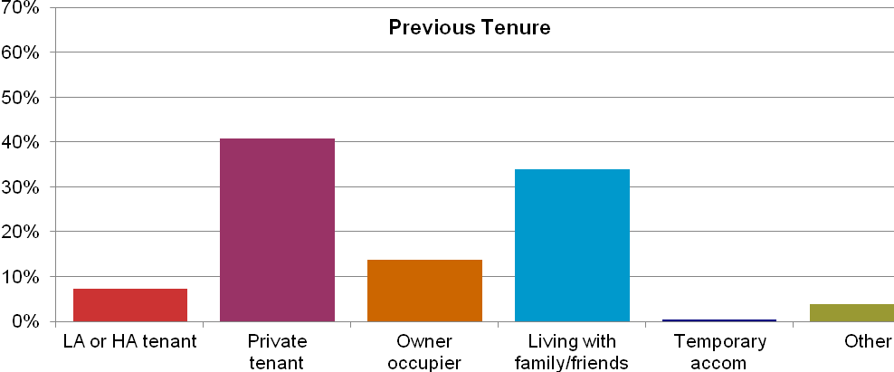
1. Data on previous tenure was not provided for 11% of sales. Percentages are of total data recorded.

The average market value of social sales during 2011/12 was £169,761. A breakdown is given in Accompanying Table 5f.

The average age of buyers is 38 years old, although the most typical age is 26 years. The average age has steadily increased over the last 5 years.

Table 5g: Key household characteristics of buyers of PRP stock, 2011/12
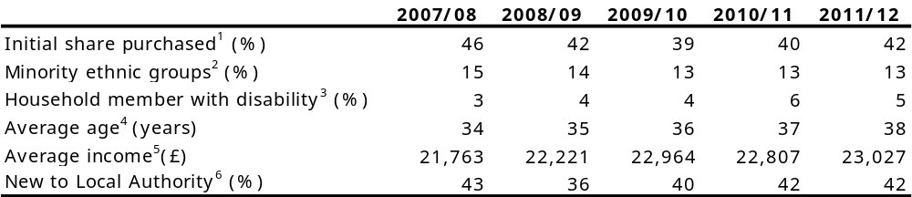
- The average initial share purchased by occupier at the time of purchase for shared ownership schemes. In 2011/12, the most common initial share purchased was 50%.
- Includes all non white head of households. No data were provided for 17% of sales; proportions are based on data provided.
- No data were provided for 33% of sales; proportions are based on data provided.
- No data were provided for 12% of sales; proportions are based on data provided.
- Average gross annual income of the head of household including benefits (except housing and council tax) and income from investments. No data were provided for 19% of sales; averages are based on data provided.
- Where the household lived in a different LA immediately before the letting (including in temporary accommodation).

- Data Quality

Scope
Data are not collected for all new lettings in England, because certain types of lettings are excluded. This includes mutual exchanges, conversions of starter or introductory tenancies to assured or secure tenancies, successions by assignment, and temporary general needs housing. A full list of exclusions can be found in the 2011/12 CORE guidance manual at: https://core.communities.gov.uk/LearnAboutCore/LACGuidesAndManuals.aspx

Data are collected for sales of self-contained dwellings and re-sales of any part-owned dwellings (shared ownership) from Private Registered Providers. This includes all HomeBuy schemes, sales made under Right to Buy, Preserved Right to Buy and Right to Acquire and other outright sales of social stock by the PRP. No details are recorded of sales of additional equity shares purchased by existing shared owners (known as ‘staircasing’). CORE does not collect information on local authority sales.

Completion
Local authority data on lettings are only available from 2004/05, when local authorities were invited to participate voluntarily in CORE. In the first year, 24% of stock-holding local authorities participated, and the number of authorities participating has steadily increased since then, to 97% in 2011/12.
While CORE captures all Private Registered Provider lettings in England, it is estimated that around 78% of local authority (LA) lettings were submitted in 2011/12 (up from 60% for 2010/11). Six stock owning local authorities did not provide any data, and others did not provide data for all their lettings. Table 6a gives more detail on the submission levels of the 169 LAs who held stock at the end of 2011/12.

Table 6a: Local authorities’ estimated lettings submission levels
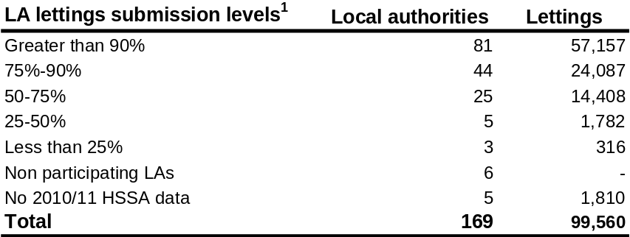
1. Based on a comparison of 2011/12 CORE lettings to the Department’s 2010/11 HSSA total lettings figures, excluding mutual exchanges.
2. The total does not match total LA submissions due to Large Scale Voluntary Stock Transfers having occurred during 2010/11 and 2011/12. Submissions from LAs that have had LSVTs have been excluded from this analysis as participation level cannot be determined

Of the 6 non-participating LAs, 4 are in London; therefore care must be taken when reviewing local authority data for London. It is estimated that 36% of total LA lettings in London were provided. Due to the incomplete LA data, a further release of key tables using weighted CORE data will be published later in the year once data from the Department’s Local Authority Housing Statistics are available.
As the number of local authorities providing data has increased slowly since 2004, comparisons of absolute numbers over time are not valid. For example, the increasing number of LA lettings reflects mainly increased participation by LAs, rather than an increase in housing provision. Comparisons of percentages over time, and with PRP data, are more likely to be robust, depending on the specific data being compared and how complete data are.

Optional data
At the point of data collection, tenants and buyers are not obliged to provide all the information requested. Some variables will have missing responses in cases where personal information has been refused, or where the information is unknown. The proportions of missing data for individual data items have been highlighted as appropriate in the notes accompanying the tables.
For example, the question on tenants’ income has tended to be a sensitive one and had a relatively high refusal rate. However, the simplification of the question from 2011/12 onwards appears to have reduced the amount of missing data as shown in Table 6c.

Table 6b: Proportion of lettings with missing income details
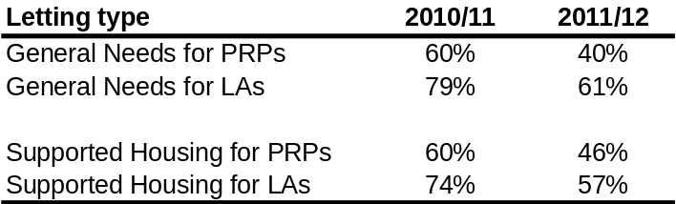

Further, a tenant can refuse to take part in an interview to gather all the household details, although we believe that this is marked on data returns where it may be that the interview hasn’t taken place, or the provider does not have the information, rather than it truly reflecting tenants’ desires to refuse to answer questions. The proportion of lettings where “interview refused” has been selected for household and demographic details is shown below.

Table 6c: Proportion of lettings where “interview refused” has been recorded
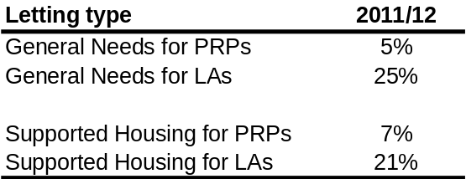

Accuracy
Data provided undergo a series of validation checks, including range checks on individual data items, cross-validation of data items for consistency and logic, and checks for missing data. Queries that can not be resolved are sent to individual providers for resolution, which usually involves checking against their manual or electronic records. We are confident that most data received is accurate; the data items where we have less certainty are those where the tenant has provided the information, particularly for sensitive areas like income. Responses to questions asked directly of tenants are subject to the usual range of bias that is seen in other face-to-face questionnaires.

Misclassification
It is possible that some Affordable Rent lettings have been submitted as social rent submissions and vice versa. Processes have been put in place to minimise this occurring and to ensure letting types are recorded correctly. These include a separate registration process for affordable rent providers, separate gateways in the online data collection system for social and affordable lettings, and a check on providers’ social and affordable rent values. However, it is still possible that there is some misclassification due to misunderstanding of whether a particular letting is social or affordable, or due to human error in data entry. The overall impact of this on the statistics reported here should be negligible.

Comparability between the countries of the UK

Each of the countries of the UK produces its own statistics on social housing lettings and sales (see “Related statistics” section below). The Department for Communities and Local Government is responsible for collecting and publishing data for England. The devolved countries do not collect directly comparable data due to different requirements and data collection methodologies.

Changes to data collection for 2011/12

There were a few changes to the questions asked of providers for 2011/12, which are important to know when comparing any data with data from previous years:
- Ethnic categories were updated to match the 2011 census which required:
  - Gypsy, Romany, Irish Traveller being moved from a unique ethnic group to be part of White ethnic group,
  - Chinese being moved from Chinese or Other ethnic group to Asian or Asian British ethnic group; and
  - The addition of Arab to Other ethnic group.
- A simplification of the question about tenants’ income, from separate questions on the elements of employment earnings, state benefits, Child Tax Credit, and occupational or stakeholder pension income, to one question requesting net weekly income.
- The removal of the question on occupation for all tenants, and the restriction of the occupation question just to the main buyers for social housing sales.

From September 2011, information was collected on Affordable Rent lettings in addition to social rent lettings. Although most questions mirrored those asked of social lettings, there were the following differences in the affordable rent questions:
- Two additional questions were added to record if the letting was a fixed term tenancy and the duration of any fixed term tenancy;
- Information regarding the number of times the unit had been previously offered was restricted to just those times the unit had been offered as an Affordable Rent property.

Copies of the CORE “logs”, which detail the questions asked on lettings and sales, can be found at: https://core.communities.gov.uk/LearnAboutCore/LACLogs.aspx

- Uses of lettings and sales data
Detailed information on lettings and tenants provides an essential evidence base for monitoring and developing government policy. For example, information on lettings has been used extensively to develop DCLG’s understanding of how social housing allocations are being made, and information on tenants has been used in analysis leading up to welfare reform. Information on sales has been used to inform policies on affordable home ownership. The range of information collected is also used to answer Parliamentary Questions.
The Homes and Communities Agency, which incorporates the Social Housing Regulator, use the information to obtain a better understanding of the socio-economic and demographic make up of affordable housing customers by tenure. The income and housing costs data allows them to consider affordability levels by tenure. Migration between tenures and areas can also indicate where there is differing demand for housing. This analysis contributes to understanding local housing markets and affordable housing products.
Individual providers of social housing use analysis of their own data to better understand allocations of housing, the use of application schemes such as Choice Based Lettings, and sales of low cost home ownership schemes, with an overall objective of informing housing management strategies. Local Authorities are able to interrogate new lettings data across their wards, comparing statistics between councils in their sub-regions and regions. In addition, they are able to monitor the performance of PRPs in their areas individually and in aggregate, to see whether they are providing effective services for households on their waiting lists. PRPs have been utilising this data for 20 years to improve their management services for residents. Given their complex stockholdings across geographical boundaries, larger providers are able to collate data by operational area and so interrogate performance according to their particular requirements.
Researchers including public and private sector organisations, charities and trade bodies in the social housing sector also make use of the data.

Related statistics

Local authority housing data
Local authorities report on a range of housing-related data to the Department for Communities and Local Government, through the Local Authority Housing Statistics return. Prior to 2011/12, much of this information was collected through the Department’s Housing Strategy Statistical Appendix (HSSA). Lettings figures for 2011/12 will be published later in the year; these will be used to update the estimate how complete local authority data are through CORE. More information can be found here:
http://www.communities.gov.uk/housing/housingresearch/housingstatistics/housingstatisticsby/localauthorityhousing/
Due to the shortfall in participation of local authorities, DCLG publish a number of live tables that are weighted using local authority reported total lettings. These are normally published in December each year following the publication of the Local Authority Housing Statistics. For more information see:
http://www.communities.gov.uk/publications/housing/weightingimputationmethod

More information on local authorities’ activities under homelessness legislation can be found through the quarterly Statutory Homelessness statistical release here:
http://www.communities.gov.uk/publications/corporate/statistics/homelessnessq22012

Information on local authority sales of social housing can be found here: http://www.communities.gov.uk/publications/corporate/statistics/socialhousingsales201011

Private registered provider social housing
The Regulator for Social Housing in England (the regulator) is a statutory regulatory committee sitting within the Homes and Communities Agency. Regulatory data are collected annually from private registered providers, including the total number of social and affordable lettings per year and some information on sales. From 2011/12, the reported number of social lettings includes mutual exchanges and overseas lettings by English-based providers, whereas previously separate breakdowns were available. CORE data excludes these categories.

2011/12 data was published on 20 August 2012 and can be found here:
http://www.homesandcommunities.co.uk/news/hca-publishes-statistical-data-return-1st-time

Housing stock in England
The Department publishes annual live tables on housing stock and vacants by tenure, which can be found at:
http://www.communities.gov.uk/housing/housingresearch/housingstatistics/housingstatisticsby/stockincludingvacants/livetables/
In addition, the English Housing Survey (EHS) provides information on the quality and quantity of both social and non-social stock in England based upon a sample of households. The 2010-11 report can be found at:
http://www.communities.gov.uk/publications/housing/ehs201011headlinereport

Devolved administrations
Social housing lettings and sales statistics for the devolved administrations of the UK are published separately by them. These data are not published alongside the England statistics in this release, because there are not directly comparable figures across the country due to differences in data collection methodologies and policies. Scotland runs a similar system to CORE, but this covers private registered provider lettings only.

Wales
- Social housing stock and rent statistics: http://wales.gov.uk/topics/statistics/headlines/housing2012/120726/?lang=en
- Social housing lettings statistics: http://wales.gov.uk/topics/statistics/headlines/housing2011/111116/?lang=en
- Social housing sales (on an annual basis from 2011-12 and previously on a quarterly basis): http://wales.gov.uk/topics/statistics/headlines/housing2012/120612/?lang=en

Scotland
- Scottish Continuous Recording System: http://www.scoreonline.org.uk/
- Social housing sales: http://www.scotland.gov.uk/Topics/Statistics/Browse/Housing-Regeneration/HSfS/Sales
- Local authority social lettings: http://www.scotland.gov.uk/Topics/Statistics/Browse/Housing-Regeneration/HSfS/StockManagement
- Social sector summary tables: http://www.scotland.gov.uk/Topics/Statistics/Browse/Housing-Regeneration/HSfS/socialhousing
- Private registered provider social lettings: http://www.scottishhousingregulator.gov.uk/publications/performance-tables-%E2%80%93-lettings-and-void-loss

Northern Ireland
- Social housing statistics including data on tenancies, household, allocations and sales can be found at: http://www.dsdni.gov.uk/index/stats_and_research/housing_publications.htm

Revisions policy
This policy has been developed in accordance with the Department for Communities and Local Government Revisions Policy.

There are no scheduled revisions to the annual data. Providers cannot retrospectively submit or revise data after the closedown deadline date for the reporting year.

Unscheduled revisions to the data can arise where either we, or a data provider, realises that they have submitted incorrect data and wish to correct it, or where an error in statistical processing is discovered. In these cases, a judgment is made as to whether the change is significant enough to publish a revised statistical release.

Where figures for previous years are shown, but have been revised following the original release, this will be clearly noted.

Definitions
Some of the key terms referred to in this statistical release are defined below. A full set of definitions can be found in the CORE guidance manual for 2011/12: https://core.communities.gov.uk/CORE/DocumentsUpload/Materials%20&%20Training/Archived%20guides%20and%20manuals/CORE%20manual%202011-12.pdf.pdf
Private registered providers (PRPs) - PRPs refer in this document to Private Registered Providers of social housing in England that are registered with the social housing regulator (for the data year in this analysis, this was the Tenant Services Authority; on 1st April 2012 regulatory functions transferred to the HCA’s Regulation Committee). This term excludes local authority registered providers.
General needs housing - General needs housing covers the bulk of housing stock for rent and includes both self-contained and shared housing. It is stock that is not designated for specific client groups requiring support, or stock that does not have the special design features that are specific to housing for older people or supported housing. Where additional support is offered to all residents as a matter of course, this stock is not general needs (see definition of supported housing).
Supported housing - Housing is categorised as supported housing within CORE on the basis of either special design facilities or features, or by designation for a particular client group. The definitions are based on Circular 03/04 published by the Housing Corporation (subsequently TSA) in April 2004. If housing is targeted at a specific client group but does not have a designated support purpose or the required special design features, then it should be classed as general needs housing.
Housing for older people - Properties intended for older people (regardless of the actual characteristics of each tenant) and which incorporate the range of basic facilities and special design features set out below, or are specially designated housing for older people. The distinctive design features should be over and above lifetime homes adaptations to general needs properties. The age of tenants actually resident is not a defining feature.
Affordable rent – Affordable Rent is the principal element of the new supply offer through the new Affordable Homes Programme, 2011-2015, funded by the Homes and Communities Agency. Affordable rented housing is housing let by registered providers of social housing to households who are eligible for social rented housing. Affordable Rent is not subject to the national rent regime but is subject to other rent controls that require a rent of no more than 80 per cent of the local market rent. For more detailed information, follow the link below:
http://www.homesandcommunities.co.uk/affordable-homes
From 1 April 2012, Local Authorities are able to offer Affordable Rent on flexible tenancy terms.
Social rent - Social rented housing is housing owned and managed by local authorities and other registered providers, for which guideline target rents are determined through the national rent regime. It may also include rented housing owned or managed by other persons and provided under equivalent rental arrangements to the above, as agreed with the local authority or with the Homes and Communities Agency as a condition of grant. Although ‘affordable rent’ will be the main new supply offer, in some circumstances there will be still be limited offer of ‘social rent’ housing.
Affordable home ownership (also referred to as Low Cost Home Ownership). Affordable home ownership is usually on the basis of shared ownership or shared equity. Provision is often supported by government subsidy through a range of products such as HomeBuy and FirstBuy. Affordable home ownership options have a role to play in helping first time buyers who may be excluded from purchasing a home by affordability or deposit constraints. The NewBuy scheme, whereby the government provides additional security for the mortgage of a new build property, is not an affordable home ownership product.

European Economic Area (EEA) countries - Includes Czech Republic, Estonia, Hungary, Latvia, Lithuania, Poland, Slovakia, Slovenia, Bulgaria and Romania, Austria, Belgium, Cyprus, Denmark, Finland, France, Germany, Greece, Ireland, Italy, Luxembourg, Malta, Netherlands, Portugal, Spain, Sweden, Iceland, Liechtenstein, Norway and Switzerland.

Accompanying tables
A set of supporting tables is published alongside this statistical release. Social housing providers supplying lettings and sales data will be able to access their annual strategic summary reports and annual data submission reports from 21st September at:
https://core.communities.gov.uk/AnalyseCOREdataMain.aspx

Additionally, data can be analysed using the online reporting tools at
https://core.communities.gov.uk/ , and licenced users can download the datasets for 2011/12.

The publication of weighted social housing data, to take account of missing local authority lettings data, will be available on the Department for Communities and Local Government (DCLG) website later in 2012. The weighted publication for 2010/11 can be found here:
http://www.communities.gov.uk/publications/corporate/statistics/sociallettings201011

Background notes
The project to collect detailed social housing lettings and sales data is commonly known by the name “CORE”, which stands for the Continuous Recording of lettings and sales. It is a national information source funded by the Department for Communities and Local Government (DCLG) that records information on the characteristics of Registered Provider social housing tenants and the homes they rent and buy. Management of data collection, validation and reporting is provided by external contractors TNS.
Further information about what is collected and support on analysing and interpreting the data can be obtained via the CORE helpdesk by telephone on 0800 046 8888, or via email to: core@team.research-int.com
Policy makers and practitioners regard the system as an essential tool for monitoring housing costs, assessing affordability and developing policy. CORE provides an important source of information about new lettings and sales including, for example, household characteristics, economic status, ethnicity, primary reason for housing, source of referral and previous tenure.
CORE was set up in 1989 to record information on Private Registered Provider (PRP) lettings and sales in England. PRPs have been required to supply data for many years as a regulatory requirement of the Social Housing Regulator. Since its inception, the system has undergone many refinements and has been considerably enlarged. One of the key changes was the extension to the Local Authority sector in 2004. On 1 April 2010, CORE became a regulatory requirement for local authorities, and a requirement of the DCLG via their “Single Data List”, which lists all data requirements of local government; see
http://www.communities.gov.uk/documents/localgovernment/pdf/1886052.pdf
Lettings and sales data are reported by all registered providers, and voluntarily by those who are not registered with the Homes and Communities Agency. Information is only collected on new lettings or sales, in general needs or supported housing, made between 1 April 2011 and 31 March 2012. CORE does not currently collect information on sales from local authorities.

Confidentiality
CORE records information anonymously and absolute confidentiality on residents’ circumstances is maintained. Access to the full datasets is granted via a licence agreement, and datasets have been edited to remove or curtail some data items. A protocol on how to use CORE data is issued to users receiving CORE datasets; this advises on its use in geographical information systems and sharing with other organisations. The protocol can be downloaded from the CORE website: https://core.communities.gov.uk/

User consultation
Requirements for the type and format of data collected on social housing lettings and sales are reviewed on an annual basis in the autumn. Proposals for additional questions, amendments to questions and question deletions are sought both from within and outside Government, including inviting social housing providers to suggest changes. We are keen to ensure that any information needs that can be met through data collected in CORE are only implemented where the methodology of data collection is robust and the practicalities of collecting the data for social housing providers have been appraised. Key stakeholders who provide and use the data are identified across different organisations and consulted in more detail on specific proposals before final decisions are made. Changes for the following financial year are usually agreed around 3 months before the start of the year (i.e. before 1st April), to allow sufficient time for providers of housing management software to implement any updates, and for social housing providers to put the necessary training and procedures in place to be ready to provide the data.
Annual data is published via a statistical release and associated publications for individual providers of social housing. In-year reports are also made available to social housing providers for the purpose of management information.
The latest news on CORE, including sharing examples of the use of CORE data, updates on changes to CORE, and news on events such as practical workshops can be found in a CORE newsletter, which is published three times a year via the CORE website.
Should you have any suggestions or questions on the data collected, please contact the CORE helpdesk in the first instance by telephone on 0800 046 8888, or via email to: core@team.research-int.com

Enquiries

Statistical enquiries:
e-mail: housing.statistics@communities.gov.uk
telephone: 0303 44 42272

Media Enquiries:
office hours: 0303 44 41136
out of hours: 0303 44 41201

e-mail: press@communities.gov.uk

Department for Communities and Local Government. © Crown Copyright, 2012

If you require this publication in an alternative format please email: alternativeformats@communities.gsi.gov.uk. Please note that the nature of content means that we may not be able to provide the Statistical series of publications in all requested formats.

September 2012

ISBN 978 1 4098 3656 8

Provisional figure based on a comparison with the Department’s Housing Strategy Statistical Appendix (HSSA) for 2010/11, and excludes mutual exchanges: http://www.communities.gov.uk/publications/corporate/statistics/lahousing201011
Based on responses to the Housing Strategy Statistical Appendix 2010/11.

