

Statistical Release

17 October 2012

LOCAL GOVERNMENT PENSION SCHEME FUNDS ENGLAND 2011-12

- Local Government Pension Scheme expenditure on benefits in 2011-12 was £7.5xbillion, compared with £6.7 billion in 2010-11, an increase of 12%

- Income from employees’ contributions to the Local Government Pension Scheme in 2011-12 was £1.8 billion, a decrease on 2010-11 of more than 6%. Income from employers’ contributions to the scheme in the same period also decreased, albeit by just 0.4%.

- In 2011-12, total expenditure accounted for 74% of the Local Government Pension Scheme income, up from 58% in 2007-08.

- Income from investments rose by 13% on 2010-11 to £3.0 billion.

- The market value of the funds at end of March 2012 was £148 billion. This represents an increase of 4% on March 2011 and an increase of 52% on March 2009.

- There were less than 1.6 million employees in the Local Government Pension Scheme at the end of March 2012, a 66 thousand, or 4%, decrease over the figure for March 2011.

- The number of people leaving the Local Government Pension Scheme in 2011-12 because of redundancy was more than 27,500, an increase of more than 55% over the 2010-11 figure.

- The number of former employees entitled to deferred benefits rose to 1.4 million in 2011-12, an increase of 7% over 2010-11 and an increase of 35% over 2007-08.

This release provides information on Local Government Pension Scheme Funds (SF3) forms submitted by all 81 Administering Authorities in England that provide information on Local Government Pension Funds and associated information for the financial year 2011-12 and changes over previous years.

The release has been compiled by the Local Government Finance – Data Collection, Analysis and Accountancy division of Communities and Local Government.

Responsible Statisticians:  Steve Melbourne & Mike Young | Email: sf3.statistics@communities.gsi.gov.uk
Contact points:
Press enquiries:
Telephone 0303 444 1201
Email press.office@communities.gsi.gov.uk
Other enquiries:
Telephone 0303 444 2116
Email: sf3.statistics@communities.gsi.gov.uk
Website: www.communities.gov.uk

Web-link (pensions statistics) : www.communities.gov.uk/localgovernment/localregional/ localgovernmentfinance/statistics/pensionscheme/

Local Government Pension Scheme Funds England 2011-12
Contents |  | Page
Table 1 | Local Government Pension Scheme expenditure 2007-08 to 2011-12 | 3
Chart A | Local Government Pension Scheme expenditure in 2011-12 | 4
Table 2 | Local Government Pension Scheme income and market value of funds 2007-08 to 2011-12 | 5
Chart B | Local Government Pension Scheme income in 2011-12 | 5
Table 3 | Local Government Pension Scheme total expenditure and income 2007-08 to 2011-12 | 6
Chart C | Local Government Pension Scheme total expenditure and income 2007-08 to 2011-12 | 6
Table 4 | Number of Local Government Pension Scheme members at the end of each year 2007-08 to 2011-12 | 7
Chart D | Membership of the Local Government Pension Scheme 2007-08 to 2011-12 | 8
Table 5 | Type of retirements from the Local Government Pension Scheme 2007-08 to 2011-12 | 9
Chart E | Type of retirement from the Local Government Pension Scheme 2007-08 to 2011-12 | 9
Terminology used in this release |  | 10
Data quality |  | 12
Uses made of data |  | 12
Background Notes |  | 12

Local Government Pension Scheme Funds England 2011-12

Expenditure: 2007-08 to 2011-12

- Table 1 and Chart A provide figures for Local Government Pension Scheme expenditure from 2007-08 to 2011-12.

- Local Government Pension Scheme expenditure on benefits in 2011-12 was
£7.5 billion, compared with £6.7 billion in 2010-11, an increase of 12%.

- In 2011-12, 88% of Local Government Pension Scheme expenditure in England was on benefits in the form of pensions and annuities or lump sums, for retired members and their dependants.

- Expenditure on lump sums paid on retirement in 2011-12 was £1.7 billion. This compares with £1.4 billion in 2010-11 and is an increase of 18%.

Table 1: Local Government Pension Scheme expenditure 2007-08 to 2011-12
 |  |  |  |  |  |  |  |  |  | £ million
 |  | 2007-08 |  | 2008-09 |  | 2009-10 |  | 2010-11 |  | 2011-12
 | Total expenditure on benefits |  | 5,230 |  | 5,611 |  | 6,317 |  | 6,730 |  | 7,534
 | of which:
 | Pensions or annuities |  | 4,109 |  | 4,398 |  | 4,774 |  | 5,021 |  | 5,503
 | Lump sums paid on retirement |  | 1,036 |  | 1,048 |  | 1,323 |  | 1,441 |  | 1,706
 | Lump sums paid on death^{(a)} |  | 84 | || | 123 |  | 137 |  | 153 |  | 164
 | Optional lump sum^{(b)} |  | - |  | 41 |  | 82 |  | 114 |  | 161
 | Other benefits |  | 1 |  | 1 |  | 1 |  | 1 |  | 1
 | Disposal of Liabilities |  | 553 |  | 513 |  | 858 |  | 829 |  | 551
 | of which:
 | Transfer values |  | 540 |  | 502 |  | 846 |  | 818 |  | 551
 | Pensions Act premiums |  | 10 |  | 11 |  | 12 |  | 12 |  | 0
 | Refunds of contributions^{(c)} |  | 4 | || | 0 |  | 0 |  | 0 |  | 0
 | Costs charged to the funds |  | 375 |  | 359 |  | 384 |  | 437 |  | 468
 | of which:
 | Fund Management costs |  | 270 |  | 245 |  | 271 |  | 313 |  | 353
 | Administration costs |  | 105 |  | 114 |  | 115 |  | 125 |  | 118
 | Other expenditure |  | 27 |  | 19 |  | 19 |  | 10 |  | 38
 | Total expenditure |  | 6,185 |  | 6,502 |  | 7,578 |  | 8,007 |  | 8,592
Source: SF3 forms
(a) The rules changed from 1 April 2008. Prior to this date death benefit was twice salary, after this date it is three times salary.
(b) This was introduced from 1 April 2008
(c) The rules changed from 1 April 2008. See Terminology used in this release for further details

Chart A: Local Government Pension Scheme expenditure in 2011-12
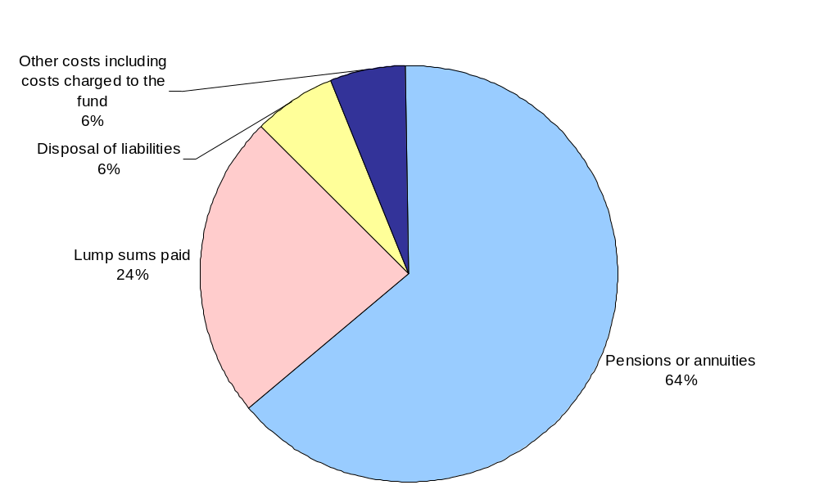

Income: 2007-08 to 2011-12

- Table 2 and Chart B provide figures of the income to the Local Government Pension Scheme income and the market value of the Local Government Pension Scheme from 2007-08 to 2011-12.

- Income from employees’ contributions to the Local Government Pension Scheme in 2011-12 was £1.8 billion, a decrease of more than 6% on 2010-11. Income from employers’ contributions to the scheme also decreased in the same period, albeit by only £27 million or 0.4%.

- In 2011-12, 67% of Local Government Pension Scheme income came from employers’ and employees’ contributions whilst income from investments provided 26% of the total.

- Income from investments rose by 13% when compared with 2010-11 to £3.0 billion; this is still below the level of 2007-08, due in the main to lower interest rates.

- The market value of the funds at end of March 2012 was £148 billion. This represents an increase of 4% on March 2011 and an increase of 52% on March 2009.

Table 2: Local Government Pension Scheme income and market value of funds 2007-08 to 2011-12
 |  |  |  |  |  | £ million
 |  | 2007-08 | 2008-09 | 2009-10 | 2010-11 | 2011-12
 | Contributions (including those from admitted authorities)
 | Employees^{(a)} | 1,680 | 1,926 | 1,974 | 1,966 | 1,839
 | Employers^{(b)} | 5,009 | 5,400 | 5,759 | 5,947 | 5,920 | *
 | Investment income (gross) | 3,165 | 2,873 | 2,572 | 2,696 | 3,045
 | of which:
 | Dividends receivable | 2,080 | 1,999 | 1,754 | 1,708 | 2,071
 | Interest receivable | 638 | 546 | 385 | 383 | 370
 | Income from property | 303 | 302 | 305 | 345 | 387
 | Other investment income | 144 | 25 | 128 | 259 | 217
 | Transfer values | 707 | 557 | 800 | 791 | 662
 | Other income | 50 | 50 | 58 | 96 | 82
 | Total income | 10,610 | 10,806 | 11,163 | 11,496 | 11,547
 |  |  |  |  |  | £ million
 | Market value of funds at end of year | 119,959 | 97,272 | 132,012 | 142,716 | 147,719
Source: SF3 forms
(a) The rate of employee's contribution to the scheme changed from 1 April 2008 from a flat rate for all employees to a variable rate dependent on salary.
(b) Includes employers' secondary contributions
* | Employers contribution for 2011-12 includes a one-off exceptional item of £65m due to transfer of responsibility of scheme

Chart B: Local Government Pension Scheme income in 2011-12
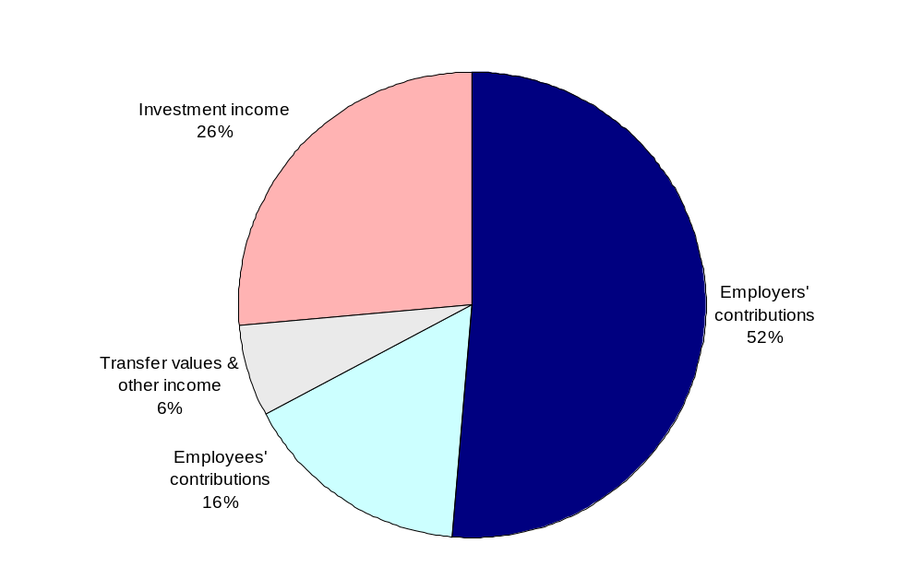

- Table 3 and Chart C provides a comparison of total Local Government Pension Scheme expenditure and income from 2007-08 to 2011-12.

- In 2011-12, total expenditure accounted for 74% of the Local Government Pension Scheme income, up from 58% in 2007-08.

Table 3: Local Government Pension Scheme total expenditures and income 2007-08 to 2011-12
 |  |  |  |  |  | £ million
 |  | 2007-08 | 2008-09 | 2009-10 | 2010-11 | 2011-12
 | Total expenditure (from Table 1) | 6,185 | 6,502 | 7,578 | 8,007 | 8,592
 | Total income (from Table 2) | 10,610 | 10,806 | 11,163 | 11,496 | 11,547
 | Excess of income over expenditure | 4,425 | 4,304 | 3,584 | 3,488 | 2,955
 | Expenditure as a % of income | 58% | 60% | 68% | 70% | 74%
Source: SF3 forms

Chart C: Local Government Pension Scheme total expenditure and income
2007-08 to 2011-12
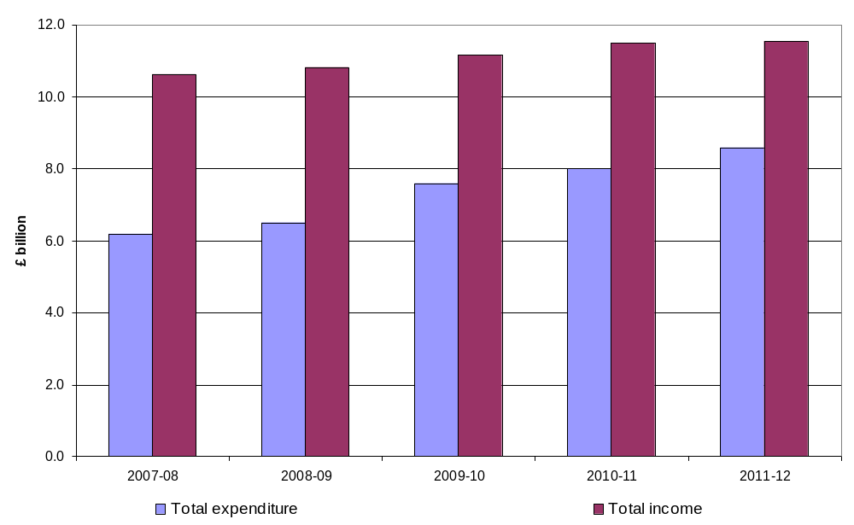

Membership: 2007-08 to 2011-12

- Table 4 and Chart D provide figures of the membership of the Local Government Pension Scheme at the end of each year from 2007-08 to 2011-12.

- There were less than 1.6 million employees in the Local Government Pension Scheme at the end of March 2012, a 66 thousand, or 4%, decrease over the figure for March 2011.

- During 2011-12 the number of pensioners rose by 56 thousand to nearly 1.3 million, an increase of 6% over the figure for the end of 2010-11.

- In 2011-12, the number of former employees entitled to deferred benefits rose by 93 thousand to 1.4 million, an increase of 7% over 2010-11, and an increase of 35% over 2007-08.

Table 4: Number of Local Government Pension Scheme members at the end of each year 2007-08 to 2011-12
 |  |  |  |  |  | Thousand
 |  | 2007-08 | 2008-09 | 2009-10 | 2010-11 | 2011-12
 | Employees | 1,656 | 1,685 | 1,684 | 1,633 | 1,567
 | Pensioners | 1,049 | 1,088 | 1,131 | 1,187 | 1,253
 | Former employees entitled to deferred benefits | 1,055 | 1,149 | 1,245 | 1,326 | 1,420
 | Former members to whom Regulation 18 of the 2007 Benefit Regulations (flexible retirees) applies | 1 | 2 | 4 | 9 | 9
Source: SF3 forms

Chart D: Membership of the Local Government Pension Scheme

2007-08 to 2011-12
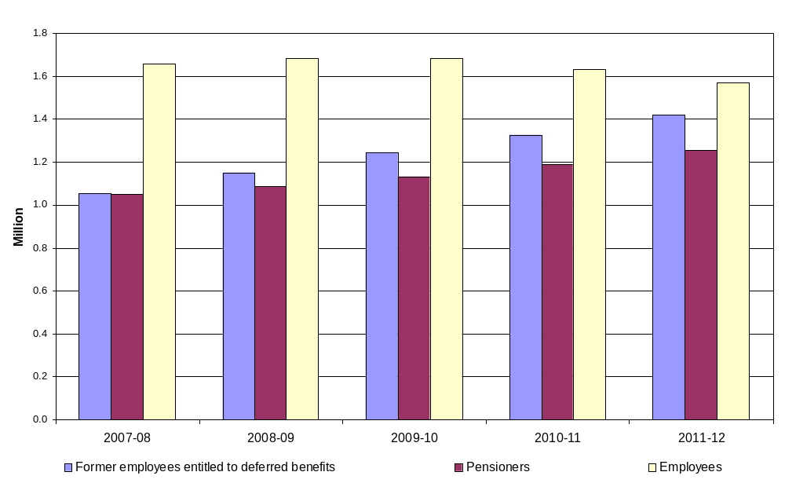

Retirements from the Local Government Pension Scheme: 2007-08 to 2011-12

- Table 5 and Chart E provide figures of the type of retirement from the Local Government Pension Scheme from 2007-08 to 2011-12.

- The number of people leaving the Local Government Pension Scheme in 2011-12 because of redundancy increased by 56% over the 2010-11 figure to over 27,500 and this is now greater than the number leaving by normal retirement.

- By 2011-12, the number of people leaving the Local Government Pension Scheme due to retirement has increased by more than 46% over the number for 2007-08.

Table 5: Type of retirements from the Local Government Pension Scheme
2007-08 to 2011-12
 | 2007-08 |  | 2008-09 |  | 2009-10 |  | 2010-11 | 2011-12
 | Redundancy | 7,927 |  | 9,346 | 12,637 |  | 17,657 | 27,525
 | Ill health retirement (pre 2008) | 4,134 | || | 1,470 | - |  | - | -
 | Tier 1,2 & 3 ill health retirement awards under LGPS^{(a)} | - | || | 2,475 | 2,898 |  | 2,903 | 2,820
 | Early payment of deferred benefits | 17,867 |  | 18,952 | 19,150 |  | 20,344 | 20,923
 | Normal retirements | 21,393 |  | 20,967 | 22,180 |  | 21,585 | 23,016
 | Total retirements | 51,321 |  | 53,210 | 56,865 |  | 62,489 | 74,284
Source: SF3 forms
(a) This was introduced on 1 April 2008. See Terminology used in this release for further details
From 2009-10 onwards ill-health retirements under the 1997 scheme are excluded

Chart E: Type of retirement from the Local Government Pension Scheme
2007-08 to 2011-12
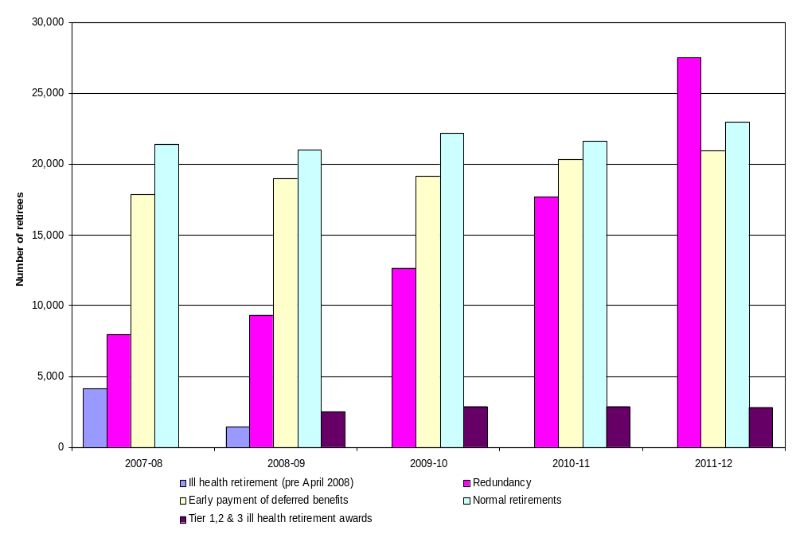

Terminology used in this release

A list of terms relating to local government finance is given in the Glossary of Terms to the Local Government Financial Statistics England No. 22 2012. This is accessible at
www.communities.gov.uk/publications/corporate/statistics/financialstatistics222012
The most relevant terms for this release are explained below.

Administering authority
A body responsible for administering a Local Government Pension Scheme fund on behalf of its members who may be drawn from a number of local authorities.

Admitted bodies
Administering authorities may admit employees of non-scheme employers to the scheme under an admission agreement.

Former employees entitled to deferred benefits
Members who leave the scheme having completed the minimum period of service but who are not entitled to the immediate payment of a pension benefit, are awarded a deferred benefit which, under normal circumstances, becomes payable when the person reaches their normal retirement age.

Former members to whom Regulation 18 of the 2007 Benefit Regulations (flexible retirees) applies
This applies to a member who had attained the age of 55 and who, with his employer’s consent, had reduced his or her hours of work (or the grade in which they were employed) and was permitted by that employer to receive all or part of their benefits under the 2007 Benefit Regulations.

Grant payable on death
This is payable to the estate of a scheme member who dies in service. Prior to 1 April 2008 this was 2 times final pay. Since 1 April 2008, when the Local Government Pension Scheme (Benefits, Membership and Contributions) Regulations 2007 and the Local Government Pension Scheme (Administration) Regulations 2008 came into effect, this has increased to 3 times final pay. This accounts for the significant increase shown in Table 1 for 2008-09 compared to earlier years.

Ill Health retirement
Under the Local Government Pension Scheme (Benefits, Membership and Contributions) Regulations 2007 and the Local Government Pension Scheme (Administration) Regulations 2008 which came into effect on 1 April 2008, there are now three levels of ill-health retirement pension payable. These levels depend on the extent to which the incapacitating condition which gave rise to the termination of employment in local government prevents the scheme member from obtaining gainful employment in the general workforce.

Local Government Pension Scheme
The pension funds in the Local Government Pension Scheme operate under regulations made under the Superannuation Act 1972. Schedules to the regulations list the scheme employers, most of these are local authorities. In England there are 81 pension funds in the Local Government Pension Scheme, each administered by an administering authority.

The assets of the pension funds are for meeting the future pension liabilities of the funds, and are part of the financial corporations sector in the National Accounts, not part of the local government sector. Pensions paid out under the scheme are therefore part of the expenditure of the pension funds, not of the local authorities that administer them. Employers’ and employees’ contributions, part of the income of the funds, are recorded as expenditure by local authorities in their revenue accounts, either directly or indirectly under employees' expenses.

On 1 April 2008, the Local Government Pension Scheme (Benefits, Membership and Contributions) Regulations 2007 and the Local Government Pension Scheme (Administration) Regulations 2008 came into effect. This Scheme includes some new and different provisions which may affect comparison with previous data sets.

Lump sum on retirement
Prior to 1 April 2006-07, scheme members on retirement became entitled to both an annual pension based on 1/80th of pensionable pay for each year of membership and a lump sum of three times that amount. Under the new regulations, entitlement is to a pension only based on a higher accrual rate of 1/60th but with the option to commute pension into lump sum.

Pension arrangements for fire fighters, police and teachers
Separate arrangements apply for the pensions of the police, fire fighters and teachers. The police and fire fighters' pensions are provided through unfunded schemes administered locally, and the cost of police and fire fighters' pensions are therefore included in local authority expenditure. Teachers’ pensions are provided through a notionally funded scheme administered by the Department for Education (DfE). There is no fund of assets, and teachers’ pensions are paid by the DfE. Employers' and employees' contributions are paid by local authorities to the DfE and are recorded as expenditure in their revenue accounts.

It should be noted that non-operational staff in the police, fire and rescue service support staff, and non-teaching staff in the education sector are covered by the Local Government Pension Scheme.

Refunds of contributions
Contributions refunded when a person leaves a pension scheme before completing a minimum period of service. Under earlier schemes, a refund of contributions could be paid to those leaving the scheme with less than 2 years service. Under the 2008 scheme, a refund of contributions can only be made to a person who has been a member of the scheme for less than 3 months.

Transfer Values
A cash value assigned to a person’s pension pot that is transferred with them when they move from one pension fund to another.
Data quality

The information in this release is based on data returned to Communities and Local Government by all 81 administering authorities in England on Local Government Pension Funds and associated information for the financial year 2011-12 (SF3) forms.

Figures are subjected to rigorous pre-defined validation tests both within the form itself, while the form is being completed by the authority and also in the Department for Communities and Local Government as the data are received and stored.

Finally, the release document, once prepared, is also subject to intensive peer review before being cleared as fit for the purposes of publication.

Following a review of data used in previous releases, the data for retirees in 2009-10 onwards have been amended (see Table 5).

Uses made of the data

The data in this statistical release are essential for a number of different purposes. A central and immediate purpose is to provide Ministers with information about the Local Government Pension Scheme. The data are also used by local authorities, their associations and regional bodies.

In addition, the data provides a benchmark on the administration and fund management of the Local Government Pension Scheme. The data are also used in compiling the National Accounts and to show the role of pension funds in the economy.

Background notes

- Statistical Releases are produced to high professional standards set out in the National Statistics Code of Practice. They undergo regular quality assurance reviews to ensure that they meet customer demands.

- The information for 2011-12 in this Statistical Release is derived from Local Government Pension Scheme Fund (SF3) forms submitted by all 81 Administering Authorities in England only.

- The pension funds in the Local Government Pension Scheme provide pensions for most local authority employees. In England and Wales there are 89 pension funds in the Local Government Pension Scheme. The assets of the pension funds are for meeting the future pension liabilities of the funds, and are part of the financial corporations sector in the National Accounts, not part of the local government sector. Pensions paid out under the scheme are therefore part of the expenditure of the pension funds, not of the local authorities that administer them. Separate arrangements apply for the pensions of the police, fire fighters and teachers.

- For press enquiries about this Statistical Release please contact the Local Government press desk on 0303 444 1201 or email press.office@communities.gsi.gov.uk. For other enquiries please telephone John Farrar on 0303 444 2116 or email sf3.statistics@communities.gsi.gov.uk.

- The responsible statisticians for this release are Steven Melbourne or Mike Young who can be contacted on 0303 444 2116

- This Statistical Release can be found at the following web address:
www.communities.gov.uk/localgovernment/localregional/localgovernmentfinance/statistics/pensionscheme/

- Timings of future releases are regularly placed on the Department’s website, http://www.communities.gov.uk/corporate/researchandstatistics/statistics/publicationschedule/ and on the UK National Statistics website, www.statistics.gov.uk/hub/release-calendar/index.html

- Further information is also available on the department’s website www.communities.gov.uk/localgovernment/localgovernmentfinance/

- For a fuller picture of recent trends in local government finance, readers are directed to Local Government Financial Statistics England No.22 2012 which is available in hard copy from Wetherby Publications Centre at communities@twoten.com (Tel. 0870 1226 236) and electronically from the Department for Communities and Local Government website www.communities.gov.uk/publications/corporate/statistics/financialstatistics222012

- In addition to data for England, DCLG also collect data for 8 administering authorities in Wales. Data for 2011-12 and comparisons with previous years can be found at:
www.communities.gov.uk/localgovernment/localregional/localgovernmentfinance/statistics/pensionscheme/summarydata/

- The Scottish Government also collect local government pension fund data. Their information can be found at the following website:
www.scotland.gov.uk/Publications/2012/02/2421/5

- DCLG also collect and publish data on the Firefighters’ pension scheme. This information can be found at the following website:
www.communities.gov.uk/fire/researchandstatistics/firestatistics/firepensionstatistics/

Symbols and convention used in this release

 | (R) | = | some data have been revised since the last statistical release
 | … | = | not available
 | – | = | not relevant
 | - | = | negative
 | 0 | = | zero or negligible
 | || | = | discontinuity in data
Rounding
Where figures have been rounded, there may be a slight discrepancy between the total and the sum of constituent items

Department for Communities and Local Government. © Crown Copyright, 2012
If you require this publication in an alternative format please email: alternativeformats@communities.gsi.gov.uk. Please note that the nature of content means that we may not be able to provide the Statistical series of publications in all requested formats.
October 2012
ISBN: 978-1-4098-3668-1

