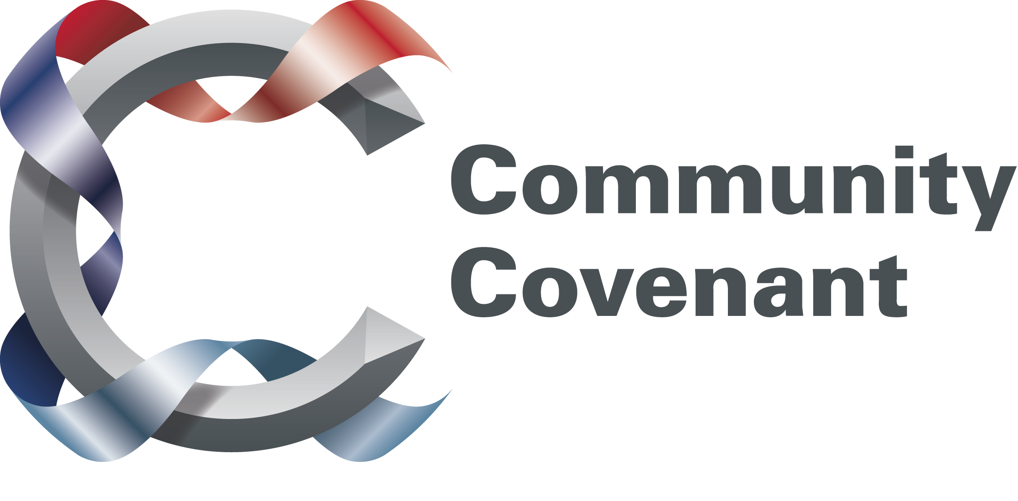

ARMED FORCES COMMUNITY COVENANT GRANT APPLICATION FORM

1. Title of Project.

2. Name of the Community Covenant Partnership.

3. Amount of funding requested from the Community Covenant Grant.

4. Local Authority contact (name, address, e-mail and telephone number).

5. Individual/organisation responsible for delivering project (project manager) (name, address, e-mail and telephone number) (if appropriate please detail type of organisation – charity etc and whether not-for-profit etc).

6. What do you intend to do? (300 words)

7. How does this contribute to overall aims of Community Covenant? (max 200 words)

8. Who will benefit from this project and how? (max 200 words) SEE ENDNOTE 1.

9. Do you intend to work with other organisations (if so who).

10. What is your projected timetable for the project? Please include start and end date for the project and major milestones.

11. How will you measure success?

12. How will the project be sustained once Community Covenant Funding has ceased? (max 200 words)

13. Please provide a breakdown of costs? SEE ENDNOTE 2.

14. Have you applied for or received other grants or financial support from other government departments, Local Authorities, charities or elsewhere to fund or partially fund the activities proposed in this business case? If yes, please give details. SEE ENDNOTE 3.

15. Does your proposal require planning permission? If so, has this been sought and agreed? Please provide copies of relevant paperwork.

COMMUNITY PARTNERSHIP ENDORSEMENT
16. Community Covenant Partnership endorsement. Please outline why you are supporting this bid. (max 500 words) SEE ENDNOTE 4.

17. In signing this document, you agree that the information given is true and correct to the best of your knowledge, the project has been endorsed by the Community Covenant Partnership and that if the bid is successful you agree to be bound by the Terms and Conditions available on our website – www.mod.uk/covenant. SEE ENDNOTE 5.

Signature________________________________ PRINT____________________________
Date______________________________
Signed by local authority representative to E-Mail_____________________________
Community Covenant Partnership

Signature________________________________ PRINT____________________________
Date______________________________
Signed by Armed Forces representative to E-Mail_____________________________
Community Covenant Partnership

ENDNOTES:

1. Provide evidence, where possible, of the numbers in the Local and Armed Forces communities who are likely to benefit from your proposal. We accept that hard evidence will not always be available but where possible the Panel would welcome plans for targeting and measuring the uptake of the services/facilities in both Local and Armed Forces communities.

2. You are asked to show a breakdown of costings for the project, where possible supported by quotations received.

3. We require to know the sources, as well as the amounts, of money being provided by other organisations that you have approached to fund your project. While a lack of any matched funding or goods/services-in-lieu is not a ‘deal breaker’, the Panel will always look more favourably on those projects which have made an effort to obtain funds from other sources. Where this has not been possible an explanation of what has been done to raise funds and the reasons why money is not available from elsewhere could well ease the progress of your bid.

4. Before submitting an application ensure that a Community Covenant has been signed for your area as the Community Covenant Grant Panel cannot authorise payment to any proposal from an area that has not signed the Community Covenant.

5. Ensure that the Community Covenant Application form is signed by the local authority and military member (normally at OF4 rank where that is feasible) of your Community Covenant Partnership, or their representatives, to assure the Panel that your proposal has the full support of your local partnership team.

COMPLETED FORMS SHOULD BE SIGNED BY THE LOCAL AUTHORITY AND MILITARY MEMBER OF THE COMMUNITY COVENANT PARTNERSHIP BEFORE COMING TO MOD (PLEASE SEE THE “COMMUNITY COVENANT GRANT - HOW IT WORKS AND CRITERIA FOR FUNDING” DOCUMENT FOR FURTHER DETAILS AND GUIDANCE OR CONTACT THE COVENANT TEAM ON 020 7218 1206 IF YOU NEED FURTHER HELP).

Applications should be returned to:

DCDS(Pers&Trg) Covenant Team
Ministry of Defence
6th Floor, Zone A
MOD Main Building
Horse Guards Avenue
London
SW1A 2HB

