
export control organisation

Customer Satisfaction Survey 2010 – Analysis Report

OCTOBER 2010

Contents

Executive Summary 3

1. Background 5

2. Responses 5

3. Results 6

3.1 Overall Satisfaction 6

3.2 Customer Overview 6
3.2.1 Types of customers 6
3.2.2 Size of organisation 7
3.2.3 Job Roles 7
3.2.4 Knowledge and Level of Interaction with ECO 8
3.2.4.1 Further analysis and comparison of customer knowledge depending on size and nature of business 8
3.2.4.2 Analysis of how customers determine need for a licence 9

3.3 Customer opinion and expectations of our service delivery performance 9
3.3.1 Satisfaction with service provided by ECO Staff 9
3.3.2 Opinion of response to delay in licence processing in case of significant delay 10
3.3.3 Customer Expectations of Licence Processing Timescales and Communication 11
3.3.4 Customer Expectations depending on type of customer 12
3.3.5 Satisfaction with ECO communications 13
3.3.6 Satisfaction with the SPIRE system 14
3.3.7 Satisfaction with ECO services and information 14
3.3.8 Opinion on ECO’s handling of customer complaints 15

3.4 Suggested Service Improvements 16

4. Conclusions and Response to Comments 17

4.1 Immediate Service Improvements 17

4.2 Action Plan for further service developments 17

Customer Satisfaction Survey 2010 – ACTION PLAN 18

Appendices 26
Appendix A – Charts 26
Appendix B – Sample cross-section of comments 34
Appendix C – Customer Survey Questions 39

Executive Summary

Background context
The Export Control Organisation (ECO), part of the Department for Business Innovation and Skills (BIS), provides the UK’s statutory “strategic” export licensing service. This is a requirement for the export or trade in military and dual-use items, in line with the UK’s international commitments.

The ECO is responsible for processing licence applications – balancing the need for a fast and efficient service for exporters with the need to conduct appropriate checks and assessments.

One of the similarities between government and the private sector is that neither can survive without customers. Most successful businesses have learned that their survival depends on knowing what their customers need and the level of service that they expect. The same holds true for the public sector. Customers of public sector organisations, such as the ECO are coming to expect a high level of service and professionalism for their taxes.

The ECO works hard to provide the best possible licensing service, within the legal constraints that the service operates. Within this context, it is recognised that excellent customer service is about learning from customers. The Customer Satisfaction Survey is one of the main mechanisms of getting feedback from users of the service.

Main feedback

Results from the 2010 Survey show that:

Overall satisfaction with the ECO is high with 67% of survey respondents expressing satisfaction with the ECO’s services.

Other key insights gained from the survey include:
- Staff are appreciated and valued for delivering a professional service. Respondents rated staff as courteous (84% satisfaction), helpful (73% satisfaction) and knowledgeable (63% satisfaction)
- SPIRE (ECO’s licensing database) is judged to be easy to use (75% satisfaction)
- The licensing process in general is communicated well (64% satisfaction)
- The final licensing decision is communicated clearly (87% satisfaction)
- Customers are informed and aware of licensing terms and conditions and their responsibilities as licence holders (87% satisfaction)
- Dissatisfaction is often linked to experiences and perceptions of processing specific licence applications. Only 4% of respondents are strongly dissatisfied with ECO’s services, but this rises to 21% of those who have not had a satisfactory response to a significant licensing delay. These dissatisfaction levels are less marked in the case of more experienced ECO customers, but it is an issue for all categories of customers.

The survey also provided customers with the opportunity to raise comments. As a result, a number of suggested service improvements have been provided which can be broadly grouped into the following categories:
- Speed of Licence Processing – Timescales and Targets
- Communication about the progress/delay in licence processing
- Relationship Management of companies
- Consistency of Licensing Advice
- Open Licensing
- Charging
- Guidance issues and customer training needs
- Improving the ECO Helpline
- Improving the ECO Website
- Improving the Checker Tools
- Improving the usability of SPIRE
- Tone and attitude of customer communications
- Staff Knowledge
- Staffing Levels

ECO Response

In response to this feedback the ECO is now actively taking a number of steps including:

Immediate Service Improvements

Some ongoing changes that we have implemented since the 2010 Customer Survey was issued, in order to improve the ECO’s service are:
- Issued update guidance about End-User Undertakings including providing an EUU Checklist form
- Reviewing with industry the content and usefulness of information available on the ECO pages of the Businesslink website.
- Highlighting average time frames for licence processing of specific destinations (such as embargoed countries) in the Awareness Bulletin).
- Development of additional open licences for less sensitive goods and destinations.

Action Plan for further service improvements

We have devised an Action Plan to address other areas where either specific action is already planned or in progress and also recognising areas where there is scope for further investigation.

1. Background

This is a results summary of the 2010 Customer Satisfaction Survey conducted by the Export Control Organisation (ECO), part of the Department for Business, Innovation and Skills. The summary is for internal ECO use only. Once the internal version has been agreed, a sanitised version will be produced, in consultation with LCG and Policy Unit, for publication on the ECO website.

As the UK’s licensing authority for strategic export controls, the ECO has to balance regulatory requirements with the needs of a diverse range of customers whose products are ‘controlled’ and therefore require a licence for export purposes.

As a service delivery organisation, the ECO is conscious of its remit to customers and continuously looks to improve, where possible, within the regulatory constraints of the export licensing system.

In this context, the ECO Customer Satisfaction Survey forms a vital aspect of ECO’s engagement and efforts to understand our customer needs and how to improve as a service, providing excellent value to both exporters and to the wider general public.

The 2010 survey was run from the end of January to April 2010.

Its launch introduced a number of changes to the way previous surveys had been conducted making it difficult to make direct correlations with previous outcomes. First, the questions have been extensively revamped since the last time the survey was conducted in Spring 2007. Second, the survey was also conducted for the first time via ECO’s export licensing database called SPIRE, which is the system used by customers to make licence applications. This meant that the survey was directly targeted at ECO’s customer base of licence applicants

2. Responses

The survey was issued directly via the SPIRE database into exporter applicant workbaskets. Details of the survey questions are at Appendix C.

Distributing the survey via SPIRE meant that a questionnaire was issued automatically to a licence applicant, triggered by the final licensing decision when applying for Standard Individual Export Licences (SIELs). Additionally, the survey was also forwarded on request to individual exporters which potentially enabled ECO to issue the survey to our wider customer base of Open General Licence (OGEL) applicants.

As a result the survey was issued directly into 1618 individual workbaskets during the survey period (January to April 2010). A total of 657 individuals responded (with an additional 44 people declining to participate).

This meant that the survey resulted in a return rate of 41%, which we recognise is extremely high for these types of surveys. For instance, it compares to a return rate of 33% for the 2007 ECO Customer Satisfaction Survey. This could be due to a number of reasons, such as the high levels of engagement that we endeavour to have with industry and other stakeholders, because respondents want to provide more feedback or as a result of the new survey distribution method via the SPIRE system.

The method of distributing the survey means that there is an element of self-selection in the responses received, which mean that the responses are not fully representative. However, given the large response rate the responses provide a very good indication of areas for improvement.

3. Results

3.1 Overall Satisfaction

Respondents have a broadly positive opinion of the ECO. 54% (agree) and 13% (strongly agree) with the statement “I am satisfied with the overall service level ECO provides”. This corresponds to a large majority (67%) of respondents who have a positive attitude to the ECO’s service provision. (See Question 8).

This high satisfaction level is testament to the way ECO operates in a highly complex service delivery area – balancing the needs of exporters in selling and delivering products quickly and efficiently while meeting the UK’s international obligations and EU and national legislation surrounding sensitive and strategic goods exports.

3.2 Customer Overview

In order to gain a better insight into the nature of our customers, the survey asked all respondents about their business, size of organisation their organisational role and their knowledge and level of interaction with ECO.

3.2.1 Types of customers

ECO’s customers operate across a wide range of sectors and industries. Given the wide range of items that are subject to controls as listed on the UK Strategic Export Control Lists, this is unsurprising.

The survey indicates that a large proportion of our respondents are from the defence (19%) and aerospace (15%) industries and 19% of respondents are manufacturers.

Beyond these sectors that are perhaps most associated with the need for export controls, the survey confirms the diversity of ECO’s customer base. ECO’s customers include a large proportion of so called “dual-use” companies (in other words companies making products for both civilian and military markets). For instance, ECO customers operate in a range of industries, such as:
- Electrical/Electronic Equipment and Components
- Oil and Gas
- Chemical
- Telecommunications, Computers, IT Services
- Transportation Services

Additionally the “other” category includes exporters from an even broader range of sectors as well as individuals (such as military vehicle and firearms owners and a non-governmental organisation). (See Question 1).

ACTION POINT
In the light of this feedback, the ECO is building on our existing relationships with trade organisations and also planning to increase our awareness raising activities in targeted sectors, in co-ordination with relevant sector organisations.
See: AP4b

3.2.2 Size of organisation

This is the first time we have examined the size of companies in our customer base and the responses to this survey indicate that the vast majority of respondents applying for licences are Small and Medium sized Enterprises (SMEs).

40% of ECO’s respondents are small companies (with 1 to 49 employees), 42% are medium sized enterprises (50 to 499 employees) with only the remaining third working in larger companies of 500 employees. Only 7% of respondents have over 2500 employees. (See Question 2)

3.2.3 Job Roles

We also wanted an understanding of who completed the questionnaire. Of all survey respondents, 27% were executives or senior managers, 43% were in a supervisory, export control level function and 30% were administrators.

While this is not a scientifically based question, the results indicate that responsibility for export controls cuts across organisations and in the majority of cases and regardless of the size of the respondent, key responsibility sits at a relatively high level in companies. (See Question 3).

3.2.4 Knowledge and Level of Interaction with ECO

Respondents were asked to indicate their level of knowledge of dealing with the ECO ranging from a novice to very experienced level (Question 4). At one extreme, roughly 26% of all respondents defined themselves as “novices” to export controls, compared to 16% who categorised themselves as “very experienced”. (See Question 4). The responses overall indicate that the majority of individuals who responded (74%) who have contact with ECO are either fairly experienced or very experienced in the export control process.

Collectively, the responses to these initial customer overview questions put into context the range of knowledge and background of ECO’s customer base and the continuing need for a more targeted awareness programme.

Respondents were also asked (Question 5) about the number of Standard Individual Export Licences (SIEL) applied for during the past year. The vast majority of respondents made under 20 SIEL applications last year. 39% said they had made 1 to 5 applications and 32% had made 6 to 20 applications – meaning 71% of respondents use the SIEL route to apply for at least some of the licences they need.

The ECO also issues a concessionary form of licence, called an Open Individual Export Licence (OIEL). The eligibility criteria for an OIEL specify that an exporter must have a track record of at least 20 relevant SIEL applications in the preceding year or a sound business case. According to the survey responses (Question 5), using an OIEL might potentially be an option for the 22% of respondents who made over 20 applications in the past year. (See Question 5)

ACTION POINT
This indicates the scope for ECO to make more companies aware of the advantages of open licences. See: AP2

3.2.4.1 Further analysis and comparison of customer knowledge depending on size and nature of business

The results were also analysed further to see what correlations (if any), there were between an exporter making a large number of SIEL applications (over 50 applications per year) and the respondent’s sector of operation.

Respondents who apply for multiple SIELs, tended to be from what might be considered the “traditional” licensing sectors such as Defence (53%), Aerospace (40%) and Marine (19%), as compared to the general sector breakdown of respondents.

Looking at the results in more detail, 21% of the respondents from the defence and aerospace sector indicated that their company employed over 2500 people. In comparison, the broader results show that only 7% of respondents employ over 2500 people.

The results indicate that respondents in these larger companies in the defence, aerospace and marine sectors were generally either satisfied or highly satisfied with ECO’s service.

3.2.4.2 Analysis of how customers determine need for a licence

The survey also captured customer opinion about how exporters across all sectors decided that a particular transaction needed a licence (See Question 7). The responses were suitably diverse, with:
- 24% saying it was a standard company procedure (indicating that their company had applied before and was aware of the procedures).
- 8% sought advice from the ECO Helpline compared to 15% who accessed guidance via the ECO’s webpages.
- 20% used the Rating Enquiry Service compared to 19% who self-rated their goods and 10% who used the Checker Tools databases.
- 4% said that they obtained information from other sources. This included advice from ECO’s Compliance or Enforcement Teams, advice from shippers, manufactures or suppliers, external export compliance consultants or as result of previous experience.

ACTION POINT
We recognise that given our broad customer base, knowledge of our service delivery options and offerings will vary widely. We are also aware that our customers often have limited resources, time and pressure to deliver to their customers. For these reasons we recognise that there is scope for the ECO to continue to develop our services further, such as increasing awareness to companies about the benefits of self rating their goods using available resources, or to provide best practice advice on good company export control practices.
See: AP1a

3.3 Customer opinion and expectations of our service delivery performance

The core questions (Questions 9 to 14) identified customers attitudes towards ECO in terms of different elements of our service provision.

3.3.1 Satisfaction with service provided by ECO Staff

Customers were asked to rate their opinion of ECO customer service levels in terms of defined aspects of customer service including courteousness, helpfulness, knowledgeableness and promptness of service (See Question 9). The responses indicate:
- 23% strongly agreed and 61% agreed that staff were courteous. (87% satisfaction)
- 20% strongly agreed and 53% agreed that staff were helpful. (73% satisfaction)
- 15% strongly agreed and 48% agreed that staff were knowledgeable. (63% satisfaction)
- 11% strongly agreed and 37% agreed that staff delivered a prompt service. (48% satisfaction)

The dip in satisfaction levels for promptness of service is reflected in the general customer comments received about the SPIRE service and key concerns about a fast timescale for processing licences.

Due to the nature of the checks and balances required in processing a licence both through ECO and in consultation with Other Government Departments who are integral to the licensing process, there is always a tension in terms of customer expectations of what constitutes prompt service and the ECO’s ability to deliver. Faster turnaround times in the past have also increased customer expectations. (See also Section 3.3.3 below)

ACTION POINT
We recognise that we need to continue to build on this range of customer satisfaction feedback. For instance we plan to introduce an updated Customer Service and Performance Code and to continue to review our staff training including in customer care and business and export awareness.
See: AP1d, AP1h and AP4e

3.3.2 Opinion of response to delay in licence processing in case of significant delay

Licence processing is probably the most central aspect of service delivery for both ECO and its customers.

Between 2007 (when SPIRE was launched) and 2010, licence application numbers have continually risen. In 2007, applications for Standard Individual Export Licences (SIELs) were almost 10,000 per year. In 2010, applications (as of September 2010) are at over15,000 and rising.

Within this context of increasing licence application numbers, we wanted to better understand current customer expectations about licence processing. In particular, we asked respondents about their perception of delays in licence processing and a final licensing decision. Respondents were asked if they felt that they had received a satisfactory explanation with regard to any licence processing delay. (See Question )

A high proportion of respondents indicated that they felt they had not received a satisfactory explanation about a licence delay. 17% strongly disagreed and 24% disagreed that ECO’s response was satisfactory.

While it should be noted that a “satisfactory” response is subjective and depends on individual perceptions, this response does, nevertheless, demonstrate a gap in customer expectations. Indeed, dissatisfaction about ‘significant’ delays in licence processing was also reflected in survey comments received about SPIRE. These were chiefly concerned with the timescale for processing licences and communication surrounding any delays.

In other aspects, however, respondents considered ECO to be responsive to specific licensing aspects. For instance, 57% of respondents agreed that ECO staff responded promptly to concerns from exporters and over 81% of respondents were happy with the clarification requests for additional information in support of the licence application.

The ECO acknowledges that the speed of issuing licences is a major factor for applicants who are seeking to fulfil orders. However exporters should be aware of the procedures for processing an application. Export control applications are each assessed against published criteria on a case by case basis (the published “EU and National Arms Export Licensing Criteria”). Depending on each specific case, an application may require further consideration beyond existing targets - which are a guide and not an absolute deadline.

ACTION POINT
We acknowledge that there is a high degree of dissatisfaction with this aspect of the licensing process and we need to look at further ways to improve our communications in this specific area. Some of the areas we will look at will include additional progress information on SPIRE or additional information about sensitive goods and sensitive destinations on the website.
See: AP1b, AP1c, AP1f and AP4b

3.3.3 Customer Expectations of Licence Processing Timescales and Communication

Looking at the survey results in more detail, there would seem to be a correlation between respondent satisfaction levels with explanations for delays in licence processing and overall satisfaction levels with the organisation. (Comparison of Questions 8 and 10a).

Customer expectations and perceptions about delays appear to have an impact on customer perceptions and opinions.

Those who felt they did not receive a satisfactory explanation to a ‘significant’ delay were more likely to be dissatisfied with ECO’s services. Only 35% of these respondents were satisfied with the overall service provided (compared to 53% generally) and 21% expressed strong dissatisfaction (compared to only 4% generally).

These same respondents are also less likely to agree that communication about the licensing process meets exporter needs. They also:
- think that the licensing process is less well communicated (35% agree compared to 54% generally) and
- believe that they are kept less well informed on the progress of specific applications (5% agree compared to 29% generally).
- do not agree that ECO staff respond promptly to queries raised (28% agree compared to 45% generally)

This group is also less likely to judge ECO staff as helpful or knowledgeable.

However on the positive side, they continue to find staff courteous and also agree that the final licence decision is communicated clearly with almost the same level of satisfaction as other respondents who have not experienced delays. (62% agree compared to 64% generally).

ACTION POINT
There is scope here for improving the ways in which we communicate with exporters and in some cases our approaches to requesting additional information. Having said that some of this could be tackled by improved management of companies’ expectations including improved education about realistic response times in relation to the types of goods involved; the destinations of the goods, and end-user issues.
See: AP1b, AP1c and AP4b

3.3.4 Customer Expectations depending on type of customer

As outlined in Section 3.1 above, overall satisfaction levels indicate that 54% (agreed) and 13% (strongly agreed) with the statement “I am satisfied with the overall service level ECO provides”. (See Question 8).

In comparison, more experienced ECO respondents generally expressed slightly greater overall satisfaction with ECO’s customer service (55% agreed and 20% strongly agreed) and also with other specific aspects of our service provision. On the other hand, novice respondents expressed slightly lower overall satisfaction levels with ECO services (44% agreed and 16% strongly agreed that they were satisfied with ECO’s service).

The differences in opinion and expectation are also reflected in respondent attitudes to communications about the licensing process. 63% of very experienced respondents agreed that the licence process in general was well communicated. In comparison, novice respondents were less likely to indicate that the licence process in general was well communicated (43% agree). This difference in attitudes might stem from lack of knowledge and increased expectations about the licensing process from respondents who are less aware of the licensing process generally.

ACTION POINT
We recognise that we need to continually find ways to communicate and target information to different customer groupings, including ‘novice’ customers.
See: AP4a and AP4b

During the past year, our guidance material is now published via the Businesslink website (http://www.businesslink.gov.uk/exportcontrol) which is more accessible to small and medium sized businesses. We are also continually working to find fresh avenues to alert new customers to the need to be aware of export controls.

ACTION POINT
We will also look at ways at closer working across units in ECO to identify those companies who are in need of assistance with a greater understanding of export control processes – picked up by Compliance Officers; Technical Officers and Licensing Unit.
See: AP4a and AP4b

3.3.5 Satisfaction with ECO communications

The survey also asked customers to assess how well the licensing process was communicated both in general and specifically. (See Question ). The responses indicate:
- A majority of respondents judged the ECO to communicate the general licensing process well - 54% (agree) and 10% (strongly agree) or a 64% satisfaction level.
- 45% of respondents agreed and 12% strongly agreed that the ECO provided a prompt response to queries raised by the exporter. (57% satisfaction)
- 66% agreed and 15% strongly agreed that the communication of additional information required as part of the licensing process was clearly communicated (81% satisfaction)
- 65% agreed and 23% strongly agreed that the final licensing decision is communicated clearly. (87% satisfaction)
- 63% agreed and 24% strongly agreed that they were made aware of the terms and conditions of licences and the responsibilities of holding an export licence. (87% satisfaction)

Conversely, there were more mixed views in terms of information received about the progress of specific applications with only 29% agreeing (as referred to in the paragraph on Customer Expectations above).

ACTION POINT
These results relating to satisfaction with communications are very encouraging, particularly in terms of the final licensing decision and licence terms and conditions. We acknowledge however, that we have room for improvement in terms of communications about the progress of specific applications, providing a prompt response to queries and the tone of our communications.
See: AP1b, AP1d and AP1g

3.3.6 Satisfaction with the SPIRE system

SPIRE is ECO’s licence application database and has been in place since 2007, replacing the previous paper based and disc based application processes. SPIRE has the benefit of interfacing with the HMRC CHIEF system and is a one-stop-shop approach to automatic decrementation and validation of export licences at the UK border.

Most respondents indicated that they find SPIRE is easy to use - 54% agree and 21% strongly agree (75% satisfaction level). This figure dips only slightly for respondents who categorised themselves as “novices” in terms of dealing with ECO. (See Question )

In conjunction with this question, the survey also asked customers if they thought that there was adequate guidance and support available for SPIRE users (See Question 12). The responses indicate that 58% agreed and 13% strongly agreed that there was sufficient guidance and support available. This feedback mirrors the fact that the SPIRE system is generally judged to be a usable and straightforward IT system.

Customers were also invited to provide comments and suggestions specifically about the SPIRE system. On the whole these comments support the view that SPIRE is a good, workable system for exporters to use. For instance comments include “The SPIRE process is generally very good and easy to use” and “SPIRE is a good tool to use”. Most comments focused on suggestions for further improving the system by added functionality, such as providing greater progress updates, more template options and amending the user interface and input screens.

ACTION POINT
It is encouraging to see SPIRE is considered to be a good, workable system by most exporters and a definite improvement on previous application methods. We will continue to review and assess SPIRE’s functionality in conjunction with industry and where funding permits, to continue to upgrade the system.
See: AP1f

3.3.7 Satisfaction with ECO services and information

Responses were also sought on other services provided by the ECO including the website, helpline, training and seminar programme, Checker Tools, Notices to Exporters and the Businesslink website. (See Question )
- 63% agreed and 10% strongly agreed that they were satisfied with the ECO website. (73% satisfaction)
- 43% agreed and 9% strongly agreed that the ECO Helpline provided a satisfactory quality of service (52% satisfaction)
- 32% agreed and 8% strongly agreed that they were satisfied with the quality of the ECO Training and Seminars programme. The responses to this question also included a high proportion of ‘Don’t Know’ answers. If the proportion of “don’t know” responses is removed from the analysis, satisfaction levels jump to 59% (Agree) and 15% (Strongly Agree) respectively.
- 37% agreed and 5% strongly agreed that they were satisfied with the Checker Tools website. As above, there were a high proportion of “don’t know” responses. If these are removed from the analysis, then the satisfaction levels jump to 55% (Agree) and 9% (Strongly Agree) respectively.
- 55% agreed and 13% strongly agreed that the Notices to Exporters provided a satisfactory level of information
- 31% agreed and 4% strongly agreed that they were satisfied with the information and quality of service provided by the Businesslink service. Again there were a high proportion of “don’t know” respondents (45%).

These figures indicate that those who are aware of ECO services are satisfied with the information or tools provided. However, there is clearly an awareness gap in customer knowledge of ECO services particularly in relation to the ECO’s training and seminar programme and the Checker Tools.

The Businesslink website is now positioned as the main access point for government information aimed at all UK businesses. However, there is also clearly less knowledge of the Businesslink website (45% did not know or did not make use of the service). Given that the majority of the ECO’s practical guidance aimed at customers transferred to the Businesslink site at the beginning of March 2010, an ongoing programme of awareness-raising about the site is required.

ACTION POINT
Given the high percentage of companies who did not know about the training and seminar programme, on-line checker tools and Business Link, there is still room for improvement here in raising the levels of awareness. We are also continually working to improve the information provided on our export control webpages and the ECO Helpline.
See: AP1e, AP4b, AP4c and AP4d

3.3.8 Opinion on ECO’s handling of customer complaints

71% of ECO respondents have not had cause to complain about our services. (See Question 14) this figure roughly equates to the target for processing licensing applications.

Of the remaining proportion of respondents who have had reason to complain, most felt that their complaint had been dealt with efficiently. 12% of respondents either agreed or strongly agreed that their complaint was handled well. In comparison 8% indicated that they were less satisfied.

ACTION POINT
We value all feedback including complaints and we plan to issue revised guidance so that all customers are clear about our complaints handling procedure.
See: AP4e

3.4 Suggested Service Improvements

Respondents were also invited to include comments on improving both the SPIRE export licensing system and ECO’s services more generally. Both questions generated a large amount of feedback suggestions, which can be grouped as follows:
- Speed of Licence Processing – Timescales and Targets
- Communication about the progress/delay in licence processing
- Relationship Management of companies
- Consistency of Licensing Advice
- Open Licensing
- Charging
- Guidance issues and customer training needs
- Improving the ECO Helpline
- Improving the ECO Website
- Improving the Checker Tools
- Improving the usability of SPIRE
- Tone and attitude of customer communications
- Staff Knowledge
- Staffing Levels

Most feedback comments were centred on two aspects in particular - the speed of licence processing and communications about the progress or delay of specific licence applications.

There were also a large number of suggestions for SPIRE improvements. (See Section 3.3.6 above)

For a flavour of some of the comments received, see Appendix B below together with a brief response.

We are committed within ECO to Customer Service Excellence and are looking into whether we can build these requirements for improved service into our systems and processes (as outlined in the Action Plan below).

4. Conclusions and Response to Comments

We greatly welcome all customers taking the time to give feedback since it provides us with valuable information about our service, insight into customer perceptions and expectations and what we can do to continue to develop the ECO as a service delivery organisation.

The results are used by us in a number of ways:
- By informing and training staff about our customers.
- By identifying areas of our service which still need to be improved.

As explained above, this is the first survey that the ECO has conducted since 2007, during which time the survey has been extensively amended and external factors such as a large increase in licence applications may have had an impact on the results too. It is therefore difficult to directly compare and provide a benchmark with levels of satisfaction with previous surveys. Despite this, it is useful to summarise just a few of the improvements made in response to the 2007 survey, including:
- Reintroduction of the ECO helpline
- Providing contact details of Licensing Case Officers on SPIRE
- More use of voicemail and email systems
- Customer service training for staff

These previous service changes demonstrate that we are continually looking to improve and develop our services, where possible. This continues with our response to the 2010 survey as follows:

4.1 Immediate Service Improvements

Since the 2010 Customer Survey was issued, we have taken or are taking a number of actions to improve the ECO’s service including:
- Issued updated guidance about End-User Undertakings including providing an EUU Checklist form
- Reviewing with industry the content and usefulness of information available on the ECO pages of the Businesslink website.
- Highlighting average timeframes for licence processing of specific destinations (such as embargoed countries) in the Awareness Bulletin).
- Development of additional open licences for less sensitive goods and destinations.

4.2 Action Plan for further service developments

We have devised an Action Plan to address other areas where either specific action is already planned or in progress and also recognising areas where there is scope for further investigation. For more information see the attached Action Plan:

Customer Satisfaction Survey 2010 – ACTION PLAN

Action Point Number | Area of Dissatisfaction or Suggested Service Improvement | Specific Issue | Action Taken/Planned | Lead | Date  (Review / Deadline)
AP1a  (Sections:  3.2.4.2,  3.3.2,  3.3.3) | Speed of Licence Processing – Timescales and Targets | Perception and expectation that applications could be processed more quickly | We recognise that customers expect a response to applications and enquiries within the targets set out in our Performance Code. Our immediate focus will be on reviewing the delivery of the Rating Enquiry Service including provision of assistance to self rate goods. | Licensing Unit / Policy Team / Awareness Unit | January – March 2011
AP1b  (Sections:  3.3.2,  3.3.3,  3.3.5) | Communication about progress/delay in licence processing | Perception about lack of communication received by exporters about delays to specific licences | We recognise that dissatisfaction with ECO’s service is often linked to experiences and perceptions of the processing of specific licence applications. While our role is to make a careful, considered assessment of each application, we recognise some frustration can result from the processing and communication involved in dealing with the application. As a result we will be investigating ways to improve the “progress” tracking messages on the SPIRE system. | Licensing Unit | Ongoing
AP1c  (Sections:  3.3.2,  3.3.3) | Relationship Management of companies | Suggestion for licensing process to be managed on greater company basis | We have previously considered introducing greater relationship management of companies in the licensing process. Indeed this is one of the reasons why we have Open Individual Export Licences (OIELs) which are designed for companies with a track record in licensing.  Introducing further relationship management of companies could potentially be counter productive and actually risk slowing down the application process as a result of increased querying of applications. It would also be difficult to introduce relationship management based on size of company or geographic location in the UK since this is not a factor in the final licensing decision.  Nevertheless, we do recognise that there may be opportunities to widen the role of the existing Compliance Officers and this issue will be reviewed by the ECO’s internal Change Group. | Licensing Unit/  Compliance Unit / ECO Change Group | March 2011
AP1d  (Sections:  3.3.1,  3.3.5) | Consistency of Licensing Advice | Perception that there is a lack of consistency in terms of advice or documentation requests | All export licensing decisions are made on a case by case basis in relation to the EU and National Arms Export Licensing Criteria.  We are reviewing our internal training and communications with staff to ensure that all staff remain fully informed of current licensing procedures. | Licensing Unit | Early January 2011
AP1e  (Sections:  3.3.7) | Improving the ECO Helpline | Perception that the Helpline is under resourced and that advice lacks depth | We plan to improve the Helpline by introducing a call options function and reviewing our provision of our training and advice provided. We will review the new service after six months of operation. | Licence Reception Team | November 2010
AP1f  (Sections:  3.3.2,  3.3.3,  3.3.6) | Improving the usability of SPIRE | SPIRE is generally seen as a good and easy to use system but there are concerns about the lack of sufficient progress tracking information, inability to copy details of previous applications and recommendations for improving the system’s overall functionality such as error notifications and including the product rating on a SIEL. | SPIRE caters for a wide range of applicants ranging from novice system users to more ‘expert’ applicants. SPIRE’s functionality is continuously being assessed and reviewed.  Further changes are planned to upgrade the system by issuing details of ratings on the final licence document.  We plan to review how SPIRE reports on the progress of specific licence applications. | Licensing Unit / Awareness Team | Ongoing
AP1g  (Sections:  3.3.5) | Tone and attitude of customer communications | Some of our customer communications are considered to come across as too heavy handed in tone | We are very conscious of our communications with customers which range from our guidance material, Notices to Exporter notifications, communications about specific licences and the final licensing decision.  We will issue revised guidance to staff on best practice in dealing with customers and review our training procedures.  Sometimes, however, it is necessary to use a more firm tone to encourage companies to take swift action as a result. | Licensing Unit/  Awareness Team | October 2010
AP1h  (Sections:  3.3.1) | Staff Knowledge | Perception of lack of consistency in the advice given by case officers | We are reviewing our internal procedures about how we train and update staff. | Licensing Unit | October 2010
AP2  (Sections:  3.2.4) | Open Licensing | Recommendation to have more platform based OGELs that are based on named end-users and destinations | We have recently introduced a new OGEL which might be suitable for companies to use for the export of their goods in relation to the Typhoon Project (subject to meeting the terms and conditions). We are currently reviewing the introduction of further OGELs where possible, depending on the nature of the goods and destinations.  In conjunction with the issuing of new OGELs, we will review our communications and training about OGELs to ensure that exporters understand as clearly as possible how they can be beneficial and aid their exporting potential.  We will also explore the possibility of promoting the use of OIELs more widely and looking at the track record of companies that might be able to consider this licensing option. | Compliance and Awareness Teams | Ongoing as new OGELs are published
AP3 | Charging  Given that this is currently under discussion it may be better to leave the planned action in this format | Suggestion that we should introduce a fast track service for a fee. | Licensing is a statutory service. Any potential changes such as the introduction of a charging policy would have to be considered carefully in terms of all implications and impact and consulted on extensively. | Policy Team | To be reviewed separately
AP4a  (Sections:  3.3.4) | Guidance issues and customer training needs | Request for clearer, updated End-User Undertaking form and for clearer guidance on plainer English | We have recently introduced an End-User Undertaking Form and associated Checklist with additional guidance on the difference between an end-user and a consignee.  We have also taken action to improve the drafting of all our communications. For instance, our Notices to Exporters are now drafted, as far as possible, to include further background explanation which puts the update into context and aims to guide companies in the actions that they need to take. | Licensing Unit/ Awareness Unit | Action complete  Ongoing
AP4b  (Sections:  3.3.2,  3.3.4,  3.3.7) | Guidance issues and customer training needs | More training and seminars in the regions and for specific sectors | We already provide a good range of training courses including on-site training. This includes information on using tools such as the Goods Checker and OGEL Checker.  All our courses are now fully advertised via both the Businesslink and UK Trade & Investment websites and their respective Events databases. We will monitor this awareness advertising to ensure that as many exporters as possible continue to be informed in good time of our continuing training programme both in London and across the UK. For those companies who have requested additional information about the seminar programme, our external feedback should ask the question about how companies want to receive/ be alerted to the information | Awareness Team | Ongoing
AP4c  (Sections:  3.3.7) | Improving the ECO Website | Perception that the ECO is website is difficult to use especially since the transfer of most guidance to the Businesslink site. | Having export control guidance on the Businesslink pages is beneficial in enabling information to reach a potentially wider audience of small and medium sized companies and to identify greater linkages with other related export and trade issues.  At a recent website review meeting held with industry representatives in September 2010, it was agreed that the new export control pages on the Businesslink website were fit for purpose.  The Committee on Arms Export Controls (CAEC) has also endorsed the move to Businesslink and the content of the new website. | Awareness Team | Ongoing
AP4d  (Sections:  3.3.7) | Improving the Checker Tools | Perception that the Checker Tools are not user friendly applications | The Checker Tools are recognised as valuable tools by a wide range of exporters and also overseas export control organisations and trade bodies.  We aim to explore new ways of funding further development of the Checker Tools to ensure that the tools can continue to develop. However, it should be recognised in the current budgetary climate that this is not a top priority.  With a continued interest in self-rating, we are also investigating the development of a Ratings Search Tool to complement the existing Goods Checker database. We are also reviewing our exporter training courses in this area. | Awareness Team | Late 2012
AP4e  (Sections:  3.3.1) | Getting Basics Right |  | We plan to issue an updated and more comprehensive Service Code and Complaints Procedure to our customers and issuing corresponding guidelines to our staff  We plan to publish more information showing trends in complaints, both formal and informal, and the action we have taken as a result; providing a mechanism for receiving customer and staff feedback on the effectiveness of the complaints procedure  We will consider introducing new measures (such as a Customer Satisfaction Index and mystery shopping) to monitor our performance in all customer contact areas in relation to standards for timeliness and quality of customer service. | Awareness Team | January 2011
AP5 | Staffing Levels | Perception of need for increased staffing resources. | As with other organisations, we need to work within our allocated resource budget. We are however constantly reviewing the way we work and are currently looking at options for improving the efficiency and effectiveness of our licence processing operation in the light of increasing licence application volumes. | ECO Director | Ongoing

Appendices

Appendix A – Charts

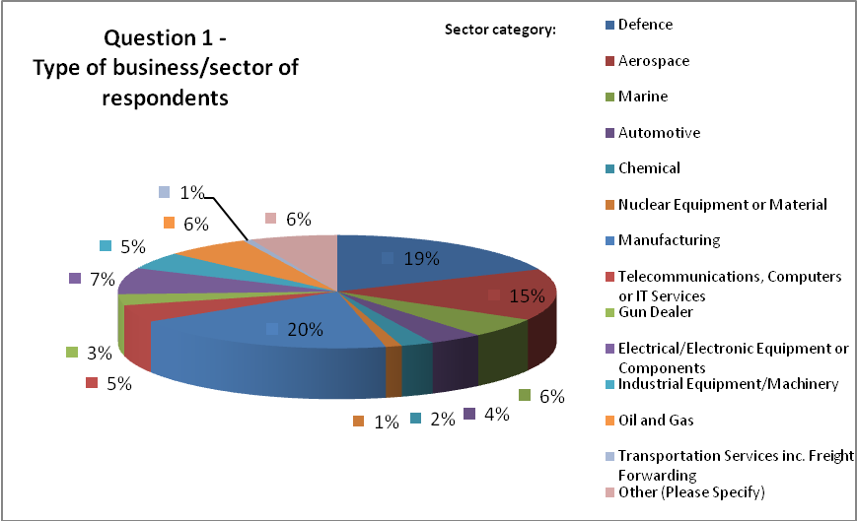
Question 1
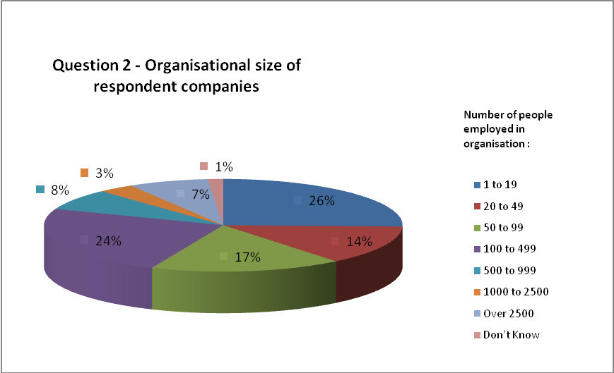
Question 2
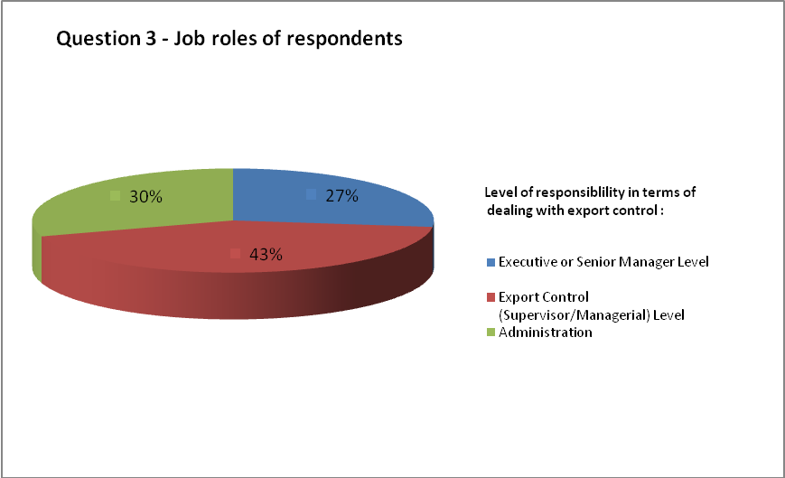
Question 3

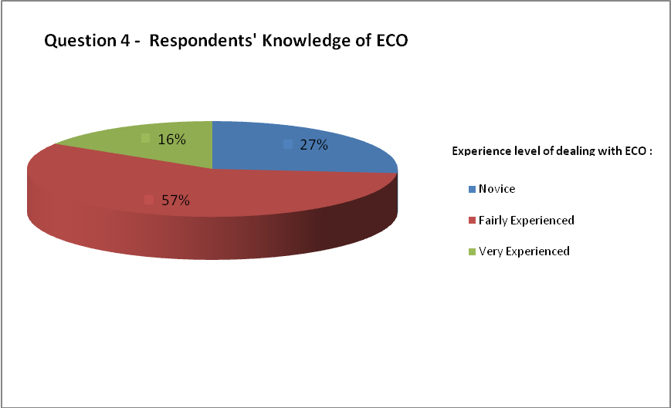
Question 4
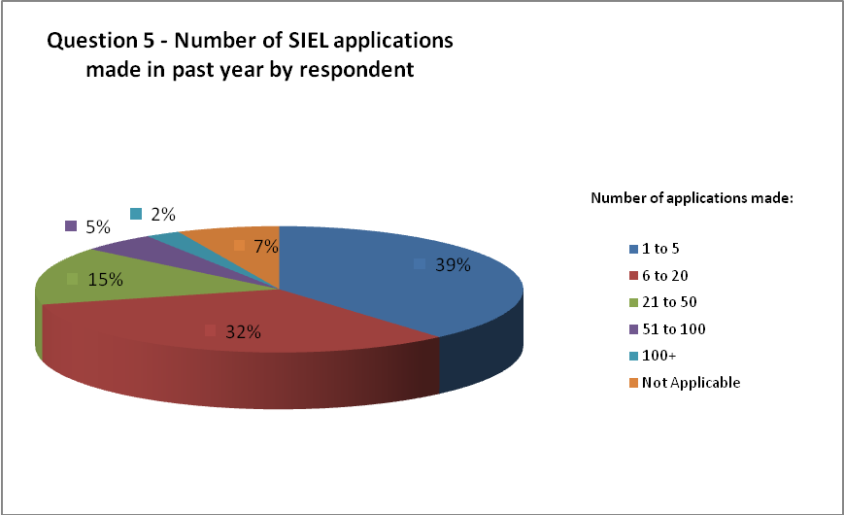
Question 5
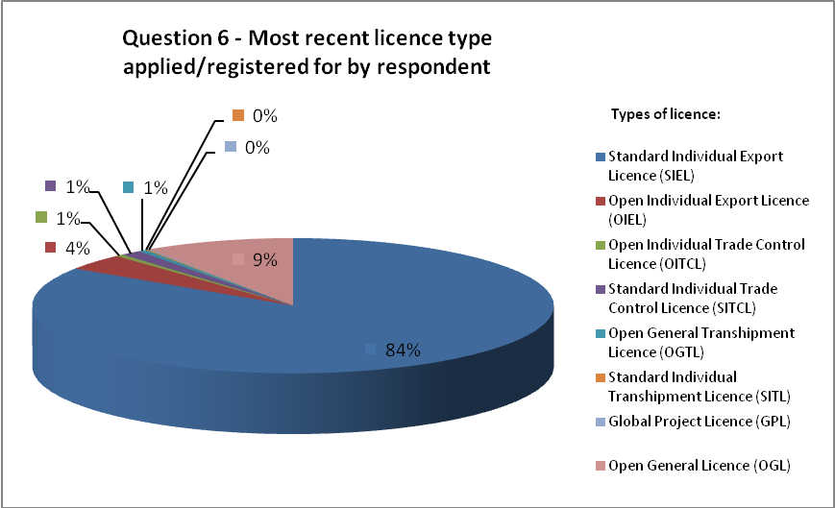
Question 6
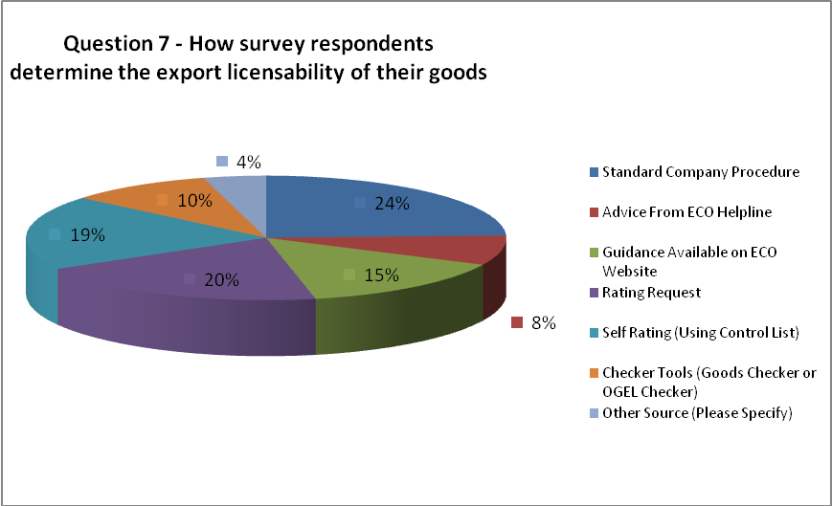
Question 7
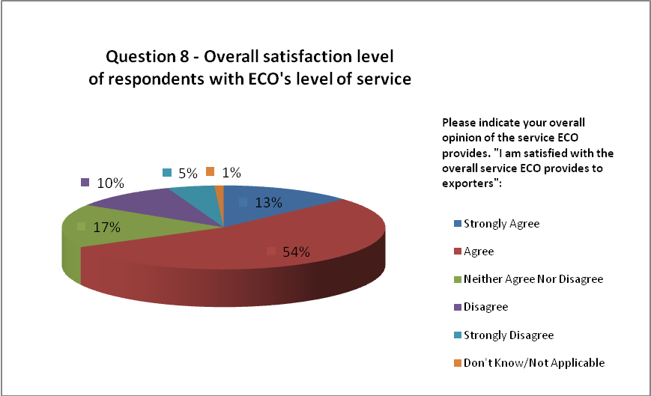
Question 8

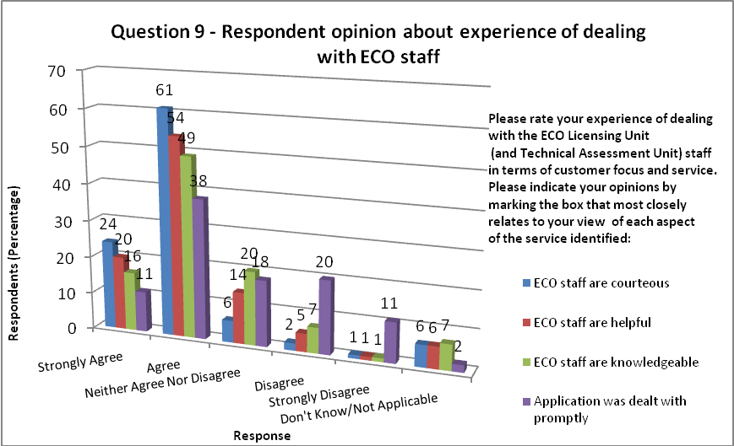
Question 9
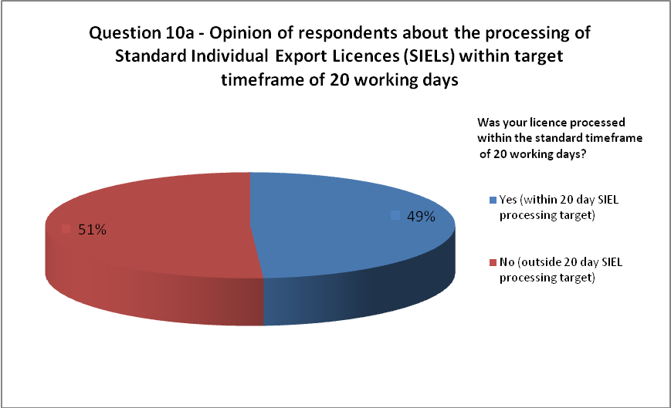
Question 10a
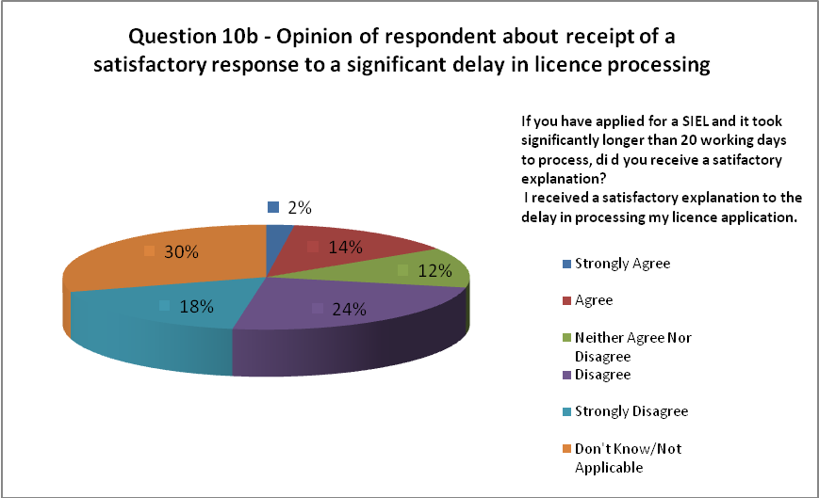
Question 10b
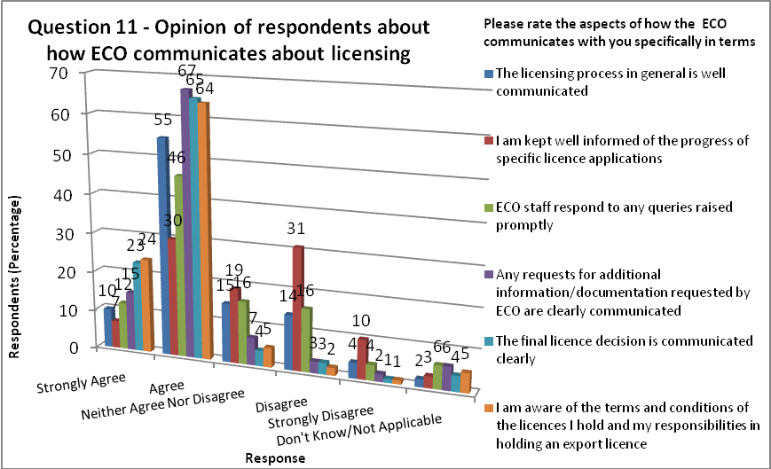
Question 11
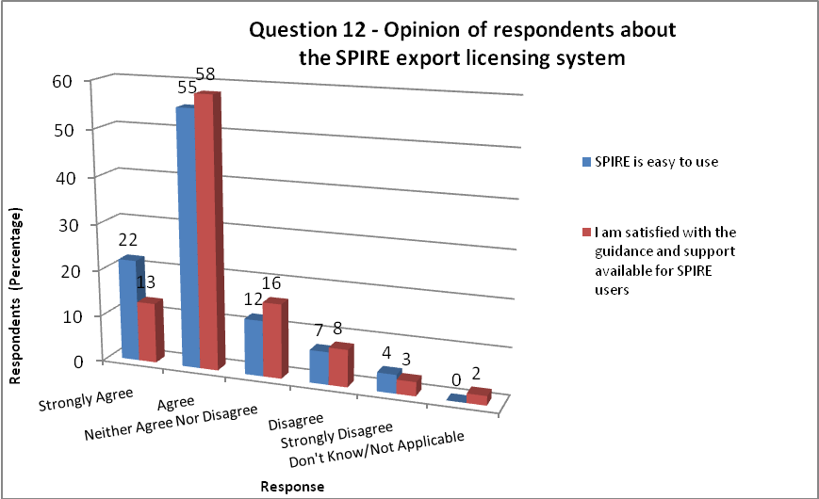
Question 112
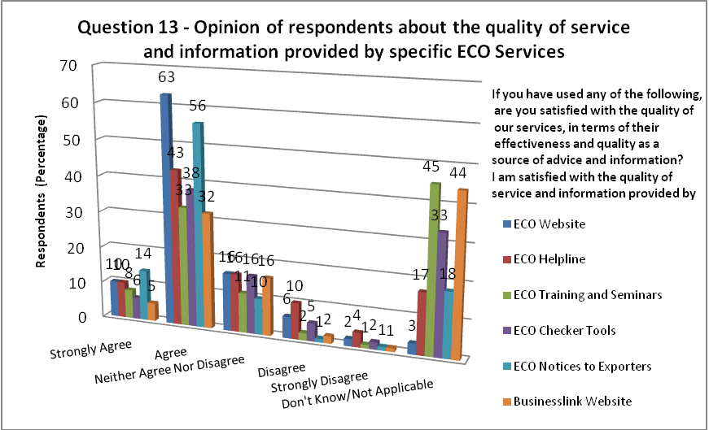
Question 123
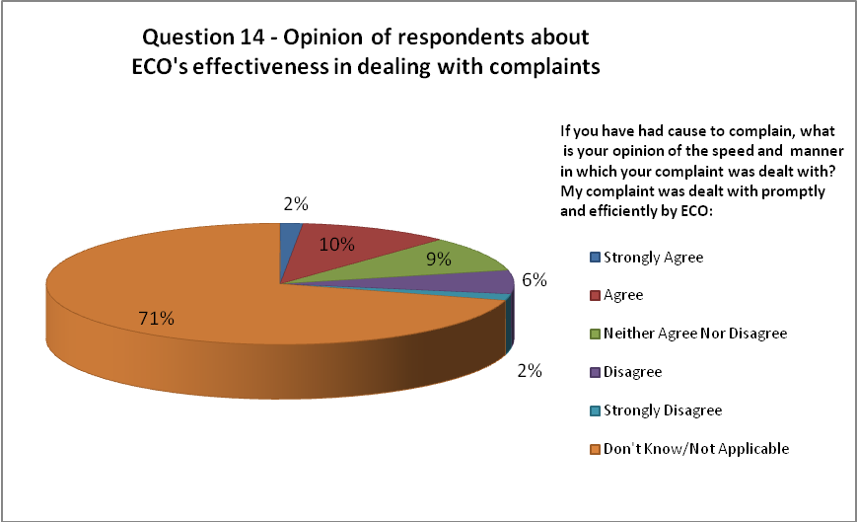
Question 14

Appendix B – Sample cross-section of comments
Customer Feedback Category | Specific Customer Comment | ECO Response
Praise | A job well done to very high and exacting standards. Please continue | We acknowledge this feedback, with thanks. No further comments.
Speed of Licence Processing – Timescales and Targets | Inconsistent approaches by licensing officers and a lack of deadline for BIS to complete its process creates a situation that we are dealing with what feels like a ‘black hole’ – information goes in and we don’t know what (or when) anything may come back. Compare this with the 10 working day deadline for businesses to respond to BIS queries (with the threat that if the information is not received the application will be regarded as ‘withdrawn’ and holding requests are not acceptable) and the system/process places an unequal burden on business to feed information to BIS under specific conditions, without any similar condition being applicable to BIS | The ECO has published targets and objects. This includes the aim of issuing 70% of SIELs in 20 working days and 90% of SIELs in 60 working days.  Our progress against targets is published in the UK’s Strategic Annual Report published by the Foreign Office (FCO) and on the ECO’s Reports and Statistics website (Searchable Database) of quarterly reports.  The published targets are a guide and customers are advised that cases are assessed on a case by case basis in relation to the Consolidated EU and National Arms Export Licensing Criteria.  Cases which take longer than our target processing times are most commonly applications to sensitive destinations and exporters are advised to use their common sense and check the latest quarterly figures.
 | The tardiness in this service is and will continue to cost UK manufacturing loss of business. US and German controls appear to be simpler and quicker | In comparison to overseas export control organisations, the ECO is judged to provide an excellent service. The ECO is frequently seen as a benchmark for other governments. However it is very difficult to directly compare actual licensing systems due to different staffing levels, legislation and working practices. Other licensing authorities might not necessarily be faster. In terms of being simpler, export controls are derived from international treaty obligations which most developed countries are signed up to.
Communication about the progress/delay in licence processing | Would be useful if more detail given on progress of application. Currently on ECO/OGD and final assessment might be useful if expected completion date was given and updated weekly/automatically as a guide even if caveats apply. | We will investigate the feasibility of providing more information on the progress/state of licences.
 | Improved communication on licence status where 20 days is exceeded – I can see on SPIRE that it’s with OGD but that means nothing to me. If there is likely to be a delay or a problem I need to know about it because long unexplained delays are detrimental to our business. | Same response as above.
Relationship Management of companies | Consistency would be good. Having dedicated teams would help – perhaps one team looking after companies A-D or a published list of teams looking after certain markets so if your allotted case officer is unavailable and your SIEL application is for India, you know who else to talk to. Maybe another team looking after big companies. It would also help if we could be advised of any delay, rather than having to chase all the time. | ECO has reviewed the possibility of relationship management of companies. This is not considered to be beneficial to the overall licensing process and might in fact lead to greater accusations of inconsistency.  The size of a company does not affect the licensing process, since licensability is determined by items being listed on the Control Lists (type of goods controlled), end-use factors and the nature of the export activity.  We are however looking further at how much more use can be made of the SPIRE Single Applicant Record (SAR) on a co-ordinated basis.
Consistency of Licensing Advice | I have had several occasions where I have spoken to different people a ECO about the same issue and had several different responses which can be confusing | We are reviewing our internal procedures about how we train and update staff.
 | The level of service obtained by ECO depends very much on who you are dealing with. If you have a pro-active well trained person then great, otherwise the experience can be extremely frustrating and time consuming. If ever the helpline is asked how a particular piece of legislation should be interpreted the general response is that we should look at the ECO website and form our own decision because ECO are not permitted to provide specific advice. | Same as above.
Open Licensing | More platform based OGELs that are based on the named End-Users and Destinations, as well as the supply chain companies. | The ECO has recently issued an OGEL for the Typhoon Project
Charging | Why cannot you have a fast track service which attracts a fee? | Licensing is a statutory service. Any potential changes such as the introduction of a charging policy would have to be considered carefully in terms of all implications and impact and consulted on extensively.
Guidance issues and customer training needs | It would benefit us greatly if your seminars or workshops are held regionally. | We already deliver training on a regional basis. As an example, the Autumn 2010 schedule of courses will include training in Newcastle, Birmingham and Cambridge. Our courses are advertised on our website at: http://www.bis.gov.uk/policies/export-control-organisation/eco-training-skills-academy
 | It is very difficult to get through by telephone. I have made enquiries regarding use and update of existing OIELs. I received guidance that I needed to update certain details but not how to update them. There are no examples/standard formats of how SIEL applications should be made. It is unclear what technical details are required and the best format for submitting these is. If there was guidance to pick out the necessary details I’m sure this would aid the ECO team in assessing product and speeding licence request time | The ECO pages on Businesslink already provide guidance on Common Pitfalls to avoid when making applications and submitting technical details.  We are also looking to introduce a set of case studies on different aspects of the licensing process, such as best practice in rating.  It is difficult for use to provide specific examples of SIEL applications online due to commercial confidentiality and the wide variety of applications and goods licensable.  However, exporters are reminded that we do offer training courses including a course on Making Better Licence Applications, which covers how to make good applications on SPIRE.
 | Notice to Exporters are written in a language more suited to lawyers than general users of the systems | We are working on improving the drafting of our Notices to Exporters to ensure that they are easily understandable and explain the impact of any changes where possible. We welcome continuing feedback on the Notices we issue via our email address: web.comments@bis.gsi.gov.uk
 | One of our biggest requirements is into the US WMD programme. There is no advice for people wishing to do this as it is assumed that no exports into a WMD programme. Yet the French and the US have such programmes into which goods may be sent.
Improving the ECO Helpline | The staff on the Helpline are always courteous. However they can only usually help on the most basic questions. | The very nature of the helpline is that it is available to provide general advice only. Due to the extensive array of goods controlled, the helpline is unable to definitively state if goods need a licence or not. However the Helpline is staffed by colleagues with extensive knowledge in export controls who will try to advise you further as much as possible.
 | The main problem with the Helpline is getting through to speak to someone | We are currently planning a number of improvements to the Helpline including introducing a call management system.
Improving the ECO Website | The ECO website has a difficult layout and its not always easy to find out the information you require. I also find that some of the links take a long time to work. | The ECO’s webpages are now published via the Businesslink site which provides access to a wide range of business related information provided by government.  When the ECO’s content was transferred to Businesslink, we consulted with industry to ensure the new website met customer needs in terms of structure.  Export Controls touch a wide variety of sectors and issues and the site needs to meet the different information needs of different queries and customers.  We continue to review the pages in consultation with industry.  Link download times are dependent on a number of factors including your own speed of connection and the type and size of document being downloaded.
Improving the Checker Tools | I found the ECO Online Checker Tool very difficult to use for our product – we eventually got an external organisation to help with our product rating. | We recommend use of the ECO Online Goods Checker Tool in conjunction with the Control Lists. The Goods Checker is a straightforward tool which is only designed to search on wording on the Control Lists. It is not programmed to recognise the names of branded goods.  We offer training in how to self-rate goods including how to make better use of both the Control Lists and Goods Checker website.
Improving the usability of SPIRE | Information on where and when a licence is delayed is not specific, outstanding with OGD is meaningless | We will review options for improving progress communications for licence applications.
Tone and attitude of customer communications | The wording of notifications requesting further information tend to be abrupt and somewhat threatening so good to be more agreeable. | We are reviewing our customer communications and will be issuing updated guidance to staff.  We will also be issuing a new Customer Code of Practice which outlines are commitments to you, our customers.
Staff Knowledge | The case officers you employ appear to have little or no experience of business in the real world and are simply box tickers. Requests for assistance or advice are regularly pushed to one side without receiving any information. | A large proportion of staff has previously worked in the private sector.  We appreciate the frustrations that you might feel if a licence is delayed and the feeling that the system is too bureaucratic, however, our role, is to carefully assess each application, as a result of our international treaty obligations. We are continually working to issue licences as speedily as possible, having made all necessary assessments and checks.
Staffing Levels | Further staff are urgently needed by BIS to process export licences within suitable timescales. | Due to the current financial situation, we need to work within our allocated resource budget and further significant staff increases are unlikely in the near future. We are however constantly reviewing the way we work and looking at options for improving the efficiency of licence processing.

Appendix C – Customer Survey Questions

- Please indicate the type of business or industry sector that your company operates within.
  - Defence
  - Marine
  - Chemical
  - Manufacturing
  - Gun Dealer
  - Industrial Equipment/Machinery
  - Transportation Services inc. Freight Forwarding
  - Aerospace
  - Automotive
  - Nuclear Equipment or Material
  - Telecommunications, Computers or IT Services
  - Electrical/Electronic Equipment or Components
  - Oil and Gas
  - Other (Please Specify)

- Please indicate how many people are employed in your organisation
  - 1 to 19
  - 20 to 49
  - 50 to 99
  - 100 to 499
  - 500 to 999
  - 1000 to 2500
  - Over 2500
  - Don’t Know

- Please indicate your level of responsibility in terms of Export Control
  - Executive or Senior Manager Level
  - Export Control (Supervisor/Managerial Level)
  - Administration

- How indicate your experience of dealing with the Export Control Organisation
  - Novice
  - Fairly Experienced
  - Very Experienced

- How many licence (SIEL) applications have you/your company made over the past year?
  - 1 to 5
  - 6 to 20
  - 21 to 50
  - 51 to 100
  - 100+
  - Not applicable

- With reference to the licence you have just applied for or most recently received, please indicate that type of licence that this application refers to
  - SIEL
  - OIEL
  - OITCL
  - SITCL
  - OGTL
  - SITL
  - GPL
  - OGL

- How do you usually determine that a particular export requires a licence?
  - Standard company procedure
  - Advice from ECO Helpline
  - Guidance available on ECO website
  - Rating request
  - Self rating (using Control List)
  - Checker Tools (Goods Checker or OGEL Checker)
  - Other Source (Please specify)

- Please indicate your overall opinion of the service ECO provides. I am satisfied with the overall service ECO provides to exporters.
  - Strongly Agree
  - Agree
  - Neither Agree nor Disagree
  - Disagree
  - Strongly Disagree
  - Don’t Know/Not applicable

Your experience of dealing with ECO – Licensing and Rating Performance and Processing

9. Please rate your experience of dealing with the ECO Licensing Unit (and Technical Assessment Unit) staff in terms of customer focus and service. Please indicate your opinions by marking the box that most closely relates to your view of each aspect of the service identified. - Option responses for each question are as follows:
  - Strongly Agree
  - Agree
  - Neither Agree nor Disagree
  - Disagree
  - Strongly Disagree
  - Don’t Know/Not applicable
9a. ECO staff were courteous
9b. ECO staff were friendly and helpful
9c. ECO staff were knowledgeable
9d. My application/query was dealt with promptly

10a Was your licence processed within the standard timeframe of 20 working days?
- Yes
- No

10b. If you have applied for a SIEL and it took significantly longer than 20 working days to process, did you receive a satisfactory explanation? I received a satisfactory explanation to the delay in processing my licence application.
- Strongly Agree
- Agree
- Neither Agree nor Disagree
- Disagree
- Strongly Disagree
- Don’t Know/Not applicable

11. This question looks more broadly at the licence process in general. Please rate the following aspects of how the ECO communicates with you specifically in terms of its licensing work. - Option responses for each question are as follows:
  - Strongly Agree
  - Agree
  - Neither Agree nor Disagree
  - Disagree
  - Strongly Disagree
  - Don’t Know/Not applicable
11a. The licensing process in general is well communicated
11b. I am kept well informed of the progress of specific licence applications
11c. ECO staff respond to any concerns or queries I have raised
11d. Any requests for additional information/documentation requested by ECO are clearly communicated.
11e. The final licence decision is communicated clearly
11f. I am aware of the terms and conditions of the licences I hold and my responsibilities in holding an export licence

12a. Please indicate your opinion of the SPIRE licensing system. SPIRE is easy to use.
  - Strongly Agree
  - Agree
  - Neither Agree nor Disagree
  - Disagree
  - Strongly Disagree
  - Don’t Know/Not applicable
12b. I am satisfied with the guidance and support available for SPIRE users
  - Strongly Agree
  - Agree
  - Neither Agree nor Disagree
  - Disagree
  - Strongly Disagree
  - Don’t Know/Not applicable
12c. Please comment on any aspects of SPIRE that you think could be improved.

Your experience of dealing with ECO – General Issues

13. If you have used any of the following, are you satisfied with the quality of our services, in terms of their effectiveness and quality as a source of advice and information? - Option responses for each question are as follows:
  - Strongly Agree
  - Agree
  - Neither Agree nor Disagree
  - Disagree
  - Strongly Disagree
  - Don’t Know/Not applicable
I am satisfied with the quality of service and information provided by the:
a. ECO website
b. ECO helpline
c. ECO training and seminar programme
d. ECO online checker tools (OGEL Checker and Goods Checker)
d. ECO Notice to Exporters
f. Business Link
g. Please add any additional comments

14. If you have had cause to complain, what is your opinion of the speed and manner in which your complaint was dealt with? Please move directly to question if this question is not applicable. My complaint was dealt with promptly and efficiently by ECO.
  - Strongly Agree
  - Agree
  - Neither Agree nor Disagree
  - Disagree
  - Strongly Disagree
  - Don’t Know/Not applicable

15. Please comment on areas where we could improve ECO’s service.

See: http://www.businesslink.gov.uk/bdotg/action/layer?r.s=tl&r.l1=1079717544&r.lc=en&r.l2=1084228483&topicId=1084563487

