

URN 10/1019

The National Evaluation of Community Development Finance Institutions (CDFIs): An Action-Orientated Summary for the Sector

June 2010




The National Evaluation of Community Development Finance Institutions (CDFIs): An Action-Orientated Summary for the Sector

Department for Business, Innovation and Skills
and the
Cabinet Office

A report by GHK
Date: June 2010

GHK 30 St Paul’s Square, Birmingham B3 1QZ
Tel: 0121 233 8900; Fax: 0121 212 0308
www.ghkint.com
CONTENTS
EXecutive summary 1
1 introduction: The Purpose of this Summary Report 3
part a: the cdfi sector and current trends 4
2 the CDFI sector IS...? 5
2.1 How are CDFIs defined? 5
2.2 How do CDFIs work? 5
2.3 What form do CDFIs take? 5
3 the scale of CDFI lending is increasing 6
3.1 Numbers of CDFIs operating in the UK 6
3.2 Sector and fund size trends 6
3.3 Operational characteristics of CDFIs 7
3.4 CDFI business clients 8
3.5 The regional geography of CDFI lending 8
3.6 Trends within the size and types of beneficiary loan 9
part B: cdfis, market failure and Enterprise Outcomes 11
4 Market failure is critical for policy support… and cdfis overcome it 12
4.1 The rationale for public support to CDFIs 12
4.2 Market failures found in the CDFI sector 12
4.3 Assessing the scale of market failure 13
4.4 The reduction of market failures through CDFI activity 13
5 CDFIS are funded to deliver public policy goals 14
5.1 CDFIs and enterprise policy goals 14
5.2 Developing the sector to support policy goals 14
part C: cdfis and economic and social impact 16
6 CDFIS deliver Strong Economic outcomes and impacts 17
6.1 The economic impacts of CDFI enterprise loans 17
6.2 The cost to a funder of using a CDFI to deliver its desired economic outputs 18
7 CDFI Social outcomes and impacts are important but need reporting more effectively 20
7.1 Defining, measuring and valuing the social outcomes and impacts of the CDFI sector 20
8 the cdfi sector: from Rationale to impact 21
8.1 ‘Logic models’ for CDFIs 21
part D: a sustainable sector 23
9 the journey to sustainability 24
9.1 Defining and measuring CDFI sustainability 24
9.2 Drivers of CDFI sustainability 25
9.3 Financial models of CDFI enterprise lending activities 28

EXecutive summary
This Sector Summary of the National Evaluation of Community Development Financial Institutions (CDFIs) seeks to aid the CDFI sector and its’ practitioners in:
- understanding rationales for policy intervention, theories of market failure and economic and social impact;
- providing information to the sector to aid strategic planning; and,
- identifying key areas for development of CDFI monitoring and performance reporting activity, which would strengthen the evidence base for future policymaking, investment decisions and performance management.
The Summary Report is divided into four Parts each beginning with a Summary Box, including Potential Actions. All the material is provided in full in the main report.

Part A – The CDFI Sector and Current Trends
The CDFI sector is maturing with numbers of CDFI’s at a plateau, the emergence of stronger governance systems, and evidence of operational moves to enhance sustainability. The value of funds and numbers of enterprise loans made by the sector continue to rise.
The sector continues to deliver enterprise loans to its core target markets of start-ups, SMEs and social enterprises, particularly in disadvantaged areas and communities, and who cannot access mainstream finance.
Significant growth of SME and social enterprise lending contrasts with stagnating levels of micro lending. Overall, the geographical coverage of the sector remains patchy.
Potential Action:
To review individual CDFI operational characteristics and metrics against updated market segment and sector descriptions to provide perspective on the ‘place’ of your CDFI within a transforming sector.
Part B – CDFIs, Market Failure and Policy Goals
The principle objective of the enterprise-lending CDFI sector is to provide finance for viable businesses that cannot access such funds from the mainstream banking sector. The scale and extent of this demand, and target markets, remains poorly understood.
There is very strong evidence of CDFIs overcoming and reducing the range of market failures in access to finance, especially in social enterprise markets.
CDFIs are publicly funded and supported as a ‘delivery mechanism’ which reduces market failure and achieves a number of positive enterprise outcomes. Enterprise outcomes develop and change, and funders do have the choice of a number of delivery mechanisms. In recent years, strong support has remained in place to develop the sector’s capacity, capabilities and potential sustainability.
Potential Action:
To understand the concept of market failure, and positive enterprise outcomes, as a basis for public support to the sector;
To support and/or initiate developments - at sector, market segment and CDFI level – to calculate the extent of demand for CDFI services and, in turn, the potential ‘ask’ of funders.

Part C – CDFIs and Economic and Social Impact
Robust, detailed and comprehensive evidence is now available of the economic impact of CDFI enterprise lending. This standard methodology has been applied at CDFI and sector level and draws on an expected standard range of CDFI monitoring data.
Despite poor monitoring data on income and expenditure against activities, given the known levels of public expenditure, CDFIs are efficient delivery mechanisms for enterprise lending and the sector represents value for money.
To demonstrate fully its value and cost effectiveness, the sector needs to develop its description and measurement of social benefits and impacts within a comprehensive and common framework.
More broadly, the use of logic models in this document illustrates how the sector and individual CDFIs can map their activities against funders’ goals and as the basis of developing business cases, performance assessment and evidence of impact. This can be a useful ongoing tool ensure that CDFIs are able to align activity within a changing policy landscape.
Potential Action:
To map your individual CDFI and activities against a logic model and associated policy objectives;
To work with the CDFA and Change Matters to: develop common metrics and indicators for income, activity expenditure, and outputs; and the development of a common framework to identify and assess social benefits and impact.
Part D – A Sustainable Sector
CDFI and sector sustainability (operational and financial) remains a goal of the sector and is likely to be critical during a period of reduced public spending.
The evidence presented highlights the extent of the challenge, how this challenge varies significantly across market segments, and the trade-off between sustainability and delivery of policy outcomes.
Known drivers of sustainability and current individual CDFI and sector data has been used to produce seven financial business models of typical CDFIs to illustrate the journey to sustainability.
Potential Actions:
To use the financial model to support CDFI business planning and development;
To support the sector (through Change Matters) to agree on common and clearly understood definitions of key metrics as the basis of performance management.

introduction: The Purpose of this Summary Report
In March 2010, the National Evaluation of Community Development Finance Institutions (CDFIs) was published by the Department of Business Innovation and Skills (BIS) and the Cabinet Office. The evaluation, undertaken by GHK Consulting, provided the first fully comprehensive analysis of the enterprise financing activities of CDFIs. The work focused primarily on the performance of English CDFIs and used a mixture of literature and policy review, a national survey of CDFI business clients, stakeholder consultations and an analysis of trends in the activity and size of the CDFI sector.
As the sector has matured, given the development of alternative interventions and delivery mechanisms and forthcoming budgetary constraints for funders, evidence of delivery of outcomes and impacts by the sector is of heightened importance. The main evaluation objective was to inform UK policy on the medium- to long-term strategic role of CDFIs, and to establish the rationales for, and benefits from, continued public sector support to the sector.
This Summary seeks to aid the CDFI sector and its’ practitioners in:
- understanding rationales for policy intervention, theories of market failure and economic and social impact;
- providing information to the sector to aid strategic planning; and,
- identifying key areas for development of CDFI monitoring and performance reporting activity, which would strengthen the evidence base for future policymaking, investment decisions and performance management.
Following this introduction, the Summary Report is divided into four parts:
- Part A: The sector and current trends;
- Part B: Why support the sector? Overcoming market failure and delivering positive enterprise outcomes;
- Part C: Why support the sector? Evidence for economic and social impact; and,
- Part D: Moving towards a sustainable CDFI sector.
Each part begins with a Summary Box, including Potential Actions.
All the material in this Summary Report is provided in full in the main report.

part a: the cdfi sector and current trends

Summary
The CDFI sector is maturing with numbers of CDFI’s at a plateau, the emergence of stronger governance systems, and evidence of operational moves to enhance sustainability. The value of funds and numbers of enterprise loans made by the sector continue to rise.
The sector continues to deliver enterprise loans to its core target markets of start-ups, SMEs and social enterprises, particularly in disadvantaged areas and communities, and who cannot access mainstream finance.
Significant growth of SME and social enterprise lending contrasts with stagnating levels of micro lending. Overall, the geographical coverage of the sector remains patchy.
Potential Action:
To review individual CDFI operational characteristics and metrics against updated market segment and sector descriptions in order to provide perspective on the ‘place’ of your CDFI within a transforming sector.

the CDFI sector IS...?
The sector is comprised of a diverse set of organisations with distinctive histories.

How are CDFIs defined?
CDFIs are specialist enterprises, often operating on a not-for-profit basis, which deliver finance and other support services to enterprises and individuals.
The Community Development Finance Association (CDFA) – the trade association for the sector – defines CDFIs as:
‘...independent organisations which provide financial services with two aims: to generate social and financial returns. They supply capital and business support to individuals and organisations whose purpose is to create wealth in disadvantaged communities or underserved markets’.

How do CDFIs work?
CDFIs operate on the basis of public (and some philanthropic and/or private) funding of loan finance for on-lending, including the operating costs of lending activity. They also tend to have an explicit social welfare mission, for instance by focussing their lending within disadvantaged areas and/or amongst financially excluded groups. Regarding enterprise lending, the CDFI sector focuses on businesses – start-up and existing, for-profit and/or social enterprises – that cannot obtain finance from the mainstream banking sector.

What form do CDFIs take?
A 2002 report by the UK Social Investment Forum divided the CDFI sector into six different types of organisation:
- Community loan funds – the majority of the CDFI sector: organisations that provide loans to for-profit and/or social enterprises, often with an overarching social mission and sometimes focussed on a particular geographic area;
- Micro-finance funds – a sub-sector of the above: organisations that specialise in providing very small loans to micro enterprises;
- Community development venture capital – operates like mainstream venture capital but with a community development mission;
- Social banks – operate as mainstream banks but with strict ethical policies and social and/or environmental goals;
- Community development credit unions – credit unions (i.e. co-operatives owned and controlled by members with a ‘common bond’) with a particular community development mission; and,
- Mutual guarantee societies – formal associations of SMEs that pool their savings in banks in order to provide collective guarantees.

the scale of CDFI lending is increasing
Following a decade during which the number of CDFIs grew rapidly, there is evidence of consolidation around fewer, larger organisations, and a greater emphasis on performance and sustainability.

Numbers of CDFIs operating in the UK
The wide range of organisations that could potentially be considered a CDFI makes measuring the size of the sector in the UK a challenge. Figure 1 uses data on CDFA membership to plot trends in the size of the sector since 2003 (note that the data on size includes all CDFIs and combines enterprise and personal lending).
Figure 1: The number of CDFIs and size of the total capital pot and loan portfolio, 2003-08
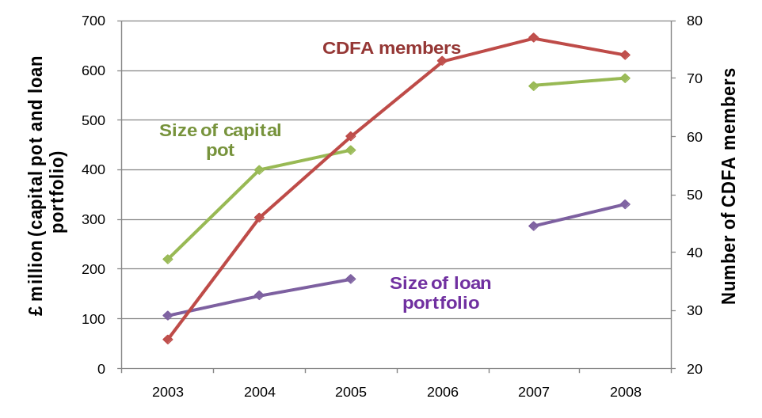
Source: Capital pot and loan portfolio (personal and enterprise lending) – CDFA Inside Out survey 2003-2008; CDFA members – CDFA Annual Reports 2003-2008
The CDFA currently lists 74 CDFI members or associate members, a figure which has seen consolidation since 2006 following rapid growth from 2003, and is confident that its membership constitutes the substantial majority of the CDFI sector in the UK.

Sector and fund size trends
Fund size is a measure of the total loan pot available to a CDFI. It comprises the value of:
- loans outstanding;
- loans committed but not drawn; and,
- any other capital that the CDFI has available for lending but which has not been committed.
In contrast to CDFI numbers, the financial size of the sector has grown steadily since 2003. Headline figures for the sector show significant increases in the amount of loan capital available (note that this analysis excludes two disproportionately large CDFIs – Triodos Bank and Bridges Community Ventures – and is thus not comparable with the data shown in Figure 1):
- The value of lending capital held by the CDFI sector increased by 22%, from £201m in 2006/7 to £246m in 2008/9;
- Average CDFI fund size increased by 25%, from £3.5m to £4.3m in 2008/9;
- The growth of a handful of large national social enterprise lenders (such as Charity Bank) is also evident (indeed it has been necessary to remove Triodos Bank from the analysis since it is as large as the rest of the CDFI sector combined);
Figure 2 shows the distribution of loan fund sizes within the CDFI sector between 2006/7 and 2008/9.
Figure 2: Distribution of sizes of CDFI loan funds, 2006/7 to 2008/9
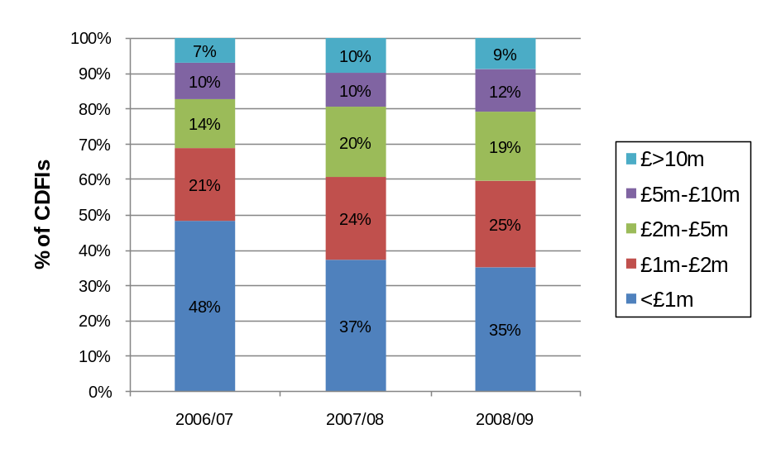
Base = 58 CDFIs (2006/07); 51 CDFIs (2007/08); 57 CDFIs (2008/09). Source: Inside Out
This shows that:
- Around 40% of CDFIs had loan funds of over £2 million, up from 31% in 2006/7; and,
- CDFIs with loan funds of less than £1m decreased from 48% to 35% of total funds.
Relatively large loan funds (worth over £5 million) are still rare within the sector. However, by 2008/9, they had increased to 21% of the total number of CDFIs.

Operational characteristics of CDFIs
A number of trends are evident from the study, including:
- The majority of CDFI lending is unsecured, although this is slowly decreasing – the CDFI sector average was 61% of the value of the loan portfolio unsecured in 2006/7, compared to 55% in 2008/9. Personal guarantees were the most common type of security taken by lenders;
- A growing proportion of CDFIs now charge fees as part of their lending activity –46% of CDFIs levied an administration fee (the most commonly used type of fee) in 2008/09, up from 30% in 2006/07;
- Levels of bad debt have increased marginally within the CDFI sector, but still represent a small proportion of total outstanding lending (though a number of CDFIs have very high loan write-off rates);
- Loan write-off rates vary by market sector – within enterprise lending markets, the overall loan write-off rate was highest for loans to micro enterprises (equal to 12% of total outstanding lending in 2008/9); social enterprise lending had the lowest overall loan write-off rate, equivalent to just 4% of total outstanding lending to the sector;
- Business support services remain integral to CDFI operations. The nature of the CDFI sector’s target market means that many loan applicants are not investment ready, and may need support in building up their proposal to a stage where it can go forward (e.g. through the preparation of a business plan). For a CDFI, this process forms part of the loan consideration and appraisal process, and also enhances the ability of a business to repay its loan (often taking the form of both pre- and post-loan support). Services include:
- Informal advice during/after application process (offered by 89% of CDFIs in 2008/9); and,
- More in-depth forms of business support (including one-to-one mentoring and formal training) were provided by 72% of CDFIs in 2008/9, compared with 50% in 2006/7.

CDFI business clients
A national client survey showed that a relatively large proportion of business beneficiaries are social enterprises (42%), and that there is considerable diversity in client characteristics (e.g. covering Industrial and Provident Societies, Community Interest Companies, sole traders, charities and SMEs). This reflects the variety of ‘target’ markets served by CDFIs.
Other ‘typical’ characteristics of the CDFI client base include:
- Very small businesses (employment and turnover) are well served – for example, 76% clients are micro-businesses (employing between 0 and 9 people) and 14% are small firms. Of all the clients, 42% are start-ups;
- 52% of beneficiaries have an annual turnover of less than £250,000, and of these 25% have an annual turnover of less than £50,000;
- The sectoral spread of CDFI business clients broadly reflects that of the economy in general; and,
- Ambition: some 42% of businesses used their CDFI loan to finance the costs of start-up, whilst another 43% used it to fund growth (see Error: Reference source not found). In contrast, only 7% had used it to prevent business closure.
Figure 3: The main way in which businesses used their CDFI loan
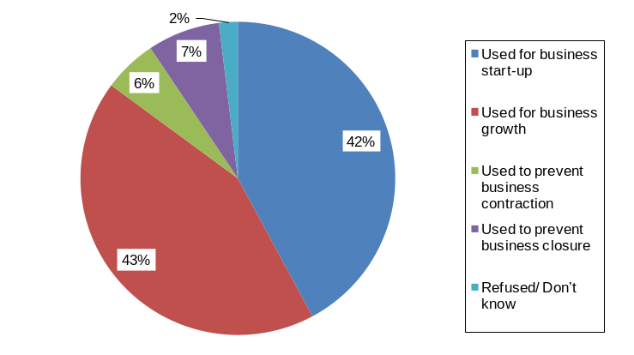
Base = 363 businesses

The regional geography of CDFI lending
There are substantial variations in the regional geography of CDFI lending - for example in market types, amounts, trends over time, and loan fund deployment rates. Figure 4 shows the geographical distribution of the outstanding loan portfolio of the CDFI sector in 2008/09, broken down by the four key market segments:
- The largest volume of outstanding loans in 2008/09 (amounting to £42.2m in total) are provided by CDFIs that operate UK-wide. The majority of loans were to social enterprises;
- There are large regional variations in the value of CDFI lending. In 2008/09, total outstanding lending in the North West, for example, was £20.9 million compared to just £0.7 million in the North East;
- There are also regional variations in the balance of lending across the four key market segments. In Northern Ireland and Scotland, the majority of outstanding lending was to social enterprises; in the North East and the East of England, it was to micro enterprises; in Yorkshire & Humber and the North West, it was to SME’s.
- 29% of CDFI loans are located in the 20% most deprived areas of the country.
Figure 4 Value of CDFI outstanding lending by region and market segment, 2008/09
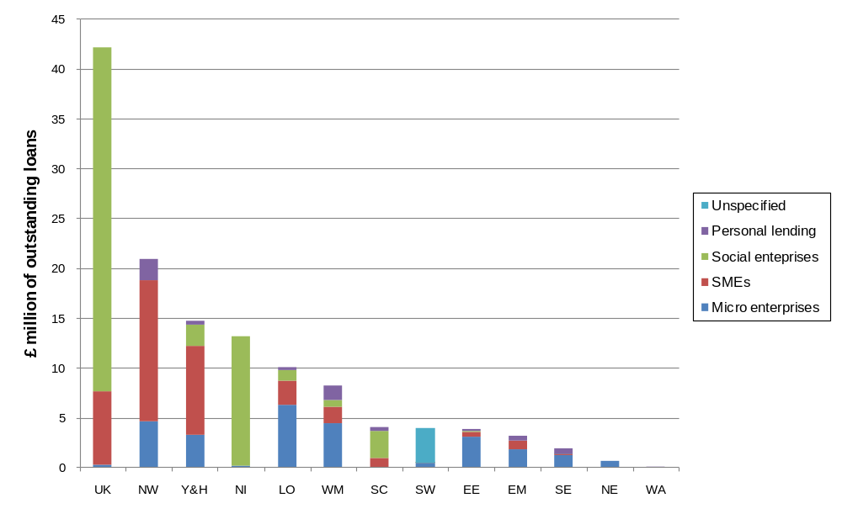
Note: NW (North West), Y&H (Yorkshire and Humber), NI (Northern Ireland), LO (London), WM (West Midlands), SC (Scotland), SW (South West), EE (East of England), SE (South East), EM (East Midlands), NE (North East), and WA (Wales); UK represents national lenders. Base = 57 CDFIs. Source: Inside Out

Trends within the size and types of beneficiary loan
There have been some important sectoral shifts in CDFI lending activity in the past three years, with the following trends evident:
- Substantial increase in total enterprise lending (all types of business), increasing by 48%, from £82 million in 2006/7 to £121 million in 2008/9;
- Substantial increase in social enterprise lending, up by 42%, from £38 million in 2006/7 to £54 million in 2008/9;
- Lending to SMEs has more than tripled, increasing by 245%, from £11 million in 2006/7 to £37 million in 2008/9; and,
- Micro lending has ‘stagnated’, up by just 6% over the period 2006/7 to 2008/9 compared to an average enterprise lending increase of 48%.
With respect to the average size of loans, CDFIs are delivering loans in greater numbers and with a higher total value than ever before:
- Loans to social enterprises were the largest, on average worth £72,600 in 2008/9, an increase of 27% since 2006/7;
- Loans to SMEs were on average worth £33,700 in 2008/09, an increase of 57% since 2006/7;
- Loans to micro enterprises were the smallest, at £7,300 on average in 2008/9, an increase of 8% since 2006/7; and,
- There was a 36% rise in the average value of all enterprise loans (all types of business), to £21,100 in 2008/09, increasing from £15,515 in 2006/07.
The most common loan lengths for CDFI enterprise loans are either 3 to 4 years (29% of the total), or 5 to 6 years (23% of the total).

part B: cdfis, market failure and Enterprise Outcomes

Summary
The principle objective of the enterprise lending CDFI sector is to provide finance for viable businesses that cannot access such funds from the mainstream banking sector. The scale and extent of this demand, and target markets, remains poorly understood.
There is very strong evidence of CDFIs overcoming and reducing the range of market failures in access to finance, especially in social enterprise markets.
CDFIs are publicly funded and supported as a ‘delivery mechanism’ which reduces market failure and achieves a number of enterprise outcomes. Enterprise outcomes develop and change, and funders have the choice of a number of delivery mechanisms. In recent years, strong support has remained in place to develop the sector’s capacity, capabilities and potential sustainability.
Potential Actions:
To understand the concept of market failure, and enterprise outcomes, as a basis for public support to the sector;
To support and/or initiate developments - at sector, market segment and individual CDFI level – to calculate the extent of demand for CDFI services and, in turn, the potential ‘ask’ of funders.

Market failure is critical for policy support… and cdfis overcome it
The basis of public sector support to the sector is the ability of CDFIs to overcome market failures in access to finance markets.

The rationale for public support to CDFIs
The principle objective of the enterprise-lending CDFI sector is to provide finance for viable businesses that cannot access such funds from the mainstream banking sector. Access to external finance is an important issue for businesses (and entrepreneurs) particularly for start-ups and small businesses which tend to lack retained profits that they can re-invest in the business (see Box 1). The funding of enterprise lending by CDFIs by the public sector is, therefore, a response to market failures in the access to finance market.
Box 1: Costs of setting up and growing businesses - a 2008 study put the median average cost of starting a business at £7,500, and found that a significant proportion of start-ups required external funding to meet this need. Established firms also seek finance in order to fund growth; the same study reported that 36% of SMEs had sought external finance in the previous three years. The median average amount of funding sought was estimated to be £45,000 per firm, though this varied significantly depending on the size of the business.
A market failure is a situation where the market has not and cannot of itself be expected to deliver an efficient outcome. There are many types of potential market failure: under market conditions the benefits of public goods are not reflected in the returns made to a private provider and thus provision would not take place; externalities (e.g. the costs of pollution are not borne by the polluter); and imperfect information and asymmetric information (for example, to judge the risk of an action or investment). Public sector interventions seek to redress these market failures to ensure fair and equitable markets and maximise the welfare (economic, social and environmental) benefits to society.

Market failures found in the CDFI sector
CDFIs address the consistent market failure to reflect the economic and social benefits of lending in underserved markets. This leads to reduced enterprise outcomes (e.g. fewer and under-capitalised businesses and foregone economic benefits), particularly amongst disadvantaged groups and areas.
Specific market failures occurring in the sector which provide government with a strong rationale for investing in CDFIs include:
  - Information failure on the part of the private banking sector towards the potential viability of a loan finance applicant (‘viable but unbankable businesses’). This derives mainly from the high transactions costs to lenders associated with generating and appraising deal flow and providing investment and aftercare support;
  - Information failure on the part of potential loan applicants who are unaware of the financing options available and/or have negative perceptions of mainstream finance providers (e.g. banks);
  - Externality failure: the social returns from CDFI loan finance exceed the private returns available to lenders (‘foregone economic and social benefits’).
The national evaluation confirmed that theoretical arguments underpinning the market failure rationale for policy support to CDFIs remain valid; indeed, during the onset of the credit crunch these failures have intensified rather than dissipated.

Assessing the scale of market failure
A number of reports have sought to measure overall ‘demand’ for CDFI lending (i.e. the extent of market failure). Such studies have typically applied information obtained from surveys of businesses’ and entrepreneurs’ access to finance behaviour to data on business numbers and estimates of potential start-ups. Using this method of approach, a 2003 study estimated that the ‘access to finance gap’ in the West Midlands region amounted to around 19,300 existing businesses and 7,000 potential new starts. Another study into demand for CDFI support in the South East region estimated that each year around 9,400 viable businesses are refused mainstream finance and would be eligible for a CDFI loan.
A further way to estimate the scale of market failure is through analysis of CDFI lending activity. Since CDFIs generally require finance applicants to prove that they have been rejected by a bank, the scale of CDFI lending provides a good indication of the minimum size of the finance gap caused by market failure. As at April 2009, the CDFI sector had around 6,500 outstanding enterprise loans.
Overall, comprehensive knowledge of the demand (latent and existing) for CDFI lending across the range of target markets remains poor and an area for development. Put another way, policymakers are unable to calculate what would be the cost (to all investors) for the sector to reduce the scale of market failures across different market segments. For example, how much would it cost, annually, to fund the majority of viable ex-offender start-ups/ businesses which are unable to access mainstream lending?

The reduction of market failures through CDFI activity
Current trends highlight how the CDFI sector is addressing market failure:
- Improved provision has reduced the market failure for social enterprises: there are now more specialist providers and the mainstream banking sector increasingly understands the market;
- For individual businesses, CDFI activity is reducing information failures as individual clients go on to successfully access mainstream funding following receipt of a CDFI loan. The main reason given is that, crucially, a CDFI loan enables enterprises to develop and demonstrate to subsequent lenders a track record in borrowing and repayment;
- CDFI investment therefore makes a recipient more ‘bankable’, including evidence of a growing co-financing trend in the market;
- The capacity of the sector to meet underserved markets (market failure) has grown substantially: between 2003 and 2008 outstanding loans have tripled in value; and,
- The ‘credit crunch’ showed the sector to be a flexible and fast moving delivery mechanism, able to respond to an increased scale of demand as access to mainstream loan finance became much harder for a range of businesses.

CDFIS are funded to deliver public policy goals
Market failures exist in ‘all walks of life’; policymakers intervene in those where overcoming them will meet public policy goals (i.e. the goals and objectives for society expressed by the government of the day). Public policy has generally been supportive of CDFIs, recognising both the market failures that CDFIs address, and the public policy goals that can be accomplished by developing the sector.

CDFIs and enterprise policy goals
CDFIs are a potential ‘delivery mechanism’ for policy makers to achieve a number of policy goals and it is in the strong interest of CDFIs that they understand this institutional and funding landscape.
The enterprise lending activities of CDFIs can be seen to work towards four policy goals:
- Enterprise growth - enterprise has been identified by the government as one of the five drivers of productivity. CDFIs have a role to play within this goal as providers of finance for businesses that cannot access the finance they need in order to fulfil their potential. CDFIs are seen as ‘gap fillers’ in the general enterprise finance market;
- Enterprise-driven regeneration - many CDFIs originated as specialist enterprise finance providers in deprived areas, and so have been identified as important actors in the delivery of public policy regeneration goals;
- Support for social enterprises - CDFIs have been identified as important intermediaries in the social enterprise financial support infrastructure; and,
- Enterprise within under-represented groups - certain groups in society face disproportionate barriers in accessing mainstream finance. For example, a requirement that entrepreneurs provide collateral for a loan may prove more of a problem for individuals from groups where incomes and levels of asset ownership (e.g. a house) are relatively low (such evidence exists with respect to women and certain Black, Asian or Minority Ethnic (BAME) groups). CDFIs, many of which trace their origins to within such communities or which have developed specialisms in engaging with these communities (e.g. through outreach), have been seen as ideally placed to support enterprise growth in these areas.

Developing the sector to support policy goals
Alongside specific funding against enterprise outcomes, the sector has also been supported to develop its capacity and capabilities (through funding, for example, to create and develop the CDFA and the Phoenix Fund). A number of evaluations have highlighted the on-going issues of sector development, including:
- Overcoming the ‘patchiness’ of CDFI coverage: Individual CDFIs need to increase both the scale and coverage of their lending activity (particularly if sustainability goals are to be met);
- Extending partnership working: To be part of a seamless access to finance and business support landscape will require improved partnership working between CDFIs, other providers of business finance (e.g. banks), and the business support infrastructure (e.g. Business Link);
- Developing capacity and capability: Improvements in the capacity and capability of the sector, particularly in relation to the governance of CDFIs, are required. The CDFA has developed a Code of Practice that its members are expected to meet and, linked with this, has published the Change Matters performance framework for the sector which sets out good practice across three CDFI operational domains: finance, business and impact;
- Demonstrating impact: Considerable improvements are needed in the quality of the evidence base capturing the impact of CDFIs. This includes demonstrating in a consistent and comprehensive manner the full range and extent of economic and social impacts; and,
- Moving towards financial sustainability: the sector should be moving towards an end point where the need for direct public sector financial support could be scaled back or even eliminated altogether. It is recognised, however, that there is a trade-off between achieving full sustainability and maintaining the depth and breadth of support that CDFIs typically seek to deliver in their target markets.

part C: cdfis and economic and social impact

Summary
Robust, detailed and comprehensive evidence is now available of the economic impact of CDFI enterprise lending. This standard methodology has been applied at CDFI and sector level and draws on an expected standard range of CDFI monitoring data.
Despite poor monitoring data on income and expenditure against activities, given the known levels of public expenditure, CDFIs are efficient delivery mechanisms for enterprise lending and the sector represents value for money.
To demonstrate fully its value and cost effectiveness, the sector needs to develop its description and measurement of social benefits and impacts within a comprehensive and common framework.
More broadly, the use of logic models in this document illustrates how the sector and individual CDFIs can map their activities against funders’ goals and as the basis of developing business cases, performance assessment and evidence of impact.
Potential Actions:
To map your individual CDFI and activities against a logic model and associated policy objectives;
To work with the CDFA and Change Matters to: develop common metrics and indicators for income, activity expenditure, and outputs; and, the development of a common framework to identify and assess social benefits and impact.

CDFIS deliver Strong Economic outcomes and impacts
The first ever comprehensive national assessment of the economic impacts of the enterprise lending activities of the CDFI sector was undertaken by the evaluation, providing the most robust evidence base for policy makers and funders.
A key calculation is of ‘net impact’ (or ‘additionality’) which is a measure of the extent to which something might have happened anyway. In this case, would businesses have accessed money elsewhere if they had not received a CDFI loan, and ultimately would they have started-up/grown without CDFI support? Where they did start-up, was economic impact reduced by, for example, the new firm putting another local firm out of business? Alternatively were the jobs created taken by individuals who were not resident in the target area?

The economic impacts of CDFI enterprise loans
A ‘snapshot’ assessment of the net impacts generated by the CDFI sector’s outstanding enterprise loan portfolio (which consisted of 6,505 loans in October 2009), shows that:
  - At a local community level (defined as an area within 2 miles of each business), 1,705 additional businesses have been created, and a further 1,372 businesses were safeguarded (at regional level, the equivalent figures are 883 businesses and 790 businesses);
  - At a local community level, around 40% of these businesses are social enterprises;
  - At a local community level, around 22% of these businesses have been created in deprived areas (and a further 34% of the businesses safeguarded were located in deprived areas); and,
  - At local community level, around 3,600 jobs have been created, and a similar number of jobs safeguarded (at a regional level, the equivalent figures are over 4,600 jobs created and over 7,500 jobs safeguarded).
The economic impact of these new and expanded businesses and their associated jobs can then be assessed in terms of the contribution they make to the local and regional economy (measured through GVA, or Gross Value Added), which is a key indicator by which different publicly funded interventions are compared.
Table 1 summarises the net business, employment and turnover impacts generated by the outstanding CDFI loans according to either their local community or regional impact.
As a snapshot assessment, these figures are likely to underestimate the full ‘lifetime’, or persistence, of impact of the loans made (both until repayment has been made and after repayment).
Table 1: Net business, employment, turnover and GVA impacts of CDFI lending
Geographic area | Net impacts | All | Social enterprises | Deprived areas
Local community | Businesses created | 1,705 | 719 | 371
Local community | Businesses safeguarded | 1,372 | 505 | 469
Local community | Jobs created | 3,635 | 1,689 | 1,252
Local community | Jobs safeguarded | 3,618 | 981 | 1,078
Local community | Turnover created | £560m | £244m | £113m
Local community | Turnover safeguarded | £788m | £198m | £216m
Local community | GVA created | £113m | £49m | £23m
Local community | GVA safeguarded | £160m | £40m | £44m
Region | Businesses created | 883 | 279 | 187
Region | Businesses safeguarded | 790 | 272 | 303
Region | Jobs created | 4,614 | 1,544 | 1,401
Region | Jobs safeguarded | 7,571 | 1,904 | 2,723
Region | Turnover created | £301m | £107m | £43m
Region | Turnover safeguarded | £461m | £129m | £81m
Region | GVA created | £61m | £22m | £9m
Region | GVA safeguarded | £94m | £26m | £17m
Base = 6,505 business loans (all); 2,715 business loans (social enterprises), 1,917 business loans (deprived area)

The cost to a funder of using a CDFI to deliver its desired economic outputs
Despite the lack of full sector data, most especially on expenditure, the national evaluation was able to create a methodology to show the maximum public sector cost per unit of net economic impact (e.g. a business start-up or a job created) delivered by the CDFI sector at both a local community level and regional level. The data in Table 2 below shows that:
- On average, the maximum cost to the public sector of CDFIs supporting the creation of a local business is £18,400; the regional figure for business creation by comparison is £35,629;
- The cost at local community level can vary from as much as £9,250 (creation of a social enterprise) to £30,500 (micro business creation);
- On average, the maximum cost to the public sector of CDFIs creating a local job is £8,800; the regional figure is £6,950; and,
- The difference between the local community and regional figures is due to almost half of jobs created by CDFI supported businesses within, for example, deprived areas being filled by individuals resident outside of the locality.
Put another way, for every £1 invested by the public sector in to CDFIs, at the local level you would get a GVA return of £1.82 if using that £1 in the micro market and £8.33 if using that £1 in the large social enterprise lending market. On average, across all markets, a £1 investment would return £3.57 worth of new GVA or safeguard £5.00 worth of existing GVA in the local economy (see Table 2).
Table 2: Estimated (maximum) public sector cost per unit of net economic impact: local community level, and on the basis of this, the amount of GVA created/ safeguarded per £1 of public sector expenditure
Market segment | All markets | Micro enterprises |  | SMEs |  | Social enterprises
CDFI size | All markets | Small | Large | Small | Large | Small | Large
Business created | £18,443 | £30,542 | £24,713 | N/A | N/A | £12,316 | £9,252
Business safeguarded | £22,913 | £52,147 | £42,195 | £19,299 | £14,950 | £17,533 | £13,171
Job created | £8,820 | £16,858 | £13,641 | £15,105 | £11,701 | £5,339 | £4,010
Job safeguarded | £8,863 | £38,084 | £30,817 | £2,932 | £2,271 | £9,195 | £6,907
£1 turnover created | £0.06 | £0.11 | £0.09 | £0.06 | £0.05 | £0.03 | £0.02
£1 turnover safeguarded | £0.04 | £0.30 | £0.24 | £0.01 | £0.01 | £0.04 | £0.03
£1 GVA created | £0.28 | £0.55 | £0.44 | £0.32 | £0.24 | £0.16 | £0.12
£1 GVA safeguarded | £0.20 | £1.46 | £1.18 | £0.05 | £0.04 | £0.20 | £0.15
£ GVA created/ safeguarded per £1 of public sector expenditure
GVA created (£) | £3.57 | £1.82 | £2.27 | £3.13 | £4.17 | £6.25 | £8.33
GVA safeguarded (£) | £5.00 | £0.68 | £0.85 | £20.00 | £25.00 | £5.00 | £6.67

At a regional level, the most notable net impact is a greater level of jobs created and safeguarded than at the local level. Nevertheless, public sector cost to create or safeguard £1 GVA is higher than at local level. On average, across all markets, a £1 investment would return £1.89 new GVA or safeguard £2.94 worth of GVA in the regional economy.
The CDFI sector is now able to provide evidence of the scale and extent of its positive economic impacts in a robust and comprehensive manner. Given the known levels of public sector support, CDFIs are efficient delivery mechanisms for enterprise lending and the sector represents value for money.
It should be noted, however, that the standard and common methodology for assessment of value for money had to be revised due to the lack of transparency of the sector in reporting income and expenditure figures.

CDFI Social outcomes and impacts are important but need reporting more effectively
From a public policy perspective, the ability of CDFIs to demonstrate the full range of their impacts is crucial if the value and cost-effectiveness of the sector is to be understood and compared against other policy interventions. The value and impact of the sector reported in Section 6 does not include the potential value of the sector’s social impact.

Defining, measuring and valuing the social outcomes and impacts of the CDFI sector
The CDFI sector has long highlighted the range of its social impacts. CDFIs generate various social impacts, including:
- Employment creation and income generation in disadvantaged areas and under-represented groups;
- Skills development and attitudinal impacts;
- Local service provision;
- Enhanced social capital;
- Improved physical environment, etc.
The evaluation highlighted the lack of consistent articulation and description of social outcomes at the level of individual CDFIs and the sector in its entirety.
The evaluation supported the CDFA in trialling reporting of social outcomes as part of the Inside Out annual CDFI survey and, additionally, successfully sought reporting of social impacts in the business client survey.
A key finding from this work was that few CDFIs measure these social benefits. Previous evaluations of CDFIs have also identified the need for improvements in the social impacts evidence base. It should be noted, however, that a cost needs to be recognised in reporting against these impacts.
A major issue is that there is no common framework for undertaking these measurements and benchmarking performance, although the sector is actively seeking to develop such a framework, and is engaged with broader social value initiatives at government level.

the cdfi sector: from Rationale to impact
As the CDFI sector has grown and matured, and as awareness has been raised amongst funders of the sector’s activities, there has been a related growth in the need for strategic planning, monitoring and performance frameworks.

‘Logic models’ for CDFIs
Figure 5 below outlines an understanding of CDFI activity from a generic enterprise-lending policy perspective using the technique of a logic model. Figure 5 illustrates the logic underpinning a CDFI, beginning with public policy objectives, through the activities that policymakers would fund, to the outputs, outcomes and impacts that funders would expect to result from the activities delivered.
Such logic models are often used as the basis for developing evaluation frameworks to support the development of programmes, projects and organisations. Metrics (and associated indicators) are developed to follow activities through outcomes to impact.

Figure 5: Logic model for enterprise lending in the CDFI sector
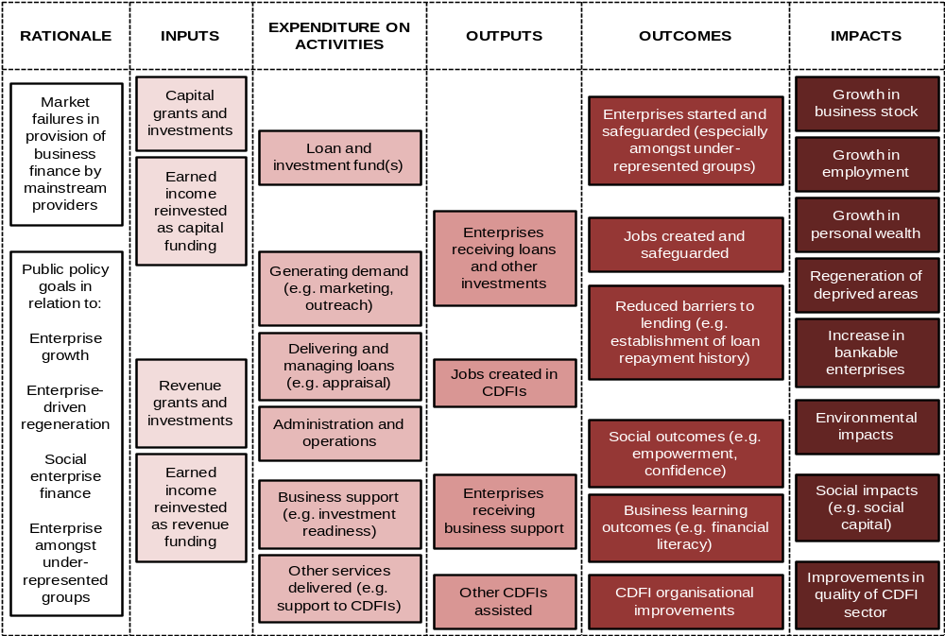
The logic models for individual CDFIs will vary depending on their specific rationale(s) and objectives, which in turn will change the significance, balance and details of each of the components. Figure 6 provides examples of different CDFI scenarios and illustrates a number of potential sector models that could be developed.
Figure 6: Examples of how different CDFI rationales might affect priorities within each area of the logic model
Rationale | General enterprise growth | Enterprise-driven regeneration | Support for social enterprises | Enterprise in under-represented groups
Inputs | RDA enterprise programmes  Banks | Community regeneration funds (LEGI) | Charitable foundations  Social investors | Charitable foundations
Expenditure on activities | Generation of demand  Loan processing operations | Community outreach  Business support | Generation of demand  Business support | Community outreach  Business support
Outputs | Volume delivery of loans | Loans within deprived areas  More business support needed | Loans for social enterprises | Loans for target groups  More business support needed
Outcomes | Volume start-ups/ growth  Reduced access to finance barriers | Start-ups/ growth and social outcomes (aspirations etc)  Learning outcomes | Social enterprise start-ups/ growth | Start-ups/ growth and social outcomes (aspirations etc)  Learning outcomes
Impacts | Business stocks  Bankable businesses | Business stocks in deprived areas  Social/ equity impacts | Social and environmental impacts  Bankable social enterprises | Business stocks amongst target groups  Social/ equity impacts

part D: a sustainable sector

Summary
CDFI and sector sustainability (operational and financial) remains a goal of the sector and is likely to be critical during a period of reduced public spending.
The evidence presented highlights the extent of the challenge, how this challenge varies significantly across market segments, and the trade-offs between sustainability and delivery of policy outcomes.
Known drivers of sustainability and current individual CDFI and sector data has been used to produce seven financial business models of typical CDFIs to illustrate the journey to sustainability.
Potential Actions:
To use the financial model to support individual business planning and development;
To support the sector (through Change Matters) to agree on common and clearly understood definitions of key metrics as the basis of performance management.

the journey to sustainability
CDFIs have historically received significant amounts of public sector funding and support - through a variety of mechanisms and schemes - in order to deliver their lending activities. This support has been justified primarily on the basis of market failures and delivery of public policy priorities as discussed in Part B. Movement towards sector sustainability, and evidence of strategies for sustainability, is likely to be critical during a period of reduced public funding.

Defining and measuring CDFI sustainability
The CDFI sector – alongside micro finance more broadly – uses two key definitions of sustainability (which have been further developed and implemented by the CDFA as part of the Change Matters performance framework):
- Operational sustainability: Operational sustainability describes the extent to which a CDFI is able to cover its operational costs (mainly staff and overhead costs) through income generated through its core activities (usually taken to be the interest earned on loans, any fees charged, and interest generated on invested capital reserves). As CDFIs grow and diversify, however, what constitutes ‘core’ activities has tended to expand (including, for example, commercial property rental, the management of loan funds for other organisations, the delivery of business support, the provision of back office services to charities and other loan funds, and consultancy/ training services);
- Financial sustainability: Financial sustainability refers to the ability of a CDFI to cover its operational costs and also meet its capital requirements (principally to replace lending capital lost through bad debt, but also potentially to increase the overall size of the loan fund) through earned income. Earned income in this respect includes the various sources identified above.
There is no comprehensive assessment of the sustainability (operational or financial) of the CDFI sector and such an assessment is hampered by:
- Variations in definitions: most especially, how different sources of income should be treated (e.g. whether public sector support is a grant or a payment for services delivered), and also as to which types of expenditure should be included in the calculations (for example where within a multi-faceted organisation the limits of the CDFI should be delineated);
- A lack of available data: The CDFA’s Inside Out survey does not collect comprehensive data on CDFI income and expenditure, meaning that information needs to be collected from each CDFI through their published accounts, which may not be publicly available;
- Variations in accounting procedures: Even where published accounts are available, variations in accounting procedures means that it is not always possible to calculate sustainability. Where CDFIs are part of larger groups, separate accounts may not be available, or in other cases there are financial transfers between companies (within a larger group) that make accurate assessments of income and expenditure difficult. In other cases, however, CDFIs do not publish sufficient information in their accounts to enable a calculation of sustainability to be made; for example, by not disaggregating income or expenditure by source and/ or activity.
The national evaluation used income data from Inside Out, together with case study CDFI material, to derive calculations on sector sustainability (see Figure 7):
- average operational sustainability within the sector has increased from 30% in 2006/07 to 39% in 2008/09; and,
- financial sustainability for the sector has increased from 22% in 2006/07 to 24% in 2008/09.
The CDFI sector is moving in the right direction but remains a substantial distance away from operational and financial sustainability.
Figure 7: Estimated median operational and financial sustainability of the CDFI sector, 2006/07 to 2008/09
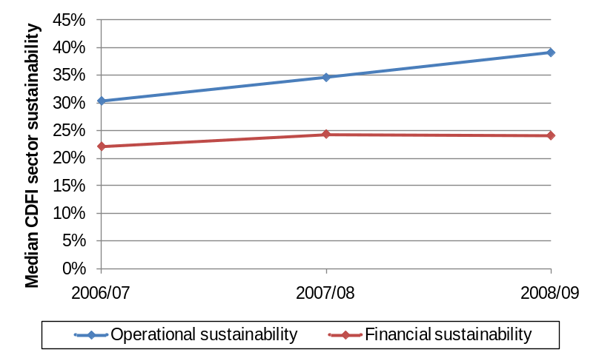
Source: GHK calculations, based on Inside Out (2006/07 to 2008/09)

Drivers of CDFI sustainability
A range of evidence suggests that there are a number of areas of good practice that contribute towards achieving higher levels of operational and financial sustainability. Drivers of sustainability include:
- Increased scale of lending pot: providing greater portfolio income and facilitating larger (and more efficient) loans;
- Improved partnership working: in particular, the referral of viable businesses contributing to policy targets by partners and, relatedly, the provision of pre- and post-loan business support by partners. In this regard, the sector continues to, in most cases, express disappointment at the quality of partnerships with Regional Business Links and mainstream banks;
- Increased staff efficiency: focus of effort and expenditure on loan activity, reducing other administrative activity and broader formal and informal business support to applicants and clients alike;
- Improving portfolio performance: maximising income through loan fees and interest rates and, more fundamentally, reducing bad debt;
- Reduction in very small loans: Some funders support CDFIs in providing very small loans given their policy objectives and the potential to create a greater social and economic impact per pound of lending. Nevertheless, the cost of delivering very small loans and collecting interest and principal often exceeds the amount earned; a move away from such loans will increase CDFI sustainability.
Nevertheless, inherent within the drivers of sustainability are clear trade-offs between pursuing sustainability and securing ‘depth of reach’ against policy targets; for example, larger loans, lower risk clients, higher rates of interest and minimal business support all improve sustainability but are likely to reduce policy impacts. Indeed, some evidence exists of ‘mission creep’ within the sector in response to the demands of sustainability (for example, moves out of the micro enterprise market and the choice of ‘next best’ cases rather than the highest risk cases in terms of policy objectives). The potential for mission creep expanded during the credit crunch and recession, and current evidence suggests sustainability was set-back by these events (although this is still to be fully determined).

Financial models of CDFI enterprise lending activities
Table 3 provides a set of seven financial models for enterprise lending activities by CDFIs:
- a ‘base’ model for the CDFI sector as a whole (based on sector-wide averages); and,
- models of a set of small and large CDFIs, each broken down by the three key enterprise market segments.
Details of the methodology underpinning the models, and the sources of data used, are shown in Table 4. Table 3 highlights:
- the extent to which the CDFI sector is still some distance from achieving sustainability;
- only a large CDFI focussing on the social enterprise lending market was able to achieve 100% operational sustainability;
- none of the CDFI models were close to achieving 100% financial sustainability;
- taking into account the opportunity costs of providing capital to CDFIs, sustainability falls even further (32% across the sector as a whole); and,
- a CDFI focussing on micro enterprise lending, whether small or large, is a very long way away from sustainability. Consequently, such a CDFI would need to access considerable amounts of external funding to cover its ongoing operating and financial costs.
There are a number of key variables within the models that have a significant impact on income and/or costs, and thus levels of sustainability, and are closely related to drivers of sustainability. These variables can be altered to provide scenarios for the journey to sustainability for different types of CDFI:
- a large CDFI serving the micro enterprise market would, on average, be 32% operationally sustainable under the model. Keeping levels of bad debt at 12% (this market will always have a higher level of risk), a 100% level of operational sustainability could be achieved by increasing the scale of operations to 200 outstanding loans, by increasing income per loan to from 7.7% to 15% of the value of each loan, and by increasing loan officer productivity to 20 new clients per year. For a smaller CDFI, an increase in the number of outstanding loans from 44 to 65, in combination with the changes to staff efficiency etc. outlined for larger CDFI, would also lead to 100% operational sustainability;
- CDFIs lending to SMEs are arguably much closer to achieving operational sustainability, and thus only relatively small changes to operating models are required in order to achieve 100% operational sustainability. For example, if a CDFI increased its income per loan from 7.7% of the value to 12%, operational sustainability would exceed 100% for both small and large SME lenders. For small lenders, achieving financial sustainability would require further adjustments, for instance by increasing the number of outstanding loans to 40 from 23; and,
- As noted previously, a large CDFI lending to social enterprises will most likely have achieved operational sustainability using the model. By increasing income per loan from 7.7% of the value to 12%, and by increasing the number of outstanding loans to 100, such a CDFI would also achieve over 100% financial sustainability.
Table 3: Financial models of the enterprise lending activities of CDFIs
PROFILE OF MODEL
A | Target enterprise market | All | Micro | SMEs | Social | Micro | SMEs | Social
B | Relative size of CDFI | Average | Small | Small | Small | Large | Large | Large
C | Number of outstanding loans | 112 | 44 | 23 | 21 | 176 | 91 | 83
D | Value of each outstanding loan | £21,131 | £7,327 | £33,744 | £72,606 | £7,327 | £33,744 | £72,606
E | Total value of outstanding loans | £2,374,952 | £322,379 | £767,686 | £1,510,606 | £1,289,518 | £3,070,745 | £6,042,425
INCOME
F | Income earned per outstanding loan p.a. | £1,631 | £565 | £2,604 | £5,604 | £565 | £2,604 | £5,604
G | Total earned income p.a. | £183,299 | £24,881 | £59,250 | £116,589 | £99,525 | £237,000 | £466,354
COSTS
H | Number of new loans p.a. | 39 | 15 | 11 | 8 | 59 | 43 | 30
I | Number of new loans per technical staff p.a. | 11 | 14 | 11 | 5 | 14 | 11 | 5
J | Number of technical staff | 3.5 | 1.0 | 1.0 | 1.5 | 4.1 | 3.9 | 6.1
K | Number of support staff | 2.7 | 0.8 | 0.7 | 1.2 | 1.6 | 1.5 | 2.3
L | Total staff costs p.a. | £213,034 | £63,295 | £59,118 | £92,618 | £193,348 | £180,589 | £282,923
M | Total non-staff overhead cost p.a. | £127,820 | £37,977 | £35,471 | £55,571 | £116,009 | £108,353 | £169,754
N | Total operational costs p.a. | £340,854 | £101,272 | £94,589 | £148,189 | £309,357 | £288,942 | £452,676
O | Write-offs as a % of outstanding lending | 7% | 12% | 5% | 4% | 12% | 5% | 4%
P | Total value of write-offs p.a. | £158,163 | £38,446 | £38,672 | £59,618 | £153,784 | £154,689 | £238,472
Q | Total operational and financial costs p.a. | £499,017 | £139,718 | £133,261 | £207,807 | £463,140 | £443,631 | £691,148
R | Notional capital cost p.a. | £77,901 | £10,574 | £25,181 | £49,549 | £42,297 | £100,723 | £198,198
S | Total operational, financial & capital costs p.a. | £576,918 | £150,292 | £158,442 | £257,357 | £505,438 | £544,355 | £889,345
SUSTAINABILITY
T | Income-cost gap (operational) | -£157,555 | -£76,391 | -£35,339 | -£31,601 | -£209,832 | -£51,942 | £13,678
U | Operational sustainability | 54% | 25% | 63% | 79% | 32% | 82% | 103%
V | Income-cost gap (operational/ financial) | -£315,718 | -£114,837 | -£74,011 | -£91,219 | -£363,615 | -£206,631 | -£224,793
W | Financial sustainability | 37% | 18% | 44% | 56% | 21% | 53% | 67%
X | Income-cost gap (operational/ financial/ capital) | -£393,619 | -£125,411 | -£99,192 | -£140,768 | -£405,913 | -£307,355 | -£422,991
Y | Total sustainability | 32% | 17% | 37% | 45% | 20% | 44% | 52%
Z1 | Value of gap per outstanding loan | £3,502 | £2,850 | £4,360 | £6,766 | £2,306 | £3,378 | £5,083
Z2 | Value of gap per £’000 of outstanding loans | £166 | £389 | £129 | £93 | £315 | £100 | £70
Table 4: Methodological details of the CDFI financial models shown in Table 3
Name of indicator |  | Details
A | Target enterprise market | Micro enterprise (0-9 employees), SME (10-249 employees)
B | Relative size of CDFI | See H and K
C | Number of outstanding loans | Total number of outstanding enterprise loans (Inside Out 2008/09)
D | Value of each outstanding loan | Value of outstanding enterprise loans / Number of outstanding enterprise loans (Inside Out 2008/09)
E | Total value of outstanding loans | C * D
F | Income earned per outstanding loan p.a. | Annual income from interest and fees (Inside Out 2008/09) / Number of outstanding loans (Inside Out 2008/09) = £1,631, or 7.718% of value of outstanding loan (all CDFIs). 7.718% applied to average value of outstanding loans for each market group (C)
G | Total earned income p.a. | C * F
H | Number of new loans p.a. | Average number of new loans made per year (Inside Out 2008/09), by market segment. Average value doubled for large CDFIs and halved for small CDFIs
I | Number of new loans per technical staff p.a. | Number of new loans made per year / Number of technical staff (Inside Out 2008/09). Technical staff = loan officers, operations manager, and business support officers
J | Number of technical staff | H / I
K | Number of support staff | J * Ratio of technical staff to support staff (Inside Out 2008/09) (1:0.77). Support staff = Chief Executive, administration, ‘other’. Ratio halved for large CDFIs (1:0.39)
L | Total staff costs p.a. | J * Average annual salary per technical staff (Inside Out 2008/09) (£28,789) * 1.12 (approximate value for National Insurance costs) + K * Average annual salary per support staff (Inside Out 2008/09) (£33,472) * 1.12
M | Total non-staff overhead cost p.a. | L * 1.6 (assumes overhead costs = 60% of total staff costs)
N | Total operational costs p.a. | L + M
O | Write-offs as a % of outstanding lending | Value of write-offs by market segment / Value of outstanding lending by market segment (Inside Out 2008/09)
P | Total value of write-offs p.a. | E * O
Q | Total operational and financial costs p.a. | N + P
R | Notional capital cost p.a. | Value of outstanding lending (E) * average annual LIBOR Rate (over last 4 years) (3.3%)
S | Total operational, financial & capital costs p.a. | Q + R
T | Income-cost gap (operational) | G – N
U | Operational sustainability | G / N
V | Income-cost gap (operational/ financial) | G – Q
W | Financial sustainability | G / Q
X | Income-cost gap (operational/ financial/ capital) | G – S
Y | Total sustainability | G / S
Z1 | Value of gap per outstanding loan | X / C
Z2 | Value of gap per £’000 of outstanding loans | X / E * 1000

The full report, including Executive Summary, is available at http://www.bis.gov.uk/assets/biscore/enterprise/docs/10-814-evaluation-community-development-finance-institutions
The full report, including Executive Summary, is available at http://www.bis.gov.uk/assets/biscore/enterprise/docs/10-814-evaluation-community-development-finance-institutions
www.cdfa.org.uk
UKSIF (2002) Community Development Finance Institutions: A New Financial Instrument for Social, Economic and Physical Renewal
CDFA (2008) Annual Review 2008
Again, excluding Triodos Bank and Bridges Community Ventures.
Note: ‘UK’ category concerns lending by CDFIs operating nationally that cannot be disaggregated by region.
Note: this data concerns lending by CDFIs that only lent within the region in question; the regional breakdown of lending by nationally-oriented CDFIs is not available.
The “20% most deprived Lower Super Output Areas” according to the Index of Multiple Deprivation (2007 in England, 2008 in Wales, and 2009 in Scotland).
HM Treasury (2004) The Graham Review of the Small Firms Loan Guarantee
Cosh, A., Hughes, A., Bullock, A., and Milner, I. (2008) Financing UK Small and Medium Sized Enterprises: The 2007 Survey. Report from the Centre for Business Research
www.bis.gov.uk/Policies/better-regulation/policy/scrutinising-new-regulations
BERR (2008) The Economic Drivers of Government-Funded Business Support: Supporting Analysis for ‘Solutions for Business: Supporting Success’
NEF and Bert Nicholson (December 2003) Analysis of the Need and Demand for Development Funding of Community Development Finance Institutions In the West Midlands
Small Change Research Partnership (2006) Financial Exclusion: Baseline and Mapping
CDFA (2009) Op cit.
Roper, S. et al. (2006) Exploring Gender Differentials in Access to Business Finance: An Econometric Analysis of Survey Data
Smallbone, D. et al. (2003). Access to Finance by Ethnic Minority Businesses in the UK. International Small Business Journal, 21(3), 291-314.
These have included the 2004 National Evaluation of the Phoenix Fund, feasibility studies and evaluations of regional CDFI programmes that have been commissioned by the RDAs, and a small number of evaluations of individual CDFIs
CDFA (2009) Change Matters: The UK CDFI performance framework
The full methodology is available in the National Evaluation report available at: http://www.bis.gov.uk/assets/biscore/enterprise/docs/10-814-evaluation-community-development-finance-institutions. This methodology meets HMG’s Green Book requirements, see http://www.hm-treasury.gov.uk/data_greenbook_guidance.htm which sets out the principles upon which all public sector economic assessment is based.
At a regional level there is much greater likelihood of other businesses being affected by increased competition from CDFI-supported businesses such that, for example, new business start-ups are offset by others closing (the net impact).
It is also the case that repaid loans could be ‘re-cycled’ through a further round of lending and trigger a subsequent round of impacts, although the methodological justification and calculation of such benefits remains in its infancy and is not included within Green Book guidance.
Note that this is a maximum cost in the sense that it is an estimate of the gap between earned income and expenditure of the sector, and may thus be partially (or even fully) met by non-public sources of finance.
See http://www.sroi-uk.org/
The CDFI financial model has been reviewed by experts in the field of CDFI financial operations, including representatives from BIS and the CDFA

