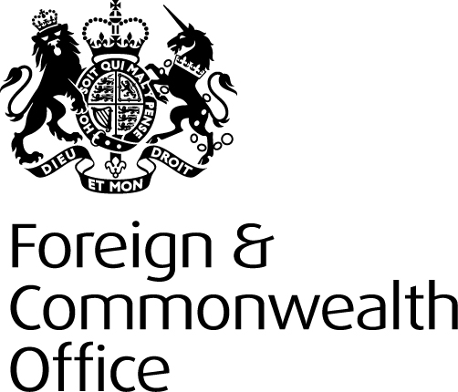

Pre-Qualification Questionnaire Invitation

British High Commission, Kathmandu, Nepal.
Structural Strengthening Works and Replacement Roof.
Contract Ref.No.06012

CPG/Estate Contracts

1.0 BACKGROUND INFORMATION
The Foreign & Commonwealth Office (FCO) are seeking expressions of interest from experienced fit out contractors, for the provision of structural strengthening works and replacement roof structure at the British High Commission, Kathmandu, Nepal.

1.1 THE REQUIREMENT
The British High Commission in Kathmandu is situated in a high risk earthquake zone (4) and is susceptible to frequent seismic activity. The FCO have undertaken a number of seismic risk reports that indicate that the HMA Residence will require significant structural strengthening works to protect against future seismic activity
The FCO Estates and Security Directorate (ESD) have completed a feasibility study to establish the best course of action to remedy building fabric deficiencies. The resultant report identified a number of options and the following has been agreed as the best course of action.
- Replace all timber structures with new lightweight structural members and replace roof coverings.
- Renew all flat roof coverings.
- Carry out structural reinforcement to the building fabric by means of jacketing internal and external walls.
- Additional works to bathroom and kitchen canopy.
The Foreign & Commonwealth Office is inviting experienced contractors who can demonstrate extensive experience in this type of work. As part of the pre-qualification process shortlisted contractors may be expect to be interviewed to confirm capability.
This procurement will be contracted using the NEC3 Short-form contract.

  - TIMETABLE

Set out below is the proposed procurement timetable. This is intended as a guide and, whilst the Authority does not intend to depart from the timetable, it reserves the right to do so at any time.

Date or Target Date | Activity
10 August 2012 | PQQ issued
31 August 2012 | PQQ final response time and date
3 September 2012 | Completion of PQQ assessment and list of bidders identified
Early September | Interviews (if required)
7 September 2012 | ITT Issued
5 October 2012 | Submission of Bid
Early November 2012 | Bid Evaluations and internal Assurance
Mid November 2012 | Interviews
Late November 2012 | Contract Award
Late December 2012 | Mobilisation
August 2013 | Practical completion

1.3 AUTHORITY NAMED CONTACT
The Authority’s named contact point for the procurement is:

Mr Terry Wilson
Corporate Procurement Group
Foreign and Commonwealth Office
Old Admiralty Building
London SW1A 2PA
Telephone No.+44 (0) 020 7008 1406
Email: terry.wilson@fco.gov.uk
www.fco.gov.uk
The Authority will not enter into detailed discussion of the Service requirements at this stage. If the Authority considers any question or request for clarification to be of material significance, both the query and the response will be communicated, in a suitably anonymous form, to all Potential Providers who have expressed an interest.

1.4 INSTRUCTIONS FOR COMPLETION

Recipients are invited to complete the PQQ and to submit it, together with any requested supporting information, to the Authority by the due date for return (11:00hrs (BST) 31 August 2012). Potential Providers are required to submit their completed PQQ via the Authority’s eProcurement portal. There may be restrictions regarding the length of answers or attachments and anything in excess of this may be disregarded.

“Project: 139 PQQ: 117 British High Commission, Kathmandu, Nepal – Structural Strengthening and Roof Replacement Works”

How to Express Interest in this PQQ: 1. Register your company on the eSourcing portal (this is only required once) - Browse to the eSourcing Portal:https://fco.bravosolution.co.uk and click the link to register. - Accept the terms and conditions and click "continue" - Enter your correct business and user details - Note the username you chose and click "Save" when complete - you will shortly receive an e-mail with your unique password (please keep this secure); 2. Express an Interest in the Tender - Login to the portal with the username/password - Click the "PQQs/ITTs Open to All Suppliers" link. (These are Pre-Qualification Questionnaires or Invitations to Tender open to any registered supplier) - Click on the relevant PQQ/ITT to access the content - Click the "Express Interest" button in the "Actions" box on the left hand side of the page - This will move the PQQ/ITT into your "My PQQs/My ITTs" page (This is a secure area reserved for your projects only) - You can now access any attachments by clicking the "Settings and Buyer Attachments" in the "Actions" box; 3. Responding to the tender - You can choose to "Reply" or "Reject" (please give a reason if rejecting) - You can now use the 'Messages' function to communicate with the buyer and seek clarification - Note the deadline for completion, then follow the onscreen instructions to complete the PQQ/ITT - There may be a mixture of online & offline actions for you to perform (there is detailed online help available), You must then publish your reply using the publish button in the "Actions" box on the left-hand side of the page. If you require any further assistance please consult the the online help or contact the eTendering help desk.

Potential Providers should answer all questions as accurately and concisely as possible in the same order as the questions are presented. Where a question is not relevant to the Potential Provider’s organisation, this should be indicated, with an explanation. Where attachments are requested to be submitted within the electronic PQQ, these shall be submitted in a PDF format (Adobe or similar).

Bids not submitted via the FCO’s eProcurement portal will not be considered.

1.5 SUBMISSION OF COMPLETED PRE-QUALIFICATION QUESTIONNAIRES

If you would like to formally express an interest in this requirement, please submit your completed PQQ via the Authority’s eSourcing portal at https://fco.bravosolution.co.uk no later than 11:00hrs (BST) 31 August 2012). The reference for these requirements on the BRAVO eProcurement Portal is “Project: 139 PQQ: 117 British High Commission, Kathmandu, Nepal – Structural Strengthening and Roof Replacement Works”

Completed PQQs may be submitted at any time before the closing date. Please note that completed PQQs received after the closing date may be rejected. Bids not submitted via the eProcurement portal will not be considered.

