|  |  |  |
| --- | --- | --- |
|  | **K. J. Somaiya Institute of Engineering and Information Technology, Sion, Mumbai**  *Accredited ‘A’ Grade by NAAC with 3.21 CGPA*  *3 Programs Accredited by National Board of Accreditation*  *Permanently Affiliated to University of Mumbai,*  *Best College Award by University of Mumbai (Urban Region), ISTE (MH), and CSI (Mumbai)*  *UGC Recognized Institute under Section 2(f) and 12(B) of the UGC Act, 1956* |  |

# Experiment No. 1

## Aim:

* Installation of Jenkins.

## Theory:

Jenkins is a free and open-source automation server. It helps automate the parts of software development related to building, testing, and deploying, facilitating continuous integration and continuous delivery. The Jenkins project was originally named Hudson, and was renamed after a dispute with Oracle, which had forked the project and claimed rights to the project name.

Jenkins is Java-based and can be installed from Ubuntu packages or by downloading and running its web application archive (WAR) file — a collection of files that make up a complete web application to run on a server. The simplest way to install Jenkins on Windows is to use the Jenkins Windows installer. That program will install Jenkins as a service using a 64 bit JVM chosen by the user. Keep in mind that to run Jenkins as a service, the account that runs Jenkins must have permission to login as a service.

Jenkins will be installed on a server where the central build will take place. The following flowchart demonstrates a very simple workflow of how Jenkins works.

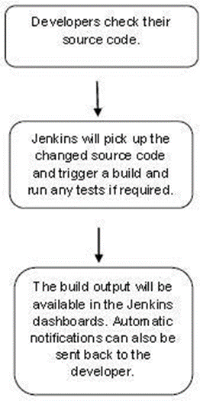

Jenkins needs some disk space to perform builds and keep archives. One can check this location from the configuration screen of Jenkins. By default, this is set to ~/.jenkins, and this location will initially be stored within your user profile location. In a proper environment, you need to change this location to an adequate location to store all relevant builds and archives. Once can do this in the following ways

● Set "JENKINS_HOME" environment variable to the new home directory before launching the servlet container.

● Set "JENKINS_HOME" system property to the servlet container.

● Set JNDI environment entry "JENKINS_HOME" to the new directory.

The following example will use the first option of setting the "JENKINS_HOME" environment variable.

First create a new folder E:\Apps\Jenkins. Copy all the contents from the existing

~/.jenkins to this new directory.

Set the JENKINS_HOME environment variable to point to the base directory location where Java is installed on your machine. For example,

|  |  |
| --- | --- |
| **OS** | **Output** |
| Windows | Set Environmental variable JENKINS_HOME to the location you desire. As an example you can set it to E:\Apps\Jenkins |
| Linux | export JENKINS_HOME =/usr/local/Jenkins or the location you desire. |

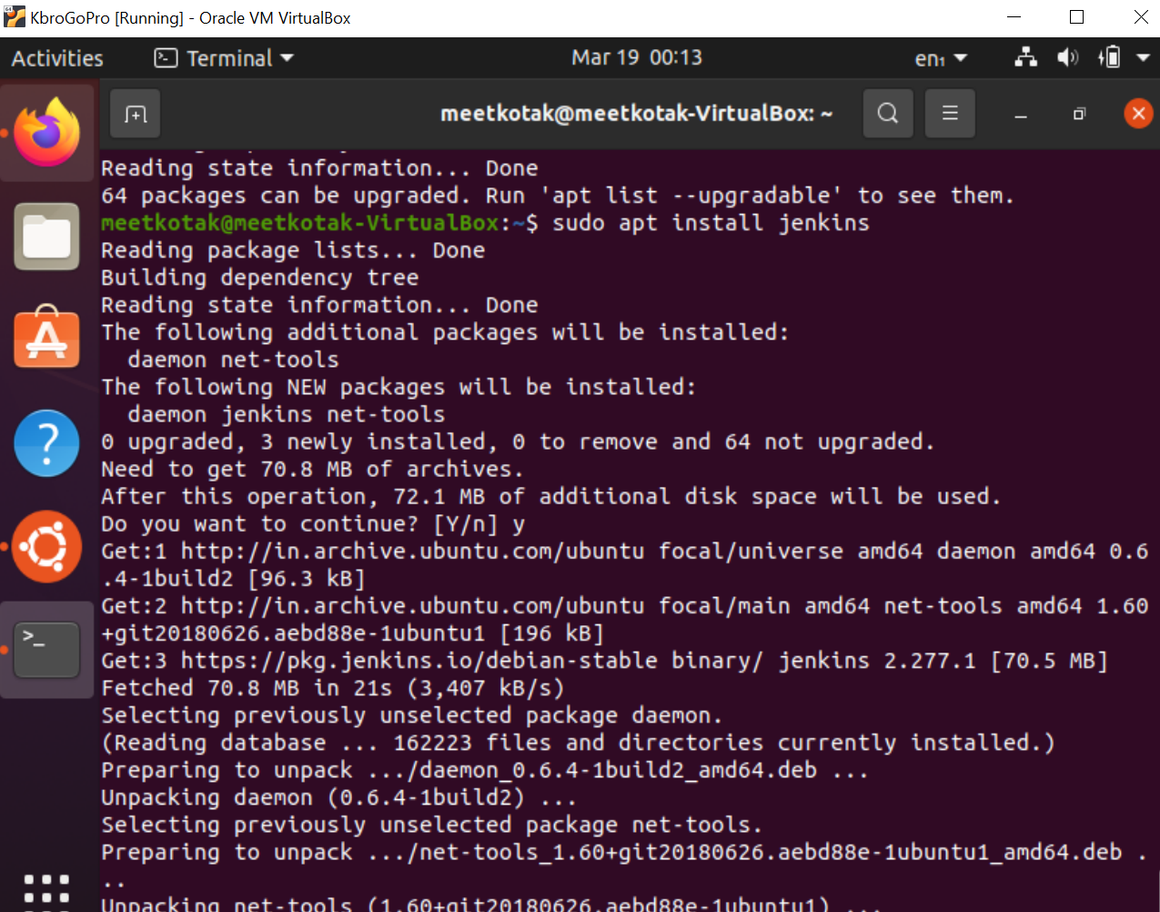

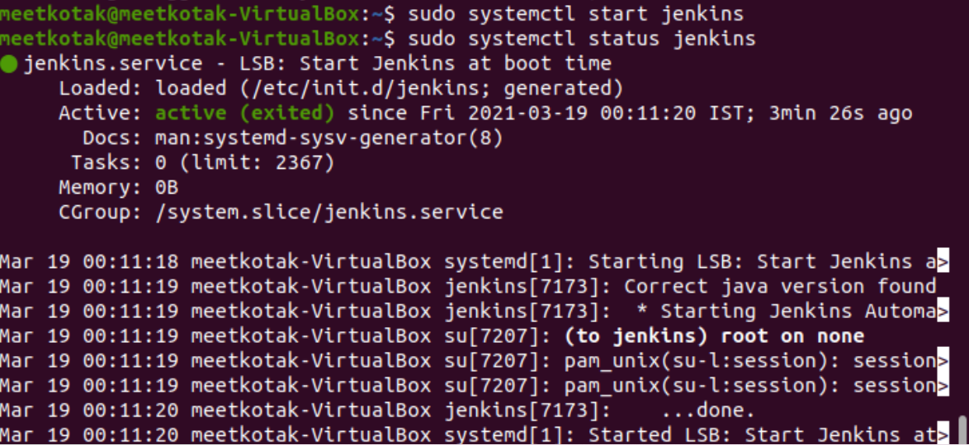

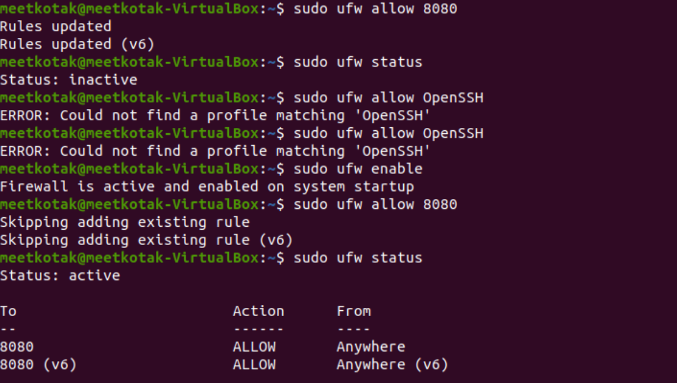



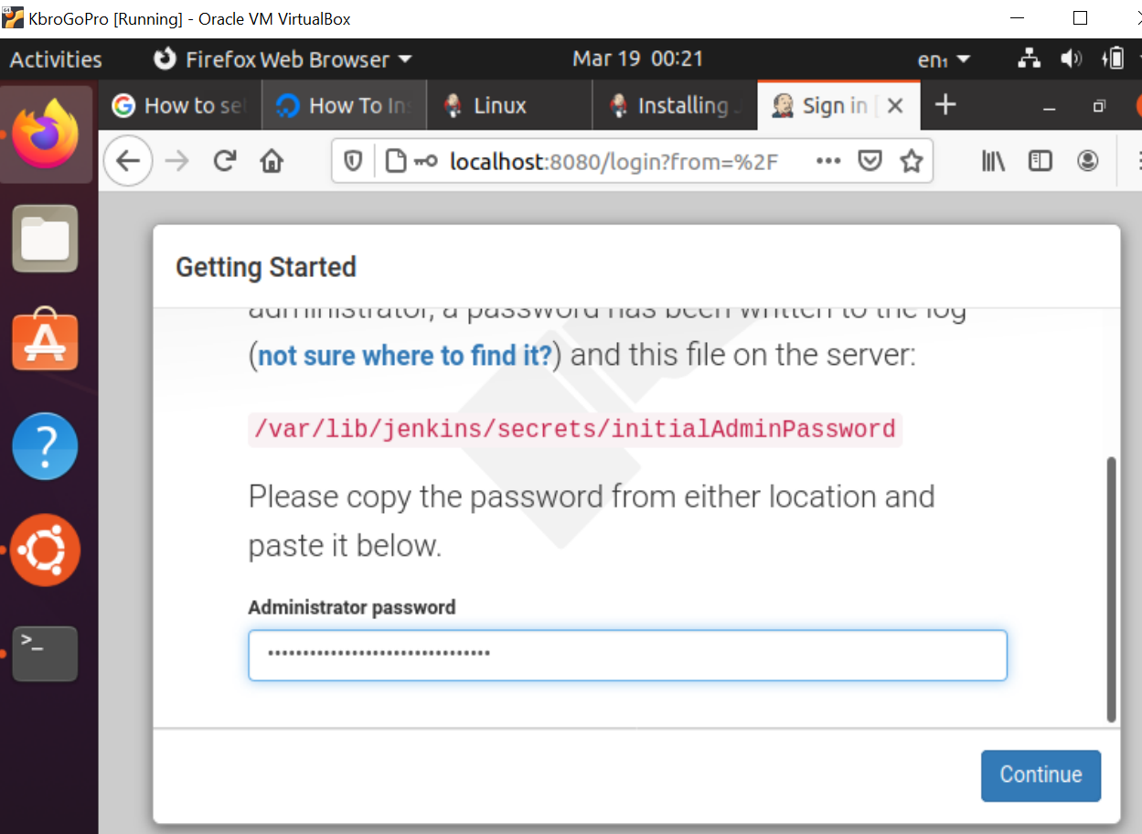

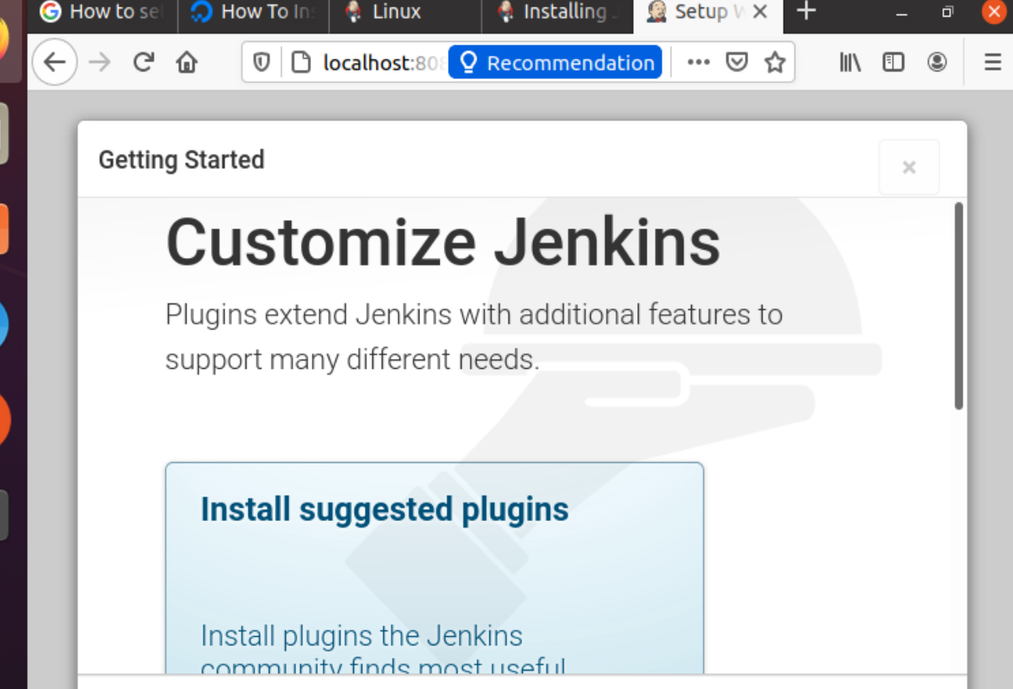

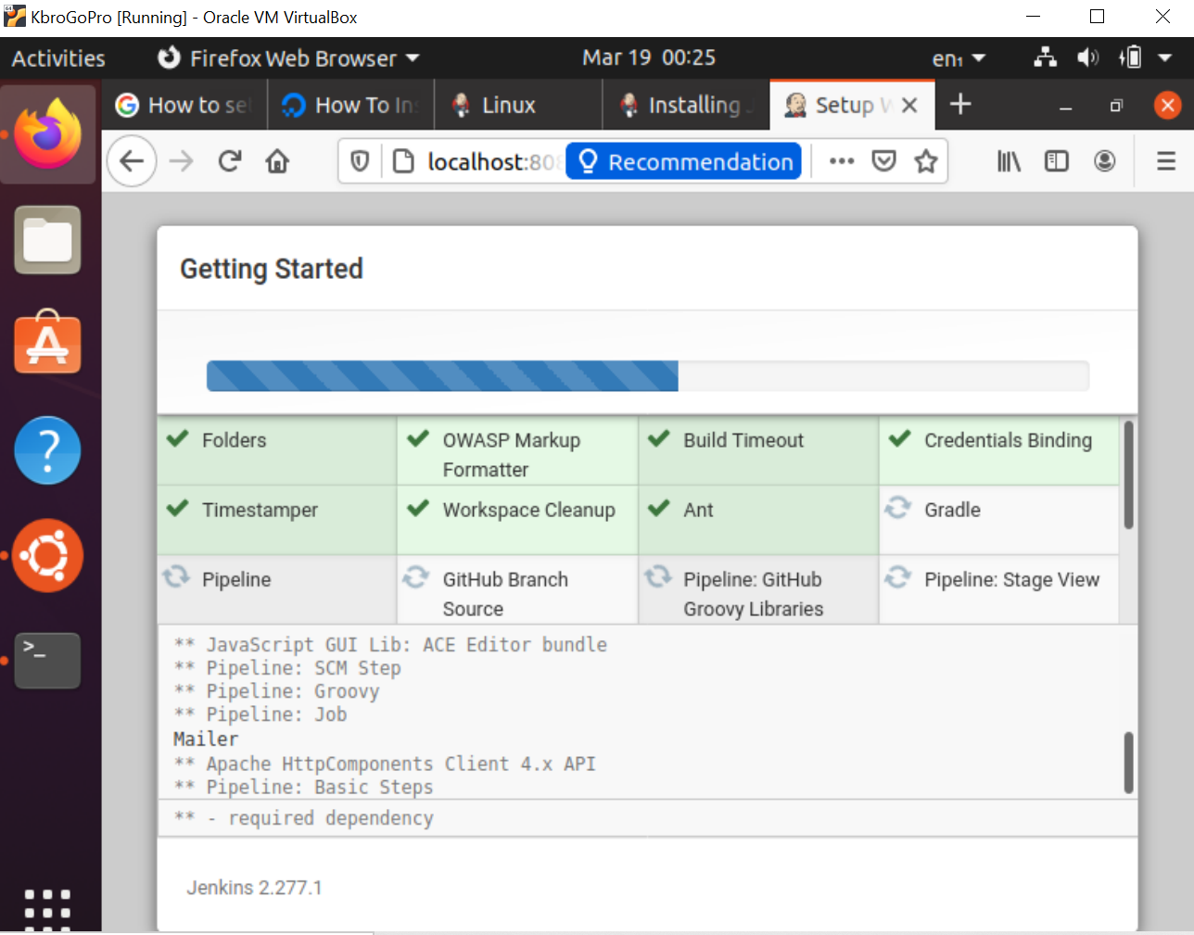

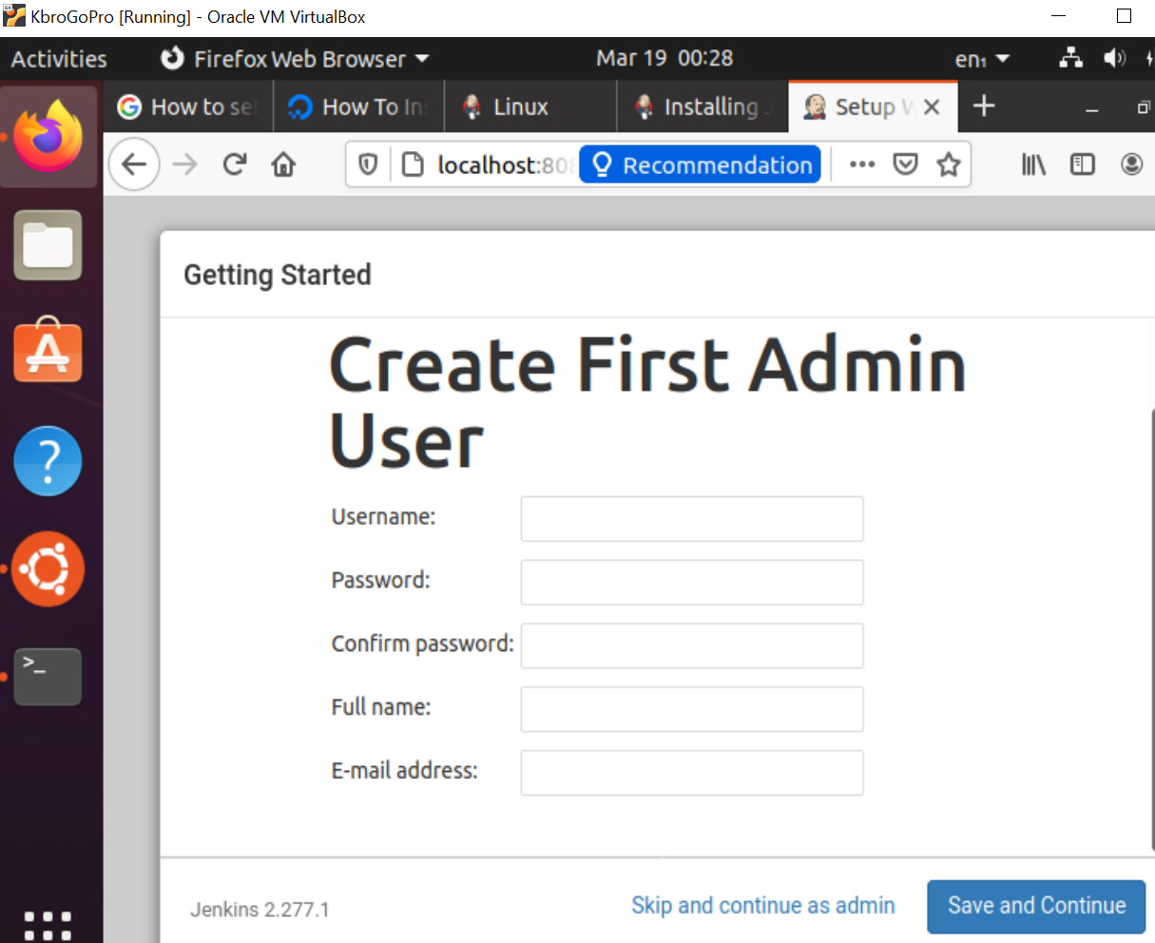

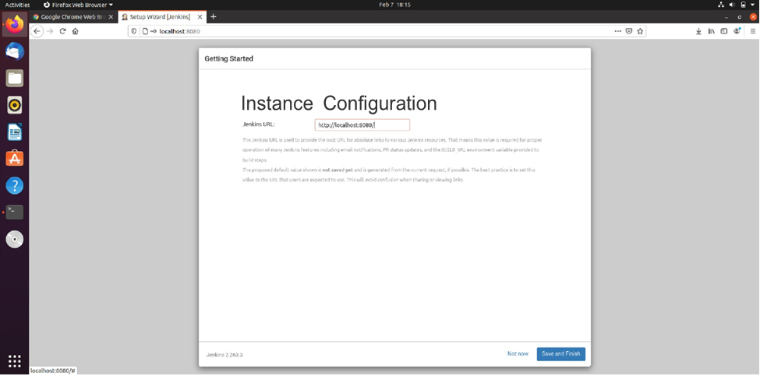

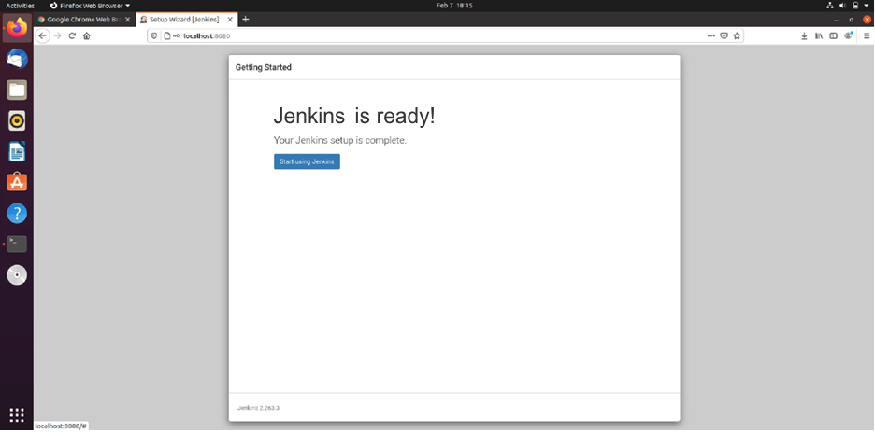

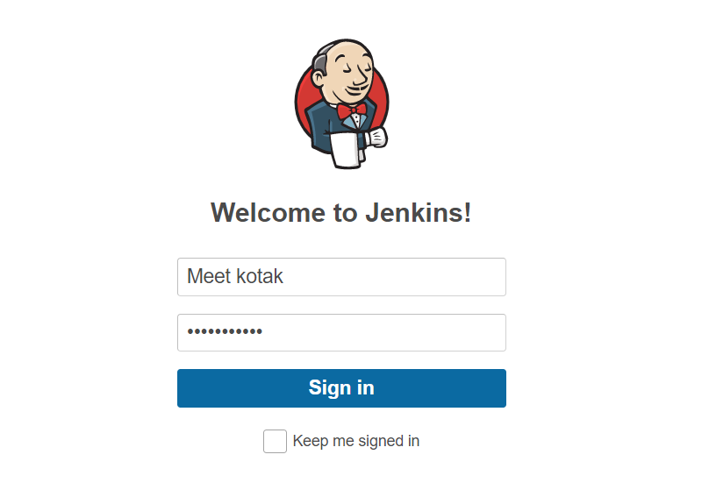

## Conclusion:

* From this experiment we were able perform installation of Jenkins on Ubuntu.