Name: _________________________________________ Date: _____________ Class: _____________

**Lesson 7: Equilateral Triangle**

*All exercises should be opened in the editor and ran in the terminal as stated in the introduction.

**Lesson 7:** Open the editor and open lesson7a.hs. Look at the code carefully.

***Exercise:*** *Determine what the program will draw.*

*Run the program to check.*

**Notes:**

Questions:

1. What shape did the program create?
2. How is point c computed in the program?
3. Why is the list [c,d] assigned to circle_circle (a,b) (b,a) ?
4. Why is d not shown when you run the program?

***Lesson 7 Ending Exercises:***

***Exercise:*** *Manipulate the program lesson7a.hs to draw a picture with the characteristics of the one below:*

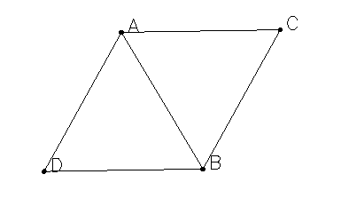

*Save the program as yourname_lesson7b.hs*

*Run the program to check.*

***Exercise:*** *Manipulate the program lesson7b.hs to draw a picture with the characteristics of the one below:*

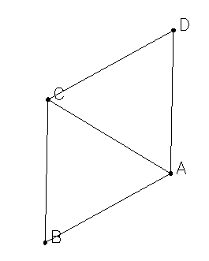

*Save the program as yourname_lesson7c.hs*

*Run the program to check.*

***Exercise:*** *Manipulate the program lesson7a.hs to draw a picture with the characteristics of the one below:*

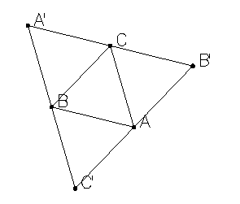

*Save the program as yourname_lesson7d.hs*

*Run the program to check.*