**Lesson 1: Points, Lines, Segments**

*All exercises should be opened in the editor and ran in the terminal as stated in the introduction.

**Lesson 1 Part 1:** Open the editor and then open lesson1a.hs. Look at the code and write down what you understand in the code. Run the code.

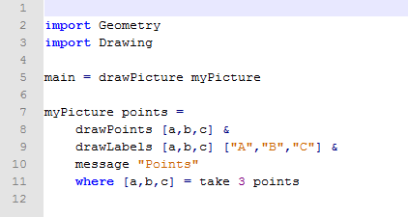

The teacher should refer to the Reference Sheet for the list of concepts and functions used in this lesson and then briefly describe the following characteristics of the code:

Lines 1-7 are boilerplate (Boilerplate section in the Coding Overview)

Lines 8-11 are the actual program

The operator & is described at the beginning of the section Function Reference List – Drawing Functions in the Coding Overview.

The program illustrated here consists of a single equation that defines the function myPicture as a composite picture which includes 3 graphical elements:

* A picture with points A, B and C
* A picture with their labels
* A message at the bottom that reads “Points”

These 3 partial pictures are combined with the operator & to create the final picture.

Line 11 is an auxiliary definition of A,B and C in terms of points. The list points is an infinite list of random points, from which 3 points are taken. Therefore, take 3 points is a list consisting of just the first 3 points from the infinite list. This list is deconstructed into 3 separate variables.

Questions:

1. What function draws the points?

drawPoints

1. What function draws the labels?

drawLabels

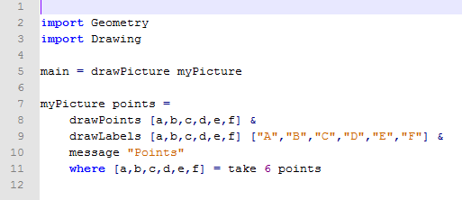

***Exercise:*** *Draw and Label three additional points in the program.*

*Save the program as yourname_lesson1b.hs*

*Run the program to check.*

Questions:

How do you think we would draw a segment between points A and B?

Answers may vary: drawSegment (a,b)

**Lesson 1 Part 2:** Open the editor and then open lesson1c.hs.

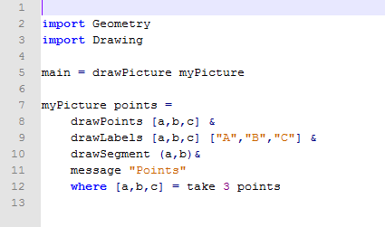

***Exercise:*** *Determine what the program will draw.*

*Run the program to check.*

Note that the argument of drawPoints is a list of points, but the argument of drawSegment is a tuple (pair) of points.

Questions:

What function do you think we would use to draw lines?

Answers may vary: drawLine (a,b)

**Lesson 1 Part 3:** Open the editor and then open lesson1d.hs.

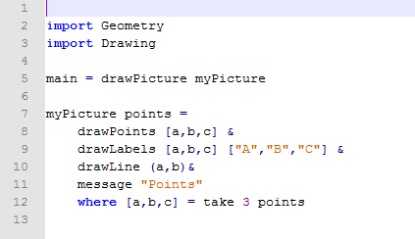

***Exercise:*** *Determine what the program will draw.*

*Run the program to check.*

***Lesson 1 Ending Exercises:***

***Exercise:*** *Open lesson1e.hs*

*Sketch a drawing of what you think is happening in this program.*

*Run the program to check your answer.*

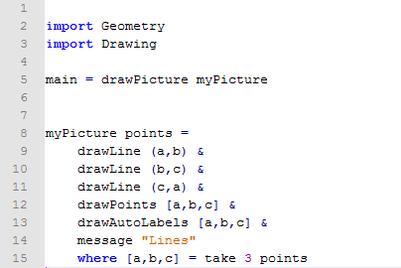

***Exercise:*** *Open lesson1f.hs.   
 Complete the program to draw the following objects:*

1. *Segment AB*
2. *Line BC*
3. *Segment CA*
4. *Message needs to read “Segments and Lines”*

*Save the program as yourname_lesson1f.hs.*

*Run the Program to check your answer.*

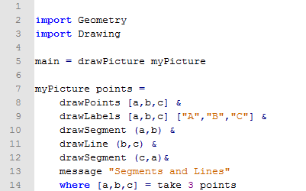

***Exercise:*** *Using four random points, how many segments would you need to connect each point with the other three points on the graph? 6*

*Manipulate one of the programs above to check your answer.*

*Save the program as yourname_lesson1g.hs*

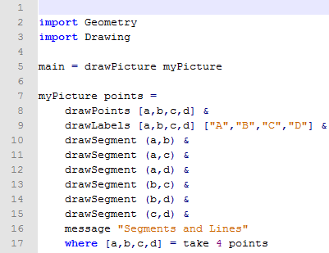

***Exercise:*** *Repeat the above exercise for 5 random points. 10*

*Save the program as yourname_lesson1h.hs*

