**Lesson 3: Midpoint & Distance**

*All exercises should be opened in the editor and ran in the terminal as stated in the introduction.

**Lesson 3 Part 1:** Open the editor and then open lesson3a.hs. Look at the code and write down what you understand in the code. Run the code.

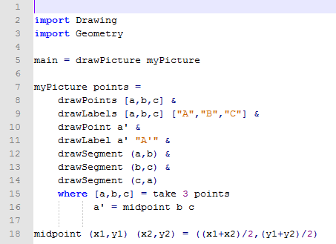

Notes to Teacher:

* This program has two 3 toplevel definitions (main, myPicture and midpoint)
* The function myPicture has 2 auxiliary definitions (line 15 and line 16)
* The midpoint should be similar to the formula used in class. Discuss it.

Questions:

1. What does the program do?

Draws a triangle and the midpoint of side or segment BC.

1. Why did the programmer use a’ in the language?

Because the midpoint is across from angle A

***Exercise:*** *Draw and Label the two missing midpoints of the other segments. Label appropriately as discussed in the question above.*

*Save your program as yourname_lesson3b.hs*

*Run the program to check.*

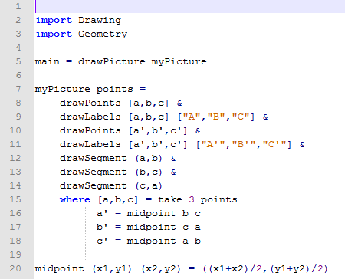

***Exercise:*** *Manipulate the program you just created, lesson3b.hs, to draw the 3 segments connecting the midpoints.*

*Save your program as yourname_lesson3c.hs*

*Run the program to check.*

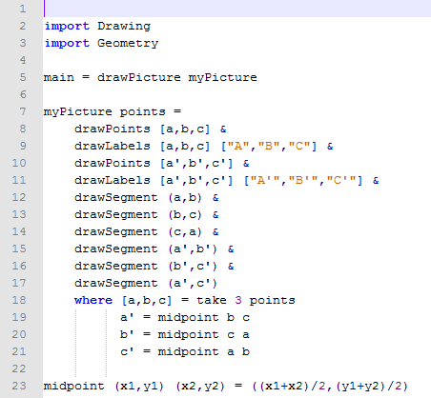

**Lesson 3 Part 2:** Open the editor and then open lesson3d.hs.

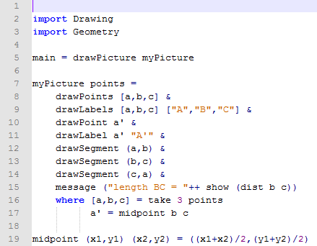

**Question:**

This program should look familiar to lesson3a.hs.

1. What do you think the program does differently than lesson3a.hs?

Run the program.

Draws triangle ABC. Identifies the midpoint of side BC as A’. Also displays the distance of side BC.

1. What does the function dist b c do?

Calculates the length or distance of side BC.

1. What does the function message do?

Displays a message to the user.

Note to Teacher: You will need to also discuss all of the factors of the following row:

message ("length BC = "++ show (dist b c))

Refer to the Coding Overview.

***Exercise:*** *Open the editor and then open lesson3e.hs.*

1. *What does the program do?*

*Run the program to check.*

1. *What does the function* messages *do?*

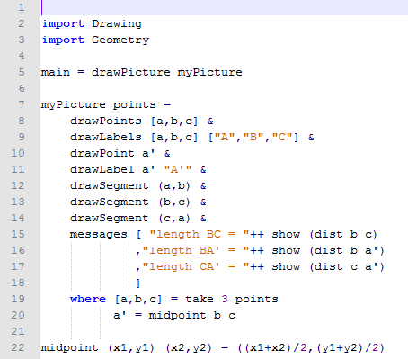

Note to Teacher: You will need to discuss how the messages function is used to show more than one message to the user.

***Lesson 3 Ending Exercises:***

***Exercise:*** *Open lesson3d.hs*

*Manipulate the program to do the following:*

1. *Draw all three midpoints of the segments.*
2. *Draw all of the segments connecting the midpoints.*
3. *Show the measure the distances of all 3 original sides.*
4. *Show the measure the distances of all 3 segments connecting the midpoints.*

*Save the program as yourname_lesson3f.hs*

*Run the program to check*

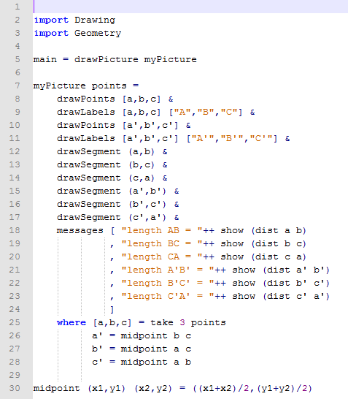

***Lesson 3 Further Applications:***

*Teachers you can easily extend this lesson by removing the randomness from the programs.*

*Key_lesson3N1*

*This program allows the user to change the points for a and b to actually get an output for the midpoint m.   
Students could use this program to check answers for classwork and homework or use it to solve more complex problems in which calculating the midpoint is a minute step.*

*Note to teacher: If the points are out of the domain and range of [-10,10], the points/line may not appear on the graph unless you zoom out. The coordinates of the midpoint will appear whether it is in or out of the domain and range of [-10,10].*

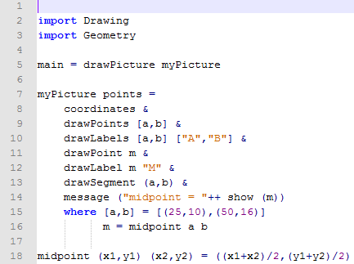

***Lesson 3: Further Applications:***

*Teachers you can easily extend this lesson by removing the randomness from the programs.*

*Key_lesson3N2*

*This program allows the user to change the points for a and b to actually get the length of AB.   
Students could use this program to check answers for classwork and homework or use it to solve more complex problems in which calculating the distance is a minute step.*

*Note to teacher: If the points are out of the domain and range of [-10,10], the points/line may not appear on the graph unless you zoom out. The length of the segment will appear whether the points are in or out of the domain and range of [-10,10].*

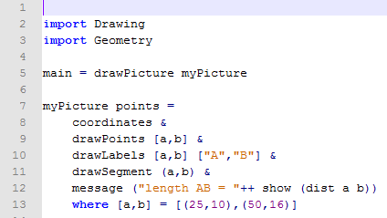

***Lesson 3: Further Applications:***

*Key_lesson3f.hs*

*The students should have written a program similar to this in the ending exercise. You can show the students how the program created two similar triangles because the side lengths are proportional.*

*You could also extend this exercise by having students show the distance of all the segments in the four triangles created. This could be used to show that the four triangles are congruent.*

