**Lesson 4: Angles**

*All exercises should be opened in the editor and ran in the terminal as stated in the introduction.

**Lesson 4:** Open the editor and then open lesson4a.hs. Look at the code and write down what you understand in the code. Run the code.

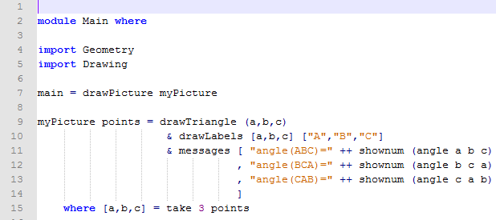

Questions:

1. What does the program do?

Draws Triangle ABC and displays the angle measure of each angle.

1. What does the b stand for in shownum (angle a b c)?

b is the vertex of the angle being measured.

Note to Teacher: You will want to briefly discuss the function drawTriangle (a,b,c).

***Exercise:*** *Open lesson4b.hs in the editor. Look at the program and sketch a picture of what the program is doing?*

*Run the program to check.*

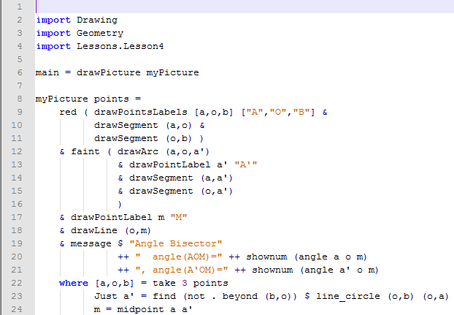

Note to Teacher: You will need to discuss line 23.

Questions:

1. What do you notice about the two angles that are drawn?

The angle measures are the same.

1. What does the program draw?

Draws the angle bisector of a given angle.

1. How does the program calculate where a’ should be?

Calculating the intersection of line OB and Circle OA that is not beyond line OB.

1. What does the function drawArc (a,o,a’) do?

Draws and Arc centered at O going through A and A’.

*Review the description of find in the section Function Reference List – System Functions and the description of beyond in the section Function Reference List – Geometry Functions in the Coding Overview before proceeding. The function (not.beyond (b,o)) is a composite predicate that will return True for points that lie either between (b,o) or beyond (o,b)*

*The definition in line 23 is incomplete, since we do not check for Nothing. However, it is almost impossible in this case that no point be found, and we could actually prove this claim for ideal points. So, in this case, it is OK to do without using the general case … of construc*tion

***Lesson 4 Ending Exercises:***

***Exercise:*** *Open yourname_lesson3f.hs*

*Manipulate the program to show the angle measures of the 3 angles in the large triangle and the three angles in the triangle created by the midpoints.*

*Save the program as yourname_lesson4c.hs*

*Run the program to check*

***Question:*** *What do you notice about the angle measures in the large triangle compared with the smaller triangle?*

Note to Teacher: Similar Triangles are created.

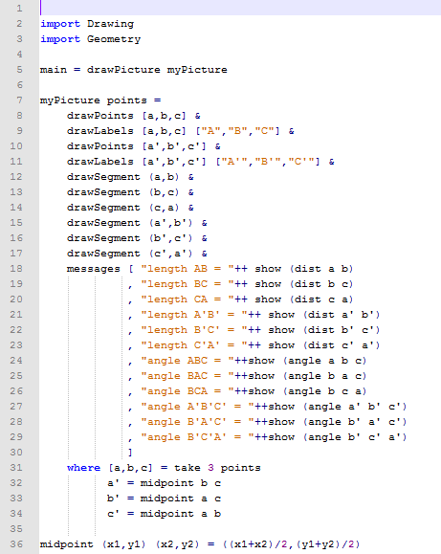

***Lesson 4 Further Applications:***

*Teachers you can easily extend this lesson through classifying triangles.*

*lesson4d.hs*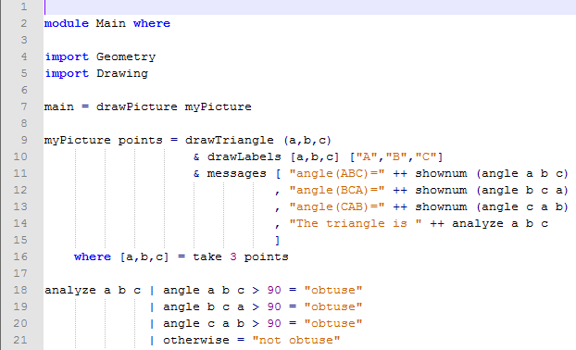

*The students should have seen a similar program in lesson4a.hs. This program will display a message on whether the triangle is acute, right, or obtuse.*

*My suggestion is to show the students how to display whether or not it is obtuse. Then have them manipulate the program to show whether it is acute, right, or obtuse as in key_lesson4e.hs.*

*Example key_lesson4e.hs: There are other methods to writing this program.*

