**Lesson 5: Perpendicular & Parallel Lines**

*All exercises should be opened in the editor and ran in the terminal as stated in the introduction.

**Lesson 5 Part 1:**

***Exercise:*** *Open lesson5a.hs in the editor. Create a sketch of what the program is drawing.*

*Run the program to check your answer.*

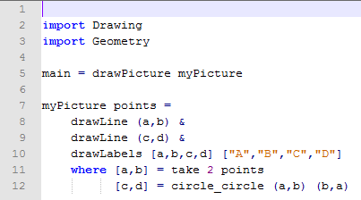

***Exercise:*** *Manipulate lesson5a.hs to label the intersection point as* E *and display the message “Perpendicular Lines.”*

*Save the program as yourname_lesson5b.hs*

*Run the program to check your answer.*

**Lesson 5 Part 2:**

Question:

How can we draw a line parallel to line AB in the previous exercises?

Draw a perpendicular to line CD

***Exercise:*** *Manipulate yourname_lesson5b.hs to draw line FG parallel to line AB and display the message “Parallel Lines.”*

*Save the program as yourname_lesson5c.hs*

*Run the program to check your answer.*

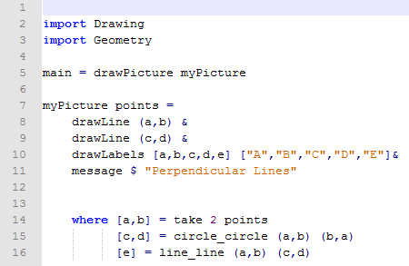

***Lesson 5 Ending Exercises:***

***Exercise:*** *Manipulate yourname_lesson5c.hs to draw another line HI parallel to line AB and display the message “Parallel Lines.” Your display should have three parallel lines and one perpendicular line.*

*Save the program as yourname_lesson5d.hs*

*Run the program to check your answer.*

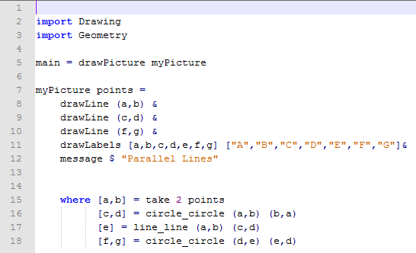

***Exercise:*** *Manipulate yourname_lesson5d.hs to remove the perpendicular line and labels of the perpendicular line from the display.*

*Save the program as yourname_lesson5e.hs*

*Run the program to check your answer.*

