**Lesson 6: Perimeter & Area**

*All exercises should be opened in the editor and ran in the terminal as stated in the introduction.

**Lesson 6:**

Questions:

What function(s) could we use to help us create a program to calculate the perimeter of a figure?

dist

***Exercise:*** *Using lesson1f.hs in the editor, create a program to draw a triangle using three points. The program should also show the lengths of the three sides and show the perimeter of the triangle.*

*Save the program as yourname_lesson6a.hs*

*Run the program to check.*

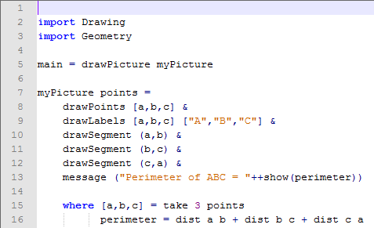

***Exercise:*** *Manipulate the above program for a four sided figure and only display the perimeter as a message.*

*Note: Instead of using* take 4 points*, use the function* quadrilateral points*.*

*Save the program as yourname_lesson6b.hs*

*Run the program to check.*

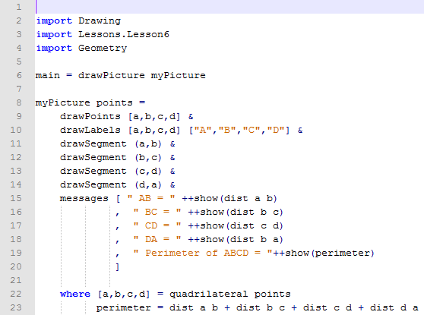

Note to Teacher: We have to use a quadrilateral function. If we were to take four random points like we did in the program with the triangle, we may not always have a quadrilateral as seen below. The quadrilateral function allows four random points to be chosen and following certain criteria it will rename the points, if necessary, to form a quadrilateral. In the case below if the quadrilateral function would have been used, it would have switched the points B and C.

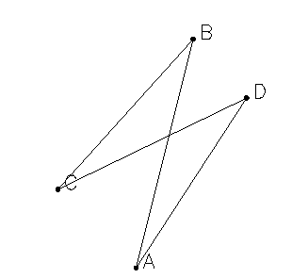It is at your discretion whether to discuss this with your students.

***Lesson 6 Ending Exercises:***

Note to Teacher: You are going to want to discuss that the triangle is drawn with a specified height and width. The students should only focus on calculating the area with the lengths of the sides, not the actual numerical value that is displayed on line 22.

***Exercise:*** *Open lesson6c.hs to calculate the area of a triangle. Show the area as a message.*

*Save the program as yourname_lesson6c.hs*

*Run the program to check.*

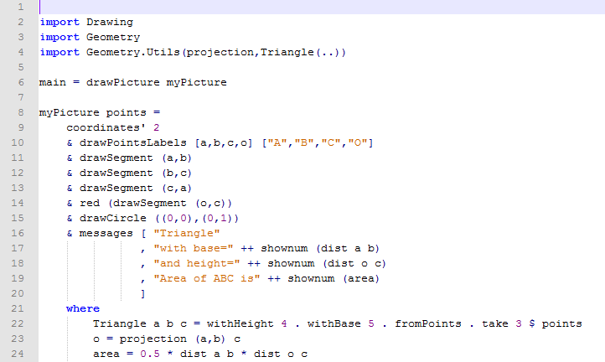

***Lesson 6 Further Applications:***

*Teachers you can easily extend this lesson through letting the students use program they just manipulated in lesson6d.hs to calculate the area of triangles with different a different height and base.*

*This could also be used as a tool for students to calculate area in a different method.*