**Lesson 7: Equilateral Triangle**

*All exercises should be opened in the editor and ran in the terminal as stated in the introduction.

**Lesson 7:** Open the editor and open lesson7a.hs. Look at the code carefully.

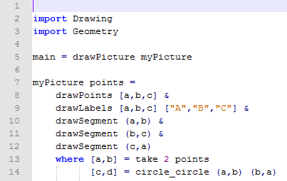

***Exercise:*** *Determine what the program will draw.*

*Run the program to check.*

Questions:

1. What shape did the program create?

Equilateral Triangle

1. How is point c computed in the program?

C is computed by the intersection of circle A with B on the circle and circle B with A on the circle.

1. Why is the list [c,d] assigned to circle_circle (a,b) (b,a) ?

The circles will intersect in two places.

1. Why is d not shown when you run the program?

We choose to only show c. It is also not listed in the drawPoints or drawLabels functions.

***Lesson 7 Ending Exercises***

***Exercise:*** *Manipulate the program lesson7a.hs to draw a picture with the characteristics of the one below:*

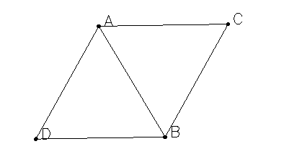

*Save the program as yourname_lesson7b.hs*

*Run the program to check.*

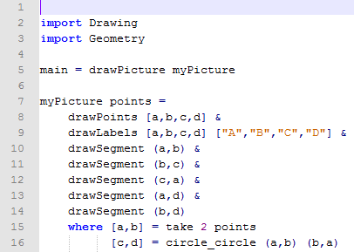

***Exercise:*** *Manipulate the program lesson7b.hs to draw a picture with the characteristics of the one below:*

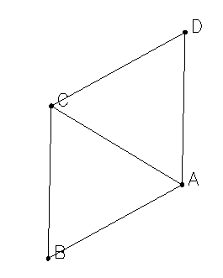

*Save the program as yourname_lesson7c.hs*

*Run the program to check.*

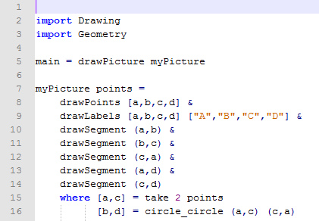

***Exercise:*** *Manipulate the program lesson7a.hs to draw a picture with the characteristics of the one below:*

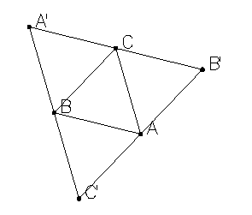

*Save the program as yourname_lesson7d.hs*

*Run the program to check.*

*Note to Teacher: The* find_apart *function is used to help students find a point that is not already part of the triangle.*

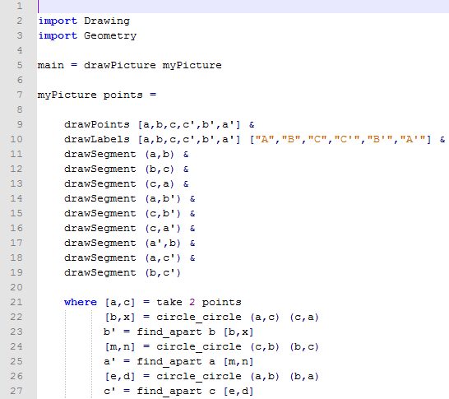

***Lesson 7 Further Applications:***

*You can create a mirror function within our program key_lesson7d.hs since the program is repetitive****.*** *(key_lesson7e.hs)*

**

*Run the program to check.*

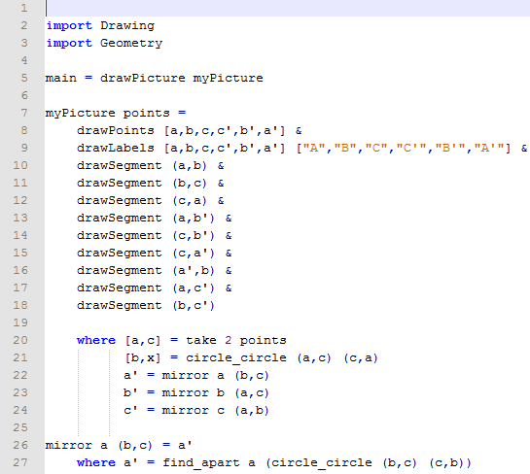

***Lesson 7: Further Applications:***

*You can also consider choosing points a and b specifically so that we can find point c or the height. Example shown in key_lesson7N.hs*

