**Lesson 8: Transformations**

*All exercises should be opened in the editor and ran in the terminal as stated in the introduction.

**Lesson 8 Part 1:** Open the editor and then open lesson8a.hs. Look at the code and write down what you understand in the code. Run the code.

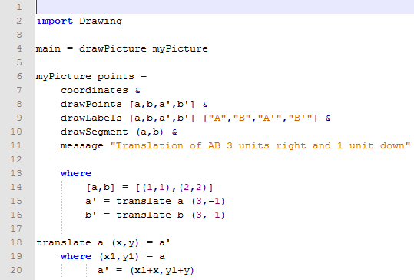

The teacher should then briefly describe the following characteristics of the code (refer to reference sheet):

translate

Questions:

1. What function makes the points move?

translate

1. Why in the translate function is a’ written as (x1+x,y1+y)?

When you translate points, you add/subtract from the original point.

***Exercise:*** *Manipulate the program lesson8a.hs to draw segment between the translated points.*

*Save the program as yourname_lesson8b.hs*

*Run the program to check.*

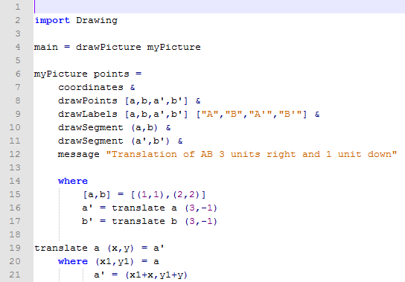

***Exercise:*** *Manipulate the program lesson8b.hs to translate a quadrilateral 2 units right and 5 units up. The quadrilateral should be made of points (0,0), (3,0), (3,3),(0,3).*

*Save the program as yourname_lesson8c.hs*

*Run the program to check.*

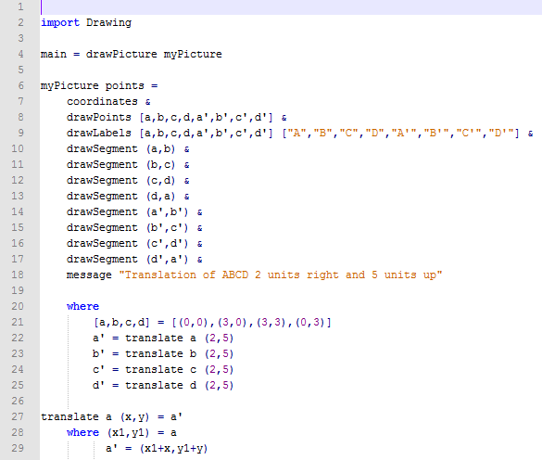

**Lesson 8 Part 2:** Open the editor and then open lesson8d.hs

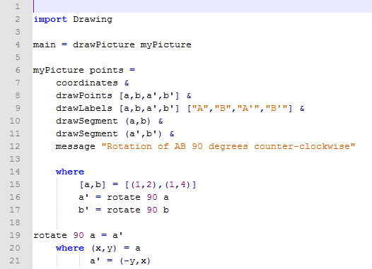

***Exercise:*** *Determine what the program will draw.*

*Run the program to check.*

The teacher should then briefly describe the following characteristics of the code (refer to reference sheet):

Rotate

Question:

1. Why is a’ = (-y,x)?

When you rotate 90 degrees counter-clockwise, the x and y switch and the new x value becomes opposite.

1. What would happen if you rotate (9,8) 180 degrees counter-clockwise?

The x and y would both become opposite. (-9,-8)

***Exercise:*** *Manipulate the program lesson8d.hs that will rotate a quadrilateral 90, 180, or 270 degrees. The program should have all three functions at the bottom. Write this specific program to rotate the quadrilateral (1,1), (1,4), (4,4), (4,1) 180 degrees counter-clockwise.*

*Save the program as yourname_lesson8e.hs*

*Run the program to check.*

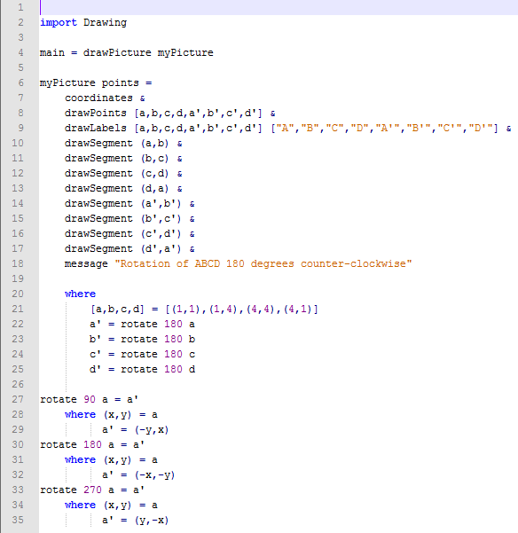

**Lesson 8 Part 3:** Open the editor and then open lesson8f.hs.

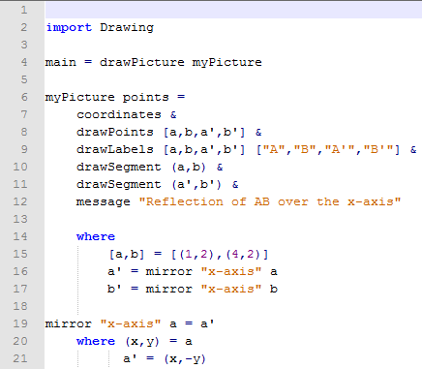

Questions:

1. Why is the function mirrors used as a transformation of reflection?

A reflection is a mirrored image.

1. Why is a’ = (x, -y)?

A reflection over the x-axis only changes the y value of the original point.

***Exercise:*** *Determine what the program will draw.*

*Run the program to check.*

The teacher should then briefly describe the following characteristics of the code (refer to reference sheet):

mirror

***Exercise:*** *Manipulate the program lesson8f.hs to reflect triangle (1,2),(4,2),(3,3) over the x-axis.*

*Save the program as yourname_lesson8g.hs*

*Run the program to check your answer.*

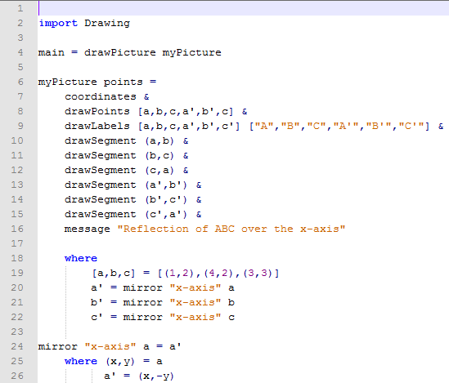

***Exercise:*** *Manipulate the program lesson8g.hs that could reflect a quadrilateral over the x or y axis. Both mirrors functions should be listed at the bottom of the program. For this specific program reflect the quadrilateral (1,2), (1,4), (3,4), (3,2) over the y-axis.*

*Save the program as yourname_lesson8h.hs*

*Run the program to check your answer.*

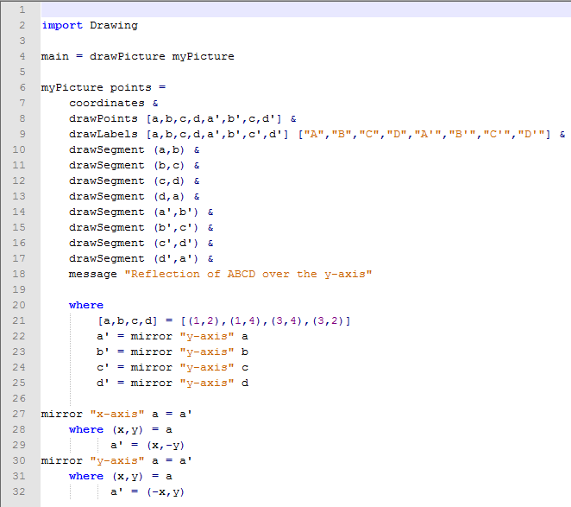

***Lesson 8 Ending Exercises:***

***Exercise:***

*Question: How can we draw a random triangle in a program?*

*Manipulate yourname_lesson8g.hs to reflect a random triangle over the x-axis.*

*Save the program as yourname_lesson8i.hs.*

*Run the Program to check your answer.*

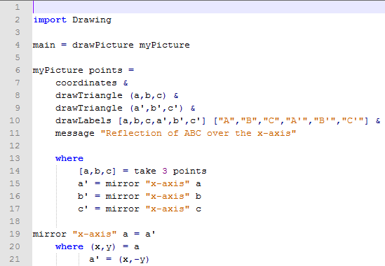

***Exercise:***

*Question: How do we perform a dilation on a figure?*

*Manipulate yourname_lesson8g.hs to dilate the triangle by a scale factor of 2 rather than reflect the triangle.*

*Save the program as yourname_lesson8j.hs*

*Run the program to check your answer.*

