MEDTRUST Hospital Appointment Booking System

# 1. Introduction

Welcome to the MEDTRUST Hospital Appointment Booking System. This Golang-based web application enables hospital staff to manage appointments, patients, and invoices efficiently. Built with scalability in mind, the system features a responsive UI, AJAX-driven updates, and dynamic modal-based forms for all major operations.

# 2. System Structure (Domain Driven Design)

The application follows Domain Driven Design (DDD), promoting modularity and testability.

Modules include:

• Domain - Core business logic  
• Exec - Parameterized query definitions  
• Entities - Data structures  
• Connection Manager - Redis/MongoDB connection pooling

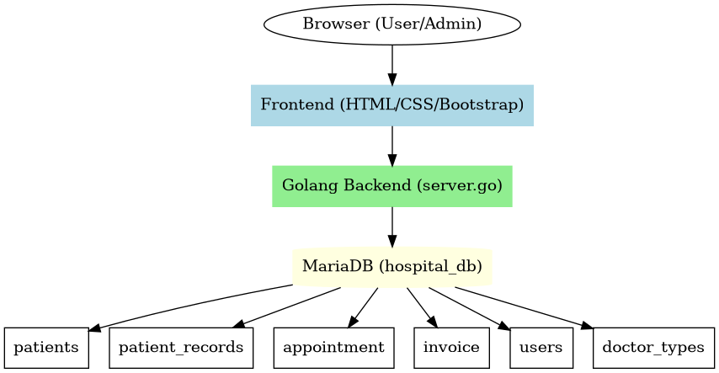

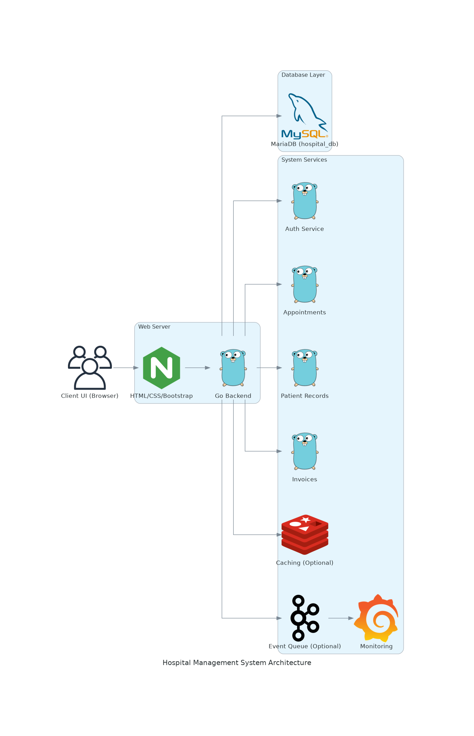

Entity Relationship Diagram:  
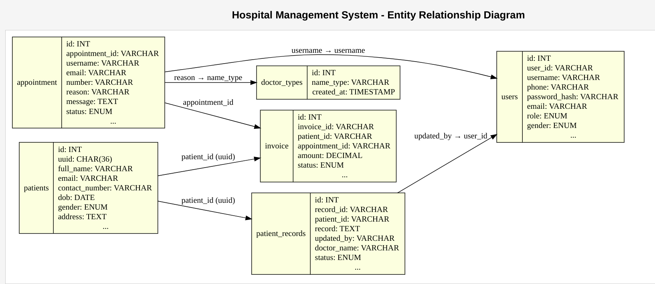

# 3. User Interface

The UI uses Bootstrap for styling and AJAX for dynamic updates. Key interactions open in modal dialogs, and success/failure is indicated with popups (green for success, red for failure) after form submission and page reload.

# 4. Functionalities and User Actions

## 4.1 Create an Account

Users can create an account by clicking the 'Register' button. Required fields include full name, email, password, and role (admin or staff). On submission, the form appears in a modal popup. A success message appears in green upon successful creation. Otherwise, an error is shown in red and the modal reloads.

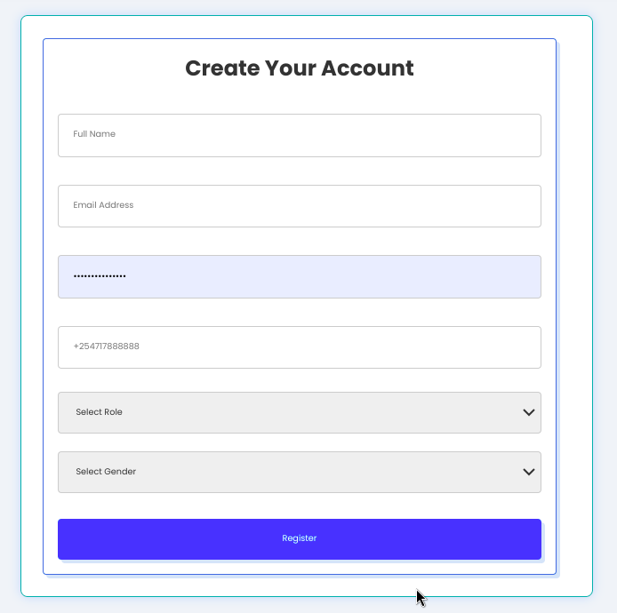

## 4.2 Login

Staff and admins log in using email and password. Session management is handled via cookies or Redis. On success, the user is redirected to the dashboard. Errors are shown in red.

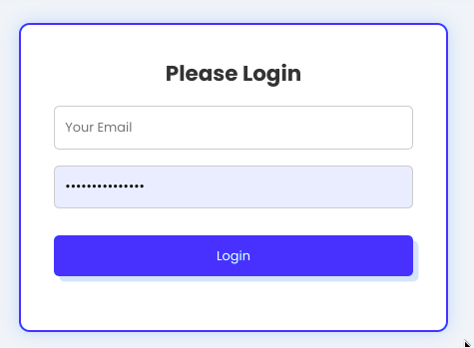

## 4.3 Create Appointment

Click 'New Appointment' to open a modal form. Select an existing patient, doctor type, date, and time. The system checks for time conflicts via AJAX. A green popup confirms success.

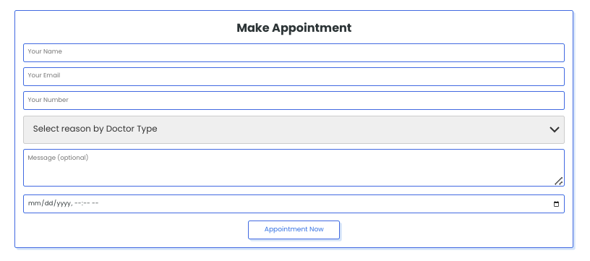

## 4.4 Reschedule Appointment

Click 'Reschedule' on any appointment listing to open the edit modal. Change date/time and submit. A popup confirms update and the list refreshes.

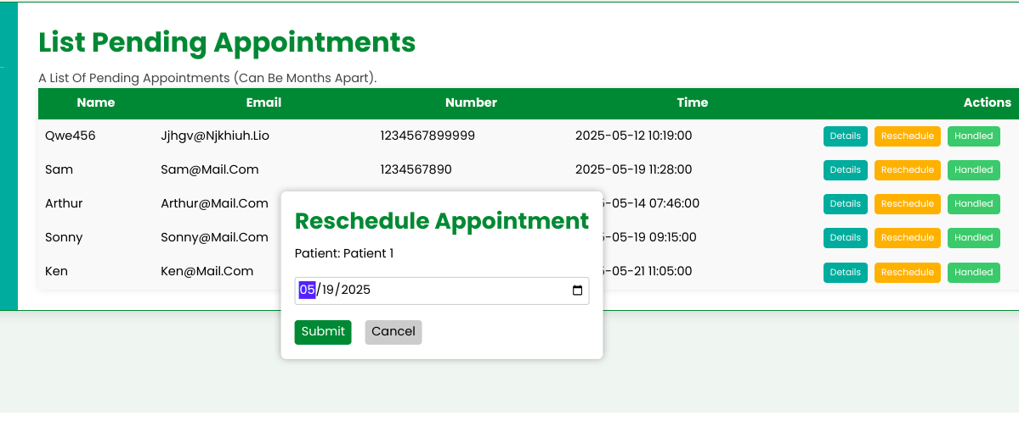

## 4.5 Create Patient

Click 'Add Patient' to open a modal. Fill in details like name, age, gender, history, and contact info. On successful creation, a green success message appears and the patient list refreshes.

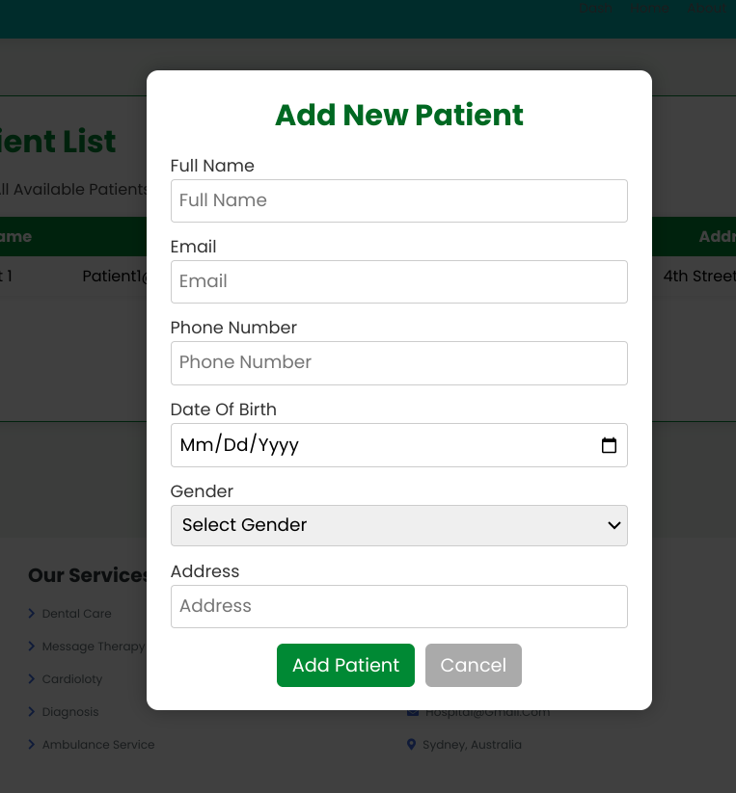

## 4.6 List Patients

The 'Patients' section displays a searchable list of all patients. You can search by name, contact, or ID. Clicking 'View' shows the patient’s records.

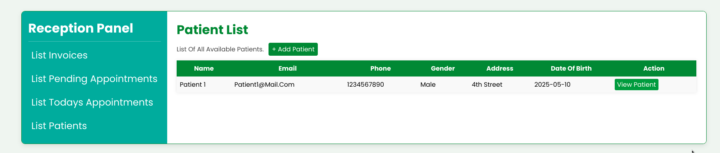

## 4.7 Create Patient Record

From a patient profile, click 'Add Record' to open a modal. You can add diagnosis, notes, or treatment plans. Submission shows a green success popup.

[Yet To create this functionality]

## 4.8 Update Patient Record

Patient records can be updated by doctors via the same modal interface. Edit any details and submit to save. Feedback is shown via popup and list reloads.

[Yet To create this functionality]

## 4.9 Create Invoice

Click 'New Invoice' from the patient or appointment view. Enter services and costs. A modal form is used, and a green popup confirms the invoice was created.

[Yet To create this functionality]

## 4.10 List Invoices

Navigate to the 'Invoices' section to view and manage all invoices. Filter by patient or status (paid/unpaid).

[Yet To create this functionality]

## 4.11 Mark Invoice as Paid

Click 'Mark as Paid' on any invoice. The status updates immediately, and a green popup confirms success.

[Yet To create this functionality]

## 4.12 Mark Appointment as Handled or Canceled

From the appointments list, click 'Mark as Handled' or 'Cancel'. A confirmation modal appears. Submission gives feedback via popup.

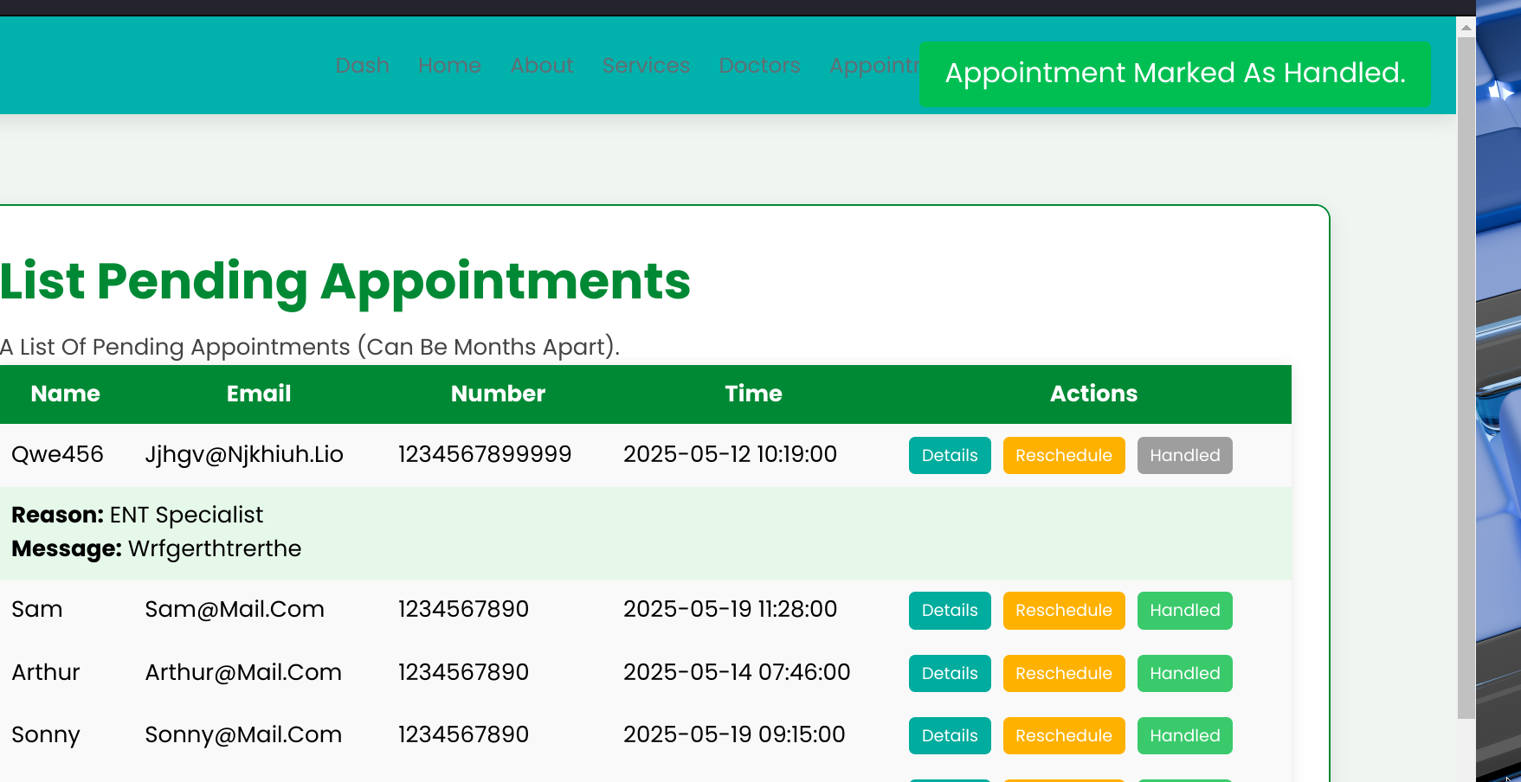

# 5. Deployment & Support

Ensure the following before deployment:

• Golang installed  
• MySQL, Redis, and MongoDB configured  
• SSL enabled  
• Static file caching  
• Logging and backup scripts  
• Email/SMS service integration

For support: Email support@medtrusthospital.org