Rmarkdown.demo

qxs

August 26, 2017

# This is my first **Rmarkdown**

library(datasets)  
data(iris)  
summary(iris)

## Sepal.Length Sepal.Width Petal.Length Petal.Width   
## Min. :4.300 Min. :2.000 Min. :1.000 Min. :0.100   
## 1st Qu.:5.100 1st Qu.:2.800 1st Qu.:1.600 1st Qu.:0.300   
## Median :5.800 Median :3.000 Median :4.350 Median :1.300   
## Mean :5.843 Mean :3.057 Mean :3.758 Mean :1.199   
## 3rd Qu.:6.400 3rd Qu.:3.300 3rd Qu.:5.100 3rd Qu.:1.800   
## Max. :7.900 Max. :4.400 Max. :6.900 Max. :2.500   
## Species   
## setosa :50   
## versicolor:50   
## virginica :50   
##   
##   
##

hist(iris$Sepal.Length)

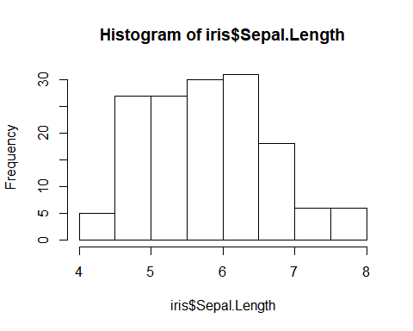 # Now I have another plot

plot(iris)

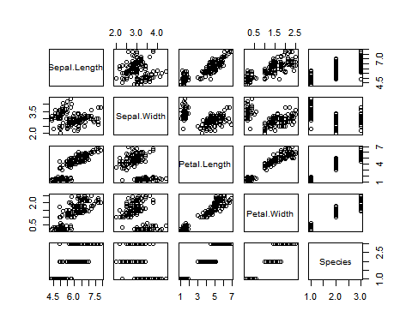

superscript2