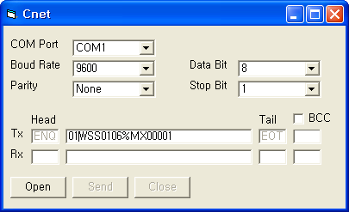
Example)
1. Built-in RS-232C Cable connection
PC : K120S PLC
2 : 7
3 : 4
5 : 5

2. Visual basic sample program from PC
01WSS0106MX00001
1. 01 : station number
2. WSS :write command
3. 01 : the number of block
4. 06 : Device length
5. MX000 : M0000 device range
6. 01: M0000 is On signal

If M0000 = 1, motor is started.
=> Tx format of PC is 01WSS0106%MX00001

If M0000 = 0, motor is stopped.
=> Tx format of PC is 01WSS0106%MX00000

3. Built-in RS-232C Parameter setting of K120S in KGLWIN.
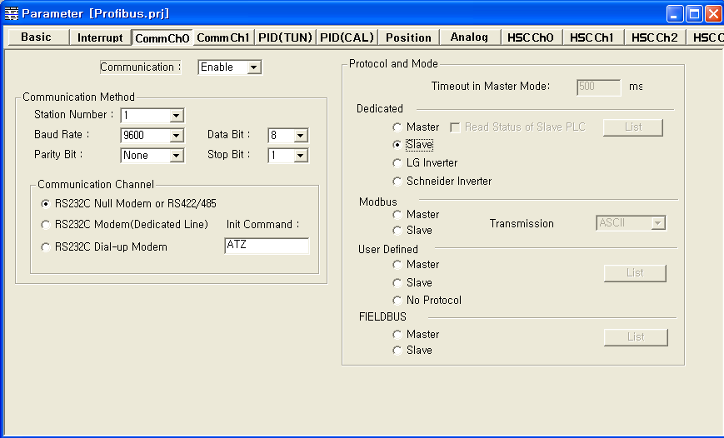

★ And you also have to set built-in positioning parameter and write the program for positioning.

