CARD Processing API

# **Objective**

The objective of this API is to post the new card details and get the card details from the in-memory database

# **API SPECIFICATION**

API context path - /cardapi/v1

Methods - POST and get

Input message type - application json

Output message type - application json

Authentication - none – any authentication can be enabled based on the api gateway used

Possible HTTP Status Code - 200,400,500,404

# **Input sample**

{

"cardNumber":"1556954993914435",

"name":"kamafffddddd",

"limit": 1234

}

# **Output sample**

{

"apiStatusCode": "200",

"apiStatusMessage": "Card Added Successfully"

}

# **High level diagram**

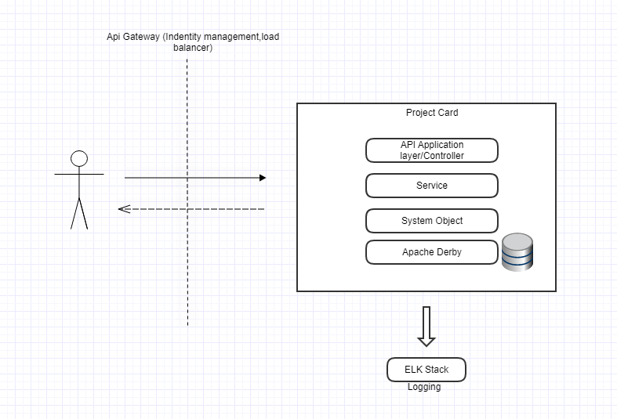

* This API perform two operations. POST and GET.
* POST request adds the new card details to the database. It validates the incoming data specially on credit card number. It performs the length check and also lunh10 algorithm is implemented to check the card number validation.
* The GET function retrieves all the data in the database.

# **Technology/Frameworks Used:**

* Java 8
* Spring Boot framework (Version – 2.4.5)
* Apache derby (InMemory database)
* Docker (Version 20.10.6) / Docker Hub
* Junit (Version 4.12)
* Maven (Version 3.5.4)
* HTTP Rest standards on endpoints
* Luhn 10 Algorithm Used
* GitHub

# **Deployment Strategy:**

# Git Branching strategy

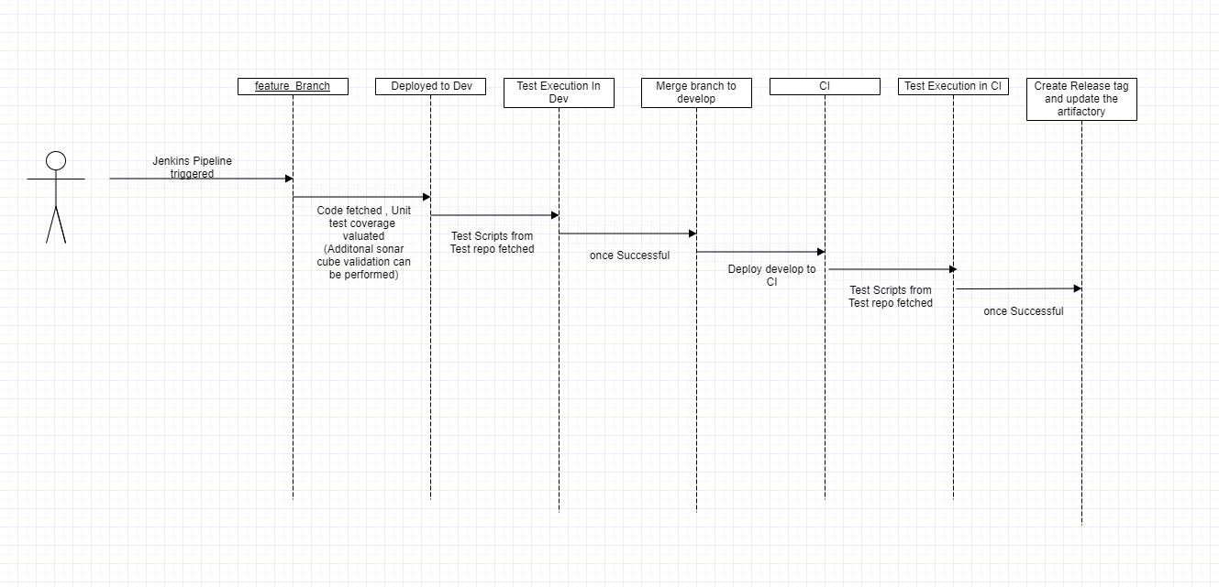

# Using Docker and Kubernetes

