**HTML TO SERVLET COMMUNICATION**

**PROGRAM CODING:**

**CLIENT CODING:**

<!DOCTYPE html>

<html>

<head>

<title>Html to Servlet Communication</title>

<style>

.HTML_Form

{

font-size: 120%;

}

input

{

font-size: 100%;

text-align: center;

}

</style>

</head>

<body bgcolor="gold">

<center>

<form method ="get" action="http://localhost:8080/pk1/index">

<center><h1>Please provide the following details</h1></center>

<div class="HTML_Form"><center><table>

<tr>

<td>Name</td>

<td><input type="text" name="name"></td>

</tr>

<tr>

<td> Place </td>

<td><input type="text" name="place"></td>

</tr>

<tr>

<td> District </td>

<td><input type="text" name="district"></td>

</tr>

<tr>

<td> State</td>

<td><input type="text" name="state"></td>

</tr>

</table></center><br><br>

<input type="submit" name="submit" value="Submit">

</div>

</form>

</center>

</body>

</html>

**SERVER CODING:**

import java.io.*;

import javax.servlet.*;

import javax.servlet.annotation.WebServlet;

import javax.servlet.http.*;

@WebServlet(name="/index",urlPatterns={"/index"})

public class index extends HttpServlet{

public void doGet(HttpServletRequest request,HttpServletResponse response)

throws ServletException, IOException {

response.setContentType("text/html");

PrintWriter Out= response.getWriter();

String Name= request.getParameter("name");

String Place =request.getParameter("place");

String District=request.getParameter("district");

String State=request.getParameter("state");

Out.println("<html>");

Out.println("<head><title>");

Out.println("First Servlet Program</title>");

Out.println("</head>");

Out.println("<body bgcolor=magenta style=text-size:120%>");

Out.println("<center><h1>Welcome "+Name+"!!</h1><br>");

Out.println("<h2>You are from "+Place);

Out.println("<br>Which is in "+District);

Out.println("<br>District of "+State);

Out.println("<br>Glad to meet you </h2></center>");

Out.println("</body>");

Out.println("</html>");

}

}

**OUTPUT:**

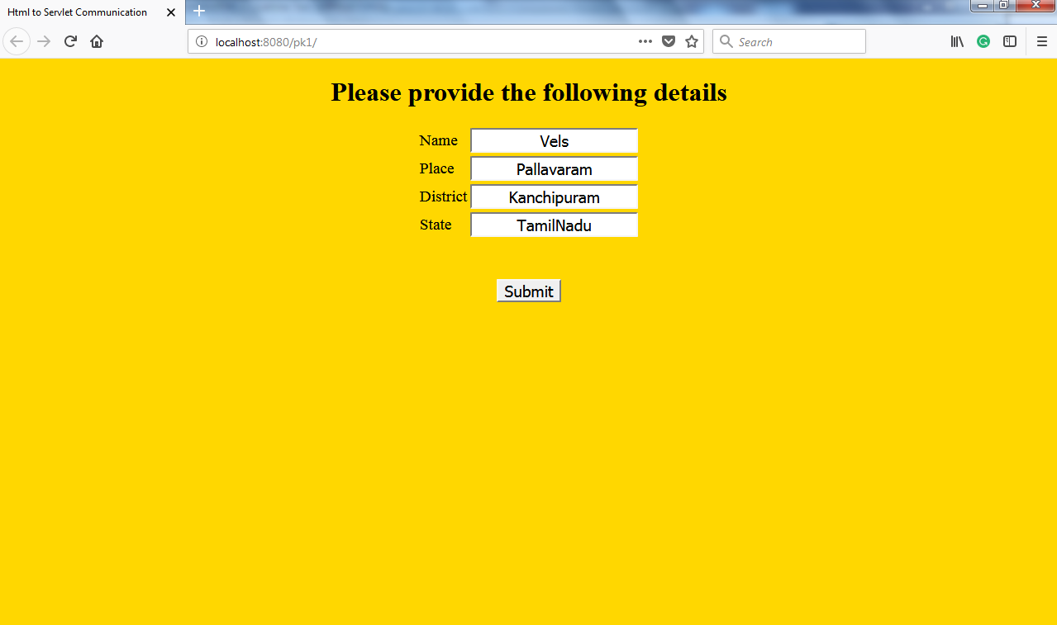

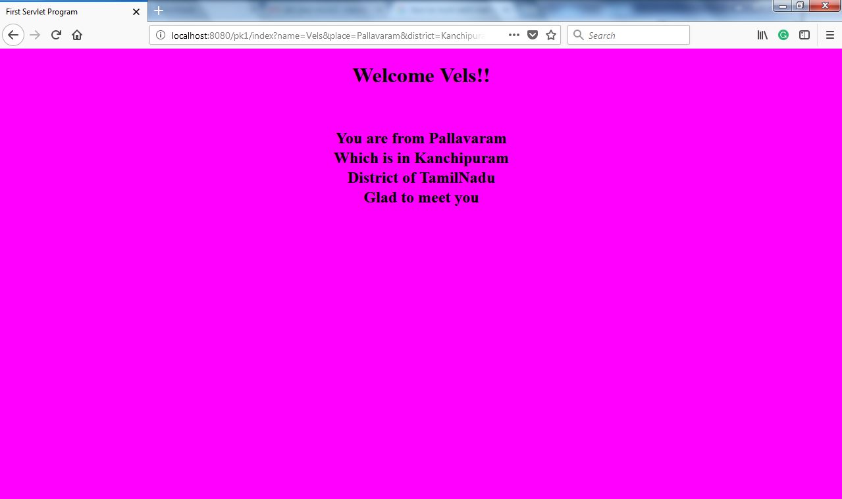

**FORM PROCESSING USING SERVLET**

**PROGRAM CODING:**

**CLIENT CODING:**

<html>

<head>

<title>Customer Survey</title>

<style>

.Survey_form

{

font-size: 120%;

}

</style>

</head>

<body bgcolor="red">

<form method="post" Action="http://localhost:8080/pk2/index">

<center><h1>Customer Information</h1></center>

<center>

<table class="Survey_form">

<tr>

<td>

<b>Name:</b></td>

<td>

<input type="text" Name="name"></td>

</tr><br>

<tr>

<td>

<b>Email-id:</b></td>

<td>

<input type="text" Name="email"></td>

</tr><br>

<tr>

<td>

<b>Age:</b></td>

<td>

<input type="radio" Name="age" value="18">less than 18<br>

<input type="radio" Name="age" value="18-25">18-26<br>

<input type="radio" Name="age" value="26-40">26-40<br>

<input type="radio" Name="age" value="40">more than 40<br>

</td>

</tr><br>

<tr>

<td>

<b>Operating System</b></td>

<td>

<select name="os" Multiple>

<option>Windows 98</option>

<option>Linux</option>

<option>Windows Vista</option>

<option>Window 7</option>

</select></td>

</tr><br>

<tr>

<td></td>

<td><input type="checkbox" Name="more" value="yes">

<u>send me more information</u></td>

</tr><br>

<tr>

<td><b>Comments:</b></td>

<td><textarea name="comments"></textarea></td>

</tr><br>

<tr><td></td>

<td>

<input type="reset" value="Clear field">

<input type="submit" Value="Proceed data"></td>

</tr>

</table>

</center>

</form>

</body>

</html>

**SERVER CODING:**

import java.io.IOException;

import java.io.PrintWriter;

import javax.servlet.ServletException;

import javax.servlet.annotation.WebServlet;

import javax.servlet.http.HttpServlet;

import javax.servlet.http.HttpServletRequest;

import javax.servlet.http.HttpServletResponse;

@WebServlet(urlPatterns = {"/index"})

public class index extends HttpServlet {

protected void service(HttpServletRequest request, HttpServletResponse response)

throws ServletException, IOException {

String name,email,more,age,comments;

response.setContentType("text/html");

PrintWriter out = response.getWriter();

out.println("<html>");

out.println("<head><title>");

out.println("survey confirmation");

out.println("</title></head>");

name=request.getParameter("name");

email=request.getParameter("email");

age=request.getParameter("age");

String value[]=request.getParameterValues("os");

more=request.getParameter("more");

comments=request.getParameter("comments");

out.println("<body bgcolor=\"green\">");

out.println("<h1><center>");

out.println("<font color=\"black\">");

out.println("<u>Congratulations "+name+"!!!</u></font></h1>");

out.println("<center>Your Survey Successfully Processed</center>");

out.println("<center><h1>");

out.println("<hr><br>");

out.println("<tr><align=\"right\"><b>EMail-id:</b></td>");

out.println("<td colspan=2 align=\"left\">");

out.println(""+email+"</td></tr><br>");

out.println("<tr><align=\"right\"><b>Age:</b></td>");

out.println("<td colspan=2 align=\"left\">");

out.println(""+age+"</td></tr><br>");

out.println("<tr valign=\"top\">");

out.println("<td align=\"right\"><b>Operating System:</b></td>");

out.println("<td colspan=2 align=\"left\">");

if(value!=null)

{

for(int i=0;i<value.length;i++)

{

if(i>0)

{

out.println("<b>");

}

out.println(""+value[i]);

}

}

out.println("</td></tr><br>");

out.println("<tr><td align=\"right\"><b>More information:</b></td>");

out.println("<td colspan=2 align=\"left\">");

out.println(""+more+"</td></tr><br>");

out.println("<tr><td align=\"right\"><b>Comments:</b></td>");

out.println("<td colspan=2 align=\"left\">");

out.println(""+comments+"</td></tr></h1><br>");

out.println("</table>");

out.println("</body>");

out.println("</html>");

}

}

**OUTPUT:**

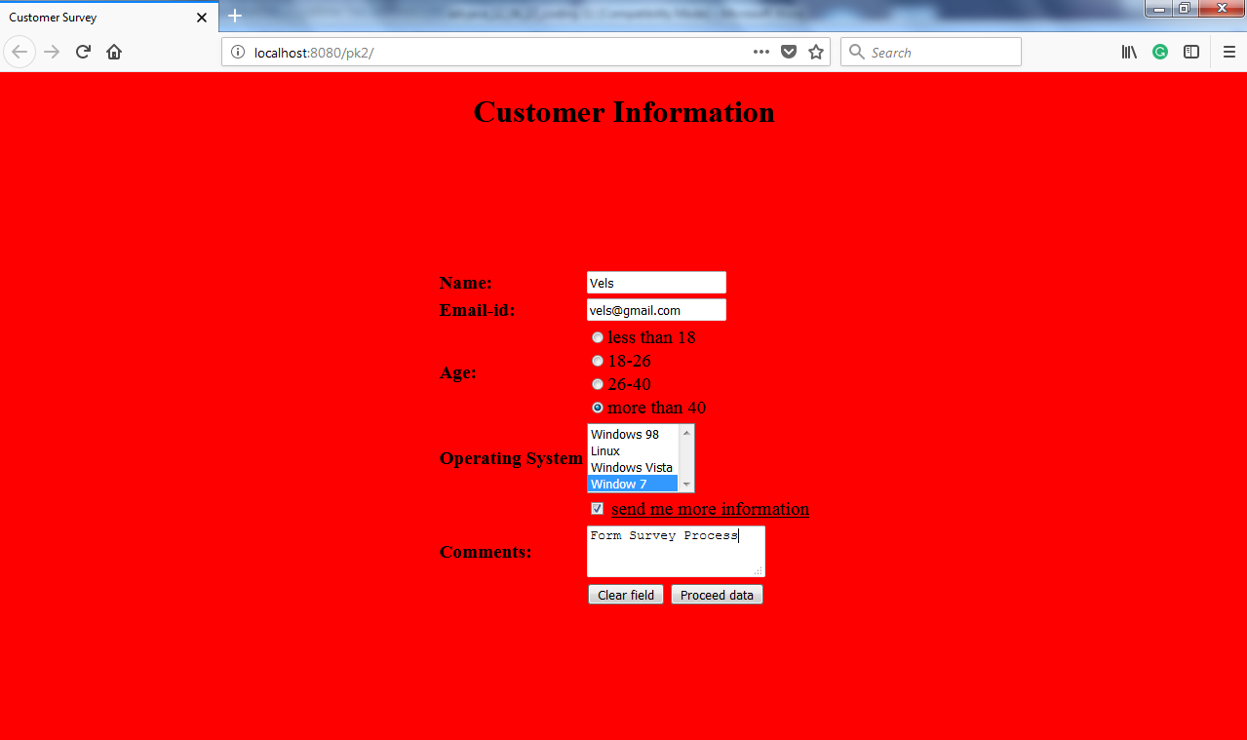

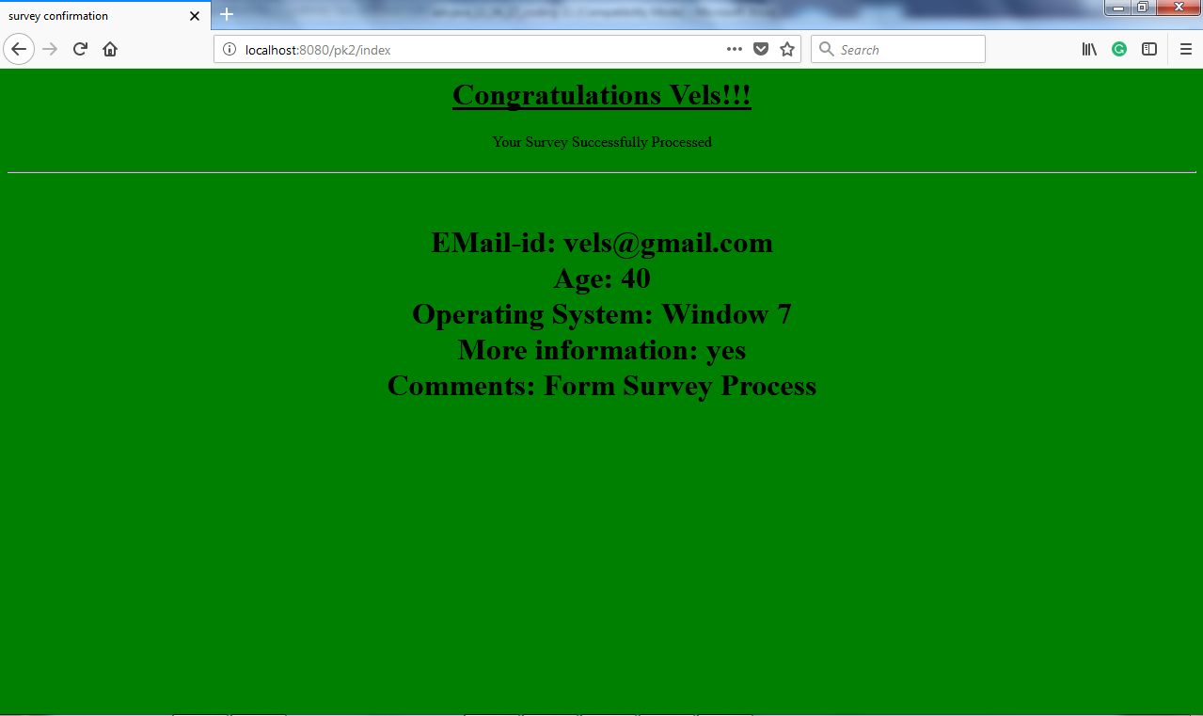

**SERVLET TO APPLET COMMUNICATION**

**PROGRAM CODING:**

**SERVLET CODING:**

import java.io.*;

import javax.servlet.*;

import javax.servlet.annotation.WebServlet;

import javax.servlet.http.*;

@WebServlet(name = "servexamp", urlPatterns = {"/servexamp"})

public class servexamp extends HttpServlet

{

public void service(HttpServletRequest request, HttpServletResponse response)

throws ServletException, IOException

{

ObjectOutputStream output=null;

try

{

output=new ObjectOutputStream(response.getOutputStream());

String str=new String("Enjoy Advanced Java Lab");

output.writeObject(str);

output.flush();

output.close();

}

catch(Exception e)

{

e.printStackTrace();

}

}

}

**APPLET CODING:**

Package Appprg;

import java.io.*;

import java.awt.*;

import java.net.*;

import java.applet.*;

public class Appprg extends Applet

{

URL url=null;

URLConnection servletConnection=null;

public void init()

{

try

{

url=new URL("http://localhost:8080/app/servletexamp");

servletConnection=url.openConnection();

servletConnection.setDoInput(true);

servletConnection.setDoOutput(true);

servletConnection.setUseCaches(false);

servletConnection.setDefaultUseCaches(false);

}

catch (Exception e)

{

e.printStackTrace();

}

}

public void paint(Graphics g)

{

try

{

ObjectInputStream input=new ObjectInputStream(servletConnection.getInputStream());

g.setColor(Color.red);

g.drawString("Applet Servlet Communication",50,50);

g.setColor(Color.blue);

String str=(String)input.readObject();

g.drawString("message is:"+str,20,100);

input.close();

}

catch(Exception e)

{

e.printStackTrace();

}

} }

**OUTPUT:**

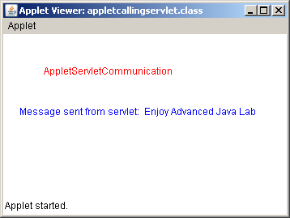

**DATABASE RETRIEVAL USING MS ACCESS**

**PROGRAM CODING:**

**SERVLET CODING:**

import java.io.*;

import java.sql.*;

import javax.servlet.*;

import javax.servlet.annotation.WebServlet;

import javax.servlet.http.*;

@WebServlet(name = "jdbcpgm", urlPatterns = {"/jdbcpgm"})

public class jdbcpgm extends HttpServlet {

public void service(HttpServletRequest request, HttpServletResponse response)

throws ServletException, IOException {

response.setContentType("text/html");

PrintWriter out = response.getWriter();

Connection con;

Statement st=null;

try {

Class.forName("sun.jdbc.odbc.JdbcOdbcDriver");

con=DriverManager.getConnection("jdbc:odbc:ites");

st=con.createStatement();

ResultSet rs;

String q="select * from emp1";

rs=st.executeQuery(q);

out.println("<html>");

out.println("<head>");

out.println("<title>Table Access</title>");

out.println("</head>");

out.println("<body bgcolor=\"green\">");

out.println("<center><h1>Database Retrieval Using MS-Access</h1></center>");

out.println("<hr size=\"5\" color=\"black\">");

out.println("<center><table border=\"1\">");

out.println("<tr><th>Employee name</th><th>Employee ID</th><th>Salary</th></tr>");

while(rs.next())

{

out.println("<tr><td>"+rs.getString("ename")+"</td>");

out.println("<td>"+rs.getString("dept")+"</td>");

out.println("<td>"+rs.getInt("salary")+"</td></tr>");

}

out.println("</table>");

st.close();

con.close();

out.println("</body></html>");

}

catch(ClassNotFoundException e)

{

out.println("Driver Loading Problem"+e);

}

catch(SQLException e)

{

out.println("SQL Error"+e);

}

}

}

**OUTPUT:**

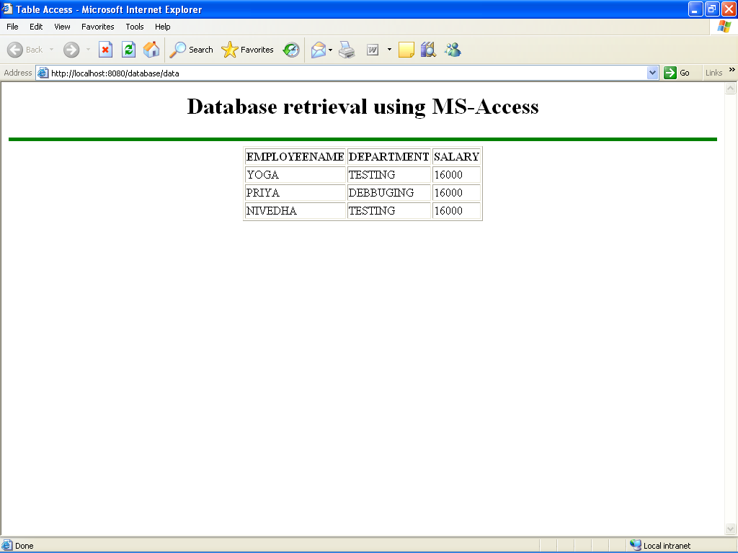**DATABASE RETRIEVAL THROUGH PREPARED STATEMENT**

**PROGRAM CODING:**

**SERVLET CODING:**

import java.io.*;

import java.sql.*;

import javax.servlet.*;

import javax.servlet.annotation.WebServlet;

import javax.servlet.http.*;

@WebServlet(name = "database", urlPatterns = {"/database"})

public class database extends HttpServlet {

public void service(HttpServletRequest request, HttpServletResponse response)

throws ServletException, IOException {

response.setContentType("text/html;");

PrintWriter out = response.getWriter();

try {

Connection con;

Class.forName("sun.jdbc.odbc.JdbcOdbcDriver");

con = DriverManager.getConnection("jdbc:odbc:dhana1");

PreparedStatement ps;

String sel;

sel = "select*from student1 where rollno=?";

ps = con.prepareStatement(sel);

ps.setInt(1,2);

ResultSet rs;

rs = ps.executeQuery();

out.println("<html>");

out.println("<head>");

out.println("<title>data retrieval using prepared statement</title>");

out.println("</head>");

out.println("<body bgcolor=\"grey\">");

out.println("<h1><center><font color=\"green\"> database retrived using prepared statement</font></center></h1>");

out.println("<hr size=\"5\" color=\"black\">");

while (rs.next()) {

out.println("<b>roll number:</b>" + rs.getInt("rollno") + "<br>");

out.println("<b>student name:</b>" + rs.getString("sname") + "<br>");

out.println("<b>student's address:</b>" + rs.getString("address") + "<br>");

}

out.println("</body></html>");

out.close();

con.close();

} catch (ClassNotFoundException e) {

out.println("connectionproblem" + e);

} catch (SQLException e) {

out.println("SQL Error" + e);

}

}

}

**OUTPUT:**

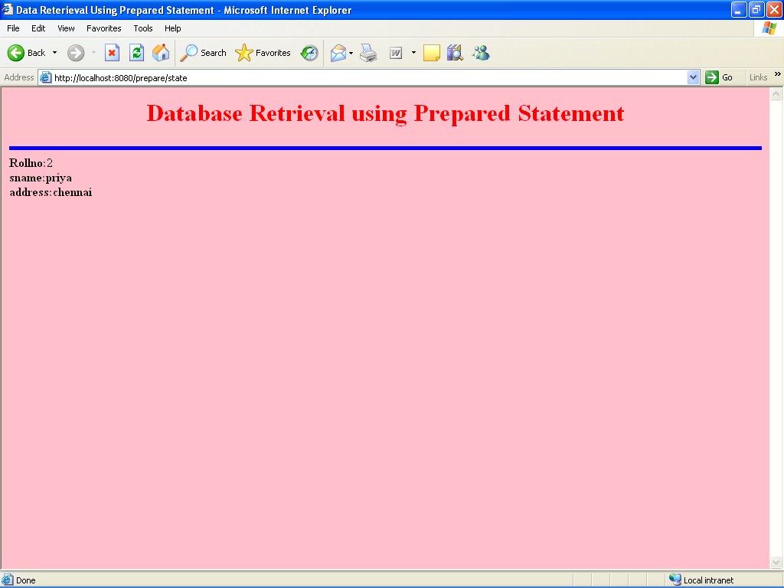

**DATABASE RETRIEVAL USING ORACLE**

**PROGRAM CODING:**

**SQL Command:**

create table stud_123(name varchar2(25),age number(3),address varchar2(50));

insert into stud_123 values(‘&name’, &age , ’&address’);

**SERVLET CODING:**

import java.io.*;

import javax.servlet.*;

import javax.servlet.annotation.WebServlet;

import javax.servlet.http.*;

@WebServlet(name = "jdbctable", urlPatterns = {"/jdbctable"})

public class jdbctable extends HttpServlet {

@Override

protected void service(HttpServletRequest request, HttpServletResponse response)

throws ServletException, IOException {

try

{

Class.forName("sun.jdbc.odbc.JdbcOdbcDriver").newInstance();

String url="jdbc:odbc:bsc";

Connection con=DriverManager.getConnection(url,"bsc","bsc");

response.setContentType("text/html");

PrintWriter out=response.getWriter();

Statement st=(Statement) con.createStatement();

ResultSet rs=st.executeQuery("select*from studu2");

out.println("<html>");

out.println("<head><title>");

out.println("Sample JDBC");

out.println("</title></head>");

out.println("<body bgcolor=\"#ff6765\">");

out.println("<font color=\"blue\">");

out.println("<h1><center>Data retrivel Using Oracle Database</center></h1>");

out.print("<center>");

out.print("<table border=\"1\"bgcolor=\"cyan\">");

out.print("<tr><th>");

out.print("Name");

out.print("</th>");

out.print("<th>");

out.print("Age");

out.print("</th>");

out.print("<th>");

out.print("Address");

out.print("</th>");

out.print("</tr>");

while(rs.next())

{

out.print("<tr><td>");

out.print(rs.getString("name"));

out.print("</td>");

out.print("<td>");

out.print(rs.getInt("age"));

out.print("</td>");

out.print("<td>");

out.print(rs.getString("address"));

out.print("</td>");

out.print("</tr>");

}

out.print("</table>");

out.print("</center>");

out.print("</font>");

out.print("</body>");

out.print("</html>");

}

catch(Exception e)

{

System.out.println("exception caught");

}

}

}

**OUTPUT:**

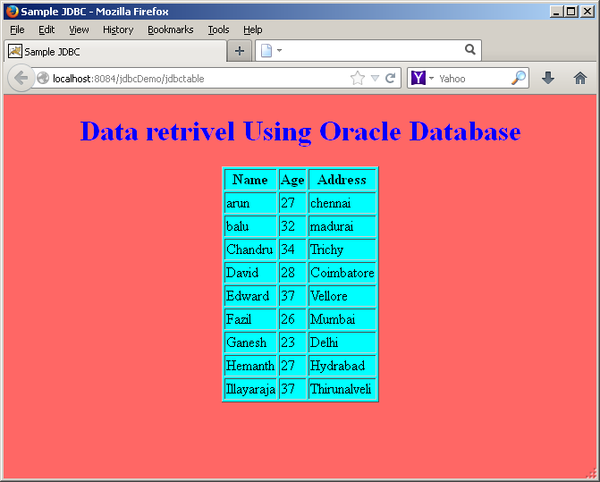

**CREATING WEB SERVICES WITH RMI**

**PROGRAM CODING:**

**MYINT1.java:**

import java.io.*;

import java.rmi.*;

public interface myint1 extends Remote

{

public String getName(int no)throws RemoteException;

}

**MYSERV1.java:**

import java.rmi.*;

import java.rmi.server.*;

public class myserv1 extends UnicastRemoteObject implements myint1

{

myserv1()throws RemoteException

{

super();

}

public String getName(int no)throws RemoteException

{

if(no==1)

{

return"staff";

}

else

{

return"students";

}

}

public static void main(String args[])

{

try

{

myserv1 m1=new myserv1();

Naming.rebind("bsc",m1);

System.out.println("Server reads");

}

catch(Exception e)

{

System.out.println("myserv1:"+e);

}

}

}

**CLIENT.JAVA:**

import java.io.*;

import java.rmi.*;

class client

{

public static void main(String args[])

{

try

{

DataInputStream din=new DataInputStream(System.in);

System.out.println("ENTER A NUMBER");

int x=Integer.parseInt(din.readLine());

myint1 n=(myint1)Naming.lookup("bsc");

System.out.println("value from server="+n.getName(x));

}

catch(Exception ex)

{

System.out.println("myclient:"+ex);

}

}

}

**OUTPUT:**

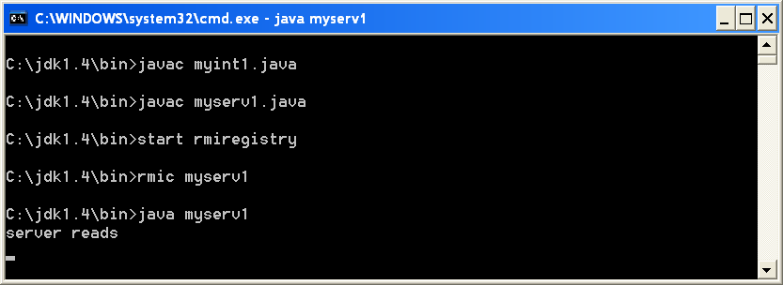

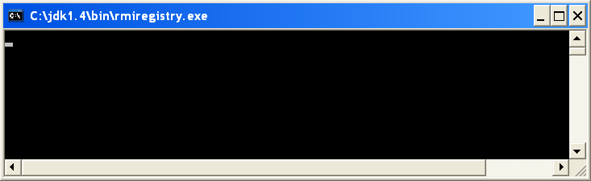

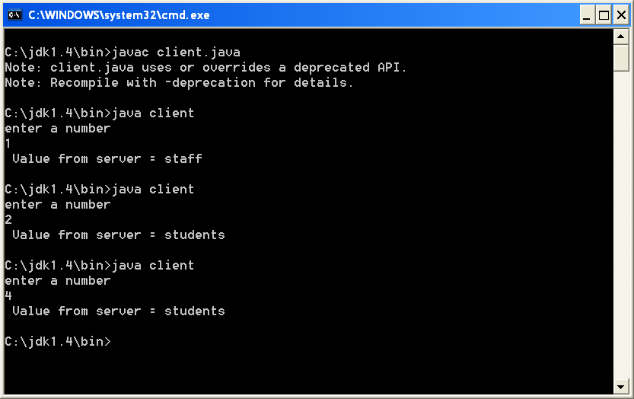

**BUILDING WEB APPLICATION USING JSP**

**PROGRAM CODING:**

**JSP CODING:**

<html>

<head>

<title>Web Application</title>

<style>

.Webapp

{

position:fixed;

top:50%;

left:50%;

transform:translate(-50%,-50%);

}

</style>

</head>

<body bgcolor="blue">

<div class="Webapp">

<center><h1>Welcome to Advanced Java Lab</h1></center>

</div>

</body>

</html>

**SERVER CODING:**

import java.io.*;

import javax.servlet.*;

import javax.servlet.http.*;

import javax.servlet.annotation.WebServlet;

@WebServlet(name = "index", urlPatterns = {"/index"})

public class index extends HttpServlet

{

public void doGet(HttpServletRequest request, HttpServletResponse response)

throws ServletException, IOException

{

RequestDispatcher dist=request.getRequestDispatcher("webapp.jsp");

dist.forward(request,response);

}

}

**OUTPUT:**

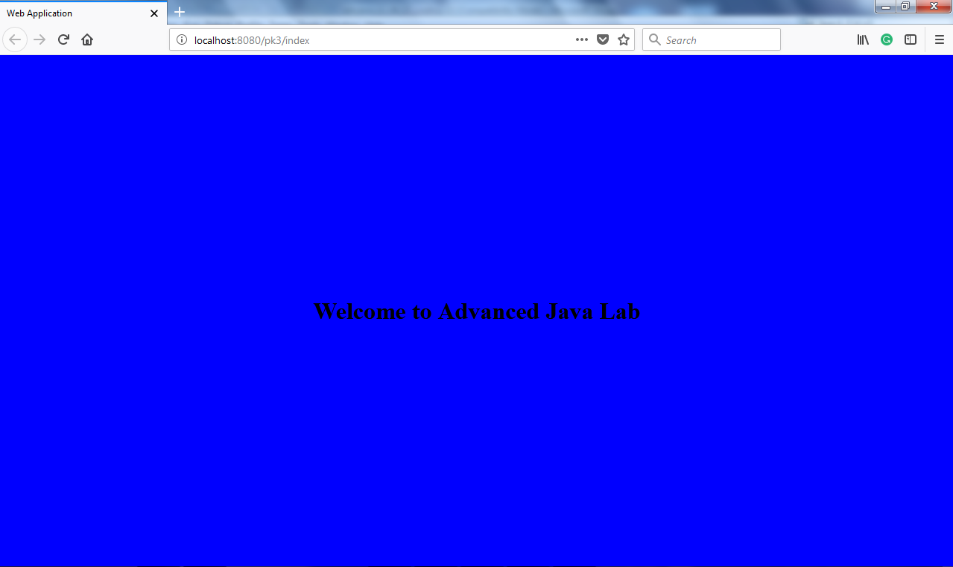

**ARITHMETIC CALCULATION USING JSP**

**PROGRAM CODING:**

**JSP CODING:**

<html>

<head>

<title>Arithmetic Calculations</title>

</head>

<body bgcolor="olive">

<br>

<h1><center>

<font color="red">

Mathematical Calculation Using Java Server Page</font></center></h1>

<br><br><font color="maroon">

<%

int operand1=35,operand2=20;

int sum,sum1;

sum=operand1+operand2;

sum1=operand1-operand2;

out.println("<center><h1>"+"The addition of "+operand1+" and "+ operand2 +" = "+sum+"</h1></center><br>");

out.println("<center><h1>"+"The subtraction of "+operand1+" and "+operand2+" = "+sum1+"</h1></center><br>");

%>

</body>

</html>

**OUTPUT:**

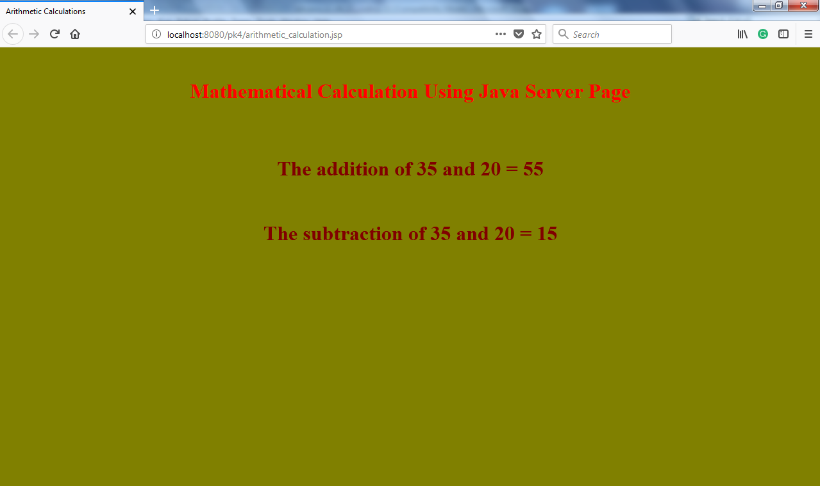

**DESIGNING ONLINE APPLICATION USING JSP**

**PROGRAM CODING:**

**HTML CODING :**

<html>

<head>

<title>ONLINE APPLICATION</title>

<style>

tr.break td{

height:10px;

}

</style>

</head>

<body bgcolor="darkgoldenrod">

<form method="post" action="Online_App.jsp">

<br><br>

<center><h1>Designing Online Application Using Jsp</h1></center>

<br>

<center>

<table>

<tr>

<td>

WHAT IS YOUR NAME?

</td>

<td>

<input type="text" name="uname">

</td>

</tr><tr class="break"><td colspan="2"></td></tr>

<tr>

<td>

WHAT IS YOUR MAIL-ID?

</td>

<td>

<input type="text" Name="mail">

</td>

</tr><tr class="break"><td colspan="2"></td></tr>

<tr>

<td>

WHAT IS YOUR AGE?

</td>

<td>

<input type="text" Name="age">

</td>

</table>

<br><br> <input type="submit" value="submit">

</center>

</form>

</body>

</html>

**JSP CODING:**

<html>

<head>

<title>JSP Application</title>

</head>

<body bgcolor="teal">

<font color="black">

<center><h1> My Details </h1></center>

<hr><br>

<%

out.println("<center><h2>Name: <b>"+ request.getParameter("uname")+"</b><br><br>");

out.println("Mail-id: <b>"+ request.getParameter("mail")+"</b><br><br>");

out.println("Age: <b>"+ request.getParameter("age")+"</b><br></h2></center><hr>");

%>

</body>

</html>

**OUTPUT:**

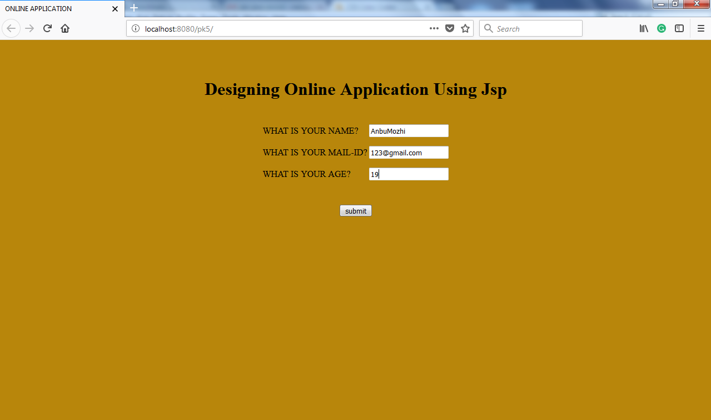

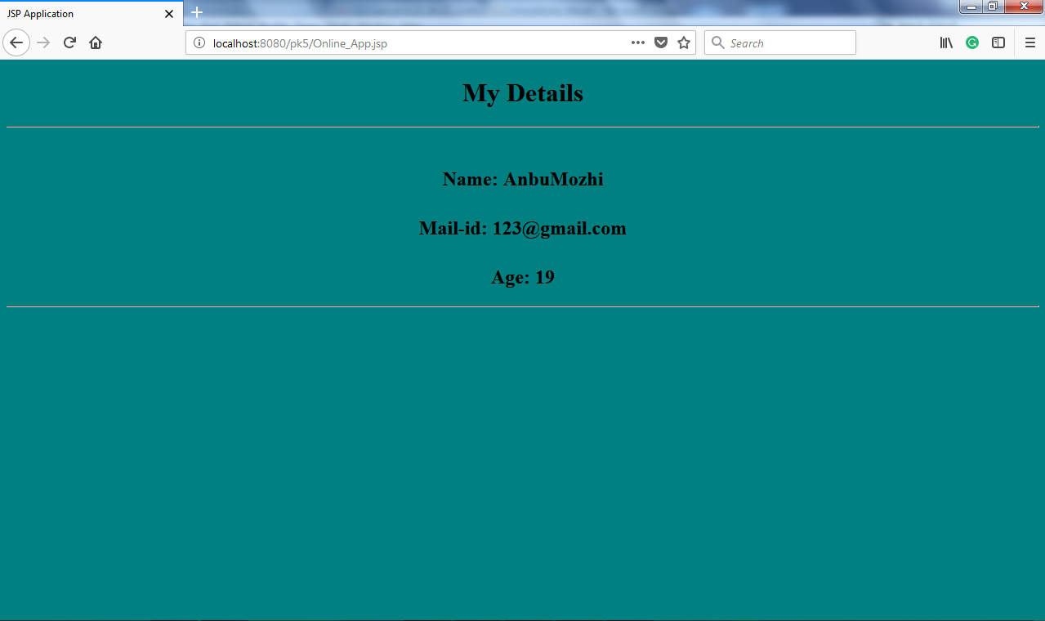

**INCLUDE DIRECTIVE USING JSP**

**PROGRAM CODING:**

**STATIC FILE:**

<html>

<body bgcolor="violet">

<center>

<h1><font color="red">

VELS UNIVERSITY

</font></h1><br></center>

</body>

</html>

**DYNAMIC FILE:**

<html>

<head>

<title> My JSP Page </title>

</head>

<body bgcolor="black">

<h1><center>

<font color="white">

<%="WELCOME TO MY JSP PAGE"%>

</font>

</center>

</h1>

</body></html></h1>

</body></html>

**JSP FILE:**

<html>

<head>

<title>Program To Include Directive</title>

</head>

<body bgcolor="blue">

<br><center><font size="20">

<jsp:include page="dynamiic_file.jsp"/>

<jsp:include page="index.html"/>

</font>

</center>

</body>

</html>

**OUTPUT:**

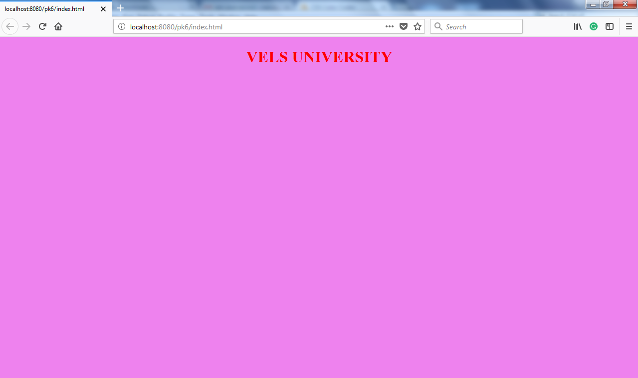

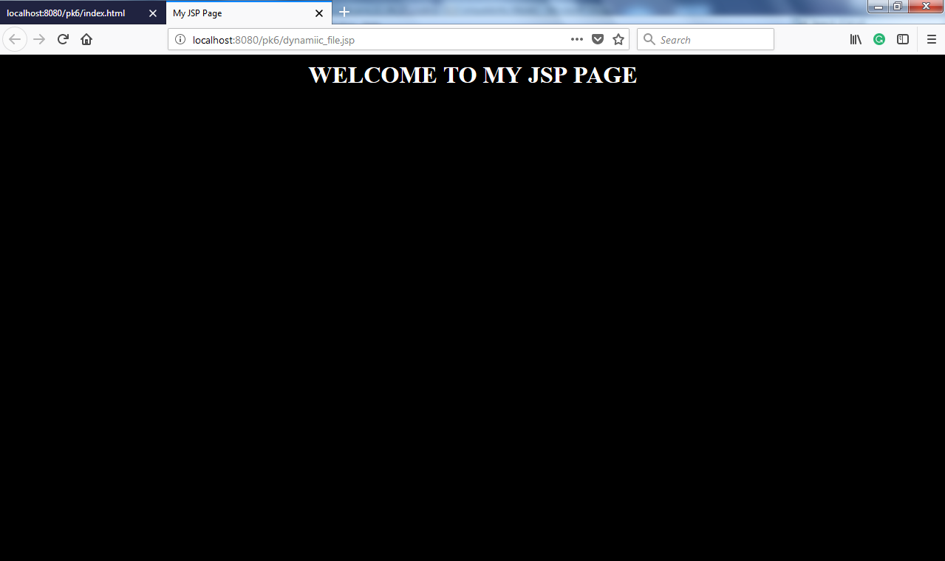

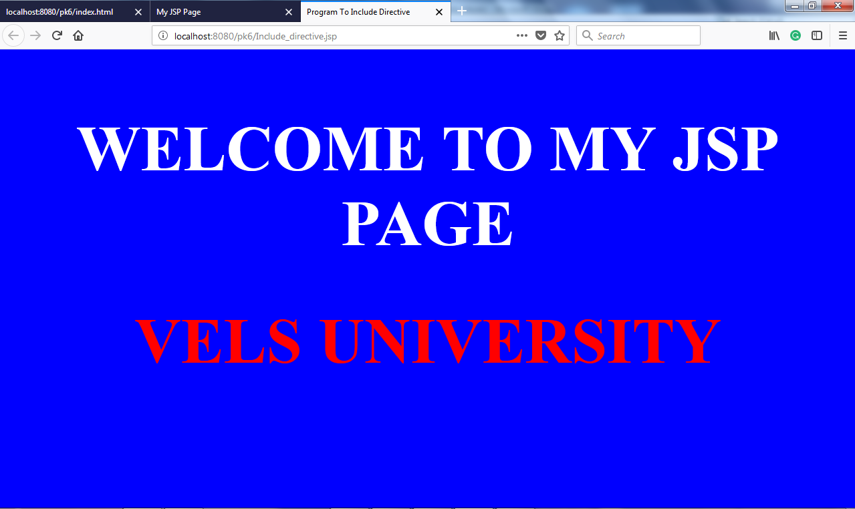

**JAVA BEAN APPLICATION USING JSP**

**PROGRAM CODING:**

**Simple.java**

package bsc;

public class simple1

{

private double p;

private double n;

private double r;

privatedouble s;

private double tr;

public double getp()

{

return p;

}

public void setp(double tp)

{

p = tp;

}

public double getn()

{

return n;

}

public void setn(double tn)

{

n = tn;

}

public double getr()

{

return r;

}

public void setr(double tr)

{

r=tr;

}

public void calc()

{

s = p*n*r/100;

}

public double gets()

{

calc();

return s;

}

}

**JSP CODING:**

<%@ page language="java"%>

<html>

<head>

<title>Java Bean Demo</title>

</head>

<body bgcolor="gold">

<center><h1><font color="black">

JAVA BEAN APPLICATION USING JSP</font></h1></center>

<jsp:useBean id="si" scope="session" class="bsc.simple1">

<jsp.setproperty name="si" property="p" value=10000"></jsp.setproperty>

<jsp.setproperty name="si" property="n" value=10"></jsp.setproperty>

<jsp.setproperty name="si" property="r" value=8"></jsp.setproperty>

<h3>PRINCIPLE AMOUNT:</h3>

<h2><jsp.getproperty name="si" property="p"></jsp.getproperty></h2>

<h3>THE NO.OF YEARS:</h3>

<h2><jsp.getproperty name="si" property="n"></jsp.getproperty></h2>

<h3>THE INTEREST RATE:</h3>

<h2><jsp.getproperty name="si" property="r"></jsp.getproperty></h2>

<h3>THE SIMPLE INTEREST:</h3>

<h2><jsp.getproperty name="si" property="s"></jsp.getproperty></h2>

</jsp:useBean>

</body>

</html>

**OUTPUT:**

