

TRIBHUVAN UNIVERSITY

**INSTITUTE OF ENGINEERING**

**PASHCHIMANCHAL CAMPUS**

LAMACHAUR, POKHARA

A Project Report

On

**“THEATRE BOOKING SYSTEM”**

**SUBMITTED BY:**

Yogendra Baskota [PAS077BEI045]

Rajan Kumar Gupta [PAS077BEI047]

Ukesh Aryal [PAS077BEI048]

**SUBMITTED TO:**

Er.Balkrishna Nyaupane

**ACKNOWLEDGEMENT**

We owe our deepest gratitude to the Department of Electronics and Computer Engineering, IOE, Pashchimanchal Campus for providing us with an opportunity to work on a Database Management System (DBMS) Project as a part of our syllabus. It is an honor for us to express our gratitude to our project Teacher Mr. Bal Krishna Nyaupane who gave us the golden opportunity to do this wonderful project of Theatre Booking System.

We are thankful to and fortunate enough to get constant support, encouragement, and guidance from our teacher for their suggestions and lectures that paved towards the completion of this project. In addition, we would like to thank our colleagues for their valuable comments and their suggestions during this project. Any kind of suggestion or comment will be highly appreciated and acknowledged.

**ABSTRACT**

Theatre booking system plays a crucial role in the efficient management of ticket reservations and audience engagement for various theatrical performances. This abstract explores the fundamental aspects and functionalities of a modern theatre booking system, highlighting its importance in enhancing the overall theatre-going experience.

The theatre booking system is a comprehensive software application designed to facilitate seamless ticket booking, seat selection, and payment processing for audiences interested in attending live performances, such as plays, musicals, concerts, and other events hosted in a theatre venue. This system employs user-friendly interfaces accessible through multiple platforms, including web browsers, mobile devices and so on.

The primary objectives of a theatre booking system are to streamline ticket reservations, optimize seat allocation, and provide real-time information to both customers and theatre administrators.

Table of Contents

**1. INTRODUCTION 5**

**2. PROBLEM STATEMENT 7**

**3. OBJECTIVE 7**

**4. METHODOLOGY 8**

**4.1. Entity-Relationship Diagram 8**

**4.2. Relational Schema 9**

**4.3. Schema Diagram 10**

**4.4. SQL Queries 11**

**5. Result 17**

**6. Conclusion 20**

# INTRODUCTION

In the modern age, the internet has become an indispensable aspect of our daily lives, transforming the way we carry out activities and providing services that have significantly impacted various sectors. From education and transportation to entertainment and health, the services offered by the internet have revolutionized the way we interact with the world around us.

In this digital landscape, we proudly present the innovative Theatre Booking System, where the enchantment of live theatre merges seamlessly with the convenience of modern technology. Our cutting-edge platform is designed to transform the way you book tickets for your favorite theatrical experiences, providing user-friendly solution that ensures you never miss out on the magic of the stage. Gone are the days of waiting in long queues or navigating through tedious booking processes. With our Theatre Booking System, securing your seat at the hottest shows is just a few clicks away. We understand the value of your time and the excitement of experiencing live performances, and that is why we have developed a platform that simplifies the entire ticket-booking journey.

The heart of our system lies in its user-friendly interface, carefully crafted to offer an intuitive and seamless booking experience. From the moment you visit our website or mobile app, you will be greeted with a clean and visually appealing design that guides you effortlessly through the process of selecting and reserving your preferred seats. To cater to your individual preferences and enhance your theatre going experience, our platform allows you to explore an interactive seating layout. Gone are the days of blindly choosing a seat and hoping for the best view. With our virtual seating arrangement, you can examine the theatre layout and select the perfect spot for an immersive and unforgettable experience. But that's not all our Theatre Booking System is equipped with a plethora of features to make your journey even more enjoyable. We offer a wide range of secure and diverse payment options, ensuring that your transactions are smooth and reliable.

We recognize the importance of real-time information, especially when it comes to securing tickets for highly anticipated shows. Our system provides immediate updates on ticket availability, show timings, and seat allocation. This ensures that you are always up to date with the latest information, avoiding the disappointment of missing out on your favorite performance. To make your theatre experience even more personalized and convenient, our Theatre Booking System allows you to create your own unique profile. By doing so, you gain access to a host of benefits, including saving your booking history, preferences, and receiving customized recommendations for shows that align with your interests. The benefits of our platform extend beyond the audience, as theatre management can also make the most of our comprehensive features. With valuable insights provided by our reporting and analytics tools, theatre owners can optimize show scheduling, ticket pricing, and promotional strategies to create an unforgettable experience for you, the audience.

We understand that the world is constantly on the move, and so are you. Therefore, we have ensured that our Theatre Booking System is fully optimized for mobile devices. Whether you are at home, at work, or on the go, you can easily book your tickets and embark on a captivating theatre experience at your convenience. At the core of our Theatre Booking System is a commitment to security and data privacy. We understand the importance of safeguarding your personal information and payment details, and we take every measure to ensure that your data remains protected. When booking with us, you can have complete peace of mind knowing that your information is in safe hands.

# PROBLEM STATEMENT

The Theatre Booking System faces significant challenges that hinder its ability to provide a seamless and satisfying booking experience for both customers and theatre management. One of the key problems is the inefficiency of the booking process. Traditional methods, such as long queues at box offices, lead to customer frustration and discourage potential audiences from booking tickets. This results in lost opportunities for theatres to maximize ticket sales and engage a broader audience. Streamlining the booking process is essential to attract more patrons and ensure a smooth and convenient ticket purchasing journey.

Another critical issue faced by the Theatre Booking System is the lack of real-time information. Customers often struggle to find up-to-date details on show timings, ticket availability, and seating arrangements. The absence of real time updates leaves customers uncertain about the availability of seats for their desired shows. As a consequence, potential attendees may miss out on booking their preferred seats or fail to stay informed about last-minute changes or additional ShowTime. Providing immediate and accurate information is crucial for enhancing customer satisfaction and ensuring they can plan their theatre outings effectively.

The absence of diverse and secure payment options is another problem faced by the Theatre Booking System. Limited payment methods can prevents potential customers from booking tickets online, as they may prefer alternative options that suit their preferences or provide better security. By offering a wider range of payment choices, the Theatre Booking System can provide to a broader audience, including those who are more comfortable with specific payment platforms. Implementing secure payment gateways is also vital in establishing trust and ensuring customer’s financial information remains protected during transactions. Solving this issue will contribute to an increase in online ticket sales and a more inclusive booking system.

# OBJECTIVE

The objective of a Theatre Booking System is:

* To provide real-time information on ticket availability, show timings, and seat allocations.
* To prioritizes the security and privacy of customer data, ensuring that personal information and payment details are protected from unauthorized access or misuse.
* To enhance the overall theatre-going experience for customers by offering features such as seat selection and visualization, personalized profiles, and promotions, the system aims to engage customers and create a more enjoyable and memorable theatre experience.

# METHODOLOGY

The methodology of a Theatre Booking System involves the systematic approach and strategies used to design, develop, and implement the system. It encompasses various stages, including planning, analysis, design, implementation, testing, and maintenance.

## **Entity-Relationship Diagram**

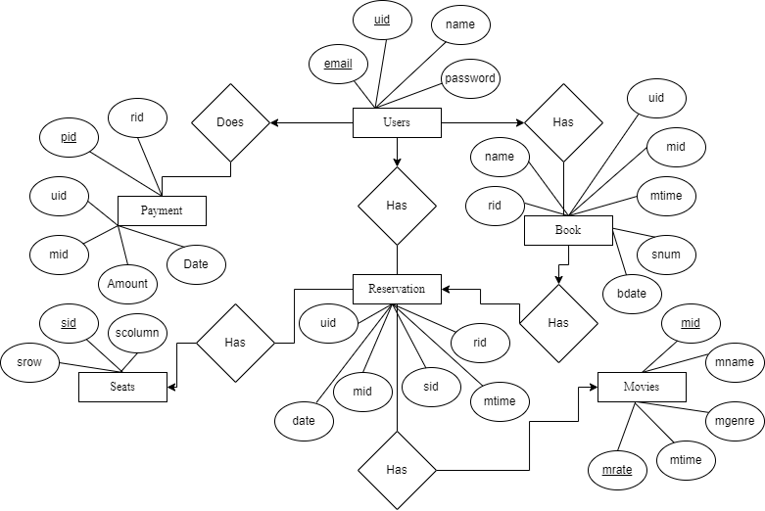

**Figure 4.1: Entity-Relationship Diagram**

## **Relational Schema**

Movies:

|  |  |  |  |  |
| --- | --- | --- | --- | --- |
| mid | mrate | mtime | mname | mgenre |

Book:

|  |  |  |  |  |  |  |
| --- | --- | --- | --- | --- | --- | --- |
| rid | name | snum | bdate | mtime | uid | mid |

Payment:

|  |  |  |  |  |  |
| --- | --- | --- | --- | --- | --- |
| pid | amount | date | rid | uid | mid |

Reservation:

|  |  |  |  |  |  |
| --- | --- | --- | --- | --- | --- |
| mtime | date | sid | rid | mid | uid |

User:

|  |  |  |  |
| --- | --- | --- | --- |
| uid | email | name | password |

Seats:

|  |  |  |
| --- | --- | --- |
| sid | scolumn | srow |

**Figure 4.2:** **Relational Schema**

## **Schema Diagram**

Reservation

payment

Movies

Book

|  |
| --- |
| rid |
| name |
| mtime |
| snum |
| bdate |
| uid |
| mid |

|  |
| --- |
| mtime |
| date |
| rid |
| sid |
| uid |
| mid |

|  |
| --- |
| pid |
| amount |
| date |
| rid |
| uid |
| mid |

|  |
| --- |
| mid |
| mrate |
| mgenre |
| mtime |
| mname |

|  |
| --- |
| sid |
| scolumn |
| srow |

User

Seats

|  |
| --- |
| email |
| name |
| password |

**Figure 4.3:**  **Schema Diagram**

## **SQL Queries**

* Create database theatre booking system;
* Show databases;
* Use theatre booking system;

* Table structure
* CREATE TABLE `book` (

`uid` int(5) NOT NULL,

`mid` int(10) NOT NULL,

`name` varchar(255) NOT NULL,

`rid` int(5) NOT NULL,

`mtime` varchar(255) NOT NULL,

`snum` int(5) NOT NULL,

`bdate` varchar(255) NOT NULL

) ENGINE=InnoDB DEFAULT CHARSET=utf8mb4;

* CREATE TABLE `movies` (

`mid` int(10) NOT NULL,

`mname` varchar(255) NOT NULL,

`mgenre` varchar(255) NOT NULL,

`mtime` varchar(255) NOT NULL,

`mrate` varchar(6) NOT NULL

) ENGINE=InnoDB DEFAULT CHARSET=utf8mb4;

* CREATE TABLE `payment` (

`pid` int(5) NOT NULL,

`rid` int(5) NOT NULL,

`uid` int(5) NOT NULL,

`mid` int(10) NOT NULL,

`amount` int(10) NOT NULL,

`date` varchar(255) NOT NULL

) ENGINE=InnoDB DEFAULT CHARSET=utf8mb4;

* CREATE TABLE `reservation` (

`rid` int(5) NOT NULL,

`sid` varchar(10) NOT NULL,

`uid` int(5) NOT NULL,

`mid` int(10) NOT NULL,

`mtime` varchar(255) NOT NULL,

`date` varchar(255) NOT NULL

) ENGINE=InnoDB DEFAULT CHARSET=utf8mb4;

* CREATE TABLE `seats` (

`sid` varchar(10) NOT NULL,

`scolumn` varchar(10) NOT NULL,

`srow` varchar(10) NOT NULL

) ENGINE=InnoDB DEFAULT CHARSET=utf8mb4

* CREATE TABLE `users` (

`uid` int(5) NOT NULL,

`name` varchar(255) NOT NULL,

`email` varchar(255) NOT NULL,

`password` text NOT NULL

) ENGINE=InnoDB DEFAULT CHARSET=utf8mb4;

* Dumping data into tables
* Book:

INSERT INTO `book` (`uid`, `mid`, `name`, `rid`, `mtime`, `snum`, `bdate`) VALUES

(18986, 171546, 'AAA', 630, '9', 1, '2022-08-02'),

(14640, 171546, 'AAA', 653, '9', 3, '2022-08-02'),

(18986, 175521, 'BBB', 724, '9', 1, '2022-08-02'),

(16377, 171546, 'AAA', 810, '9', 2, '2022-08-02'),

(15184, 171546, 'AAA', 911, '9', 2, '2022-08-02');

* Movies:

INSERT INTO `movies` (`mid`, `mname`, `mgenre`, `mtime`, `mrate`) VALUES

(131228, 'AAA', ' afadf', '12', '200'),

(160984, 'BBB', 'dami', '12', '200'),

(171546, 'AAA', ' afadf', '9', '175'),

(173651, 'BBB', 'dami', '3', '250'),

(175521, 'BBB', 'dami', '9', '175'),

(181207, 'AAA', ' afadf', '3', '250'),

(187940, 'CCC', 'gafd', '9', '175'),

(193602, 'CCC', 'gafd', '3', '250'),

(195565, 'CCC', 'gafd', '12', '200');

* Payment:

INSERT INTO `payment` (`pid`, `rid`, `uid`, `mid`, `amount`, `date`) VALUES

(5235, 911, 15184, 171546, 350, '2022-08-02 '),

(6830, 810, 16377, 171546, 350, '2022-08-02 '),

(7806, 653, 14640, 171546, 525, '2022-08-02 '),

(8636, 724, 18986, 175521, 175, '2022-08-02 '),

(8915, 630, 18986, 171546, 175, '2022-08-02 ');

* Reservation:

INSERT INTO `reservation` (`rid`, `sid`, `uid`, `mid`, `mtime`, `date`) VALUES

(810, ' A1 ', 16377, 171546, '9 ', '2022-08-02 '),

(810, ' A2 ', 16377, 171546, '9 ', '2022-08-02 '),

(653, ' A3 ', 14640, 171546, '9 ', '2022-08-02 '),

(653, ' A4 ', 14640, 171546, '9 ', '2022-08-02 '),

(653, ' A5 ', 14640, 171546, '9 ', '2022-08-02 '),

(630, ' B1 ', 18986, 171546, '9 ', '2022-08-02 '),

(911, ' B2 ', 15184, 171546, '9 ', '2022-08-02 '),

(911, ' B3 ', 15184, 171546, '9 ', '2022-08-02 '),

(724, ' A1 ', 18986, 175521, '9 ', '2022-08-02 ');

* Seats:

INSERT INTO `seats` (`sid`, `scolumn`, `srow`) VALUES

(' A1', '1', '1'),

(' A2', '2', '1'),

(' A3', '3', '1'),

(' A4', '4', '1'),

(' A5', '5', '1'),

(' B1', '1', '2'),

(' B2', '2', '2'),

(' B3', '3', '2'),

(' B4', '4', '2'),

(' B5', '5', '2');

* User:

INSERT INTO `users` (`uid`, `name`, `email`, `password`) VALUES

(18, 'admin', 'admin@project.com', '$2b$08$ttok6m5cPwnZFz8KWwC68e6fajojkXnbkOaVZUMs8riI4GXN7nG8m'),

(10122, 'test', 'test@project.com', '$2b$08$U7oKZqQZBOLRgrWs9LeuquN3ir/pegDoGqNJfP40YPI41EkuQImXW'),

(14640, 'chill', 'chill@project.com', '$2b$08$qF2R1Sh67rKT00dkHJ9FjupUilaGddmeOC45B0uzdw00W6ywBdN8a'),

(15184, 'sohan', 'sohan@project.com', '$2b$08$IRgR9CIdEfN1Eia3MBgUB.6sG6.iUubluXjbfGgYnqhRu1kOuqS/G'),

(16377, 'suresh', 'suresh@project.com', '$2b$08$dhq3H.P7akLtNhfGAgosreRukzWxlrZe1H.B85P4cmUZazCgjeY1i'),

(18986, 'hello', 'hello@project.com', '$2b$08$7PXLbBQrOcwgTC1/q.9SjeZCiU3.Gp6swcxbb19js7DvTjU63Aq9O');

* Index for dumped tables
* Book:

ALTER TABLE `book`

ADD PRIMARY KEY (`rid`),

ADD KEY `fky1` (`uid`),

ADD KEY `fky3` (`mid`);

* Movies:

ALTER TABLE `movies`

ADD PRIMARY KEY (`mid`,`mrate`);

* Payment:

ALTER TABLE `payment`

ADD PRIMARY KEY (`pid`),

ADD KEY `fk1` (`uid`),

ADD KEY `fk2` (`mid`),

ADD KEY `fk3` (`rid`);

* Reservation:

ALTER TABLE `reservation`

ADD KEY `uidfk` (`uid`),

ADD KEY `fk9` (`mid`);

* Seats:

ALTER TABLE `seats`

ADD PRIMARY KEY (`sid`);

* User:

ALTER TABLE `users`

ADD PRIMARY KEY (`uid`,`email`(100));

* Constraints for dumped tables
* Book:

ALTER TABLE `book`

ADD CONSTRAINT `fky1` FOREIGN KEY (`uid`) REFERENCES `users` (`uid`) ON DELETE CASCADE ON UPDATE CASCADE,

ADD CONSTRAINT `fky3` FOREIGN KEY (`mid`) REFERENCES `movies` (`mid`) ON DELETE CASCADE ON UPDATE CASCADE;

* Payment:

ALTER TABLE `payment`

ADD CONSTRAINT `fk1` FOREIGN KEY (`uid`) REFERENCES `users` (`uid`) ON DELETE CASCADE ON UPDATE CASCADE,

ADD CONSTRAINT `fk2` FOREIGN KEY (`mid`) REFERENCES `movies` (`mid`) ON DELETE CASCADE ON UPDATE CASCADE;

* Reservation:

ALTER TABLE `reservation`

ADD CONSTRAINT `fk9` FOREIGN KEY (`mid`) REFERENCES `movies` (`mid`) ON DELETE CASCADE ON UPDATE CASCADE,

ADD CONSTRAINT `uidfk` FOREIGN KEY (`uid`) REFERENCES `users` (`uid`) ON DELETE CASCADE ON UPDATE CASCADE;

# Result

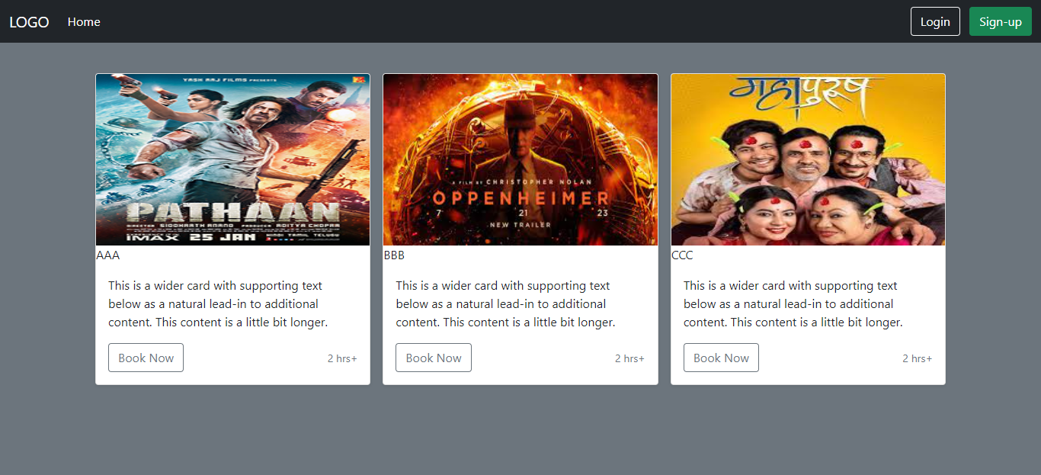

User Dashboard: User can login or register from here.

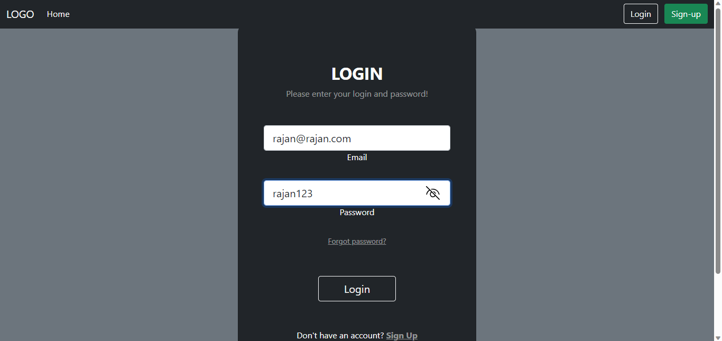

This is the dashboard from where a user can book and reserve the seats.

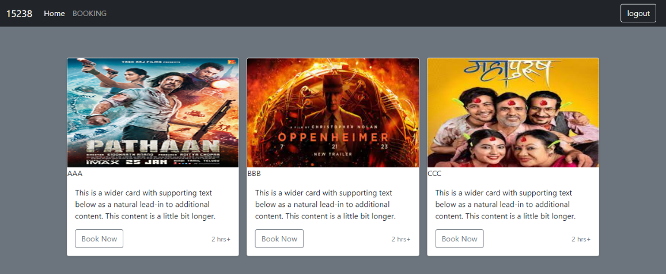

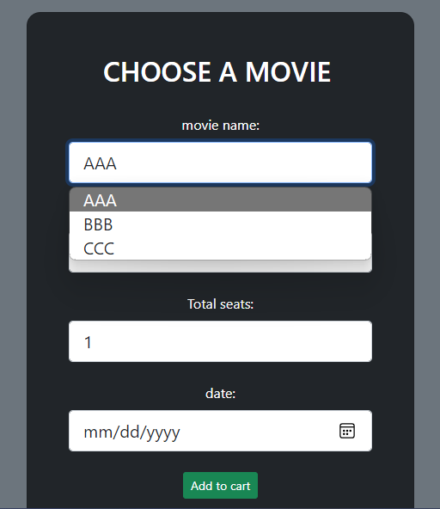 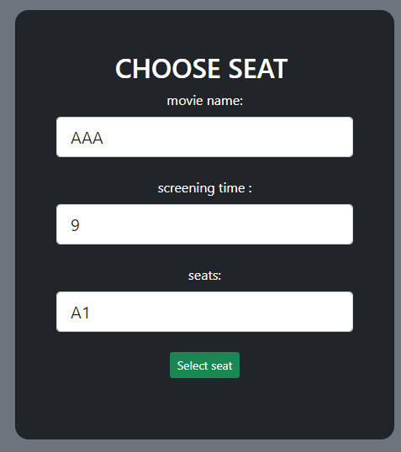

This is the page for generating bills.

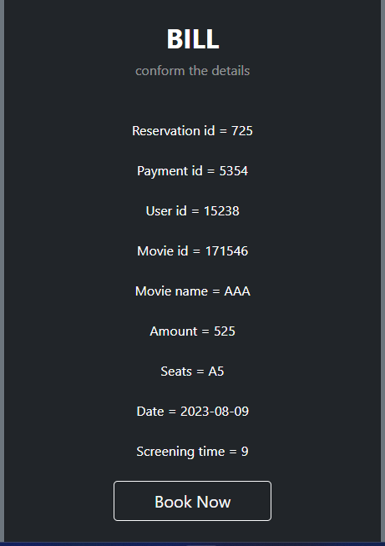

Admin Dashboard:

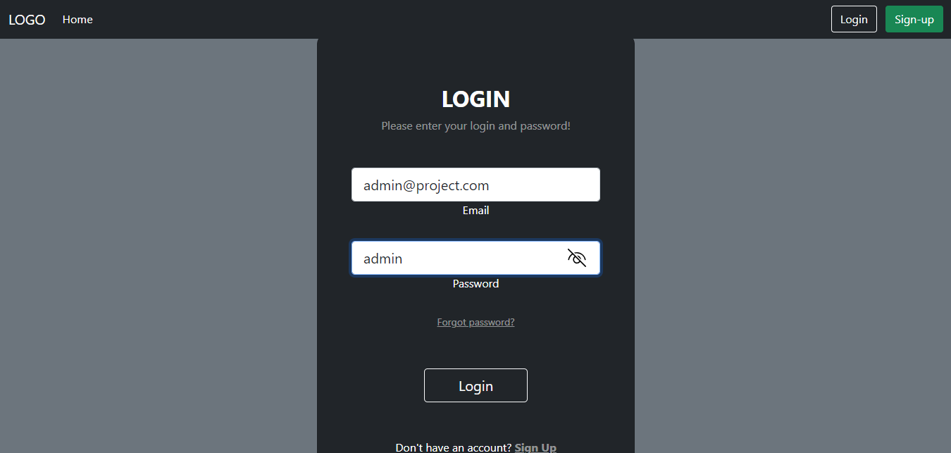

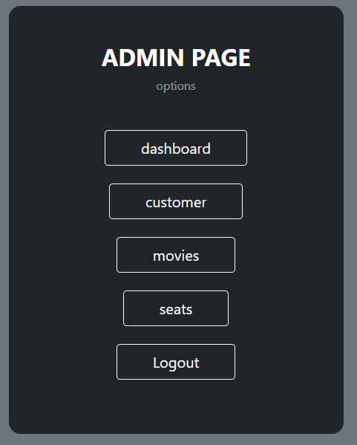

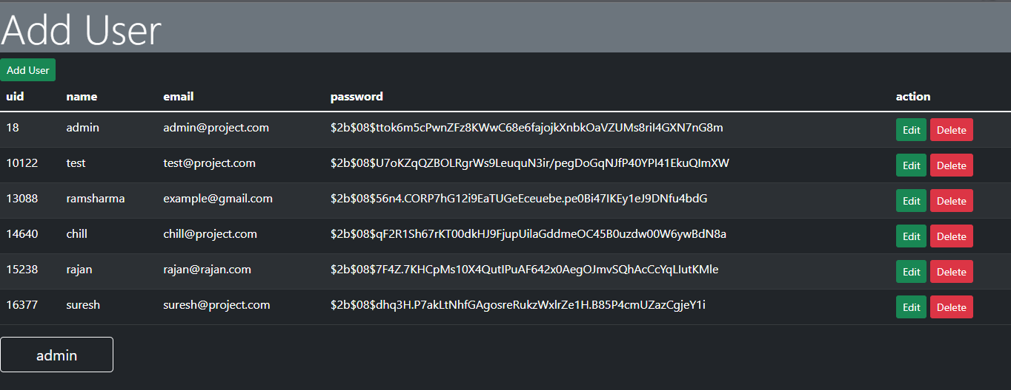

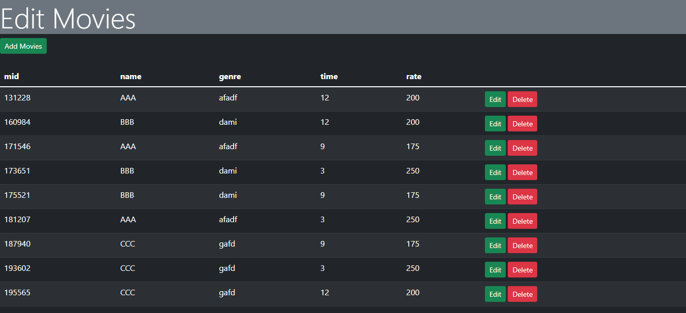

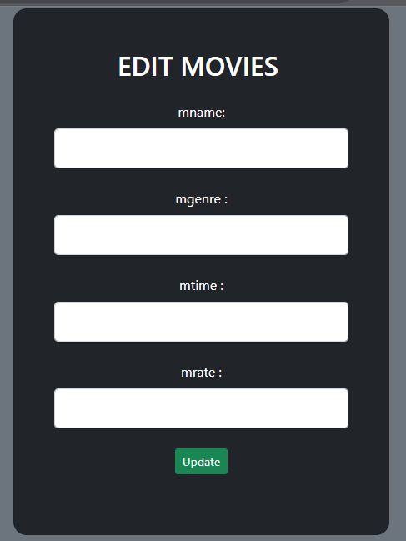 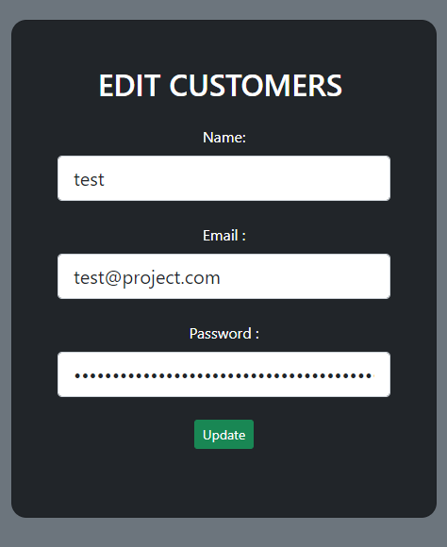

# Conclusion

Theatre booking systems have revolutionized the way audiences interact with and experience live performances. Theatre booking systems have become extremely important for theaters in the modern world. They provide a convenient and customer-focused way for people to buy tickets. These systems also help theater administrators by giving them valuable information about their audience. As technology keeps improving, these booking systems will likely get even better, making the experience of going to the theater even more enjoyable for people all over the world.