**SPREADSHEET PROJECT:**

**ZOMATO RETAURANTS**



Alphin A J

**CONTENTS**

1. **Data Preprocessing**
2. **Objective Questions**
3. **Subjective Questions**

**1. Data Preprocessing (Data Cleaning):**

* Remove duplicates from whole table (Raw Data).
* Handling missing values;
  + Found blanks in Cuisines column.
  + Replacing it most repeated value based on the nature of dataset.
* Checking the datatype of the columns.
* Formatting : changing the date structure for ‘Datekey_Opening’ column.
* Sorting the dataset.
* Extracting ‘year’ from ‘Datekey_Opening’ column.
* Adding Customized price for each restaurants with currency symbols.
* Changing the currencies to INR in the column ‘Average_Cost_for_two(INR)’.

**2. Objective Questions:**

1. What is the total no. of tables present in the data?

There are 2 tables (worksheets) in the excel file, i.e., Raw data and country description.

2. What is the total no. of attributes present in the data?

20 attributes(columns) are present in the data.

3. How many categorical columns are there in the data?

There are 12 categorical columns in the raw data which is found using COUNTIF function.

4. The data consists of some inconsistent and missing values so ensure that the data used for further analysis is cleaned.

Since missing values were found in cuisines column, all the blank values were under Country name, United States of America. So, blanks in cuisines were replaced with mode of cuisines which are in the Country ‘United States of America’. i.e, ‘Mexican’ which is calculated in the sheet ‘4. Fill_Cusines(missing values)’.

5. Using the LookUp functions, fill up the countries in the original data using the country code.

Using VLOOKUP function Country name was looked up in raw data and filled.

=VLOOKUP(C2,'country description'!A:B,2,0) (‘8,10,12,13. Raw Data’ sheet)

6. Create a table to represent the number of restaurants opened in each country.

A pivot table was created with worksheet name as ‘6&7.Restrnts in each Cntry& yr’ for showing the no of restaurants for each country.

7. Also, the management wants to look at the number of restaurants opened each year, so provide them with something here.

A pivot table has been created for the above condition with worksheet named as ‘6&7.Restrnts in each Cntry& yr’.

8. What is the total number of restaurants in India in the price range of 4?

In (‘8,10,12,13. Raw Data’ sheet)

= 388

=COUNTIFS('Raw Data'!D:D,"India",'Raw Data'!S:S,4)

9. What is the average number of voters for the restaurants in each country according to the data?

A pivot table with worksheet named ‘9.Avg of Votes in ech Restrnts’ has been created for calculating average of votes for restaurants in each countries.

10. Calculate the average rating for all the restaurants that have price_range < 4 and provide online delivery. Use only the “IF” function, Logical Operators, and Aggregation functions to solve this problem.

For the above question 2 new columns were created in ‘8,10,12,13. Raw Data’ worksheet ;

‘10. Condition(Sum)’ to get the sum of ratings where the above condition is satisfied(have price_range < 4 and provide online delivery) and

‘10. Condition(Count)’ to get the count of ratings where the above condition is satisfied(have price range < 4 and provide online delivery) and

Average rating has been calculated in cell AA9554 i.e., = 3.2738

11. Using Conditional formatting highlight the rows of restaurants that are located in the countries or cities that you’ve suggested to the management for opening new restaurants.

Mainly 2 factors can be considered for suggesting countries for opening new restaurants;

* Count of restaurants in each country.
* Average rating of restaurants in each country.

Based on above parameters sheet_name ‘11.Suggested Countries’, countries like Canada, Qatar, Singapore, Sri Lanka can be suggested for opening new restaurants.

In sheet ‘11. Raw Data’ Restaurant column highlighted with a light orange color in the countries which have been suggested for opening new restaurants.

12. Create a new customized price column that consists of the abbreviation/symbol of the currency along with the Average_cost_for_two value. [Use string operations to do this task]

For the above qn (sheet – ‘8,10,12,13. Raw Data’),

* A column named ‘Currency_Symbol’ has been created to extract the currency symbol from ‘Currency’ column (using MID and FIND functions).
* After that, columns; ‘Currency_Symbol’ and ‘Average_Cost_for_two’ were aggregated in a new column named ‘Customized_Price’ using the string function.

13. How can you create an array formula in Excel or Google Sheets to count the number of restaurants listed that do not offer online delivery, are in the lowest price range, and have an average cost for two people less than or equal to 250 Indian Rupees?

In sheet – ‘8,10,12,13. Raw Data’ ,

* The currency conversion is calculated from sheet named ‘Currency_conversion’ and vlook up in the current sheet and convert all the avg_cost to INR in column AC (‘Average_Cost_for_two(INR)’).
* The array fn is calculated get the result based on the mentioned condition, using the formula, =SUM((P2:P9552 = "No")*(S2:S9552 = MIN(S2:S9552))*(AC2:AC9552 <= 250)) in column AB of ‘8,10,12,13. Raw Data’ sheet in cell AF4.
* And the result is 1694.

**3. Subjective Questions:**

1. Suggest a few countries where the team can open newer restaurants with lesser competition. Which visualization/technique will you use here to justify the suggestions?

Mainly 2 factors are considered for suggesting countries for opening new restaurants ;

* Count of restaurants in each country.
* Average rating of restaurants in each country.

A pivot bar chart is created based on above 2 factors.

Sheet – ‘1. Suggested Countries’

The **count of restaurants** indicates market competition: a high count shows high demand but strong competition, while a low count suggests an underserved market with growth potential. The **average rating** reflects customer satisfaction: a high rating means high expectations, and a low rating suggests an opportunity to provide better quality.

We take a threshold value for count of restaurants in each country and average rating for selecting countries for opening new restaurants.

* Count of restaurants in each country – below 25
* Average rating - below 4

Based on above threshold values from the visuals, countries such as **Canada, Singapore, Australia & Sri Lanka** can be suggested for opening new restaurants.

2. Come up with the names of States and cities in the suggested countries suitable for opening restaurants.

Sheet – ‘2.Suggested Cities’

From the above pivot table, we can analyze the cities having low ratings and providing table booking and online delivery.

It can be concluded that cities like **Armidale, Flaxton, Macedon, Penola, Yorkton, Balingup, Consort, Mayfield, Paynesville, Montville** are having low ratings and merely provide online delivery, and table bookings. These cities can be considered for setting up new restaurants in the suggested countries based on lower restaurants and low ratings.

3. According to the countries you suggested, what is the current quality regarding ratings for restaurants that are open there?

Avg rating and avg cost_for _two people in the suggested countries are considered for checking the current quality ratings of restaurants.

In the below combo chart, it is understood that avg rating and avg_cost for two are inversely related to each other. The restaurants with low avg_cost gets higher ratings when compared with restaurants having higher avg_cost for two people.

When setting up new restaurants, they should begin with a low average cost for two people until they receive positive customer feedback. After that, they should maintain a balance between the average rating and the average cost. If the average cost is too low, it could lead to a decline in revenue.

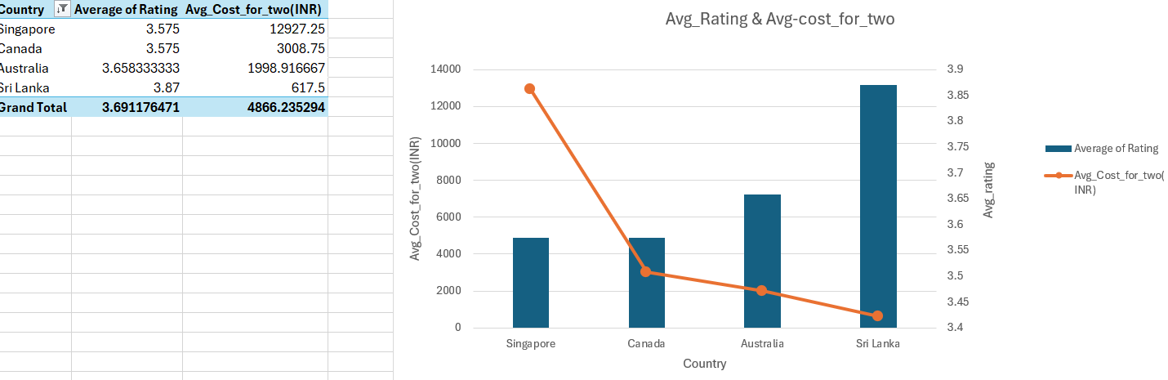

Sheet – ‘3.Quality rating’

4. Also, what is the current expenditure on food in the suggested countries, so we can keep our financial expenditure in control?

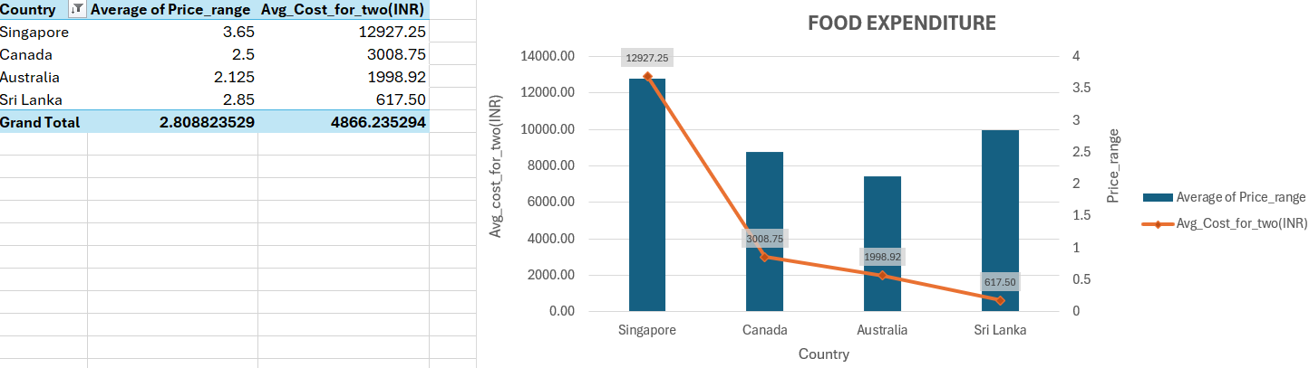

Sheet – ‘4.Food_expenditure’

The current expenditure on food in the suggested countries refers to how much people in those countries typically spend on food. This information would provide insights into consumer behavior and help Zomato manage its financial expenditure when expanding to these new markets.

From the above stacked column chart it can be derived that **Singapore** has highest average cost for 2 people, price range is in 3. In countries with higher average costs for two, consumers might have a higher disposable income, indicating a market that could sustain more expensive restaurant options.

Thus, based on the price range (if the restaurant is luxury or low cost) and average cost of food for 2 people, we can estimate the food expenditure of newer restaurants based on the market behaviour.

Based on the insights from the current expenditure trends,here are some recommendations for new restaurants ;

1. Moderate Pricing Strategy: Start with moderate prices in high-cost markets like Singapore to attract a broad audience, then adjust as you build a customer base.
2. Market Segmentation: Adapt pricing based on whether the target market prefers luxury or budget-friendly dining.
3. Leverage Customer Feedback: Begin with lower costs to gain positive feedback, then gradually increase prices.
4. Monitor Market Trends: Adjust pricing in response to consumer spending and preferences in each market.

5. Come up with the names of restaurants from the recommended states that are our biggest competitors and also those that are rated in the lower brackets, i.e., 1-2 or 2-3.



Based on sorting Votes and rating column from largest to smallest, following restaurants are the biggest competitors;

**Vivo Bar and Grill, 1918 Bistro & Grill– Australia**

**Ministry of Crab, Simply Strawberries By Jagro, The Sizzle– Sri Lanka**

**Lake House Restaurant, Tokyo Sushi – Canada**

**Fratini La Trattoria, Al'frank Cookies- Singapore**



Based on number filtering in rating column between 1 and 3, 7 restaurants in the suggested countries are rated in the lowest bracket of rating between 1 and 3, they are;

|  |
| --- |
| **Makansutra Gluttons Bay** |
| **Consort Restaurant** |
| **Star Buffet** |
| **Pier 70** |
| **Queen's Cafe** |
| **Elite Indian Restaurant** |
| **Poets Café** |
|  |

6. Which cuisines should we focus on in the newer restaurants to get better feedback? Does the choice of cuisines affect the restaurant ratings?

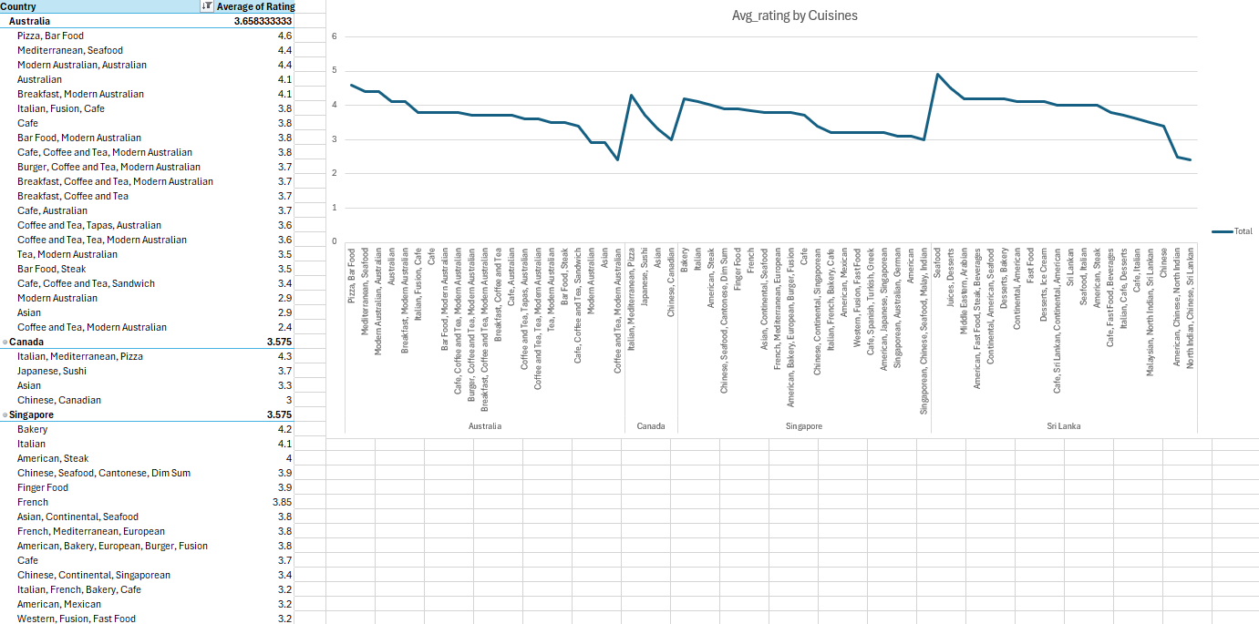

Sheet – ‘6. Cuisines by Avg rating’

* The above line charts depicts the rating of retaurants based on the type of cuisines.
* In Australia restaurants providing Pizza and barfood posess high rating which indicates more people prefer those food items., whereas in Sri Lanka most people prefer seafoods rather than Chinese items.This shows the taste preferences of the people in the particular area.

Yes, the cuisines affect the restaurant ratings because people in particular areas prefer similar kind of cuisines, and if the restaurant performs well , there will be higher rating for the cuisines mostly preferred by the people.

From the above visual, it is clear that type of cuisine affect the rating of restaurants. So while opening new restaurants in suggested countries , cuisines can be taken into consideration. Moreover, if introducing a foreign cuisine, adapt menu items to suit local tastes or dietary restrictions. In addition, exploring cuisines that align with emerging food trends like health-conscious dining, plant-based diets, or sustainable, farm-to-table concepts would also be a better option.

7. According to our current data, should we go for online delivery and table booking? Does that affect the customer’s ratings?

By adding 2 slicers for Online delivery and table booking and creating a pivot table for calculation of average rating across each countries , we can check how online delivery and table booking affects the customer rating.

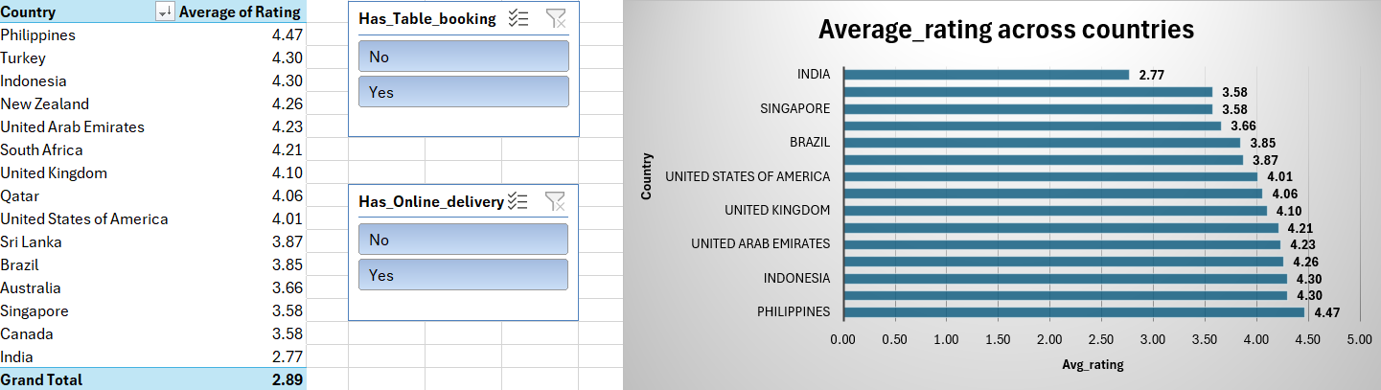

Sheet – ‘7.TableBooking & Online delivery’

By filtering on visual,

Total_average rating where online delivery available = 3.29

Total_average rating where online delivery not available = 2.75

Total_average rating where table booking available = 3.48

Total_average rating where table booking not available = 2.81

From the above insights, its clear that online delivery and table booking are crucial for higher customer ratings for the newly opening restaurants.

8. Should the team keep the rate of cuisines higher? Will that affect the feedback? According to our data are the rates of cuisines and ratings, correlated?

A pivot table has been created with avg rating and Average of Average_Cost_for_two(INR) for different cuisines in th countries.

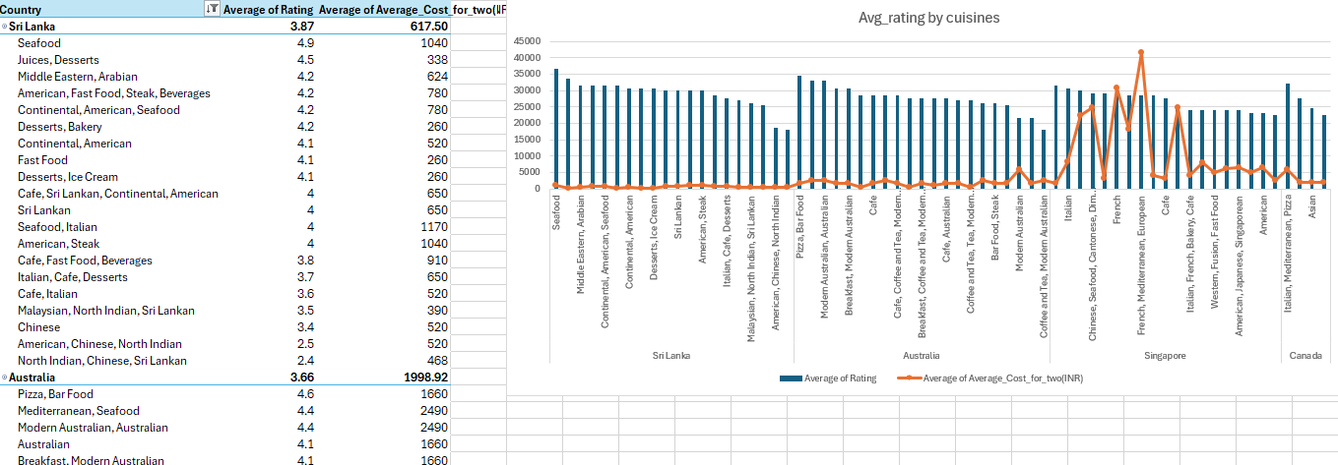

Sheet - ‘8.Avg_cost for_two & avg_rating’

From the above combo chart, it can be evaluated that cuisines possessing higher ratings have moderately high avg_cost for two people.

Therefore setting the average cost for two people slightly lower than the highest average cost for the top-rated restaurants in the target cuisine can indeed be an effective way to create competitive pricing and attract customers. This strategy can work particularly well if you're entering a competitive market where price is a significant factor for diners.

And the correlation between rate of cuisines and average ratings is 0.32 which is calculated using the formula, =CORREL(V:V,Z:Z)

9. What is the distribution of the number of restaurants of different price ranges in all the countries?

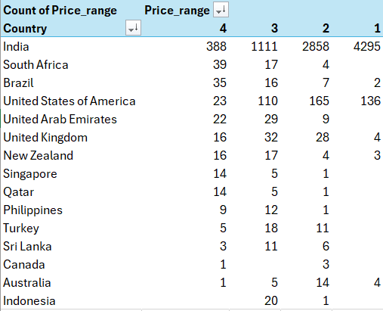

Sheet-‘ 9. Price_range’

From the above pivot table, India has highest no of restaurants with different price ranges.

10. Explain your approach in brief for suggesting countries/cities in order to open new restaurants, if the objective and subjective questions would have not been given to assist you. **[you have to give bullet pointers in order to answer this question]**

Some of the approaches I consider for suggesting countries/cities for opening new restaurants based on the available data would be

* By analyzing the variety of cuisines offered in each country and their corresponding ratings, we can identify countries with limited cuisine options and low ratings. These regions present an opportunity to open new restaurants that introduce diverse cuisines and focus on delivering high-quality food, filling a gap in the market.
* A higher number of votes across different countries indicates that more people are engaging with restaurants in those regions. This suggests a strong customer base and a thriving market, making these areas promising locations for opening new restaurants.
* By analyzing the correlation between the 'Average Cost for Two' and 'Average Rating,' we can identify countries where both factors are low. If there are significant discrepancies - such as high costs paired with low ratings - it indicates an opportunity to introduce new restaurants that strike a better balance between price and customer satisfaction.
* Cuisine preferences

• Examine the most common cuisines offered in each country and city.

* Identify cities with limited diversity in cuisines to introduce unique offerings.