

**Appendix A - Figure 1: Incident status chart**

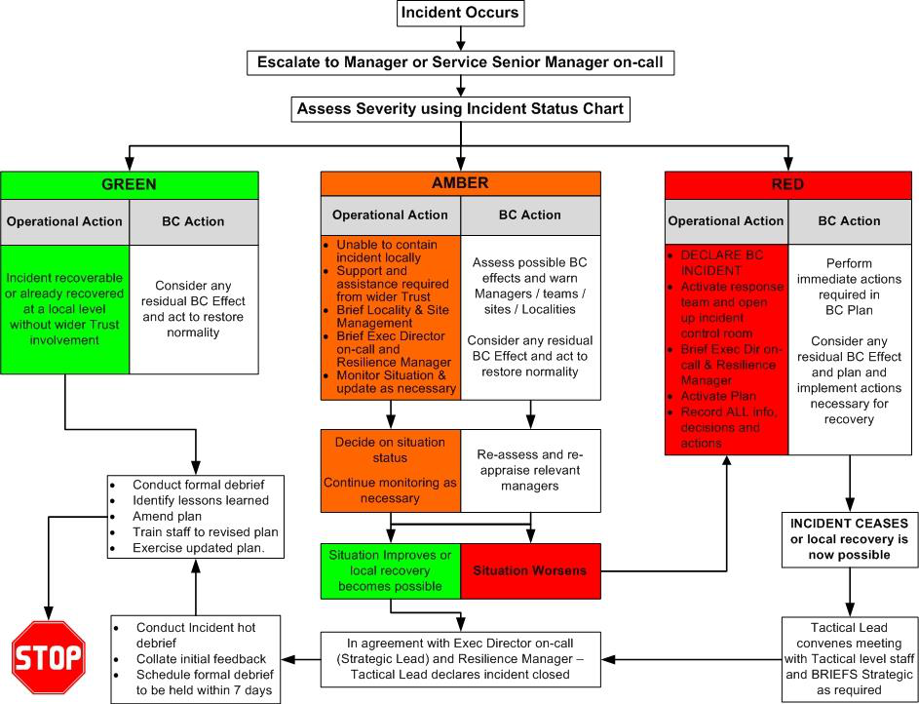

Version 2.0 Page 23 of 49