# Superstore Sales Analytics Dashboard

A professional Business Intelligence (BI) dashboard built using Microsoft Power BI to analyze sales performance, profitability, customer behavior, and regional performance using the Sample Superstore Dataset.

This project demonstrates how business data can be transformed into meaningful insights that support data-driven decision-making.

# Project Overview

The objective of this project is to analyze sales data from a retail superstore and provide interactive dashboards that help business managers monitor performance, identify trends, and make informed decisions.
The dashboard was developed following the complete Business Intelligence workflow:
- Data Collection
- Data Cleaning
- Data Transformation
- Data Modeling
- DAX Calculations
- Data Visualization
- Business Analysis
- Executive Reporting

# Project Objectives

The dashboard was designed to answer the following business questions:
- How much revenue does the business generate?
- Which products generate the highest sales?
- Which products generate the highest profit?
- Which customers contribute the most revenue?
- Which regions perform best?
- How do discounts affect profitability?
- What recommendations can improve business performance?

# Tools & Technologies Used
- Microsoft Power BI Desktop
- Power Query
- DAX (Data Analysis Expressions)
- Python
- Sample Superstore Dataset (Kaggle)

# Dataset
Dataset Name
Sample Superstore Dataset
The dataset contains information about:
- Orders
- Customers
- Products
- Categories
- Sales
- Profit
- Discount
- Quantity
- Region
- State
- Shipping Information

# Dashboard Pages

## Page 1 – Executive Overview
Provides a high-level summary of business performance.
Visuals include:
- Total Sales
- Total Profit
- Profit Margin
- Total Orders
- Monthly Sales Trend
- Sales by Category
- Sales by Region
- Top 10 Products
- Interactive Filters

## Page 2 – Sales Analysis
Provides detailed sales analysis.
Visuals include:
- Monthly Sales Performance
- Sales by Sub-Category
- Sales by Ship Mode
- Top Customers
- Sales by State
## Page 3 – Profit Analysis

Analyzes business profitability.

Visuals include:

- Monthly Profit Trend
- Profit by Category
- Profit by Region
- Top Products by Profit
- Bottom Products by Profit
- Discount vs Profit Analysis

## Page 4 – Customer Analysis
Analyzes customer purchasing behavior.
Visuals include:

- Customer Segments
- Top Customers by Sales
- Top Customers by Profit
- Orders by Segment
- Customer Sales Distribution

## Page 5 – Geographic Analysis

Analyzes regional performance.
Visuals include:
- Sales by State
- Sales by Region
- Profit by Region
- Top States by Sales
- Top States by Profit

## Report – Executive Insights & Recommendations
Summarizes the findings of the analysis.
Includes:
- Executive Summary
- Key Findings
- Business Opportunities
- Business Challenges
- Recommendations
- Future Improvements

# Key Metrics

The dashboard calculates several important KPIs:

- Total Sales
- Total Profit
- Profit Margin
- Total Orders
- Total Customers
- Average Sales per Customer
- Average Profit per Customer

# Business Insights

The dashboard reveals several important insights, including:
- Technology products generated the highest sales.
- The West region contributed the highest revenue.
- Consumer customers represented the largest customer segment.
- High discounts reduced profitability for several products.
- A small percentage of customers generated a significant share of total revenue.

# Recommendations
Based on the analysis, the following recommendations are proposed:
- Review discount strategies to improve profitability.
- Increase marketing for high-performing products.
- Strengthen customer loyalty programs.
- Expand business in profitable regions.
- Improve pricing strategies for low-profit products.

# Dashboard Preview
## Executive Overview

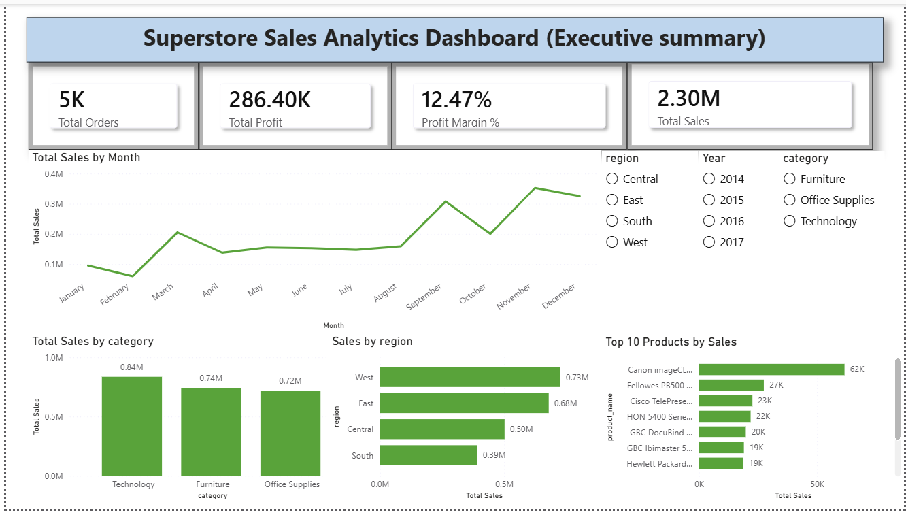
## Sales Analysis
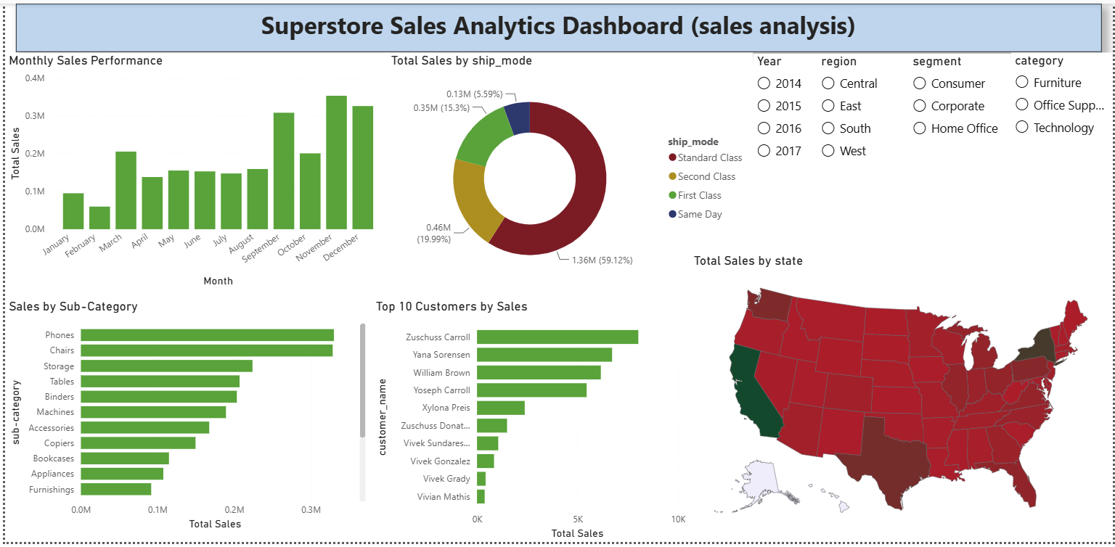
## Profit Analysis
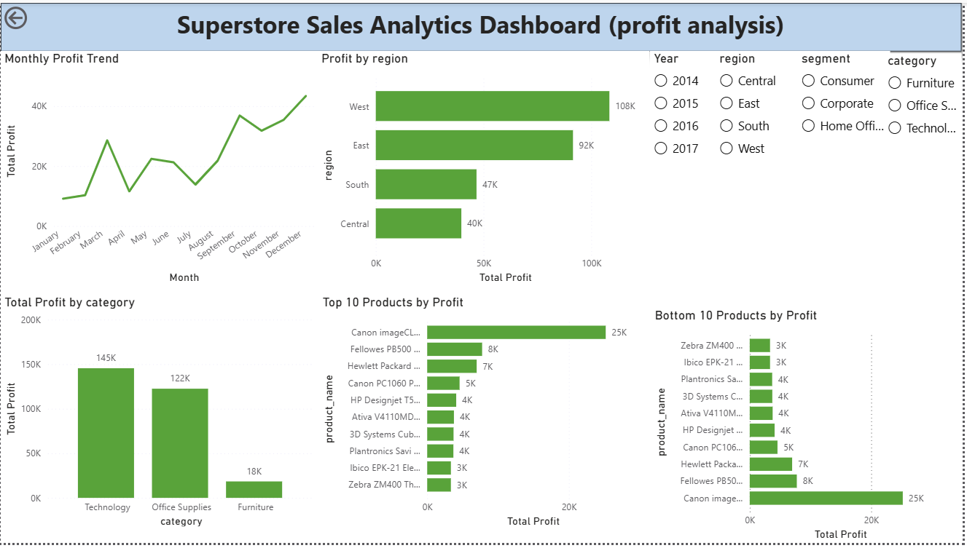
## Customer Analysis
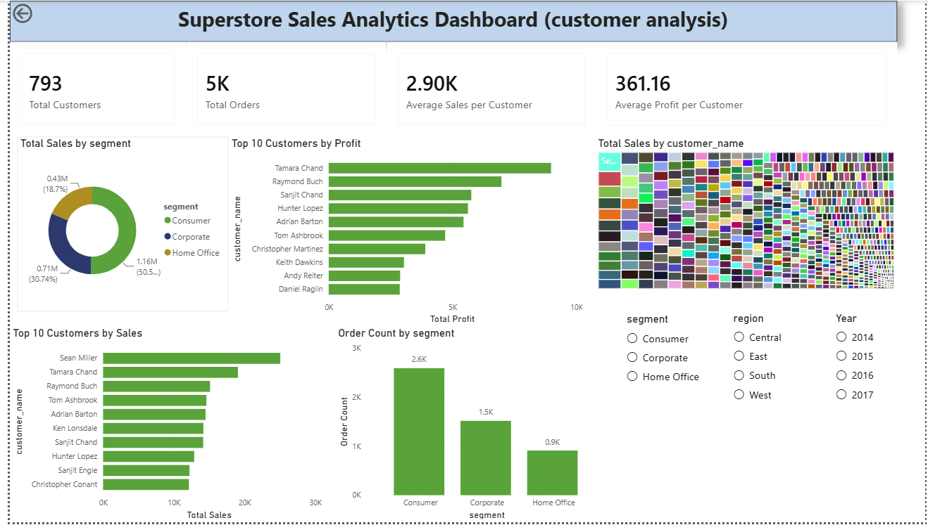
## Geographic Analysis
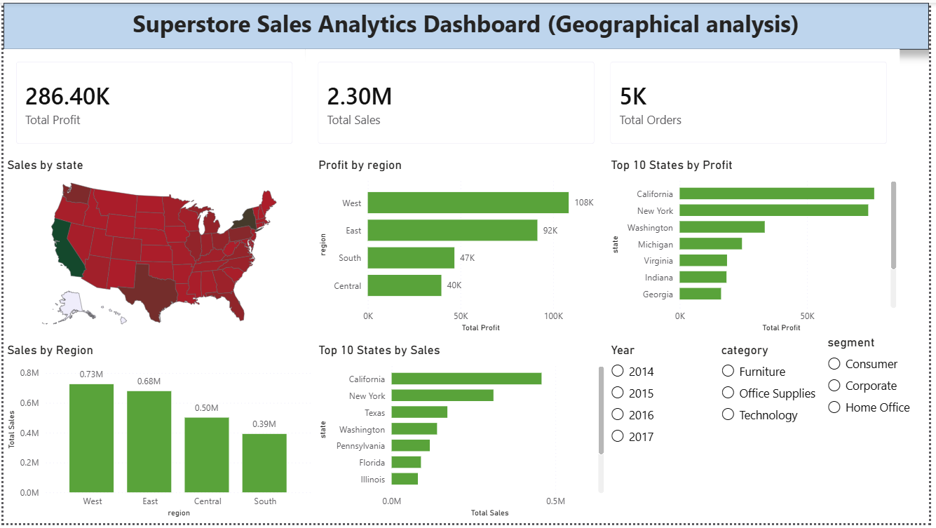

# How to Use

1. Download the repository.
2. Open the `.pbix` file using Microsoft Power BI Desktop.
3. Refresh the dataset if required.
4. Explore the dashboards using the interactive filters and slicers.

# Skills Demonstrated
This project demonstrates knowledge of:
- Business Intelligence
- Data Analytics
- Data Cleaning
- Power Query
- Data Modeling
- Star Schema
- DAX Measures
- KPI Development
- Dashboard Design
- Interactive Reporting
- Business Storytelling
- Executive Reporting

# Repository Structure
Superstore-Sales-Dashboard/
│
├── Dataset/
│ └── Sample_Superstore.xlsx
│
├── Dashboard/
│ └── Superstore_Sales_Analytics.pbix
│
├── Images/
│ ├── Page1.png
│ ├── Page2.png
│ ├── Page3.png
│ ├── Page4.png
│ ├── Page5.png
│ └── Page6.png
│
├── Report/
│ └── Executive_Insights.pdf
│
└── README.md
```

# Future Improvements

Future enhancements may include:
- Live database connection
- Real-time dashboards
- Sales forecasting
- Customer segmentation using Machine Learning
- Predictive Analytics
- Power BI Service deployment
- Mobile dashboard optimization

# Author
Alphonce Gaspar Nangu

July 2026

