**Kirby’s Adventure**

The game concept is simple. Navigate Kirby through the level by moving to each platform. Falling into the pit below would relocate Kirby back to the start of the level. Complete each level to move to the next.

**Sources:**

Entities:

* Player entity ‘Kirby’ by Darkshon: ‘https://www.spriters-resource.com/custom_edited/kirbycustoms/sheet/16835/’

Tilesets:

* Adventure 2D tileset by Neves Art: ‘https://nevesart.itch.io/adventure-2d-tileset’
* FrozenTaurus cave tileset by FrozenTaurus: ‘https://frozentaurus.itch.io/frozentauruss-cave-tileset’

Tilemap:

* Tilemaps created by myself using Tiled ‘https://www.mapeditor.org’.

Backgrounds:

* Adventure 2D tileset background by Neves Art: ‘https://nevesart.itch.io/adventure-2d-tileset’
* Pixel Fantasy Caves background by Szadi art: ‘https://szadiart.itch.io/pixel-fantasy-caves’

Sounds:

* Street Fighter ‘You Win’ soundboard: ‘<https://www.101soundboards.com/sounds/25546-you-win-street-fighter>’
* Cave Ambience sound effect: ‘https://www.zapsplat.com/wp-content/uploads/2015/sound-effects-55112/zapsplat_nature_cave_ambience_water_drips_splatters_subtle_wind_howling_distant_60081.mp3’
* Forest Ambience sound effect: ‘https://www.freesfx.co.uk/sound/18665_1517418519.mp3’

Class Diagram (see page below):

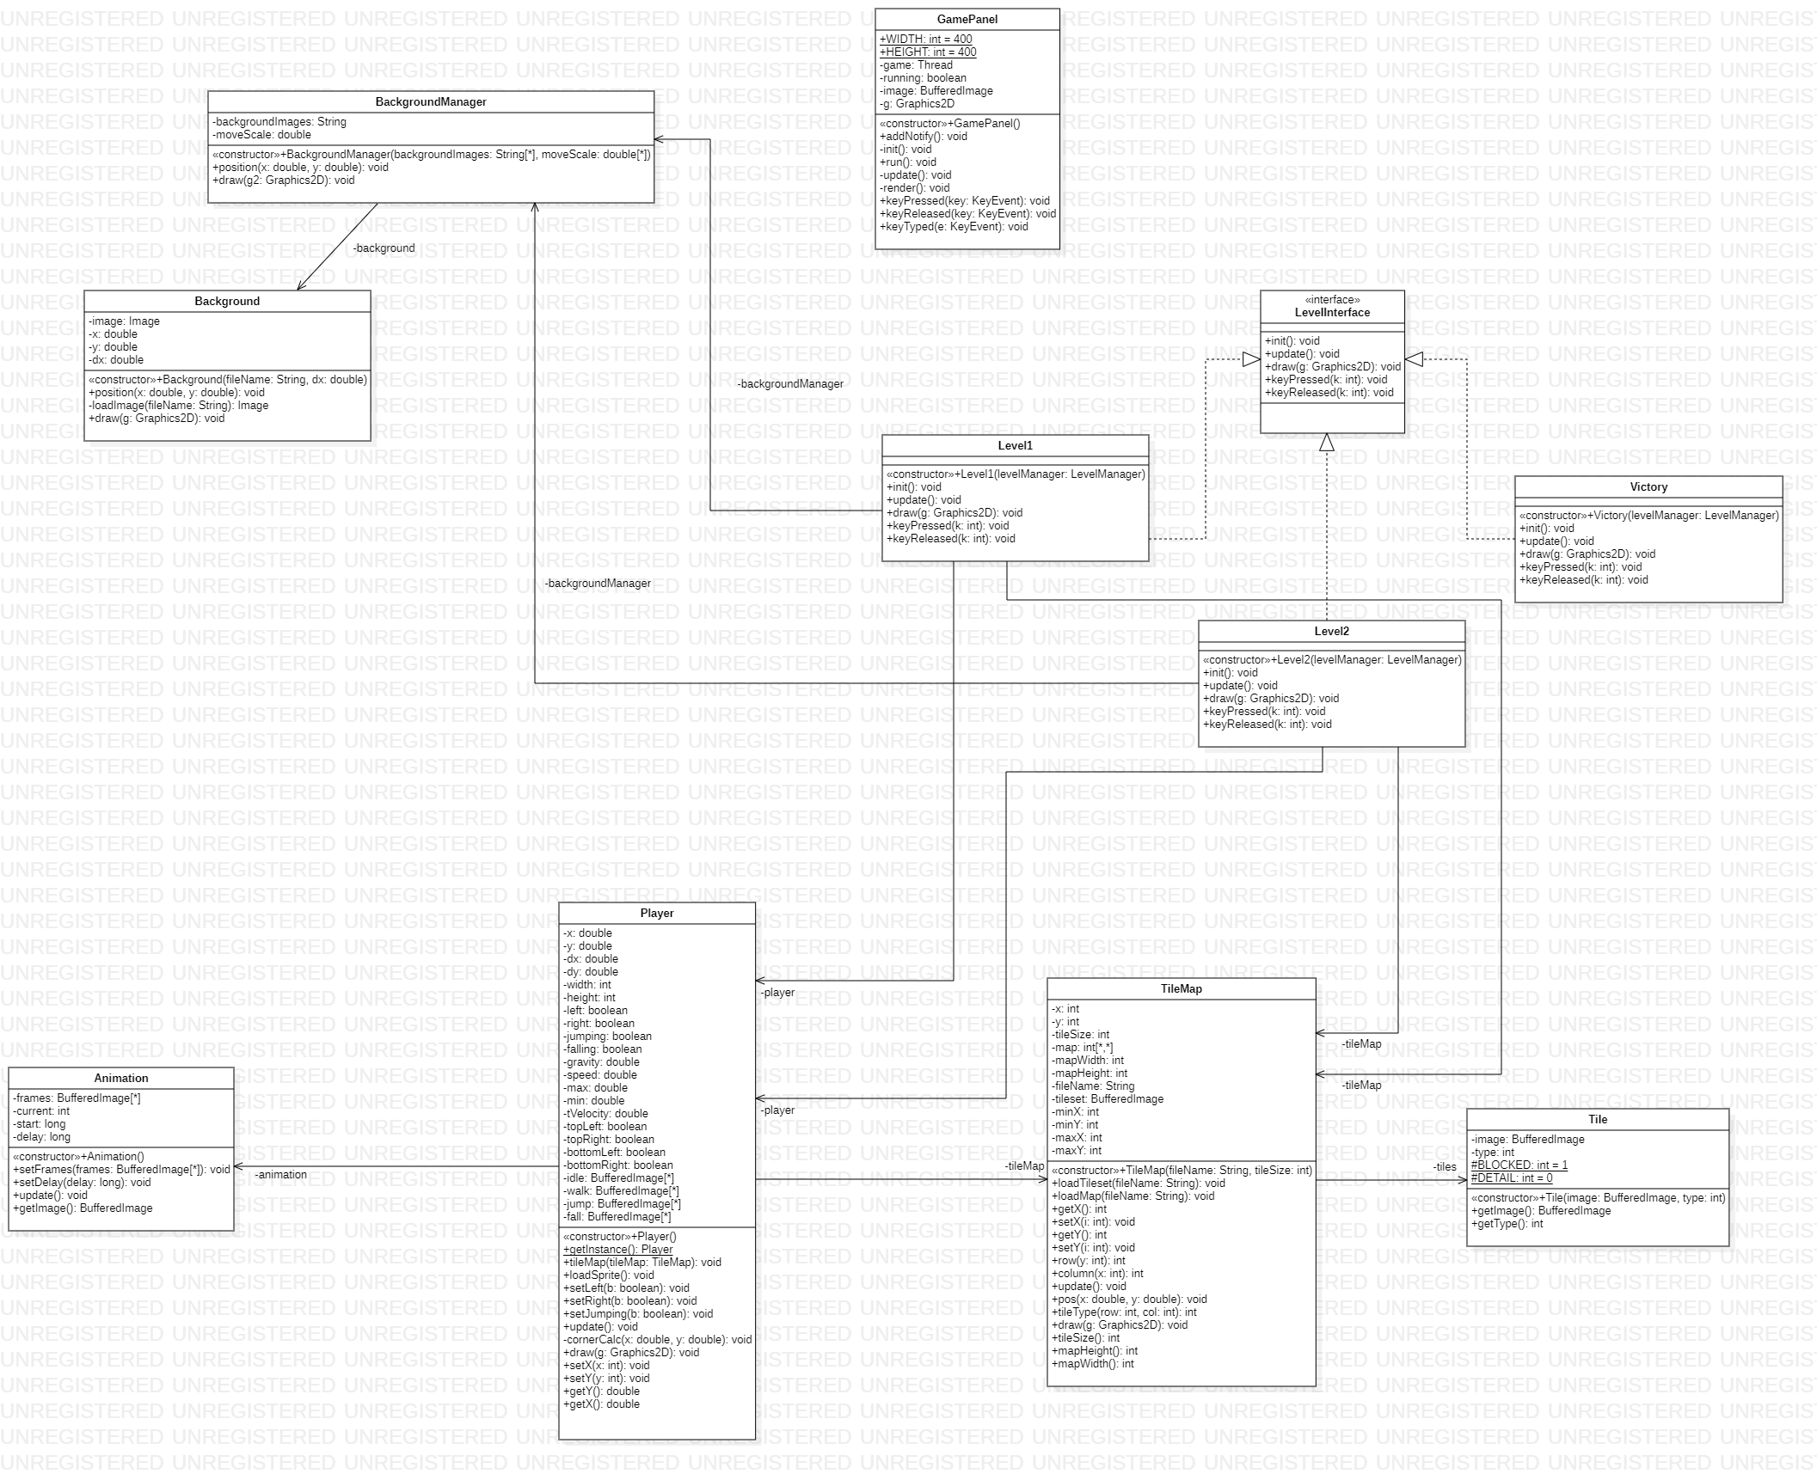

Video:

<https://www.youtube.com/watch?v=rY_RVmo2yFY>