

Literature review

Getting pwn’d by AI: Penetration Testing with Large Language Models
https://dl.acm.org/doi/abs/10.1145/3611643.3613083
Conference: foundations of software engineering
https://2024.esec-fse.org/series/fse - internationally renowned forum for researchers, practitioners, and educators to present and discuss the most recent innovations, trends, experiences, and challenges in the field of software engineering
Reproductibility: Its exploratory, no resarch / code / data to speak of.

Transforming Software Testing in the US: Generative AI Models for Realistic User Simulation
https://ojs.boulibrary.com/index.php/JAIGS/article/view/292/231
Renowned journal: yes
Theme: yes
Repro: probably not

AI Testing Framework for Next-G O-RAN Networks: Requirements, Design, and Research Opportunities
Paywall

Testing of detection tools for AI-generated text
https://link.springer.com/article/10.1007/s40979-023-00146-z?trk=public_post_comment-text
Journal: International Journal for Educational Integrity
Theme: yeah why not
Repro: Yessir - https://www.academicintegrity.eu/wp/technology-academic-integrity-working-group/

Script
Dlaczego warto jako publikację bazową – duża ilość przetestowanych narzędzi, szeroki zbiór danych teksotwych, reputowany żurnal, temat na czasie
Dlaczego spełnia kryteria – spełnia bo spełnia, patrz wyżej
Rozwiązania konkurencyjne – patrz related work/discussion?

Stop Uploading Test Data in Plain Text: Practical Strategies for Mitigating: Data Contamination by Evaluation Benchmarks
https://arxiv.org/abs/2305.10160

Test Coverage in Microservice Systems: An Automated Approach to E2E and API Test Coverage Metrics
https://www.mdpi.com/2079-9292/13/10/1913
Journal: Electronics 2024
promising, not just an exploratory study.
Repro: yessir

Omówienie tematu
Problem: E2E and API testing, and consequently coverage tracking, in distributed applications is difficult. There is a lack of coverage tools for microservice/cloud applications.
the paper introduces automated coverage metrics for evaluating the extent of E2E and API test suite coverage.
Furhtermore, it presents a way to automate those metrics and provides a POC (with source code: https://github.com/cloudhubs/test-coverage-backend )

Concreete solution that is presented: a general coverage calculation technique for both
How does it do it:
API vs E2E testing scheme
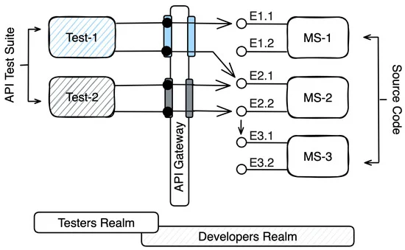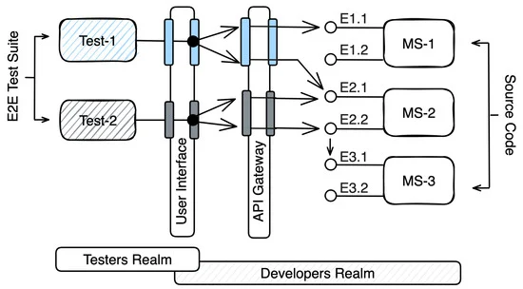
Test coverage metrics in subchapter 3.1 (its just sum and division)
data collection:
- static: source code analysis
- dynamic: logs, traces to identify endpoints called by auto tests
This data is then combined, coverage is calculated and visualised.

how is this automated?
Static Analysis: Extraction of endpoints through purpose specific parsers (eg. relying on JavaSpring endpoint „@” annotations) or AI tools - this generates a list of endpoints categorized into respective endpoints, which are fed into the coverage calculation machine.
Dynamic Analysis: capturing logs and traces from test suites that ran multiple times. The delta of those logs is then calculated to identify traces specific to each test. Trace sequences are then filtered for endpoint traces. This output is fed into the coverage calculation process
Logs, traces and the like are collected and stored via specialised tools, like
once the Machine spits out all the numbers, we move to visualisation

Alternatives

https://newjaigs.com/index.php/JAIGS/article/view/267
this one is for „hardware verification”, but its fine i think.
solution: deep reinforcement based framework for automatic test generation. The framework also incorporates static analysis. Seeks to advance test coverage
https://dl.acm.org/doi/abs/10.1145/3600006.3613161
solution: automatic e2e testing technique for cloud system operators (kuber…). Automatic e2e test generation. It models operations as current state vs desired state (state centric). If the operator doesnt provide a desired state, minimal e2e test code is generated.

Pres Script
Dla czego jako baze – dobra dokumentacja, dane, dziennik, temat ciekawy, przyszłościowy, nie wiem kurwa
Dla czego kryteria – bo tak
rozwiązania konkurencyjne / do porównania – poszukaj podobne prace o tych samych hasłach. Musisz w sumie się dowiedzieć najpierw jakie rozwiązanie oni proponują.
Kluczowy wkład – nie wiem pierdolnij coś od siebie, znasz się.

