**Automatidata**



**Project goal:**

In this fictional scenario, the New York City Taxi and Limousine Commission (TLC) has approached the data consulting firm Automatidata to develop an app that enables TLC riders to estimate the taxi fares in advance of their ride.

**Background:**

Since 1971, TLC has been regulating and overseeing the licensing of New York City's taxi cabs, for-hire vehicles, commuter vans, and paratransit vehicles.

**Scenario:**

You are a newly-hired data professional at Automatidata, a fictional data consulting firm. Automatidata’s focus is to help clients transform their unused and stored data into useful solutions. In this scenario, you will consult with The New York City Taxi & Limousine Commission to develop an app that will help users (TLC riders) estimate their taxi fares before their ride.

## Course 1 tasks:

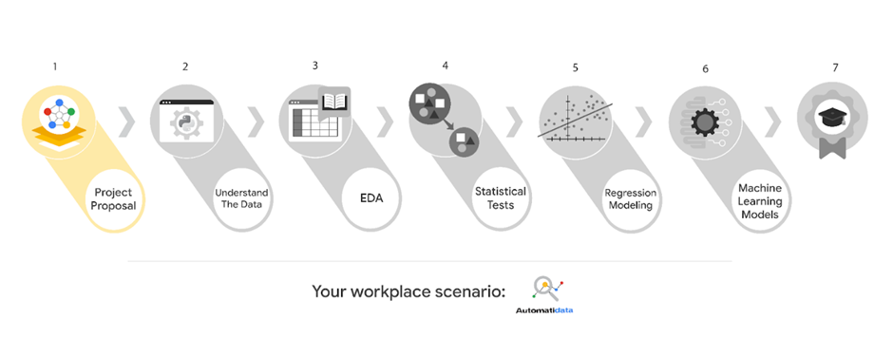

* Gather information from the notes from the last executive meeting of Automatidata
* Assign PACE stages to the requested tasks
* Organize tasks into milestones
* Create a project proposal for the executive team’s approval

## Course 2 tasks:

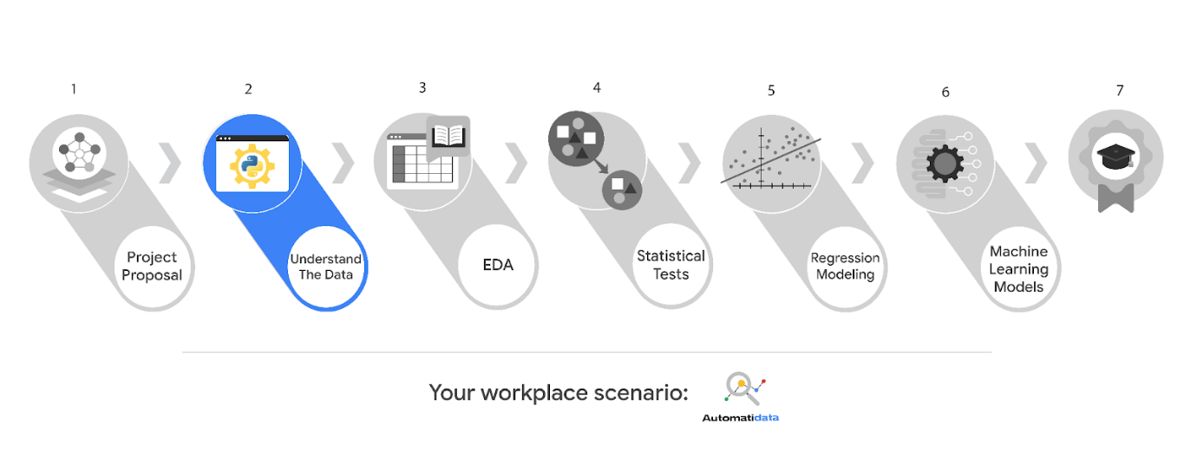

* Build a dataframe for the TLC dataset
* Examine data type of each column
* Gather descriptive statistics

## Course 3 tasks:

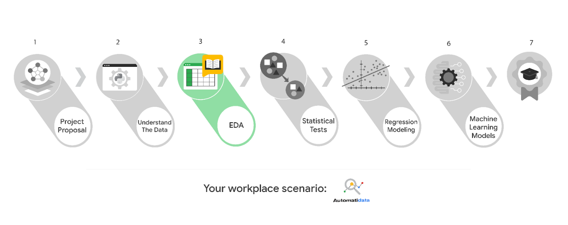

* EDA and cleaning
* Select and build visualization(s) type
* Create plots to visualize relationships between relevant variables
* Share your results with the Automatidata team

## Course 4 tasks:

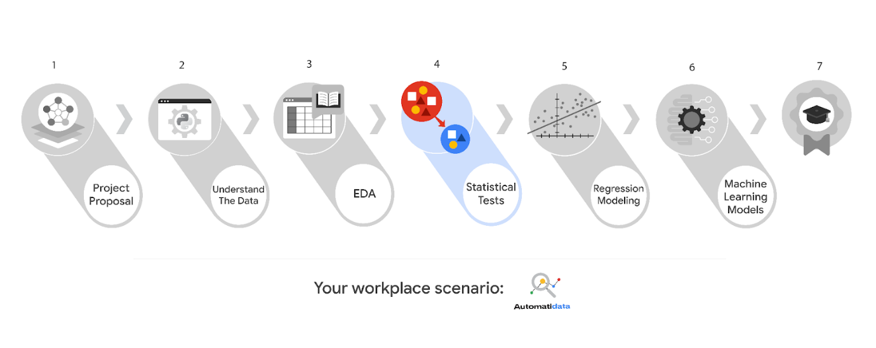

* Explore the project data
* Implement a hypothesis test
* Communicate insights with team members and TLC stakeholders

## Course 5 tasks:

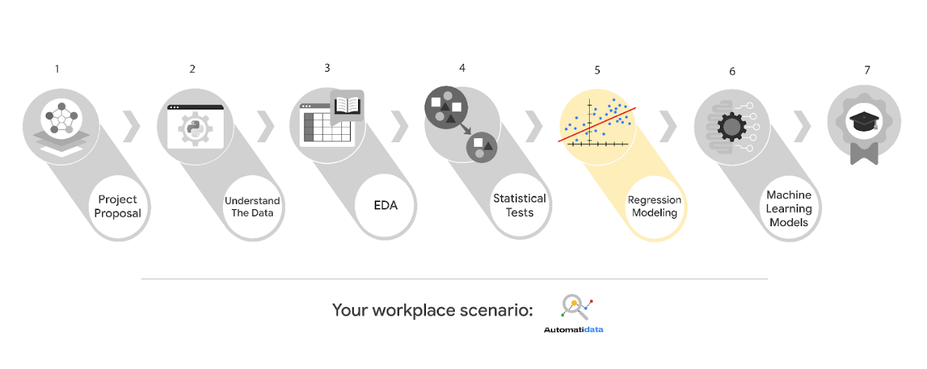

* Determine the correct modeling approach
* Build a regression model
* Finish checking model assumptions
* Evaluate the model
* Interpret model results and summarize findings for stakeholders within TLC

## Course 6 tasks:

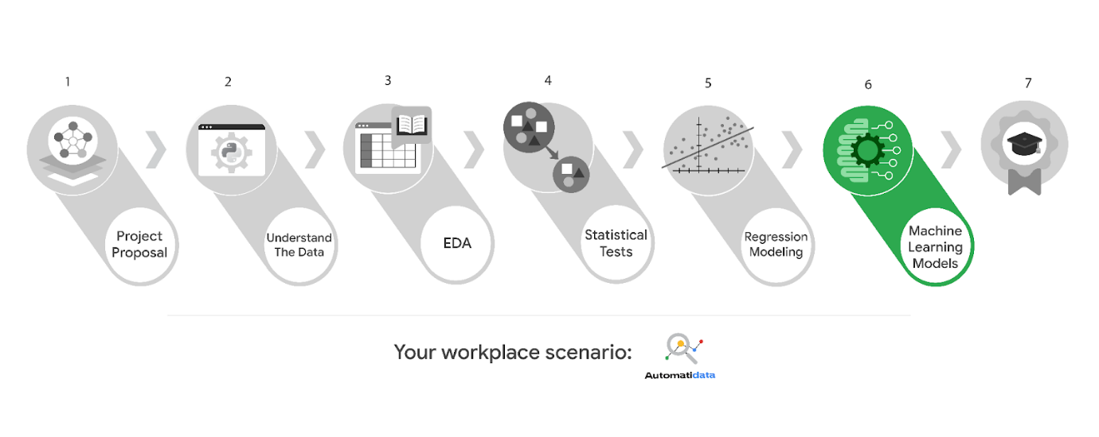

* Model building
* Model evaluation
* Summarize findings for Automatidata and the stakeholders at TLC

***Note:*** *The story, all names, characters, and incidents portrayed in this project are fictitious. No identification with actual persons (living or deceased) is intended or should be inferred. And, the data shared in this project has been created for pedagogical purposes.*