**TikTok**



**Project goal:**

The TikTok data team is developing a machine learning model for classifying claims made in videos submitted to the platform.

**Background:**

TikTok is the leading destination for short-form mobile video. The platform is built to help imaginations thrive. TikTok's mission is to create a place for inclusive, joyful, and authentic content–where people can safely discover, create, and connect.

**Scenario:**

As a data analyst on TikTok's data team, with new considerations from the leadership team, you will create a project proposal by assigning the required data analytical tasks into realistic milestones that will advise future steps in the claims classification project.

## Course 1 tasks:

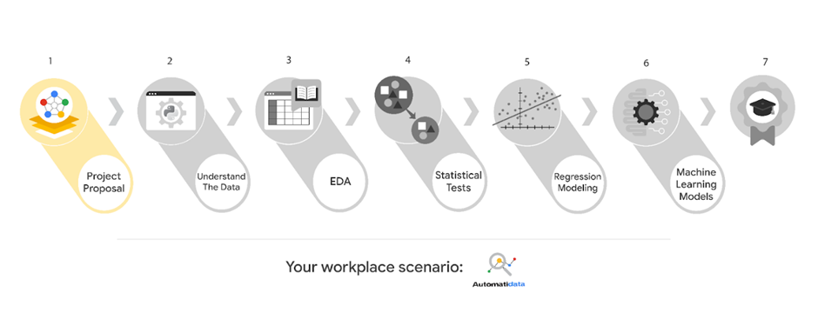

* Gather information from stakeholder notes from within TikTok
* Assign PACE stages to the requested tasks for the classification project
* Organize tasks into milestones
* Create a project proposal for the TikTok data team

## Course 2 tasks:

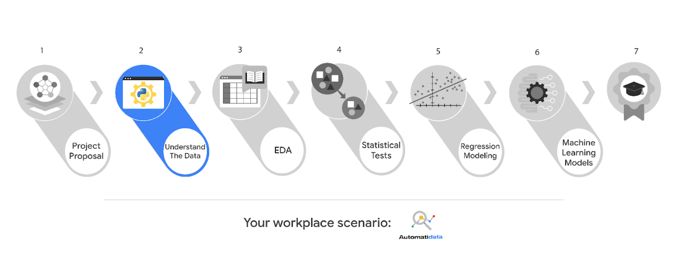

* Build a dataframe for the TikTok dataset
* Examine data type of each column
* Gather descriptive statistics

## Course 3 tasks:

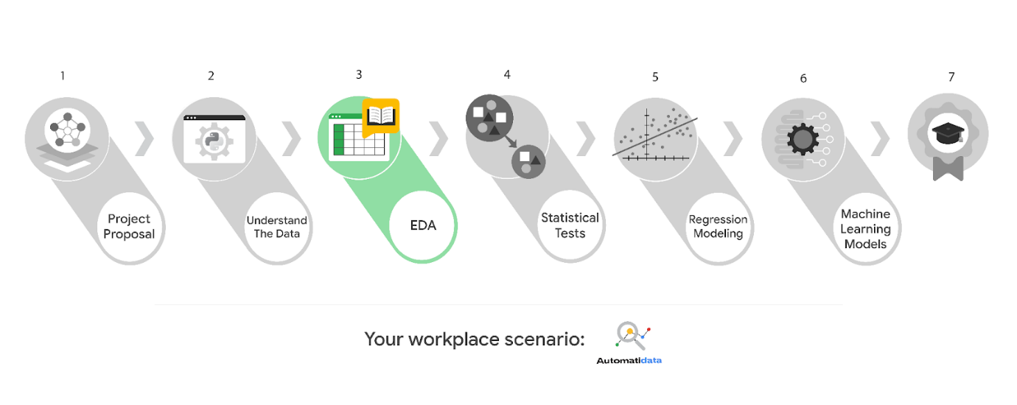

* EDA and cleaning
* Select and build visualization(s) type
* Create plots to visualize relationships between relevant variables
* Share your results with the TikTok team

## Course 4 tasks:

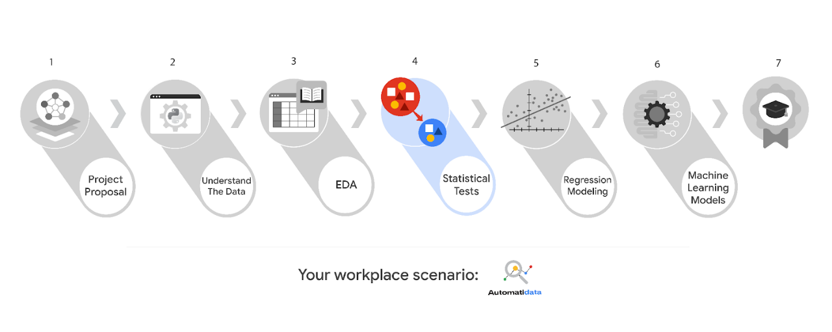

* Explore the project data
* Implement a hypothesis test
* Communicate insights with stakeholders within TikTok

## Course 5 tasks:

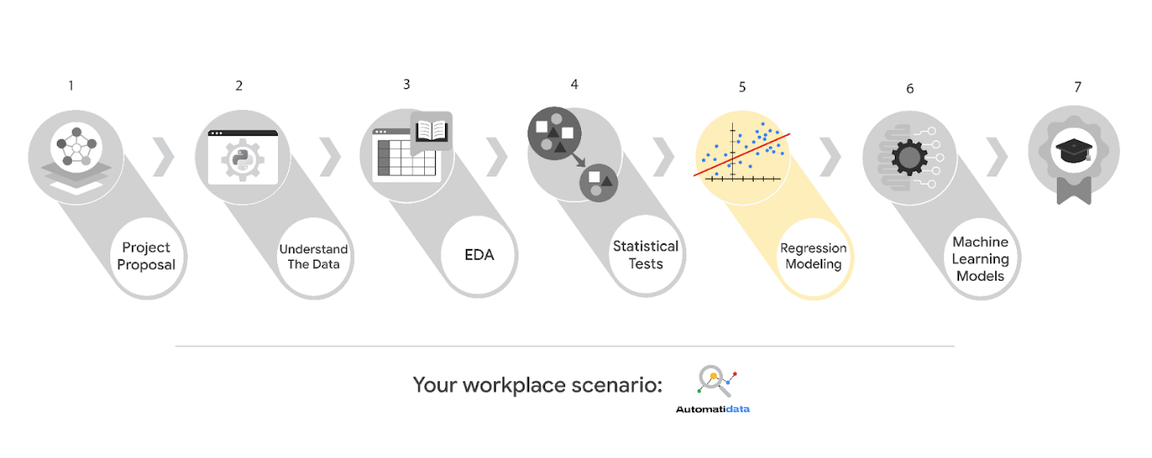

* Determine the correct modeling approach
* Build a regression model
* Finish checking model assumptions
* Evaluate the model
* Interpret model results and summarize findings for cross-departmental stakeholders within TikTok

## Course 6 tasks:

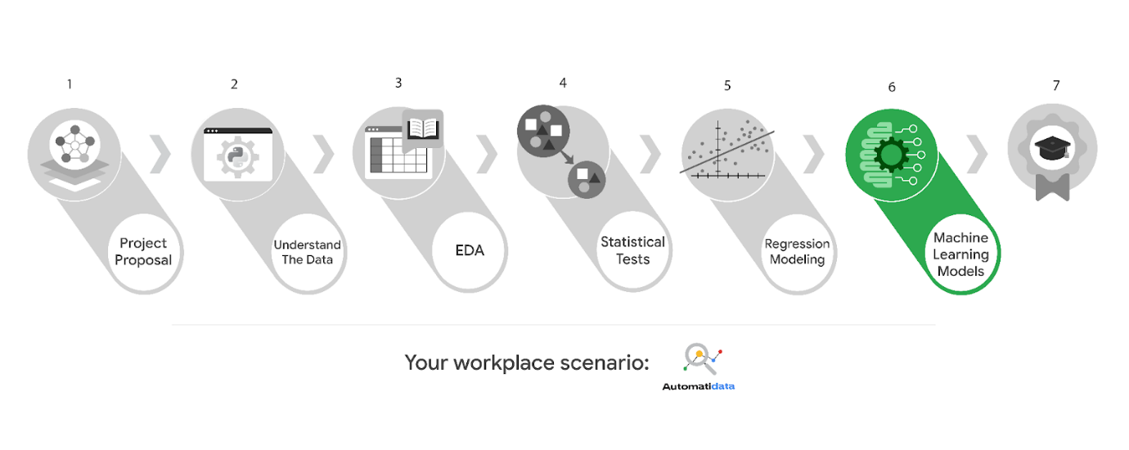

* Model building
* Model evaluation
* Summarize findings for cross-departmental stakeholders within TikTok

***Note:*** *The story, all names, characters, and incidents portrayed in this project are fictitious. No identification with actual persons (living or deceased) is intended or should be inferred. And, the data shared in this project has been created for pedagogical purposes.*