**Course 1 workplace scenarios**

**Waze**



**Project goal:**

Waze leadership has asked your data team to develop a machine learning model to predict user churn. Churn quantifies the number of users who have uninstalled the Waze app or stopped using the app. This project focuses on monthly user churn. An accurate model will help prevent churn, improve user retention, and grow Waze’s business.

**Background:**

Waze’s free navigation app makes it easier for drivers around the world to get to where they want to go. Waze’s community of map editors, beta testers, translators, partners, and users helps make each drive better and safer.

**Scenario:**

You are the newest member of Waze’s data team. Your team is about to begin their user churn project. The first step is to create a project proposal. The proposal will clearly define the overall goal of the project, and identify key tasks, milestones, and stakeholders.

## Course 1 tasks:

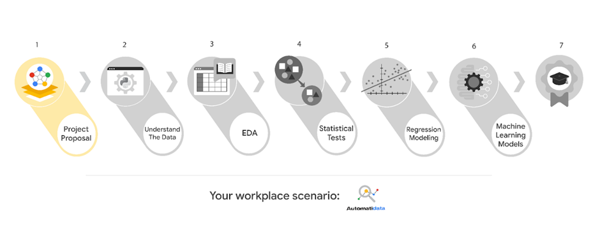

* Assign PACE stages to the requested tasks for the user churn project
* Organize tasks into milestones
* Create a project proposal for the Waze data team

## Course 2 tasks:

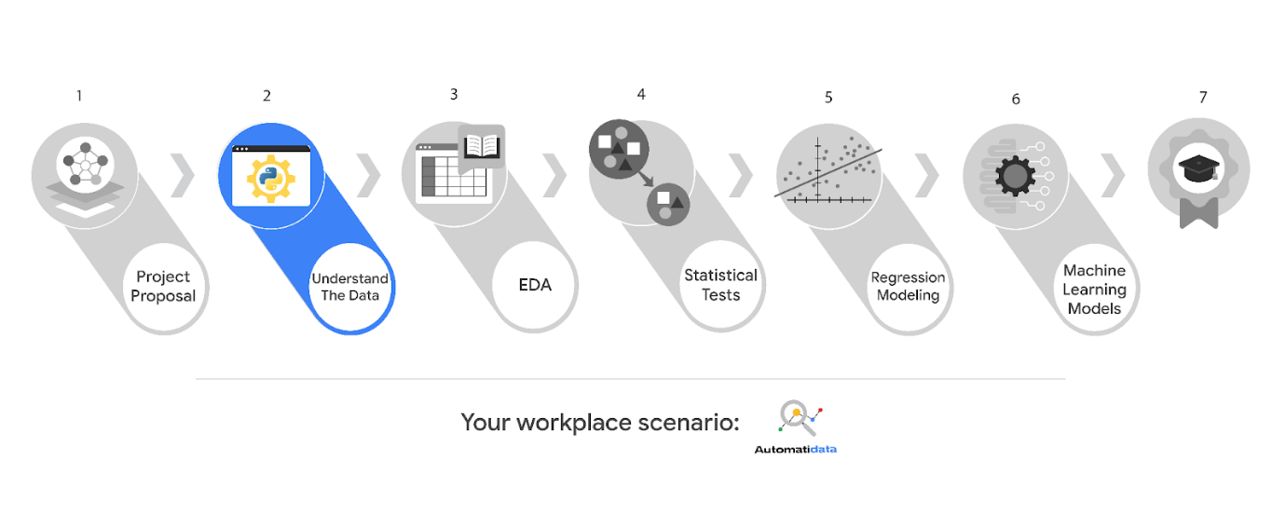

* Build a dataframe for the churn dataset
* Examine data type of each column
* Gather descriptive statistics

## Course 3 tasks:

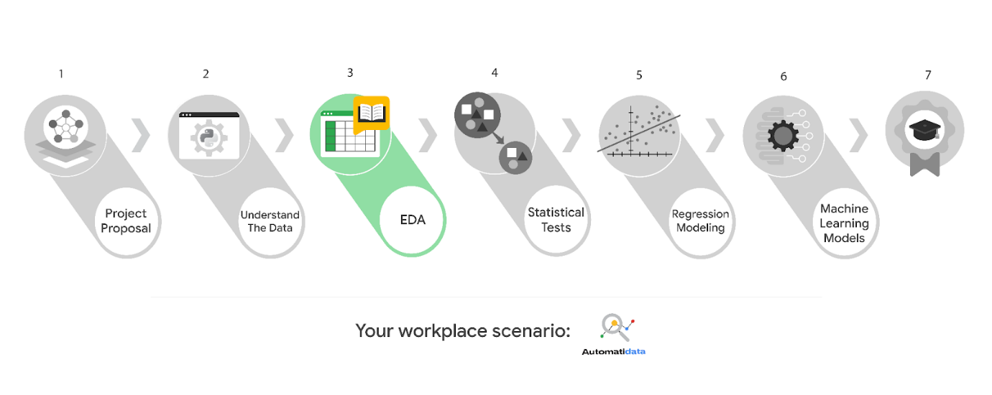

* EDA and cleaning
* Select and build visualization(s) type
* Create plots to visualize variables and relationships between variables
* Share your results with the data team

## Course 4 tasks:

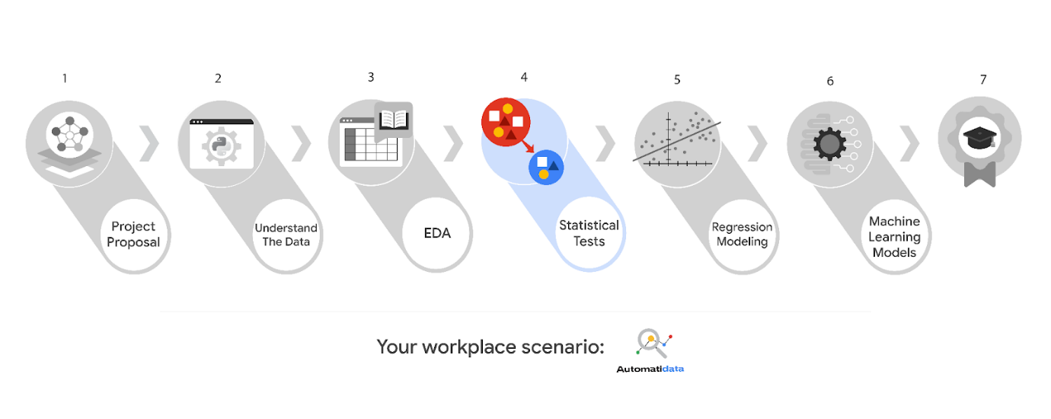

* Explore the project data
* Implement a hypothesis test
* Communicate insights with stakeholders within Waze

## Course 5 tasks:

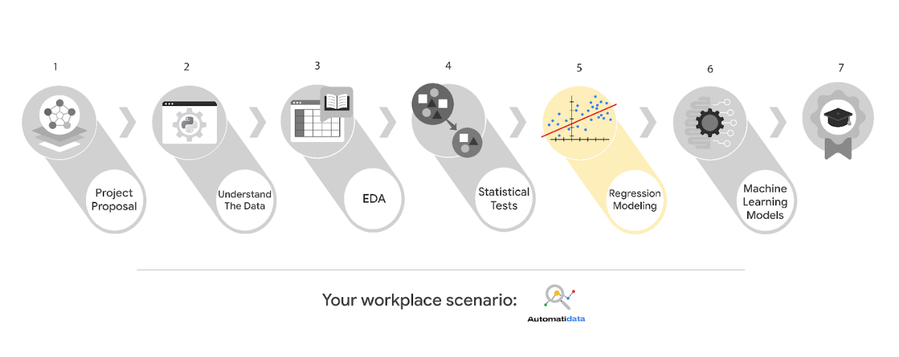

* Determine the correct modeling approach
* Build a regression model
* Finish checking model assumptions
* Evaluate the model
* Interpret model results and summarize findings for cross-departmental stakeholders within Waze

## Course 6 tasks:

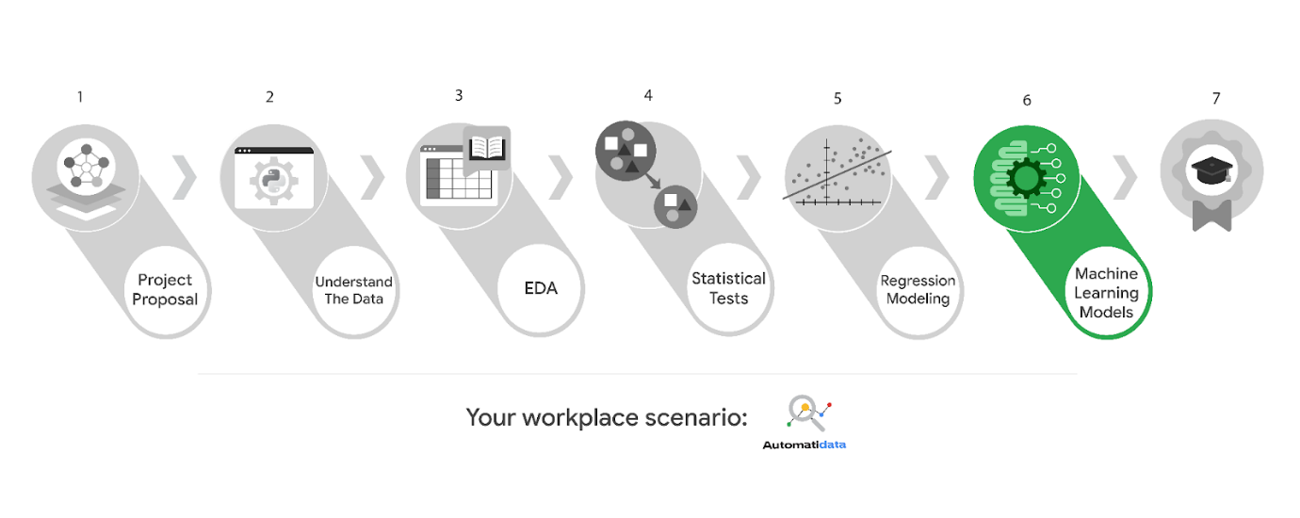

* Model building
* Model evaluation
* Summarize findings for cross-departmental stakeholders within Waze

***Note:*** *The story, all names, characters, and incidents portrayed in this project are fictitious. No identification with actual persons (living or deceased) is intended or should be inferred. And, the data shared in this project has been created for pedagogical purposes.*