SBC8080 (Single Board Version) Addendum

SBC8080 (Single Board Version) described here are a design derived from 2-board version by Vintagechips (Suzuki-san). This board is software compatible, and generally hardware compatible, but some intended changes mainly due to single board modification. Differences, notices and tips will be shown here. Please, refer a fine documents by Suzuki-san’s for any other general topics not shown here.

This board are a part of a loose-kit. You have to orde r(or make) print-circuit board by yourself. This SBC has a high component density, so please understand that it is a step more difficult to build than the original SBC8080. Furthermore, you have to prepare EPROM and GAL programmer. China-made equipents would be a good option.

Specifications

- Hardware changes
・Some components has changed. I’ll show them in a parts-list chapter.
・+12V and /RESIN signals are deleted from SBCBUS. /RESIN pin are reused as INTA signal.
・The power switch has been removed.
・Since the EPROM and 8251A are directly connected to the data bus, please do not overload it.
・The connector for the serial conversion cable is oriented in the opposite direction to the SBC8080SUB board. Install it upside down compared to the SBC8080 technical documentation. The following orientation is correct.

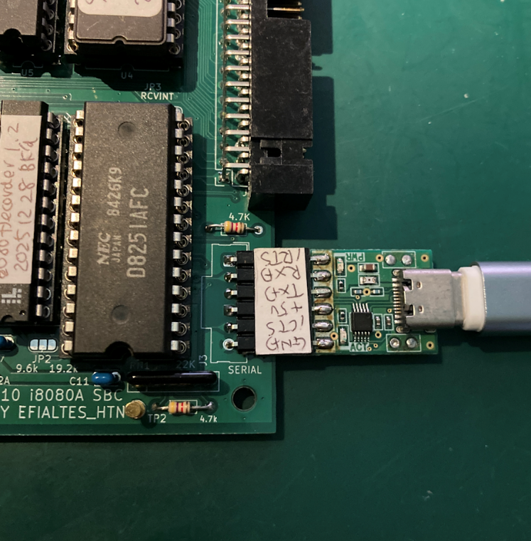

- Software changes
・The address map has been modified.
The ROM implementation area has been reduced to 16KB, from 0000H to 3FFFH. This was done to allow for the use of approximately 16KB of memory in future sub-boards.
Also, the allocation of the 8251A in the I/O space has been narrowed to 00H to 03H. This shouldn't be a problem.
・Default serial baud rate is now set to 19,200bps. If you need 9600bps, please change a jumper shown below.

I will explain jumpers in more detail in below.

HOW TO MAKE THIS BOARD

The parts list is attached below.

Reference | Value | Qty | 部品仕様
C1 | 470pF 25V | 1 | Multilayer ceramic capacitor
C2 | 10μF16V | 1 | Electrolytic capacitor
C14 | 10μF16V | 1 | polymer capacitors
C3 | 10pF 25V | 1 | Multilayer ceramic capacitors
C4 | 270μF16V | 1 | Electrolytic capacitor（for HIGH-Ripple）8mmΦ
C5 | 470μF 25V | 1 | polymer capacitors 8/10mmΦ
C6,C7,C8,  C9,C10,C11,  C12,C15,  C16,C17 | 0.1μF 25V | 10 | Multilayer ceramic capacitors（recommend X5R/X7R）2.54mm巾
C13 | 0.047μF 25V | 1 | Multilayer ceramic capacitors
D1 | 1S2076 | 1 | Signal Swithcing Diode
D2 | 1S4 | 1 | Schottky diode
D3 | LED | 1 | Any LED is OK.
D4,D5 | BAT43 | 2 | Schottky diode
J1 | Barrel_Jack_Switch | 1 | 2.1mmΦ standard DC jack
J2 | SBCBUS | 1 | 40-pin L-type box header
J3 | Serial | 1 | Single-row L-type pin header
L1 | 100μH PWR | 1 | 100μH（1.2A）inductor
R1 | 0.47 1W | 1 | Metal oxide film resistor
R2,R4,R5,  R10,R11 | 4.7K | 5 | Carbon resistor 1/6W
R3 | 330 | 1 | Carbon resistor 1/6W
R6 | 13k 1% | 1 | Metal film resistor 1/6W
R7 | 1.5k 1% | 1 | Metal film resistor 1/6W
R8,R9 | 1K | 2 | Carbon resistor 1/6W
R12 | 100 | 1 | Carbon resistor 1/6W
R13,R14 | 27 | 2 | Carbon resistor 1/6W
RN1 | 22k | 1 | Resister network(4 element)
SW1 | RESET | 1 | Small Tactile Switch
TP1 | PHI2T | 1 | Optional
TP2 | TPGND | 1 | Optional.
U1 | i8080A | 1 | Intel 8080A Equivalent
U2 | uPD8224 | 1 | Intel 8224 Equivalent
U3 | i8238 | 1 | Intel 8228/8238 Equivalent
U4 | 27C512 | 1 | 27256/27512 Equivalent
U5 | HM62256BLP | 1 | 300mil Width HM62256 Equivalent
U6 | i8251A | 1 | Intel 8251A Equivalent
U7 | DEC8080A | 1 | ATF22V10 Equivalent
U8 | MC34063AP | 1 | MC34063A equivalent.
U9,U10 | 74HC244 | 2 | 74 logic。
X1 | 18.432MHz | 1 | Crystal resonator HC-49U
S1 | 2227MC-08-03 | 1 | 8-pin IC Socket
S2 | 2227MC-16-03 | 1 | 16-pin IC Socket
S3,S4 | 2227MC-20-03 | 2 | 20-pin IC Socket
S5 | 2227MC-24-03 | 1 | 24-pin 300mil IC Socket
S6 | 2227MC-28-03 | 1 | 28-pin 300mil IC Socket
S7,S8,S9 | 2227MC-28-06 | 3 | 28-pin 600mil IC Socket
S10 | 2227MC-40-06 | 1 | 40-pin IC Socket

・A solid polymer capacitor is recommended for C14. A 10μF 50V multilayer ceramic capacitor is also OK. While electrolytic capacitors should function without problems, the voltage output will be lower.
・Use capacitors for high ripple use for C4 and C5 (especially C5). If unsure, use solid polymer capacitors. Both should be around 220-470μF. Larger capacities will likely not fit PCB space.
・Use approximately 50-100Ω for R12. For R13-R14, use approximately 27Ω if using SN74LS424 as an 8224 compatible component. 27Ω is acceptable for Intel and NEC compatible components, but simply shorting them should also work.
・Pay attention to the package width of the U5 memory. Both 600mil and 300mil widths are commercially available. 300mil packages are sometimes sold under the name SDIP.
・U4 and U7 require programming. Please program the JED file from this website into U7. For U4, please program the file obtained from Denno Densetsu.
・TP1 and TP2 test points are for debugging. Use them is up to your preference.
・The DC-DC circuit has been modified to account for intermittent oscillation. A 47μH inductor is acceptable, but please choose one that can handle around 1A.
・1/6W resistors are assumed. 1/4W resistors may fit if forced in
・A USB serial cable and a 5V 2A 2.1mmΦ AC adapter are also required. During debugging, I used products from Akizuki Denshi Tsusho. For the former, I used a USB cable and the "CH340E USB Serial Conversion Module Type-C" during debugging.
・Newer Akizuki Barrel_Jack_Switches appear to have plastic protrusions for position adjustment. Since this is not compatible, please break off the protrusions.

Jumpers

This board provides several solder jumpers for configuration flexibility. The jumper locations are shown below. JP1 and JP2 are 3-pad jumpers, while JP3 and JP4 are 2-pad jumpers. The pad marked with a small triangle is pin 1. On the finished board, the default side is shorted; to change this, you must cut the default side with a knife or similar tool. JP4 only needs to be connected.

JP1： Short between 1 and 2 (default). EPROM is 27512 type.
Short between 2 and 3. EPROM is 27256 type.

JP2： Short between 1 and 2 (default). Serial speed is 19,200bps.
Short between 2 and 3. Serial speed is 9,600bps.

JP3： Short (default) Directly connects the 8251A receive interrupt to the 8080A interrupt (INT terminal).
Open The above direct connection is not performed.

JP4： Open (default) Does not connect the INTA of the 8228/38 to SBCBUS.
Short Connects the INTA of the 8228/38 to SBCBUS.
If you want short this jumper, remove R8 (1kΩ) in the upper left.

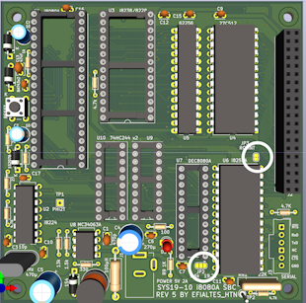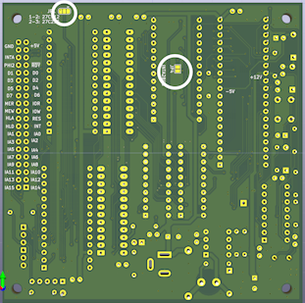
Position of JP2、JP3 Position of JP1、JP４

//

