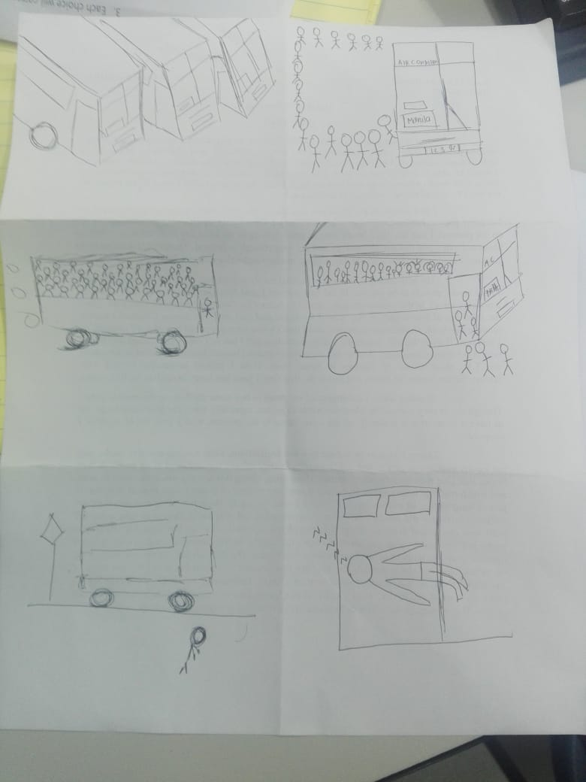

After a long day, it is finally time to go home. There are those who rides the bus when going to/from their houses. And it is a daily part of their lives



Every day is the same. Upon arrival a long line awaits. Passengers eager to go home with their families or spend their time on personal hobbies.



As one might expect, this time of the day is where people rush in. Clocking out of their school and offices at the same time will result with the buses becoming full in a blink of an eye.



The passengers just keep on coming and wont stop coming, even if the bus is on the way to its destination. The experience becomes like being a can of sardines.



As the passengers drop-off their stops, they become more tired than in their work more often than not. It was as if all of their energy was spent on that bus ride alone.



Thus, another day has gone by, and tomorrow will be another one. Doing the same things like the day that went away.