SmartCOMM GenAI Platform
Agent Design Pattern Guideline
Common LLM Gateway • Confidentiality-Based HITL Routing • Pluggable MCP Agent Framework
Companion to: SmartCOMM GenAI Platform – Solution Design Document, Agentic Architecture Edition v3.0
Version 1.2 | July 2026
CONFIDENTIAL

1. Purpose & Scope
This guideline defines three mandatory design patterns that every SmartCOMM GenAI Platform agent — existing and future — must follow. It is a companion to, and does not replace, the Solution Design Document (Agentic Architecture Edition v3.0). Where the base design describes the platform's layered hub-and-spoke architecture, this document specifies the concrete contracts, sequences and guardrails that make agents interoperable, governable and safe to extend.
The three patterns are:
- Pattern 1 — Common LLM Invocation Gateway: agents never call an LLM provider SDK or endpoint directly; all model calls go through a single, shared LLM Gateway API.
- Pattern 2 — Confidentiality-Score-Based HITL Routing: every agent output is scored for confidentiality/sensitivity, and that score — not just the existing confidence score — determines whether the task is auto-completed, supervised, or sent for mandatory human review.
- Pattern 3 — Pluggable Agent Framework via MCP: new agents (internal or third-party) are onboarded through a standard API-based Agent Interface Contract exposed over MCP, so they can be registered and invoked without changes to the Orchestrator or Gateway core.
This document applies to all agents listed in the Specialist Agent Catalogue (Section 5.2 of the base design) and to any agent added in MVP2, MVP3 or post-GA.

2. Alignment with the Base Architecture
The patterns in this guideline extend components already defined in the base design rather than introducing new layers. The mapping below traces each pattern to the base document section it governs.
Pattern | Base Design Component Extended | Base Section
Common LLM Gateway | Multi-LLM Pool + AI Gateway Multi-LLM Router | 3.3 Architecture Layers; 10. Technology Stack
Confidentiality-Based HITL | Orchestrator HITL Escalation + AIC confidence_score / hitl_required fields | 5.1 Orchestrator; 5.3 Agent Interface Contract
Pluggable Agent Framework (MCP) | Agent Interface Contract (AIC) + Tool & Knowledge Layer (SmartCOMM MCP) | 5.3 AIC; 3.3 Tool & Knowledge Layer

3. Design Principles for Agents
Every agent design or code review should be checked against these principles before it is accepted into the platform.
- No direct model calls. An agent process must have no outbound network permission to any LLM vendor endpoint; all reasoning calls route through the Common LLM Gateway.
- Stateless agent runtime. Agents hold no long-lived session state themselves; context is propagated by the Orchestrator or carried in the request payload, so agents can scale horizontally and be replaced without data loss.
- Score before you ship. Every agent output carries both a confidence_score (“is this likely correct”) and a confidentiality_score (“is this data sensitive”). Routing decisions use both, independently.
- Contract over convention. Agents are integrated through the published Agent Interface Contract (AIC) and an MCP manifest — never through bespoke point-to-point wiring to the Orchestrator.
- Everything is observable. Every LLM call, every routing decision and every human review action is emitted as an OpenTelemetry span tied to a parent session/audit ID.
- Fail closed on sensitivity. When an agent cannot compute a confidentiality score, or a scoring service is unavailable, the platform defaults to mandatory human review — never to auto-completion.

4. Pattern 1 — Common LLM Invocation Gateway

4.1 Problem Statement
In the base architecture, eight specialist agents each carry their own LLM tech stack (GPT-4o, GPT-4o-mini, Claude 3.5, Gemini, Groq, DeepSeek, HuggingFace, Cohere). If each agent calls its model provider directly, the platform ends up with: credentials scattered across agent repos, no single point for cost tracking or rate limiting, inconsistent guardrails/PII handling, and no consistent way to swap or A/B test models without redeploying agents.

4.2 Pattern Description
All agents call one internal, versioned API — the Common LLM Invocation API — instead of calling Azure OpenAI, Anthropic, Google or any other provider SDK directly. The Gateway owns provider credentials, model routing, cost metering, prompt/PII guardrails, caching and audit logging. Agents only know the Gateway's contract; they never know which underlying model actually served the request unless they explicitly pin one.
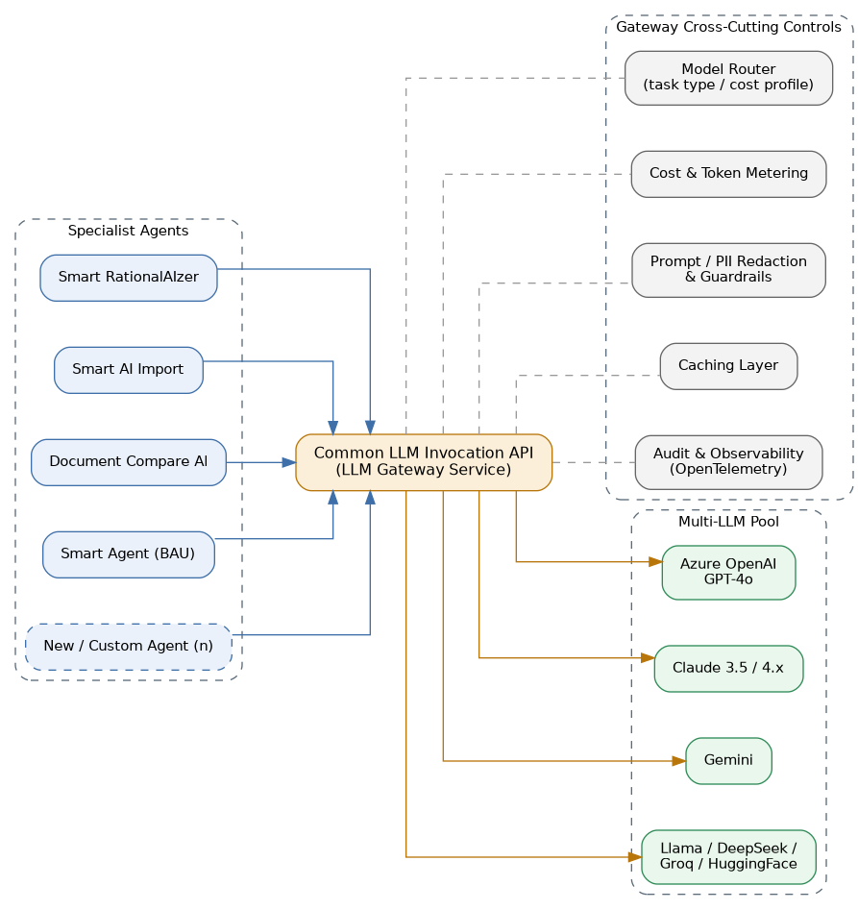
Figure 1: Agents call a single Common LLM Invocation API; the Gateway owns routing, metering, guardrails and provider fan-out.

4.3 Interface Contract
The Gateway exposes one primary endpoint that every agent SDK wraps:
POST /llm-gateway/v1/complete
Authorization: Bearer <service JWT> (agent identity, not end-user identity)
Content-Type: application/json

{
"agent_id": "smart-ai-import",
"task_type": "template_generation",
"cost_profile": "standard | premium | economy",
"preferred_model": null,
"messages": [ ... ],
"max_tokens": 2048,
"temperature": 0.2,
"session_context": { "session_id": "...", "parent_audit_id": "..." },
"data_classification": "internal | confidential | restricted"
}
200 OK
{
"status": "success",
"model_used": "gpt-4o-2024-11",
"content": "...",
"usage": { "prompt_tokens": 812, "completion_tokens": 340, "cost_usd": 0.014 },
"cache_hit": false,
"guardrail_flags": [],
"trace_id": "otel-span-id"
}

4.4 Responsibility Split
Concern | Agent Responsibility | Gateway Responsibility
Model selection | Declares task_type and cost_profile only | Applies Model Router policy; selects concrete model/version
Credentials | Holds none | Holds all provider API keys in Vault; rotates independently of agents
Cost control | Reports task context | Meters tokens/cost per agent, per session; enforces budget caps
PII / guardrails | Passes data_classification | Runs redaction, prompt-injection and output-safety checks pre/post call
Caching | None required | De-duplicates identical prompts within a TTL window to cut cost/latency
Observability | Forwards parent_audit_id | Emits OpenTelemetry span per call, linked to the session trace
Failover | Retries idempotently on 5xx | Fails over across providers per routing policy on outage or rate limit

4.5 Implementation Guidelines
- Ship a thin client library (Python + TS) that wraps the Gateway endpoint; agents import the library, not an OpenAI/Anthropic/Gemini SDK.
- Enforce network policy at the Kubernetes namespace level: agent pods have egress only to the Gateway service and SmartCOMM MCP, not to public LLM endpoints.
- Model routing policy (cost profile → model) lives in the Gateway's configuration, hot-reloadable without redeploying agents.
- Every Gateway response includes model_used and trace_id so downstream audit and cost dashboards can attribute usage per agent, per model, per workflow.
- New models or providers are onboarded once, in the Gateway, and are immediately available to every agent — no agent code changes required.
Anti-pattern to reject in review
An agent repo that imports “openai”, “anthropic”, “google-generativeai” or similar provider SDKs directly, or stores a provider API key in its own config/secret — even “temporarily for a POC.” Route it through the Gateway client library instead.

5. Pattern 2 — Confidentiality-Score-Based Human Review Routing

5.1 Problem Statement
The base design's HITL escalation triggers on confidence_score alone — i.e. “how sure is the model.” That is necessary but not sufficient: an agent can be highly confident about an output that nonetheless contains PII, regulated content (HIPAA/NAIC, as called out for GenAI Trans), commercially sensitive terms, or customer financial data. This pattern adds a second, independent score — confidentiality — so that sensitive content is reviewed by a human regardless of how confident the model was.

5.2 Confidentiality Scoring Model
Every agent computes, or requests from a shared Confidentiality Scoring Service, a score between 0.0 and 1.0 representing the sensitivity of the task input and output. The score is a function of:
- Data classification tag carried on the request (internal / confidential / restricted), inherited from the source document or ticketing system.
- PII / PHI / PCI detection results (names, SSNs, account numbers, health terms) from the Gateway's guardrail layer.
- Regulatory scope of the workflow (e.g. HIPAA or NAIC-relevant content in GenAI Trans translation jobs).
- Business sensitivity flags set on the template or customer account (e.g. legal hold, VIP customer, contractual confidentiality).
- Destination/channel of the output (external customer-facing communication scores higher than an internal QA report).

5.3 Threshold Bands and Routing
Band | Confidentiality Score | Routing Behaviour
Low | 0.00 – 0.29 | Auto-complete. Result returned to Orchestrator/caller; logged for audit, no reviewer action required.
Medium | 0.30 – 0.69 | Supervised continue. Result is delivered but a reviewer is notified asynchronously and can recall/amend within an SLA window.
High | 0.70 – 1.00 | Mandatory human review. Task pauses; output is queued in the Shell UI HITL queue and cannot proceed until a reviewer approves, edits or rejects it.
Undetermined | score unavailable | Fail closed — treated as High. Never defaults to auto-complete.
Thresholds are configurable per agent and per workflow step in the Admin & Settings module (Section 4.2 of the base design), but the High-band “mandatory review, fail closed” behaviour is a platform invariant and cannot be disabled by configuration.
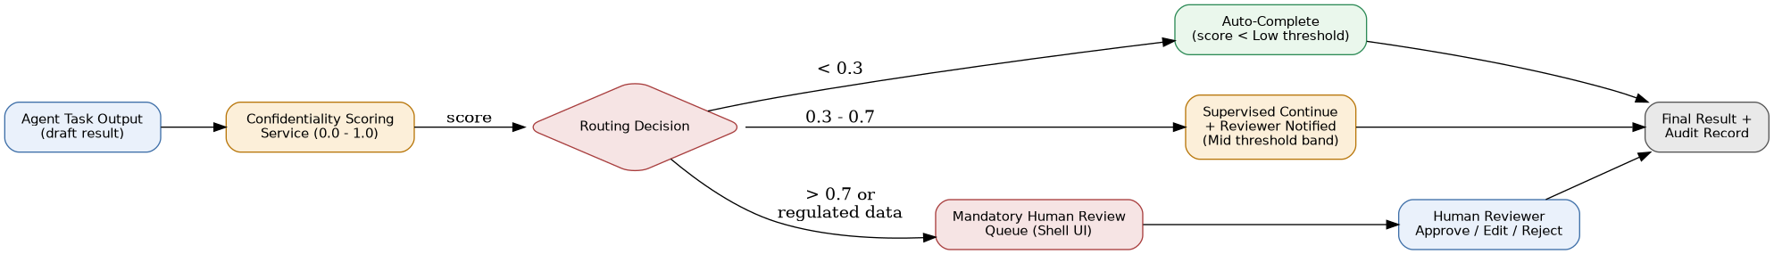
Figure 2: Confidentiality score drives auto-complete, supervised-continue, or mandatory human review.

5.4 Relationship to Confidence Score
The two scores are evaluated independently and combined with an OR rule for escalation: a task is sent to mandatory human review if confidence_score falls below its own threshold OR confidentiality_score falls into the High band. This preserves the existing base-design behaviour (escalate on low confidence) while adding an independent, non-overridable safety net for sensitive data.
Confidence | Confidentiality | Outcome
High | Low | Auto-complete
High | High | Mandatory human review (confidentiality gates it, even though the model is sure)
Low | Low | Mandatory human review (confidence gates it)
Low | High | Mandatory human review (both gate it)

5.5 Escalation Payload Schema
POST /agents/{agent-id}/review
{
"audit_id": "sess-8841-a3",
"agent_id": "genai-trans",
"task_type": "document_translation",
"confidence_score": 0.91,
"confidentiality_score": 0.83,
"confidentiality_reasons": ["PHI_DETECTED", "HIPAA_SCOPE"],
"review_band": "high",
"payload_ref": "s3://smartcomm-hitl/sess-8841-a3/draft.json",
"sla_minutes": 60,
"requested_reviewer_role": "compliance_reviewer"
}

5.6 Reviewer Workflow (Shell UI)
- High-band tasks appear in the existing HITL / BAU Operations Hub queue, tagged with the confidentiality reasons so reviewers understand why the item was flagged.
- Reviewers can Approve (unchanged), Edit-and-approve (captured as a diff for audit), or Reject-and-return-to-agent.
- Medium-band “supervised continue” items appear in a lower-priority notification lane; the reviewer can recall a delivered result within the configured SLA.
- Every decision, reviewer identity, and timestamp is written to the Audit Trail keyed by the same audit_id the Orchestrator uses (Section 5.1 of the base design).

5.7 Implementation Guidelines
- Compute confidentiality_score before the agent returns its result to the Orchestrator, not after — the score must gate delivery, not follow it.
- Keep the scoring function pluggable: start with a rules/regex + entity-recognition baseline, allow later upgrade to an ML classifier without changing the AIC contract.
- Log confidentiality_reasons (not raw sensitive values) so audits can explain a routing decision without duplicating the sensitive data itself.
- Never let an agent silently downgrade a confidentiality score it disagrees with; a downgrade request must itself go through human review.
Anti-pattern to reject in review
An agent that only checks confidence_score before returning a result, or a workflow where the confidentiality threshold can be set to 1.0 (effectively disabling human review) for a specific customer or deadline.

6. Pattern 3 — Pluggable Agent Framework via MCP

6.1 Problem Statement
The base design already requires every agent to implement the Agent Interface Contract (AIC) for “plug-and-play extensibility” (Section 5.3). This pattern makes that concrete: new agents — including third-party or partner-built agents — must be onboardable by registering an API/MCP manifest, with zero code changes to the Orchestrator, AI Gateway or Shell UI.

6.2 Pattern Description
Agents are exposed behind the existing MCP Server Layer (SmartCOMM MCP plus per-agent MCP adapters) in addition to their native REST AIC endpoints. The Orchestrator discovers agent capabilities from an Agent Registry rather than from hard-coded routing tables; the Shell UI's Agent Workbench and Workflow Studio read the same registry to surface new agents automatically.
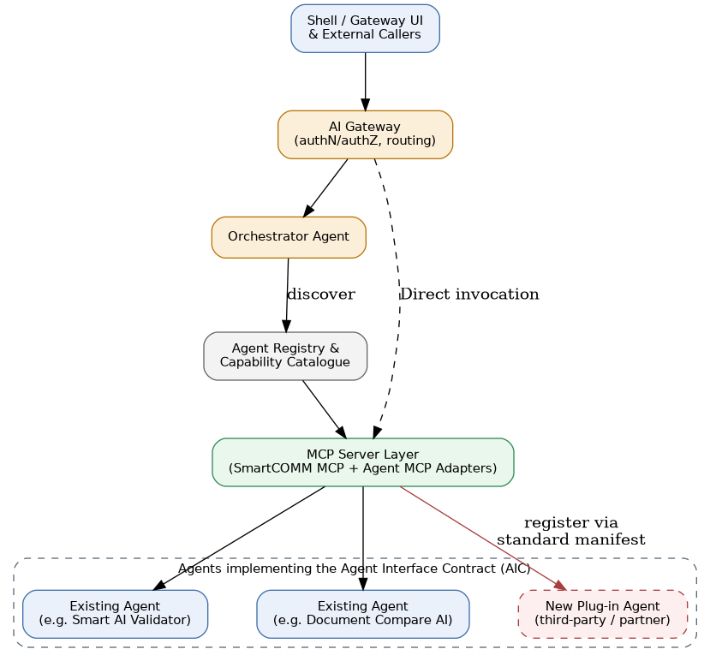
Figure 3: New agents register a standard manifest against the MCP Server Layer and Agent Registry; the Orchestrator and Gateway require no changes to invoke them.

6.3 Onboarding Flow
- 1. Implement the AIC — the agent exposes POST /agents/{agent-id}/invoke, GET /agents/{agent-id}/health, and POST /agents/{agent-id}/review exactly as specified in Section 5.3 of the base design.
- 2. Wrap the AIC in an MCP adapter — a thin MCP server that maps MCP tool calls to the agent's AIC endpoints, so orchestration frameworks (LangGraph/LangChain/Semantic Kernel) and external MCP-aware clients can call it uniformly.
- 3. Publish an agent manifest describing task types, MVP availability, cost profile, confidentiality-scoring capability, and health endpoint.
- 4. Register the manifest with the Agent Registry (a POST to the registry service, or a GitOps PR against a manifest repo, per environment).
- 5. The Orchestrator's Agent Assignment step (Section 5.1 of the base design) picks up the new agent automatically on its next capability refresh — no orchestrator redeploy.
- 6. The Shell UI's Agent Workbench and Admin & Settings module list the new agent automatically once it passes its first health check.

6.4 Agent Manifest Schema
{
"agent_id": "partner-ocr-extractor",
"display_name": "Partner OCR Extractor",
"version": "1.2.0",
"mvp_availability": "MVP3",
"task_types": ["scanned_doc_extraction"],
"invocation": {
"rest_endpoint": "https://partner-ocr.svc/agents/partner-ocr-extractor/invoke",
"mcp_endpoint": "mcp://partner-ocr.svc/mcp",
"supports_direct_mode": true,
"supports_orchestrated_mode": true
},
"llm_usage": "via-common-gateway",
"confidentiality_scoring": "supported",
"health_endpoint": "/agents/partner-ocr-extractor/health",
"review_endpoint": "/agents/partner-ocr-extractor/review",
"owner_team": "partner-integrations",
"auth": { "type": "oauth2_client_credentials" }
}

6.5 Versioning & Lifecycle
Stage | Registry State | Visible To
Registered | Manifest validated, health check pending | Platform admins only
Active | Health check passing, task_types published | Orchestrator, Shell UI, Direct callers
Deprecated | Marked with sunset_date, still callable | Existing workflows only — hidden from new workflow design
Retired | Manifest withdrawn | No one; Orchestrator routes fall back or fail with a clear error

6.6 Implementation Guidelines
- Every new agent must pass the AIC conformance test suite (schema validation for invoke/health/review, OpenTelemetry span presence, LLM-Gateway-only egress check) before its manifest is accepted.
- Direct and Orchestrated invocation must both be exercised in conformance testing — an agent cannot claim supports_direct_mode without a working Direct-Agent Bypass path through the AI Gateway.
- Confidentiality scoring is a first-class manifest capability, not an afterthought: an agent that cannot support Pattern 2 must be marked confidentiality_scoring: "unsupported" and the Gateway will force all of its outputs into mandatory human review.
- Third-party/partner agents are sandboxed: their MCP adapter runs in an isolated namespace with egress limited to the Common LLM Gateway and their own health/invoke ports — never direct access to SmartCOMM MCP, Vector DB or other agents.
- Agent Registry changes are themselves audited and versioned, so “which agent handled this task at what version” is always reconstructable.
Anti-pattern to reject in review
A new agent wired directly into the Orchestrator's code (a new if/else branch or hard-coded endpoint) instead of registering an AIC/MCP manifest, or a partner agent granted broad network access instead of the sandboxed egress described above.

7. Framework Design & Application Responsibility
The Agent Framework is a shared, versioned skeleton — a base library/image every agent starts from. It exists so that platform-wide concerns (contracts, gateway access, scoring, telemetry, lifecycle) are solved once, and so that onboarding the next agent is a configuration exercise, not a rebuild. This section draws the line between what the framework provides and what each agent application is responsible for.
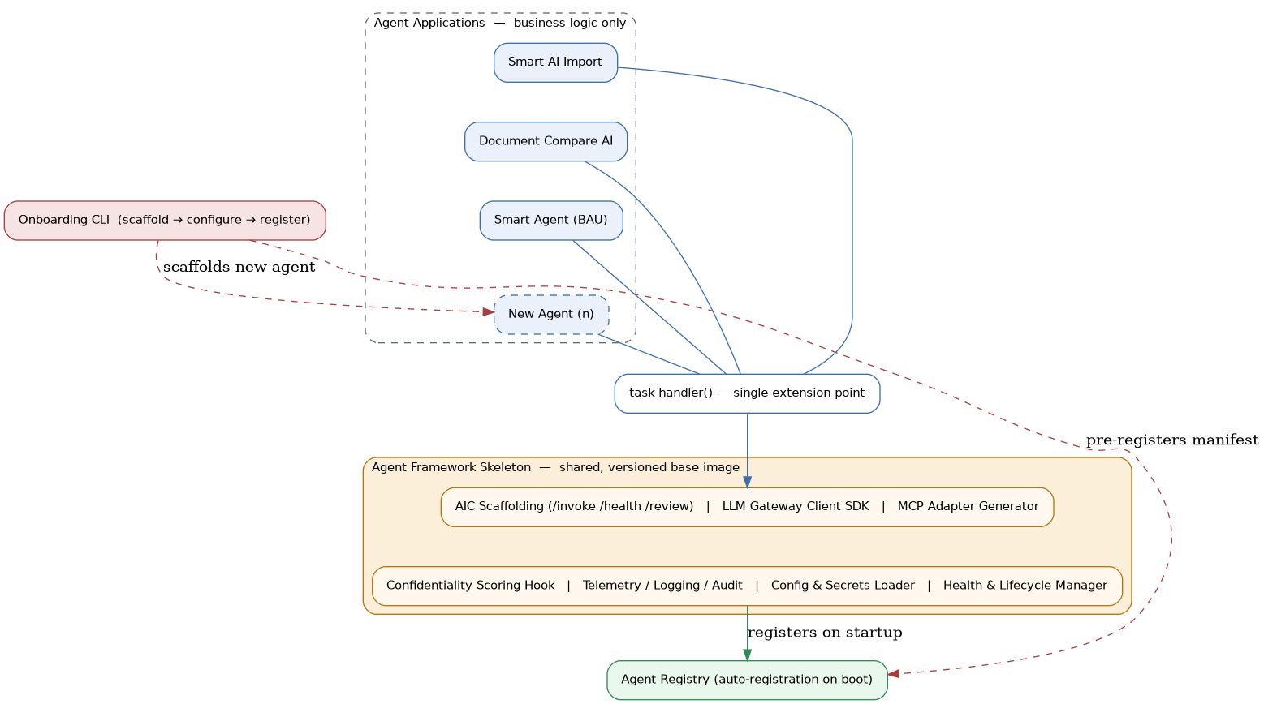
Figure 4: Agent applications supply only a task handler; the shared skeleton supplies everything needed to be a conformant, observable, pluggable agent.

7.1 What the Framework Provides (the skeleton)
- AIC scaffolding: /invoke, /health, /review endpoints, request/response validation, and error handling are generated, not hand-written per agent.
- Gateway client SDK: pre-wired access to the Common LLM Invocation API (Pattern 1); an agent cannot accidentally call a provider directly because the skeleton doesn't expose that path.
- Confidentiality scoring hook: a standard interface the agent's business logic feeds into; the skeleton enforces fail-closed behaviour (Pattern 2) if the hook is left unimplemented.
- MCP adapter generator: auto-derives an MCP-compatible interface from the AIC, so Pattern 3 onboarding needs no hand-written adapter code.
- Telemetry, logging & audit: OpenTelemetry spans, structured logs and audit-trail writes are automatic for every request the skeleton handles.
- Config & secrets loader: environment-specific configuration and Vault-backed secrets are injected consistently; agents never parse their own credentials.
- Health & lifecycle manager: startup/shutdown hooks, readiness/liveness checks, and Agent Registry auto-registration on boot.

7.2 What the Agent Application Owns
- Task handler logic: the single extension point: given a validated request, produce a result. This is the only mandatory code an agent team writes.
- Domain prompts & templates: task-specific prompt construction passed to the Gateway client, plus output parsing back into the standard result schema.
- Business validation: domain rules (e.g. SmartCOMM template schema checks) beyond the generic request/response schema the skeleton already validates.
- Agent-specific manifest fields: task types, cost profile, and confidentiality-scoring capability declared for registration, per Pattern 3.

7.3 Multi-Agent Onboarding
Because the skeleton absorbs everything cross-cutting, onboarding a new agent — or several in parallel — is a scaffold-configure-register exercise rather than a platform change:
- 1. Run the onboarding CLI to scaffold a new agent project from the skeleton template.
- 2. Implement the task handler and declare the manifest (task types, cost profile, confidentiality support).
- 3. The CLI registers the manifest with the Agent Registry; the agent auto-registers again on first boot via the Health & Lifecycle Manager.
- 4. Repeat independently for any number of agents — each is a separate deployable unit with no shared code beyond the skeleton version it was built from.
Why this matters
Teams — including partner teams — spend their effort on the one thing that differs per agent (the task handler), while contract compliance, security posture and observability come for free from the skeleton and are upgraded platform-wide simply by bumping the skeleton version.

8. Recommended Application Stack
Carried forward from the base Solution Design Document (§10) for reference — this is the platform-standard technology stack that the framework skeleton and all agents are built on.
Layer | Technology | Notes
Frontend / Shell UI | React, Tailwind CSS, Next.js | Primary UI framework; Angular for enterprise embedding
Backend / Agent Services | Python 3.11+, FastAPI, Flask | All agent services; Flask for LangGraph-based agents
Agentic Framework | LangGraph, LangChain, Semantic Kernel | LangGraph for stateful agent workflows
Multi-LLM Abstraction | AISuite, LangChain LLM adapters | Unified interface across GPT-4o, Claude, Gemini, Groq etc.
LLMs | Azure OpenAI GPT-4o, Claude 3.5, Gemini, Llama, DeepSeek, Groq | Model selection per task type and cost profile
Workflow Orchestration | Temporal, Apache Airflow | Long-running workflows; Airflow for batch migration pipelines
Vector DB | Azure AI Search, Weaviate | Semantic search for shared content and knowledge base
Messaging | Apache Kafka | Event-driven agent communication and error stream
Document Processing | SmartCOMM MCP | Primary SmartCOMM integration for all agents
CI/CD | GitHub Actions, Azure DevOps | Build, test and deploy pipelines per agent repo
Monitoring | Grafana, Prometheus, OpenTelemetry, Jaeger | Full-stack observability from agent traces to infrastructure metrics
Security | Azure AD, HashiCorp Vault, OAuth 2.0 | Zero-Trust; secrets managed by Vault; MSAL for UI auth
Containerisation | Docker, Kubernetes (AKS), Helm | All services containerised; Helm charts per agent
IaC | Terraform / Azure Bicep | All infrastructure defined as code; per-environment workspaces

9. Combined Reference Flow
The three patterns compose into a single request lifecycle. Example: a new partner-built agent processes a customer document translation request.
- 1. Discovery: Orchestrator resolves the task to “genai-trans” and “partner-ocr-extractor” via the Agent Registry (Pattern 3).
- 2. Invocation: Orchestrator calls each agent's AIC /invoke endpoint, either directly or via its MCP adapter, carrying session_context and data_classification.
- 3. Reasoning: Each agent calls the Common LLM Invocation API (Pattern 1) for any generation/classification step; no agent touches a provider SDK.
- 4. Scoring: Each agent response includes both confidence_score and confidentiality_score; GenAI Trans flags HIPAA-relevant content, pushing its confidentiality_score into the High band.
- 5. Routing: The Orchestrator's HITL Escalation logic (Pattern 2) queues the translation output for mandatory human review while the OCR extraction step, scoring Low, auto-completes.
- 6. Aggregation & Audit: Once the reviewer approves, the Orchestrator aggregates both outputs and writes a single audit record spanning both agents, the Gateway calls each made, and the reviewer decision.

10. Non-Functional Requirements & Governance Checklist
Area | Requirement
Security | Agent pods have no egress to public LLM endpoints; all provider credentials live only in the Gateway's Vault-backed secret store.
Auditability | Every LLM call, routing decision, and human review action carries the parent audit_id and is queryable end-to-end.
Availability | Gateway supports provider failover per routing policy; Agent Registry lookups are cached with a short TTL so a registry outage degrades gracefully rather than blocking invocation.
Latency | Direct-mode invocations bypass the Orchestrator but never bypass the Gateway or confidentiality scoring — the low-latency path is Gateway-inclusive by design.
Extensibility | A new agent reaches Active status without any code change in Orchestrator, Gateway, or Shell UI — manifest registration and a passing conformance suite are sufficient.
Compliance | HIPAA/NAIC-relevant workflows (e.g. GenAI Trans) cannot have their confidentiality High-band review disabled by configuration.
Cost governance | Per-agent, per-model cost is attributable from Gateway usage records; budget caps are enforced centrally, not per agent.

11. Summary
These three patterns turn the base architecture's stated principles — a shared Multi-LLM Pool, configurable HITL checkpoints, and plug-and-play agents — into enforceable contracts: a single LLM entry point agents cannot bypass, a confidentiality score that gates human review independently of model confidence, and an MCP-based manifest that lets any conformant agent join the platform without touching core orchestration code. The Framework skeleton (Section 7) is what makes those contracts cheap to adopt — new agent teams, including partners, should treat Sections 4 through 8 as the acceptance criteria for onboarding onto the SmartCOMM GenAI Platform.

