High-Level Design (HLD)
InterAS Option B — MPLS VPN Connectivity
Cisco Nexus 9000 Series | NX-OS MPLS

AS 65001 (E01/E02) ↔ AS 65000 (R01/R02 VPE)
Port-Channel Sub-Interface | FW Contexts | VRF CMI | Primary/Secondary
March 2026 | Version 3.0

1. Executive Summary
This High-Level Design defines the MPLS VPN InterAS Option B architecture connecting AS 65001 (E01 and E02 Nexus devices) to AS 65000 (R01 and R02 VPE routers) for CMI service connectivity. Customer VRFs on E01/E02 leak routes to cust_out, egress through dedicated firewall contexts, pass ACLs into VRF CMI, and reach the peer AS over port-channel sub-interfaces via MP-eBGP Option B with RFC 3107.
The inter-AS connectivity uses Port-channel1 on both E01 and E02, with per-customer dot1q sub-interfaces providing VLAN-level traffic segregation toward VPE routers. E01/R01 serves as the primary path; E02/R02 as secondary.

2. Scope and Objectives

2.1 Scope
- AS 65001: E01 and E02 Nexus devices (same AS) with iBGP VPNv4/v6 between them
- AS 65000: R01 and R02 VPE routers providing CMI service access
- InterAS Option B (RFC 3107) over Port-channel1 sub-interfaces: E01↔R01 (primary), E02↔R02 (secondary)
- Per-customer dot1q sub-interfaces on port-channel for VLAN-segregated traffic toward VPE
- Customer VRFs: Cust A, Cust B (E01), Cust C (E02) with VRF route leaking to cust_out
- Firewall integration: FW Context A (E01 path), FW Context B (E02 path)
- VRF CMI on E01/E02 as post-firewall transit VRF toward peer AS

2.2 Objectives
- Primary/secondary redundant MPLS VPN connectivity between AS 65001 and AS 65000
- Per-customer VLAN segregation on port-channel toward VPE for traffic isolation and QoS
- Centralized firewall policy enforcement per path (FW Context A and B)
- Complete IGP isolation between ASes using RFC 3107 BGP labeled unicast

3. Targeted Design Architecture

3.1 Design Overview
E01 and E02 in AS 65001 serve as both PE and ASBR. Customer VRFs leak routes into cust_out, which forwards through dedicated firewall contexts. Post-firewall traffic enters VRF CMI, which reaches VPE routers R01/R02 (AS 65000) via port-channel1 sub-interfaces. Each customer gets a dedicated dot1q-tagged sub-interface on the port-channel, providing VLAN-level segregation on the inter-AS link.

3.2 Network Topology
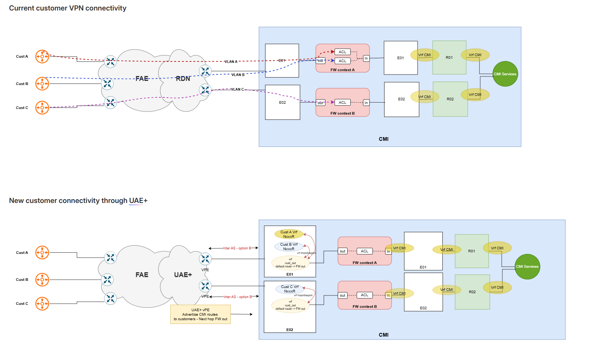

3.3 Port-Channel Sub-Interface Design
The inter-AS link between E01/E02 and R01/R02 uses a port-channel (LACP) with per-customer dot1q sub-interfaces. This provides link aggregation for bandwidth and redundancy, while VLAN tagging ensures per-customer traffic isolation on the wire.
Device | Port-Channel | Sub-Interface | VLAN (dot1q) | VRF | Customer
E01 | Po1 | Po1.100 | 100 | CMI | Cust A
E01 | Po1 | Po1.200 | 200 | CMI | Cust B
E02 | Po1 | Po1.300 | 300 | CMI | Cust C

3.4 Traffic Flow — Primary Path (E01 → R01)
Customer A/B VRF (E01) → route leak via RT to cust_out VRF → FW Context A (out→in) → ACL → VRF CMI (E01) → Port-channel1 sub-interface (dot1q tagged per customer) → MP-eBGP Option B → R01 (AS 65000) → VRF CMI → CMI Services

3.5 Traffic Flow — Secondary Path (E02 → R02)
Customer C VRF (E02) → route leak via RT to cust_out VRF → FW Context B (out→in) → ACL → VRF CMI (E02) → Port-channel1.300 (dot1q 300) → MP-eBGP Option B → R02 (AS 65000) → VRF CMI → CMI Services

3.6 Device Role Summary
Device | AS | Role | VRFs | InterAS Link | Path
E01 | 65001 | PE/ASBR | Cust_A/B, cust_out, CMI | Po1 (.100,.200) → R01 | Primary
E02 | 65001 | PE/ASBR | Cust_C, cust_out, CMI | Po1 (.300) → R02 | Secondary
R01 | 65000 | VPE | CMI | Po1 (.100,.200) ← E01 | Primary
R02 | 65000 | VPE | CMI | Po1 (.300) ← E02 | Secondary

3.7 VRF Architecture

3.7.1 VRF Design on E01
VRF | RD | RT Import | RT Export | Purpose
Cust_A | 65001:100 | 65001:100, 65001:999 | 65001:100 | Customer A traffic
Cust_B | 65001:200 | 65001:200, 65001:999 | 65001:200 | Customer B traffic
cust_out | 65001:999 | 65001:100, 65001:200 | 65001:999 | FW egress aggregation
CMI | 65001:500 | 65001:500, 65000:500 | 65001:500 | Post-FW transit (Po1 sub-ints)

3.7.2 VRF Design on E02
VRF | RD | RT Import | RT Export | Purpose
Cust_C | 65001:300 | 65001:300, 65001:999 | 65001:300 | Customer C traffic
cust_out | 65001:999 | 65001:300 | 65001:999 | FW egress aggregation
CMI | 65001:500 | 65001:500, 65000:500 | 65001:500 | Post-FW transit (Po1 sub-ints)

3.8 Route Leaking Logic
- Stage 1 — Customer to cust_out: Customer VRFs export with unique RTs, cust_out imports all customer RTs
- Stage 2 — cust_out to Firewall: cust_out default route points to FW (Context A on E01, Context B on E02)
- Stage 3 — Firewall to VRF CMI: Post-FW traffic enters VRF CMI, forwarded via Po1 sub-interfaces to VPE
- Return: cust_out exports RT 65001:999 (default via FW), imported by all customer VRFs

3.9 Firewall Integration
FW Context | Device (Primary/Sec) | Outside VRF | Inside VRF
FW Context A | E01 (Primary) | cust_out | CMI
FW Context B | E02 (Secondary) | cust_out | CMI

4. InterAS Option B Design

4.1 Why Option B with RFC 3107
- Single MP-eBGP session per ASBR pair carries all VPN prefixes
- RFC 3107 eliminates LDP/IGP between ASes — complete control plane isolation
- Port-channel provides link aggregation (bandwidth + member-level redundancy)
- Per-customer sub-interfaces enable VLAN-segregated traffic and per-customer QoS/policing
- NSF and Graceful Restart for hitless failover

4.2 BGP Session Architecture
Type | From | To | Address Family | Purpose
iBGP | E01 | E02 | VPNv4/v6 Unicast | Intra-AS VPN route sync
eBGP | E01 | R01 | VPNv4 + Labeled-Unicast | Primary InterAS (over Po1 sub-ints)
eBGP | E02 | R02 | VPNv4 + Labeled-Unicast | Secondary InterAS (over Po1 sub-ints)

4.3 MPLS Label Stack
- Outer label (IGP/Core): Directs packet to ASBR (via BGP labeled-unicast / RFC 3107)
- Inner label (VPN): Directs packet to correct VRF on destination device

4.4 Primary/Secondary Failover
Normal operation: traffic via E01 → Po1 sub-ints → R01. If E01↔R01 port-channel goes down (all members fail), BGP withdraws routes and traffic shifts to E02 → Po1 sub-ints → R02. iBGP between E01/E02 ensures full VPN table on both devices. Port-channel member-level failures are handled by LACP without BGP reconvergence.

5. Prerequisites
- MPLS license installed on E01 and E02 Nexus devices
- NX-OS version 7.2(0)D1(1)+ for full Option B / RFC 3107
- Port-channel member interfaces cabled between E01↔R01 and E02↔R02
- LACP configured on both ends of each port-channel
- Firewall contexts (A and B) provisioned with inside/outside interfaces
- VLAN IDs (100, 200, 300) coordinated with VPE team for sub-interface tagging

6. Design Recommendations
- Use LACP active mode on both ends for fast failure detection
- Configure lacp min-links to ensure minimum bandwidth before declaring port-channel up
- Apply per-sub-interface QoS policies for customer-level traffic shaping toward VPE
- Use send-community both on all eBGP VPNv4/v6 sessions
- Apply LDP-filtering ACLs (port 646) on port-channel sub-interfaces for RFC 3107
- Use next-hop-self on iBGP VPNv4/v6 between E01 and E02
- Test failover by shutting individual port-channel members and full port-channel

7. Verification Commands
Command | Purpose
show port-channel summary | Verify Po1 state and member interfaces
show interface port-channel1 | Port-channel status and traffic stats
show interface Po1.100 | Sub-interface status per customer VLAN
show bgp vpnv4 unicast | Display VPN routes from BGP table
show bgp ipv4 labeled-unicast | Verify RFC 3107 label exchange
show ip route vrf CMI | Verify CMI VRF routes toward peer AS
show ip route vrf cust_out | Verify cust_out routing and FW default
show vrf | Verify all VRF RD and interface assignments

Refer to the Low-Level Design (LLD) v3.0 for device-specific configurations.

