InterAS Option B
Connectivity Design Document

Cisco Nexus 7000/7700 Series | NX-OS MPLS
March 2026
Based on Cisco NX-OS MPLS Configuration Guide (Release 8.x)

1. Overview
This document provides a comprehensive design for InterAS Option B connectivity using Cisco Nexus 7000/7700 series switches running NX-OS. It covers architecture, configuration, and verification for all three Option B variants supported on the platform.
InterAS Option B enables MPLS VPN traffic to flow between separate Autonomous Systems (AS) by establishing MP-eBGP sessions between Autonomous System Border Routers (ASBRs). Unlike Option A, which requires per-VRF sub-interfaces, Option B uses a single BGP session to exchange all labeled VPN prefixes, providing significantly better scalability.

1.1 Scope
This design covers three InterAS Option B variants:
- InterAS Option B (Standard) – Full implementation using LDP between ASBRs for IGP label distribution (NX-OS 7.2(0)D1(1)+)
- InterAS Option B with RFC 3107 – BGP labeled unicast replaces LDP for complete IGP isolation between data centers (NX-OS 7.2(0)D1(1)+)
- InterAS Option B Lite – Restricted version with local VRF support only (NX-OS 6.2(2)+)

1.2 Prerequisites
1. MPLS license installed on all Nexus 7000/7700 switches
2. NX-OS version 7.2(0)D1(1) or later (for full Option B / RFC 3107)
3. ASBRs must be directly connected
4. MPLS feature set installed in the default VDC

2. Architecture

2.1 Network Topology
The following diagram shows the InterAS Option B topology with two Autonomous Systems connected via ASBRs:
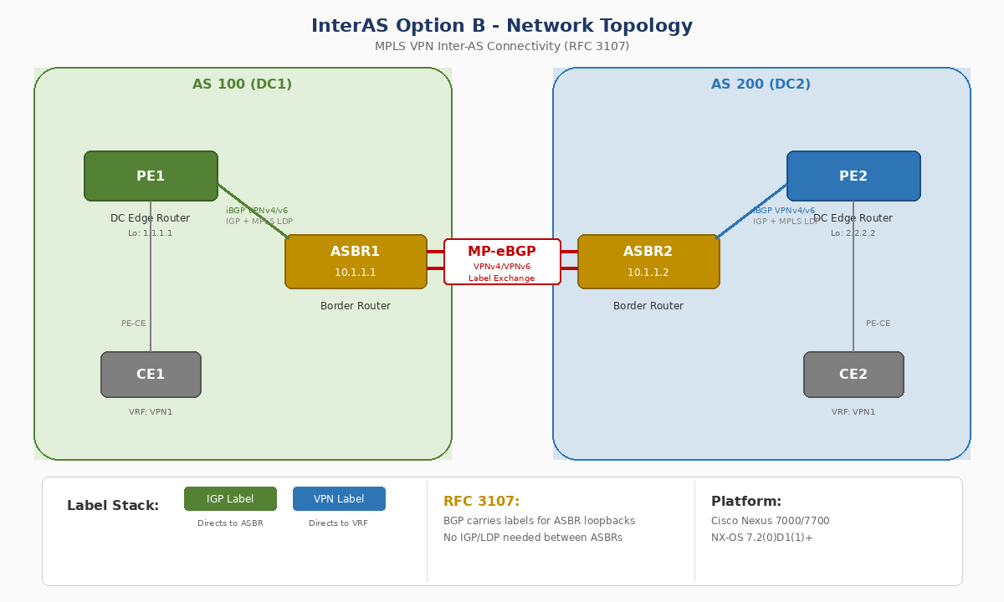

2.2 How It Works
In an InterAS Option B deployment, the ASBRs exchange VPN routing information (routes and labels) over a single MP-eBGP session. The key principles are:
- Within each AS, routing information is shared using iBGP (VPNv4/VPNv6 address family)
- Between ASes, routing information is shared using eBGP with labeled VPN prefixes
- ASBRs rewrite the next-hop and MPLS labels when forwarding NLRIs to iBGP neighbors
- Data packets carry two labels: an IGP/Core label (directs to ASBR) and a VPN route label (directs to VRF)

2.3 Key Design Decisions
Option B provides better scalability than Option A because it requires only one BGP session to exchange all VPN prefixes between the ASBRs. It also supports Nonstop Forwarding (NSF) and Graceful Restart. However, because traffic between ASBRs is MPLS-labeled, IP-based QoS mechanisms cannot be applied at the inter-AS boundary and VRFs cannot be isolated at the ASBR level.
Important limitation: InterAS Option B is not supported with BGP confederation AS configurations.

3. Option B Variant Comparison
The following table compares the three InterAS Option B variants:
Feature | Option B (Standard) | Option B (RFC 3107) | Option B Lite
Min NX-OS Version | 7.2(0)D1(1) | 7.2(0)D1(1) | 6.2(2)
Label Distribution (Inter-ASBR) | LDP (IGP + MPLS) | BGP Labeled Unicast (no LDP needed) | LDP
IGP Isolation | No (IGP runs between ASBRs) | Yes (complete isolation) | No
iBGP VPNv4/v6 | Supported within AS | Supported within AS | Limited (no MP-BGP L3VPN within AS)
eBGP VPNv4/v6 | Between ASBRs | Between ASBRs | Between ASBRs
Per-VRF iBGP Required | No | No | Yes
Scalability | High (single BGP session) | High (single BGP session) | Limited
NSF / Graceful Restart | Supported | Supported | Not specified
ACL Filtering Needed | No | Yes (filter LDP port 646) | No
Recommended For | Standard inter-DC MPLS VPN | ISP / multi-DC with full IGP isolation | Legacy or simple deployments

4. Configuration Templates

4.1 InterAS Option B (Standard)

4.1.1 Switch Feature Enablement
Enable the required features on all participating switches:
configure terminal
install feature-set mpls
feature-set mpls
feature mpls ldp
feature mpls l3vpn
feature bgp

! Define VRF
vrf context VPN1
rd 100:1
address-family ipv4 unicast
route-target import 1:1
route-target export 1:1
copy running-config startup-config

4.1.2 BGP Configuration (DC Edge / ASBR)
Configure iBGP and eBGP VPNv4/v6 sessions on DC Edge switches:
configure terminal
router bgp 100

! eBGP to remote ASBR
neighbor 10.0.0.2
remote-as 200
address-family vpnv4 unicast
send-community both

! VRF configuration
vrf VPN1
address-family ipv4 unicast
exit

copy running-config startup-config

4.2 InterAS Option B (RFC 3107)
This variant uses BGP labeled unicast instead of LDP between ASBRs, providing complete IGP isolation between data centers.

4.2.1 Switch Feature Enablement
Same as standard Option B (see Section 4.1.1).

4.2.2 BGP Configuration (ASBR - e.g., ASBR2 in AS 200)
Configure eBGP VPNv4/v6 along with BGP labeled unicast:
configure terminal
router bgp 200
address-family ipv4 unicast
redistribute direct route-map loopback
allocate-label all
exit

! eBGP to ASBR1 - labeled unicast (RFC 3107)
neighbor 10.1.1.1
remote-as 100
address-family ipv4 labeled-unicast
exit
exit

! eBGP to ASBR1 - VPNv4 via loopback
neighbor 1.1.1.1
remote-as 100
update-source loopback0
ebgp-multihop 2
address-family vpnv4 unicast
send-community both

4.2.3 iBGP Configuration (DC Edge within AS)
configure terminal
router bgp 200
address-family ipv4 unicast
redistribute direct route-map loopback
allocate-label all
exit

neighbor 3.3.3.3
remote-as 200
address-family vpnv4 unicast
next-hop-self
send-community both

4.2.4 ACL to Filter LDP Between ASBRs
Since RFC 3107 uses BGP for label distribution, LDP must be filtered on the inter-ASBR interface (port 646 TCP/UDP):
configure terminal
ip access-list LDP
10 deny tcp any any eq 646
20 deny tcp any eq 646 any
30 deny udp any any eq 646
40 deny udp any eq 646 any
50 permit ip any any
exit

interface ethernet 2/20
mpls ip
ip access-group LDP in
ip access-group LDP out
end

4.3 InterAS Option B (Lite Version)
The lite version has limitations: aggregation switch supports only local VRFs; routes learned from iBGP peers are not sent to eBGP peers and vice versa; MP-BGP Layer 3 VPN does not work within an AS.

4.3.1 Interface Configuration
configure terminal
interface ethernet 2/1
description To other ASBR
ip address 10.0.0.1 255.255.255.0
no shutdown
exit

interface ethernet 2/2
description To CE
vrf member VPN1
ip address 10.0.2.1 255.255.255.0
ipv6 address 2001:DB8:1::1
no shutdown

4.3.2 BGP Configuration (Lite)
configure terminal
router bgp 100
neighbor 10.0.0.2
remote-as 200
address-family vpnv4 unicast
send-community both

vrf VPN1
address-family ipv4 unicast
exit

copy running-config startup-config

5. Verification Commands
Use the following commands to verify your InterAS Option B deployment:
Command | Purpose
show bgp vpnv4 unicast | Display VPN routes from the BGP table
show bgp vpnv6 unicast | Display IPv6 VPN routes from BGP table
show bgp ipv6 unicast vrf <name> | Display BGP info for a VRF (6VPE)
show forwarding ip route vrf <name> | Display IP forwarding table for a VRF
show ip bgp vrf <name> | Display BGP information on a VRF
show ip route vrf <name> | Verify CE-to-CE reachability
show running-config bgp | Display running BGP configuration
show running-config vrf <name> | Display VRF running configuration
show vrf <name> interface <type> | Verify RD and interface for VRF
trace <dest> vrf <name> | Trace route within a VRF

6. Design Recommendations

6.1 Variant Selection Guide
- Choose RFC 3107 variant when you need complete IGP isolation between data centers. Preferred by most service providers.
- Choose Standard Option B when IGP convergence between ASBRs is acceptable and simpler configuration is desired.
- Avoid Option B Lite for new deployments. Only use if running NX-OS prior to 7.2(0)D1(1).

6.2 Best Practices
1. Always use send-community both on eBGP VPNv4/v6 sessions to propagate route targets between ASes.
2. For RFC 3107, apply LDP-filtering ACLs on both inbound and outbound directions of inter-ASBR interface.
3. Use next-hop-self on iBGP VPNv4/v6 sessions within the AS for proper label assignment.
4. Verify route targets (import/export) are consistent across both ASes for end-to-end VPN connectivity.
5. Test failover scenarios by verifying NSF and Graceful Restart behavior on ASBRs.
6. Note: InterAS Option B is not supported with BGP confederation AS configurations.

6.3 Licensing
MPLS Layer 3 VPN requires an MPLS license on all Cisco Nexus 7000/7700 switches. Refer to the Cisco NX-OS Licensing Guide for complete licensing details.

Reference: Cisco Nexus 7000 Series NX-OS MPLS Configuration Guide, Chapter 24 - InterAS Option B

