# **Implementation of Digital Modulation Techniques**

Objectives :

1. To be familiarized with the digital modulation techniques
2. Understanding basic digital communication system
3. Simulate BPSK, 4-QAM,16-QAM and 64-QAM in MATLAB

Introduction

# BINARY PHASE SHIFT KEYING (BPSK)

In phase shift keying (PSK), the phase of a carrier is changed according to the modulating waveform which is a digital signal. In Binary PSK (BPSK), the transmitted signal is a sinusoid of fixed amplitude. It has one fixed phase when the data is at one level and when the data is at the other level, phase is different by 180 degrees. A Binary Phase Shift Keying (BPSK) signal can be defined as,

$$V_{BPSK}\left(t\right)=b\left(t\right)\sqrt{2P}cos2πf_{c}t where 0<t<T$$

Constellation diagram of the BPSK is shown in figure 1.

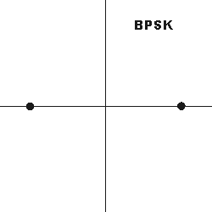

Figure 1 Constellation diagram of BPSK

# QUADRATURE PHASE SHIFT KEYING (QPSK or 4-QAM)

In QPSK, “Quadrature” means the signal shifts among phase states that are separated by 90 degrees.

The signal shifts in increments of 90 degrees from 45° to 135°, -45° (315°), or -135° (225°).

Data into the modulator is separated into two channels called I and Q.

Two bits are transmitted simultaneously, one per channel, thus doubling the spectral efficiency compared to BPSK.

Constellation diagram of QPSK is given in figure 2.

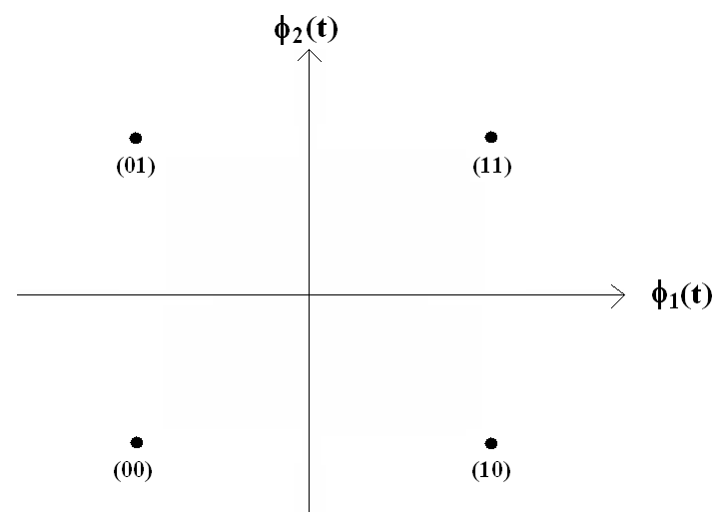

Figure 2 Constellation diagram of QPSK

# 16QAM (16- Quadrature Amplitude Modulation)

With respect to 4-QAM, 16-QAM has 4 $I$ values and 4 $Q$ values yielding 4 bits per symbol.

It has 16 states or constellations because $2^{4}=16$. The constellation diagram of 16-QAM is presented in figure 3. Table 1 shows transmitted symbols with corresponding carrier phase and amplitude.

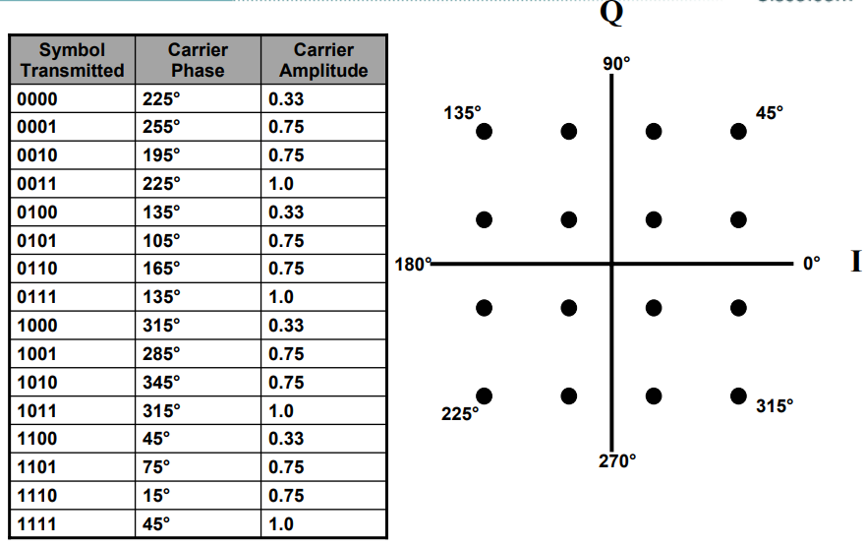

Figure 3 Constellation diagram of 16-QAM

 Table 01 QAM transmitted symbols with carrier phases and amplitude

And, the transmitted bits will be assigned to constellations as follows:

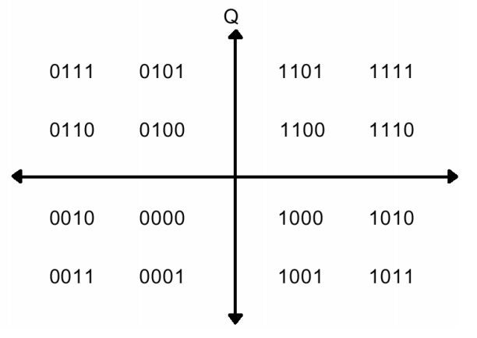

Figure 4 Constellation diagram of 16-QAM

# 64QAM (64- Quadrature Amplitude Modulation)

64-QAM has 8 $I$ values and 8 $Q$ values yielding 6 bits per symbol.

It has 64 states or constellations because $2^{6}=64$. The constellation diagram of 64-QAM is as follows:

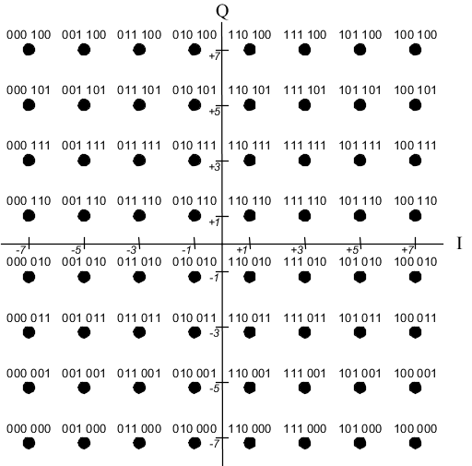

Figure 5 Constellation diagram of 64-QAM

# Basic Communication System modeling

Now let’s model an end to end basic Communication System.

The basic communication system contains source, modulator, channel, demodulator and received source as shown in figure 6.

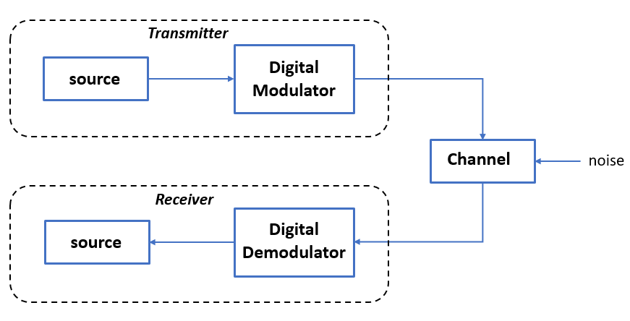

Figure 6 Basic Communication system

Regarding the digital modulation, we are going to model the system with 4 different modulation techniques.

The lab has been divided into 4 parts which are as follow:

1. BPSK implementation
2. QPSK implementation
3. 16QAM implementation
4. 64QAM implementation

Part 1:

1. Generate the source you are going to transmit:

%% Create a vector of random bits to be transmitted

n = 6000;

x = randi([0 1], 1, n);

1. Define the number of constellations which depends on the modulation technique you are going to use. BPSK has 2 constellations so:

% BPSK: 2 constellations

M1 = 2;

1. Calculate the number of bits in each constellation:

% number of bits per constellation

m1 = log2(M1);

1. Perform the BPSK modulation using the predefined function in matlab (pskmod), type help pskmod in the command window for better understanding:

%BPSK modulation

tr_BPSK = pskmod(x', M1);

1. After modulation we have the data in complex domain. Let’s plot the modulated data:

% scatter plot the modulated signal

scatterplot(tr_BPSK);

title('BPSK Transmitted');

1. The signal will pass through the Additive White Gaussian Noise (AWGN) Channel. We will use the predefined function “awgn”, after choosing the Signal to Noise (SNR) ratio:

Type awgn in the command line to understand the implementation of this function.

%% Channel

snr = 5;

r1 = awgn(tr_BPSK, snr); %received signal

1. Lets plot the constellations of the received signal

scatterplot(r1);

title('BPSK Received');

Compare between the scatter plots at the transmitter and receiver side.

1. We are now at the receiver side, so we must perform the demodulation:

Type pskdemod in the command line for better understanding.

demod_BPSK = pskdemod(r1, M1); %demodulated signal

1. After demodulation the data is binary mode (bits 0 and 1).

Let’s see if we will receive transmitted bits (generated in step 1) correctly.

errBits = 0; % bit errors or the number of received bits that have been altered

for i = 1:n

if demod_BPSK(i) == x(i)

errBits = errBits; % if the i-th transmitted bit(x) is equal to the i-th received bit(demodBPSK) -> we don't have error

else

errBits = errBits + 1; % if the i-th transmitted bit is NOT equal to the i-th received bit -> we have an error.

end

end

1. **Change the Signal to Noise ratio (SNR) then observe the scatter plots and the number of bits in error.**

**Use the following SNR values: 10, 20, 50, 0, -5, -10**

**What you notice by increasing or decreasing the SNR, regarding the number of errors and the constellations.**

Part 2:

As we did before try to perform the 4-QAM modulation.

Use “qammod” instead of “pskmod”.

Type help qammod to perform correctly the modulation.

You must do the 9 steps done before.

Part 3:

Implement 16-QAM.

Part 4:

Implement 64-QAM.

QUESTION: Can you try to estimate which of the following has the highest spectral efficiency: BPSK, 4-QAM, 16-QAM, 64-QAM after observing the number of transmitted symbols in each modulation?

ANSWER: ____________________________________________________________________________

**You can upload your reports on our channel on Teams:**

**LAB - 2024/2025 Physical Layer for software radio $→$ Files $→$ Lab02 $→$ student reports**

**Please try to compress the MATLAB files into one file called: Lab02_yourName**