# **Lab09**

# **Spectrum Sensing for Cognitive Radio (CR)**

Objectives:

1. Implement the Energy detector for spectrum sensing.
2. Performance evaluation through the Receiver Operating characteristic (ROC).

Wireless networks and information traffic have grown exponentially over the last decade, which has resulted in an excessive demand for the radio spectrum resources that are limited.

The current radio spectrum allocation policy consists of assigning the channels to specific users with licenses for specific wireless technologies and services. Those licensed users have access to that spectrum portions to transmit/receive their data, while others are forbidden even when those spectrum portions are unoccupied. Recent studies reported that the spectrum utilization ranges from 15% to 85% in the US under the fixed spectrum allocation policy. The Federal Communications commission (FCC) measurements also show that some channels are heavily used while others are sparsely used as illustrated in the Figure 1.

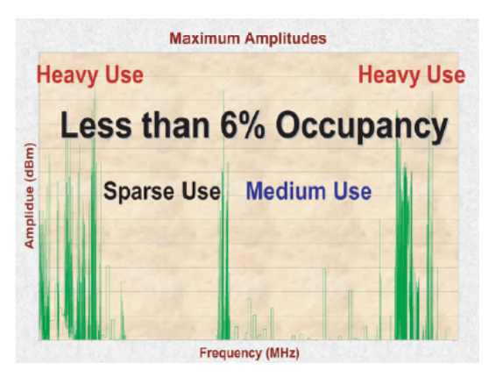

***Fig.1. Radio Spectrum Occupancy***

Allocated spectrum portions are not used all the time by their owners, called *primary users (PUs)*, which creates spectrum holes. A spectrum hole, also called white space, is a frequency band assigned to a PU, but it is not being used at a particular time and at a particular location. Therefore, the radio spectrum is inefficiently exploited. Thus, the scarcity and inefficiency of the spectrum management require an urgent intervention to enhance the radio spectrum access and achieve high network performance. To this purpose Cognitive Radio has been proposed.

Cognitive Radio is an intelligent system that can observe, learn from its environment, adapt to the environmental conditions, and make decisions in order to efficiently use the radio spectrum.

CR implement an opportunistic spectrum access that overcomes the spectrum scarcity by sharing unoccupied channels with unlicensed users, called *Secondary Users* (SUs or ***Cognitive Users***) without interfering with the PUs signals (see Fig. 2).

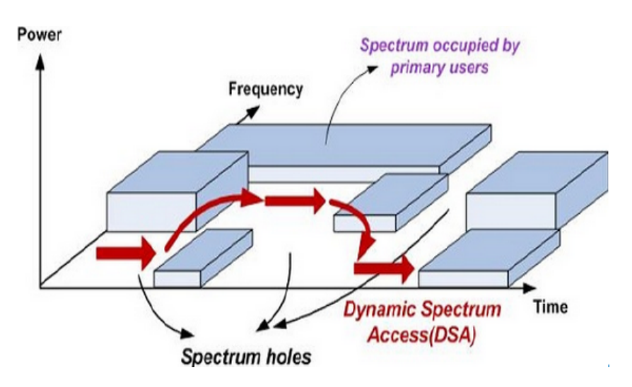

***Fig 2. Dynamic spectrum access: CR allows SUs to use the PU assigned radio spectrum when it is temporarily not being utilized.***

The dynamic spectrum access can be achieved after employing the Spectrum Sensing.

Spectrum Sensing is one of the most important processes performed by cognitive radio systems. It allows the SUs to learn about the radio environment by detecting the presence of the PU signals using specific techniques as Energy Detector.

**Energy Detector**

The Energy detection is the simplest available detector where it does not need any information about the transmitted signal other than the band occupied by the signal. It compares between the received energy and a threshold energy to decide if the signal is present or absent.

The detector output is the received signal energy as given by:

$T_{ED}=\sum_{n=0}^{N}{\left|y\right.{\left.\left(n\right)\right|}^{2}}$ (1)

Where $N$ is the sample number, $y(n)$ is the SU received signal and $T_{ED}$ is the test statistic.

Thus, the decision-based energy detection can be expressed as:

$$\left\{\begin{aligned}if T_{ED}≥λ, PU signal present \\ if T_{ED}<λ, PU signal absent\end{aligned}\right.$$

Where $λ$ denotes the sensing threshold and $T_{ED}$ denotes the energy of the SU received signal.

In this Lab we are going to implement Energy Detection for spectrum sensing in Cognitive Radio.

Download the MATLAB file “rxOFDM_signal.mat” from LAB - 2024/2025 Physical Layer for software radio $→$ Files $→$ Lab09or from aulaweb.

Task 1

The Secondary User (SU) can collect information about the radio spectrum through sensors.

Let’s suppose that the radio environment is based on OFDM technology.

The OFDM signal is sensed by the secondary user to search for white spaces in different sub-carriers (different frequencies) by implementing the Energy detector. It worth to note that white spaces consist of a low-level noise.

In this case the SU will receive one OFDM symbol each time and compare its energy with a predefined threshold to take the decision if the PU is present or absent.

Equation (1) becomes:

$T_{ED}=\left|y\right.{\left.\left(n\right)\right|}^{2} where n denots the OFDM symbol and y\left(n\right) the amplitude of symbol n$.

Note: the OFDM symbol is an IQ symbol (complex value), so its amplitude is the absolute value of the I (real part) and Q (imaginary part) values.

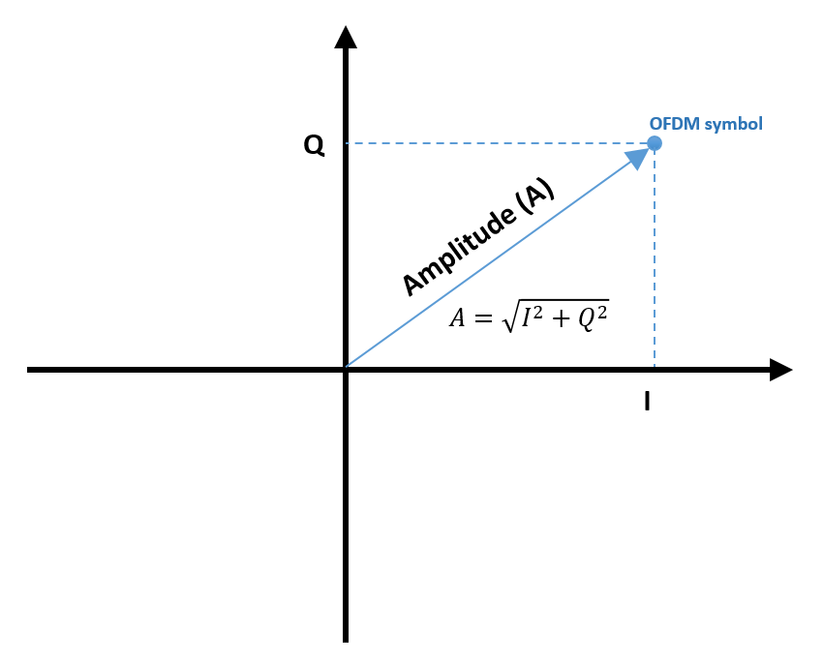

First we will load the OFDM signal and extract one sub-carrier in order to detect the Primary User transmissions in it.

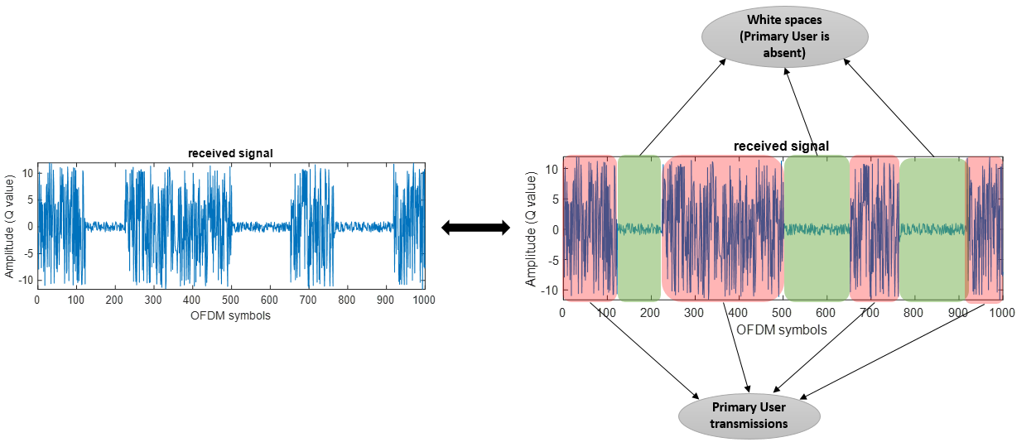

Let’s now search for white spaces (where the PU is absent) by typing the following code:

Create a new script named as “ED” and try to understand each step

% ----------------------------------------------------------------------- %

clc

clear all

close all

%% Load the OFDM signal (at the secondary user side)

load('rxOFDM_signal.mat');

%% Extract a specific sub-carrier to search the presence of the Primary User

signal = rxOFDM_signal(2,:); % 2 means that I am extracting the 2nd sub-carrier

%% Calculate the energy of each OFDM symbol

for i = 1:size(signal,2)

energy(1,i) = (abs(signal(1,i))).^2;

end

%% Compare with the threshold

threshold = 1;

for j = 1:size(energy,2)

if energy(1,j) >= threshold

PU(1,j) = 1;

else

PU(1,j) = 0;

end

end

%% Plot the signal and the output of the Energy Detector

subplot(2,1,1);

plot(real(signal));

title('received signal');

xlabel('OFDM symbols');

ylabel('Amplitude');

subplot(2,1,2)

plot(PU, 'LineWidth',2);

title('PU presence(1) / absence(0)');

xlabel('OFDM symbols');

% ----------------------------------------------------------------------- %

Threshold is an important factor in Energy detection because the decision depends on it, therefore it must be chosen carefully.

Try to change the threshold and observe the results; for example, decrease to 0.1 and increase to 10. You will see that the energy detector sometimes detects PU even if it is not present in the real signal and this known as False Alarm.

In the same script, repeat what we did before for 6 different subcarriers.

Task 2

As we see previously, the Energy detector could make false alarms due to the threshold value or due to the noise level (which depends on the Signal to Noise ratio).

In this task we are going to calculate the Receiver Operating characteristic (ROC).

The ROC curve is a performance measurement for classification or detection problems at various thresholds settings. ROC is a probability curve which tells how much the model is capable of distinguishing between classes (For example in our case the presence or absence of the PU).

The ROC curve is plotted with Probability of detection $P_{d}$ (or True Positive ratio) against the Probability of False Alarm $P_{FA}$ (or False Positive ratio) where $P_{d}$ is on y-axis and $P_{FA}$ is on the x-axis.

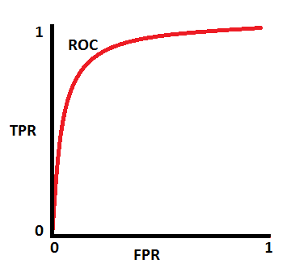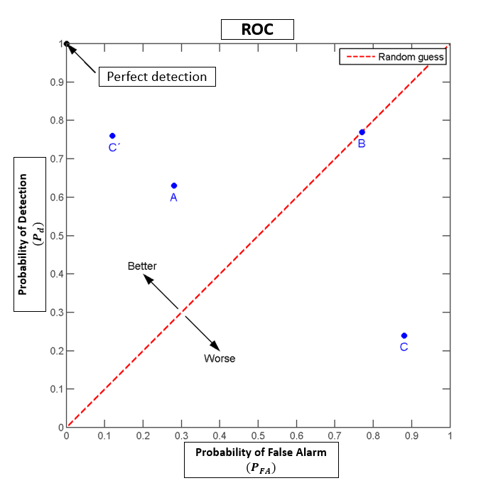

Try to follow and understand the following steps:

* Load the OFDM signal.
* Extract the sub-carrier.
* Create the Ground Truth.
  + the ground truth includes the true locations where the PU is present or absent, this vector is used for ROC evaluation.
* Calculate the energy of each symbol.
* Normalize the energy (to be between 0 and 1).
* Perform the ROC calculation function.
  + In this function we will vary the threshold between 0 and 1 to calculate all the probabilities with different threshold values.
* Plot the results.

1. Create a new Script called “Energy_Detector_ROC” and type the following code based on the aforementioned steps:

% ----------------------------------------------------------------------- %

clc

clear

close all

%% Load the OFDM signal (at the secondary user side)

load('rxOFDM_signal.mat');

%% Extract a specific sub-carrier to search the presence of the Primary User

signal = rxOFDM_signal(6,:);

%% Create the Ground Truth

ground_truth = zeros(1, size(rxOFDM_signal,2));

threshold = 1;

for i=1:size(signal,2)

if abs(signal(1,i)) >= threshold % if the amplitude of symbol i greater or equal to threshold -> the PU is present

ground_truth(1,i) = 1; % 1: PU is present / 0: PU is absent

end

end

%% Calculate the energy of each OFDM symbol

for j=1:size(signal,2)

energy_signal(1,j) = (abs(signal(1,j))).^2;

end

%% Normalize the energy signal

dataNorm = normalize(energy_signal);

%% Calculate the ROC

[Roc_f] = Roc_calculation(dataNorm, ground_truth);

x = [0 1];

y = [1 0];

z = [0 1];

zz = [0 1];

figure;

sm=0.8;

plot(smooth(Roc_f(1,:),sm), smooth(Roc_f(2,:),sm), 'LineWidth',3);

hold on;

plot(x,y, '--', 'LineWidth',1.2);

plot(z,zz,'--', 'LineWidth',1.2);

title('ROC');

xlabel('Probability of False Alarm (Pfa)');

ylabel('Probability of Detection (Pd)');

grid on;

% ----------------------------------------------------------------------- %

Before launching the Code you must ::

Create a new function named “Roc_calculation” and type this code

function [Roc_f] = Roc_calculation(f,Ground_truth) %f is the signal, Ground_truth is the reference signal

save_TP_f = [];

save_FP_f = [];

condition_positive = sum(Ground_truth);

condition_negative = length(f) - condition_positive;

for i = 0:0.001:1

TP_f = 0;

FP_f = 0;

for j = 1 : length(f)

if f(j) > i

if Ground_truth(j) == 1

TP_f = TP_f + 1;

else

FP_f = FP_f + 1;

end

end

end

save_TP_f = [save_TP_f TP_f];

save_FP_f = [save_FP_f FP_f];

end

true_positive_f = save_TP_f/condition_positive;

false_positive_f = save_FP_f/condition_negative;

Roc_f = [false_positive_f;true_positive_f];

end

And

Create another function named “normalize” and type this code:

function [dataNorm] = normalize(energy_signal)

minEner = min(energy_signal(1, :));

maxEner = max(energy_signal(1, :));

dataNorm = (energy_signal(1, :)-minEner)./(maxEner-minEner);

end

1. Extract any subcarrier you want else than 6.

Change the value of the ground truth:

if abs(signal(1,i)) >= threshold

ground_truth(1,i) = 1; % 1: PU is present / 0: PU is absent

end

Change the threshold, decrease this value to 0.9, 0.7, 0.5, 0.3, 0.1.

Try to understand why the ROC is degraded?!

Plot the signal, the ground truth (refer to task 1) and the output of the energy detector.

**You can upload your reports on our channel on Teams:**

**LAB - 2024/2025 Physical Layer for software radio $→$ Files $→$ Lab09 $→$ student reports**

**Please try to compress your MATLAB scripts (Task 1,2) into one file called: Lab09_yourName**