Lab 05
AWGN and Multipath channel modeling in the GNU radio

Objectives:
A) AWGN Channel modelling with Digital Modulation
B) Channel modelling with multipath effect
C) Implementation of Polyphase clock and Equalizer to multipath

- AWGN Channel modelling with Digital Modulation
- To investigate in detail channel behavior, we need to choose a modulation technique. Selecting PSK Mod block (Digital Modulators->PSK Mod) and setting the “Number of Constellation Points”:4 “Samples/Symbol”:2 corresponds to the QPSK digital modulation technique.

Make a flowgraph as shown below,
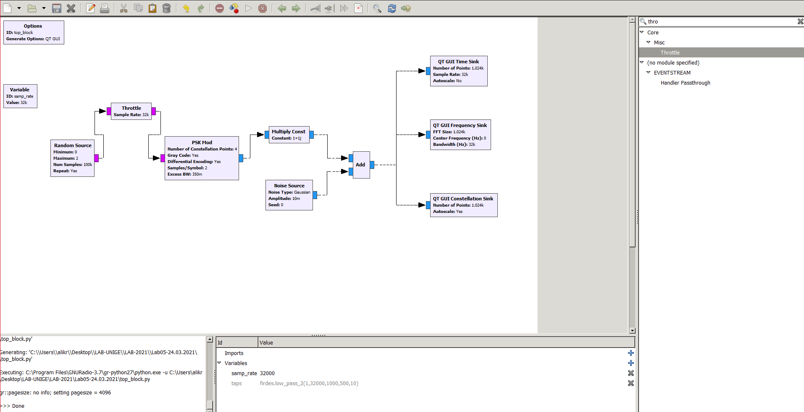
Execute and observe the output.

- Note that the modeled AWGN channel introduces mismatches between the transmitter (source) and receiver (sinks).
To find the right sampling times, we use a control loop algorithm - Polyphase Clock Sync (Synchronizers->Polyphase Clock Sync).
Modify the flow graphs as shown below:
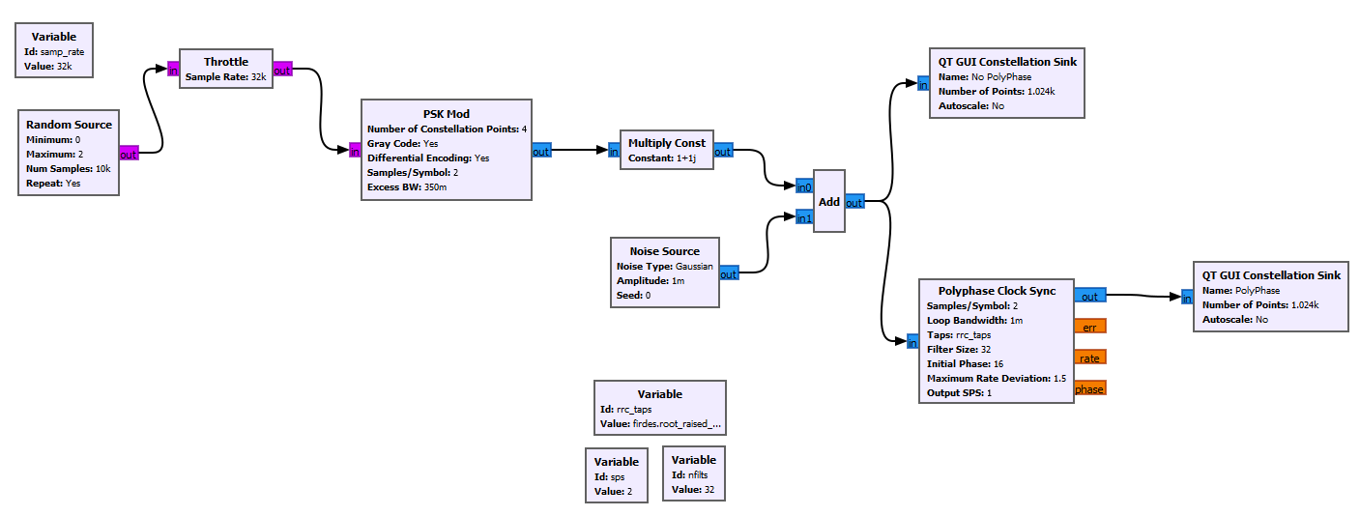

Set the parameters of the Polyphase Clock Syn as:
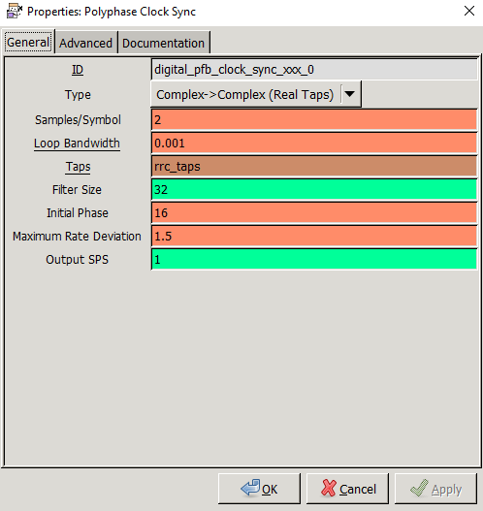

In the “value” field of Variable rrc_taps type in:
firdes.root_raised_cosine(nfilts, nfilts, 1.0/float(sps), 0.35, 11*sps*nfilts)
The taps refer to taps of the prototype filter. Since the other filter is the derivative filter, you give the block a set of taps (think of it as the upsampled RRC filter coefficients), and the block will generate the derivative filter by taking the derivative of the taps you provide it.
As can be seen, we choose to set “Filter size” to “32”. Each filter represents a different phase. The algorithm tries to drive the derivative to zero, which will occur when you have the correct filter phase. So, the number of taps gives you the quantization of the phase value. Think 2pi/N. You reduce ISI and timing errors by using a larger number of filters as the expense of complexity and memory. Generally, 32 should be enough. Detailed explanation of the functionality of the block may be found by double-clicking on it.

- Change the modulation type to 8 PSK and the amplitude of the noise source using a range with the following parameters:
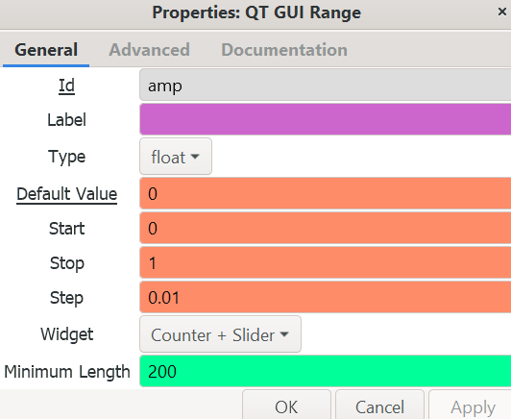

Execute flow graph and observe the constellation diagrams before and after the timing recovery. Notice that, even for relatively high noise voltage values in the channel, we can still recover proper timing.

- Channel modelling with multipath effect
- The multipath channel is described by a main path of amplitude 1.0, plus one or more paths, each with a unique delay, amplitude, and phase with respect to the main path. The channel may be represented by the following transfer function:

H(ω) = 1 + b1e-jωT1 + b2e -jωT2 + ...

where bi are the coefficients and Ti are the delays of each path with respect to the main path.
Now consider a complex-baseband discrete-time model of the channel, as shown below:

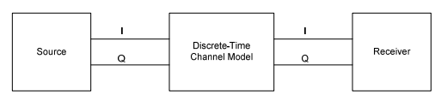
Figure a Discrete time model

Substituting z = ejωTs into the above equation, and assuming that sample time is sufficiently small compared to the delays (so we round Ti/Ts to integers k, m, etc.), we get:
H(z) = 1 + b1z -T1/Ts + b2z -T2/Ts + ... = 1 + b1z -k + b2z -m + ...
H(z) can be implemented as a complex-coefficient FIR filter. The number of taps depends on the longest delay Tmax and the sample time: Ntaps = Tmax/Ts + 1. Only those taps that match one of the path delays receive a non-zero coefficient.
2) As basis, we will use the block diagram created in the previous section. However, instead of AWGN, we will use the Channel Model block (Channel Models->Channel Model). This block allows us to model a simple static multipath environment. Channel model has 4 important parameters:
  - Noise voltage: creates AWGN with a given voltage distribution. As a default, set it to “10e-4”.
  - Frequency offset: expressed as a frequency/sample_rate, tells the signal source how much to change the output per sample such that it will take 1.0/ratio samples to make a complete sinusoid period or cycle. As a default, leave it to 0 (no offset). This way, we will still have a recognizable signal at the sink. For example, 0.25 would be, for a digital modem, one quarter of the symbol rate.
  - Epsilon: a timing offset ratio to model clock difference (inverse of the fractional interpolation ration). It is simulating how, when the transmitter sends a sample at time T, the receiver will sample it at time T+delta(t), where delta(t) is a function of time (if this were just T+delta, you can simulate that by setting just the initial phase of the fractional interpolator). For a value of 1, there is no rate change, so make that default value.
  - Taps: Taps of a FIR filter to emulate a multipath delay profile. The number of taps and their values depend on the power delay profile of the channel model we wish to emulate.

Now, Make the flow graph as shown below,

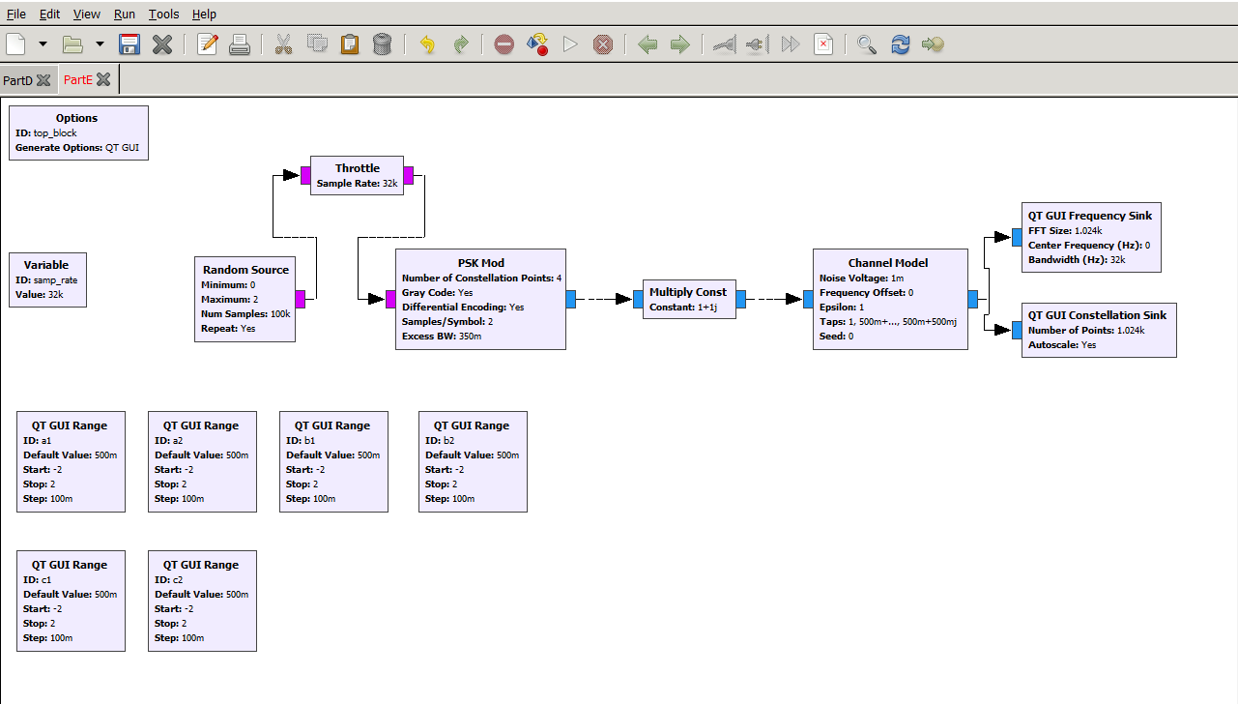

3) QT GUI Ranges are set to control the Tap values of the Channel model. As such, its “Taps” parameters should be set to “a1+a2*1j, b1 + b2*1j, c1 + c2*1j” (in linux use [a1+a2*1j,b1+b2*1j,c1+c2*1j]). For example, tap value of “1+j0” is, in its phasor form, equal to 1<(0⁰), so no effect on input and output. On the other hand, tap value of “1+j1” is in its phasor form equal to 1.41<(45⁰), so input is multiplied by 1.41 and rotated by 45 degrees. Try changing the values of a1, a2, b1, b2, c1, c2 to see what effects they have on the channel.

Set the parameters of the channel model as,
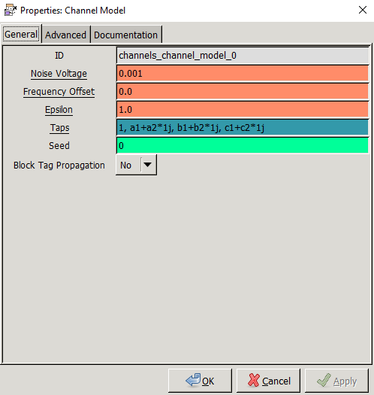
Run and observe the output.

C) Implementation of Polyphase clock and Equalizer to multipath
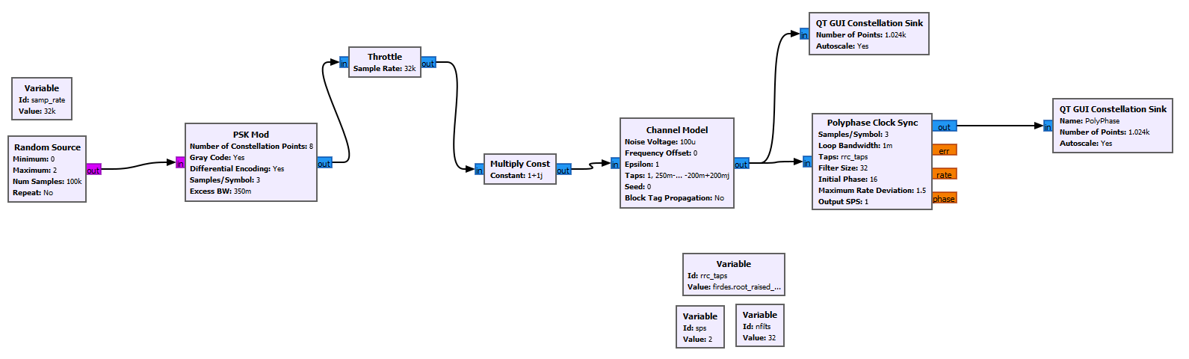
1) Build the following block diagram:

After inserting the Channel Model block, replace the current values of “Taps” from “1” to “1.0, 0.25-0.25j, 0.50 + 0.10j, -0.3 + 0.2j, 0.1 - 0.01j, -0.2 + 0.2j”.
Execute flow graph and observe the constellation diagrams before and after the timing recovery.
We can notice that we still have the effect of the multipath.

- Let’s take a look at how equalization techniques can be used to solve the multipath problem. The task of the equalization system is to determine and apply a filter that results in an equalized impulse response having zero ISI and channel distortion. This means that convolution of the channel impulse response and the equalizer impulse response must equal 1 at the center tap and have nulls at the other sample points within the filter span. The following figure shows a signal corrupted by multipath, the role of the equalizer and the resulting flat frequency response as the combination of the two.

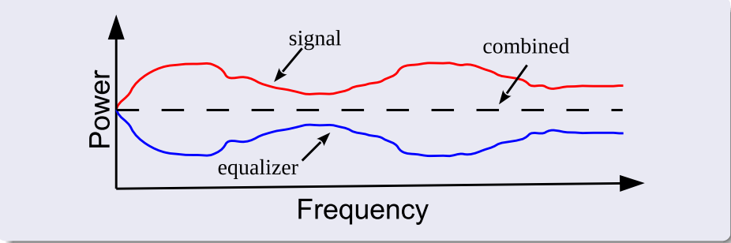

We will use Constant Modulus Algorithm (CMA) blind equalizer for correcting multipath distortions. Insert CMA Equalizer block (Equalizers->CMA Equalizer) at the output of Polyphase Clock Sync and modify your flow chart to look like this:
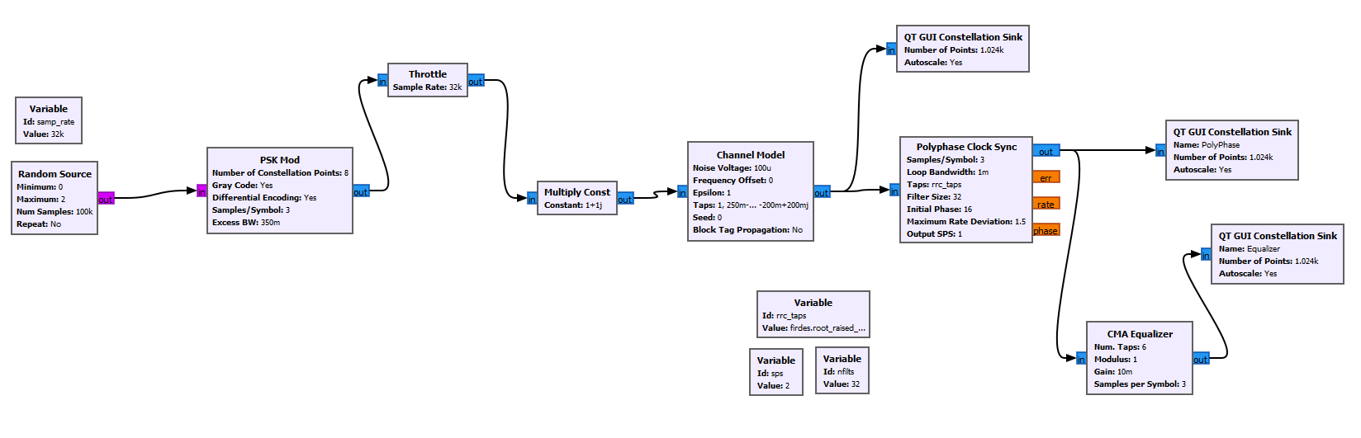
Execute the flow graph and observe the output.

You can upload your reports on our channel on Teams:
LAB - 2024/2025 Physical Layer for software radio Files Lab05 student reports

Please try to compress your gnu files (flow graphs) into one file called: Lab05_yourName

Note: create a flow graph for each Part.

