
Normal
Normal
Heading 1
Heading 1
Heading 2
Heading 2
Heading 3
Heading 3
Heading 4
Heading 4
Heading 5
Heading 5
Heading 6
Heading 6
Code Block
Default
Arial
Georgia (Corrected the spelling error.)
Impact
Tahoma
Times New Roman
Verdana
arial
Default
8
9
10
11
12
14
16
18
24
30
36
48
60
72
96
Default
Lower Alpha
Lower Greek
Lower Roman
Upper Alpha
Upper Roman
Default
Circle
Disc
Square
Default
Single
1.15
1.5
Increase
Decrease
3-6357-254-00_05 Predefined Queries (No grammar errors or misspellings found.)
Objectives
On completion of this module, participants should be able to (The text should be revised to reflect the intended meaning.):
Configure Predefined Queries – set up system metric queries.
Configure Predefined Queries – set up parameter queries.
Explore data calculation functions.
Predefined Queries
Predefined queries is a utility that manages database queries with a user-friendly interface.
The Predefined Queries page enables users to create, execute, and manage queries on a database to view historical data.
User can create on-demand reports from a Vertica database by defining queries in the Predefined Queries UI and displaying the queried data in dashboards and reports.
The queries are executed on the Vertica database every time the dashboard are loaded or refreshed.
The query is executed directly in Vertica, no data is cached in the STAKEHOLDER DASHBOARDS or Flex Reports.
The types of queries that can be created are:Data QueryParameterized Query and Predefined Queries – User Interface
Data Query
Parameterized Query and Predefined Queries – User Interface
When the interface is launched it opens in the Cloud UI. To return to the STAKEHOLDER DASHBOARDS UI, you will need to go back or open a second tab in the browser.
The Predefined Queries UI provides the following controls:
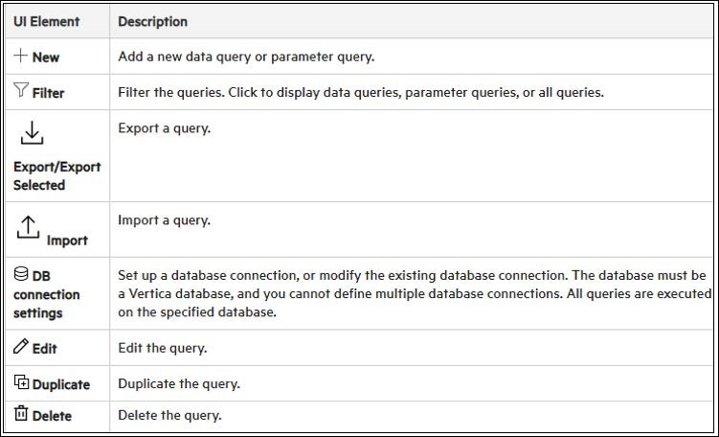
Import and Export Predefined Queries:
You can import and export the Predefined Queries from the file system.
You can select one predefined query, multiple queries, or no query (= all) and then Export them into a single file.
When importing a query with a name that already exists the system allows to Skip, Overwrite, or Cancel the import.
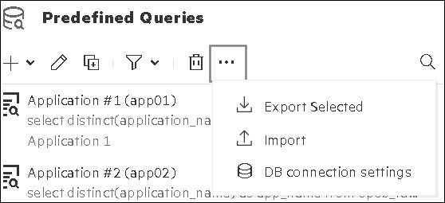
Predefined Queries have the following limitations:
Queries must return less than five MB of data.
To use the data in widgets with time dimensions, the data is displayed starting with the latest available time stamp instead of today's date and time. Therefore, make sure to properly define the time frame according to your needs when executing the query.
Use the Chart Period property in widgets to set the period for which the widget displays data. This time period must be calculated and specified in minutes.
In a Widget Group, widgets with time dimensions (for example, Line Charts) cannot be added to the group.
The query must begin with a SELECT statement and must not contain a semicolon (;) at the end.
Data Query
To retrieve data from Vertica to animate a widget in Dashboard or Reports, a query can be written manually, or as you will see in later slides, created with a few mouse clicks.
The process starts with opening the Predefined Queries page in Administration.
To create a query, use the following steps:
Provide a suitable name to the new query. This query becomes the name of the Data Channel.
Tags are optional; if added, it provide an additional identifier to the Data Channel.
In case of a simple query that fetches a single row of summarized data, use the Default Format.
Write a query and perform a test RUN, and then click SAVE DATA QUERY to create the Data Channel.
Examples:
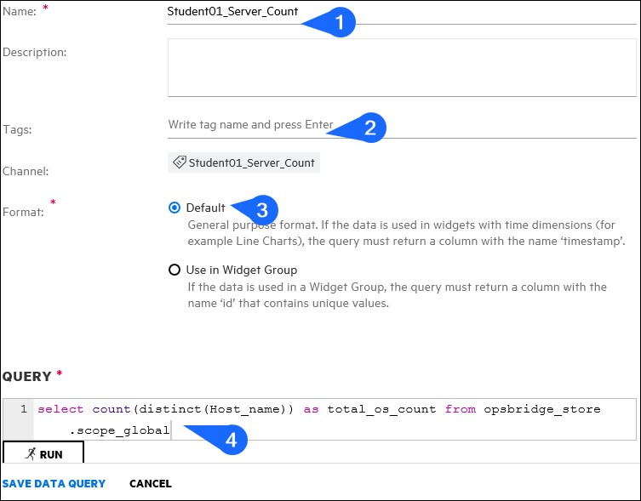
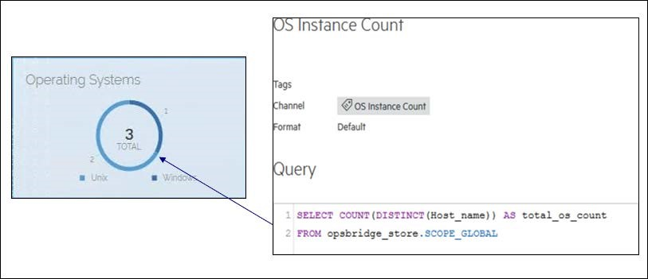

This is a simple query that produces one metric - the OS Count.
A good example of its output is the text value widget in the circle.

In another example, the query result returns two summarized metrics:Total storage and Used space to represent a Storage Utilization in a dashboard.
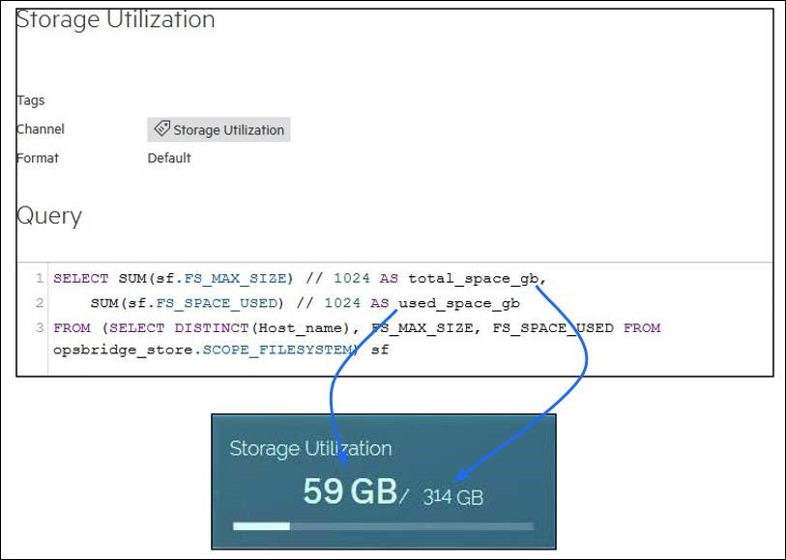
The queries that produce multiple columns and rows are typically used in Dashboards and Reports as a table output.
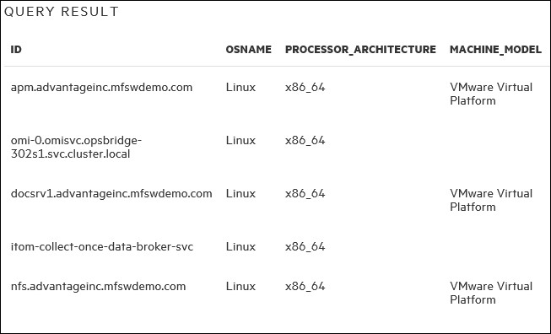
In the STAKEHOLDER DASHBOARDS, they need to be configured for the widget – Widget Group, using the option in the Query creation process.
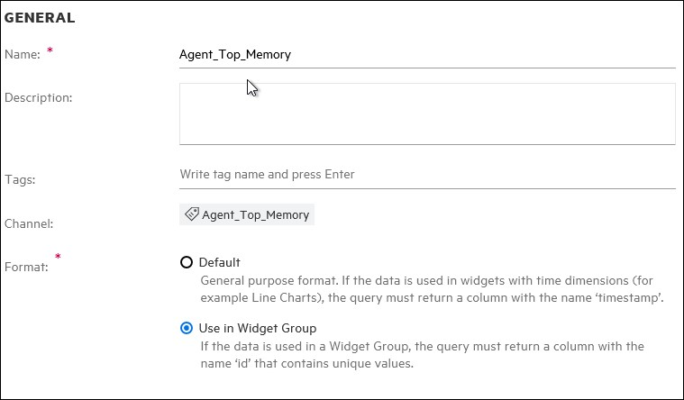
Parameter Query
Parameter queries are written to parameterize a Data Query.
It is used when the user wants to display the same dashboard for different parts of the same dataset.
When you parameterize a data query is, the parameter name must match the variable name in the query.
The selection of a parameter is available as an option during the presentation of the dashboard that contains parametered queries.If a dashboards does not use them, the UI will automatically exclude this option.
To create a Parameter Query, use the following steps:
Click Administration > Predefined Queries > + > Create Parameter Query.
Provide a suitable name to the new Parameter Query.
For selecting parameters dynamically, select the Database Query radio button (Corrected the verb tense and added the correct article.).
Write query and perform a test RUN, and then click SAVE DATA QUERY to create the Data Channel.
Select None as default, in case the query returns null.
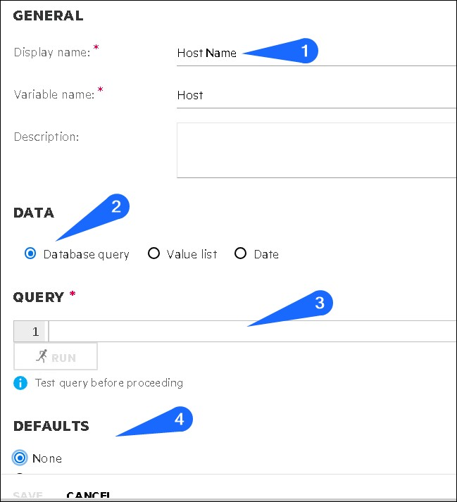
Data Retrieval (The provided text describes the process of retrieving data that can be used as a variable in a Data Query.) retrieves data that can be used as a variable in a Data Query, for example:
Parameter Query: select host from system_metricsgroup by system
Data Query: select * from system_metrics where ${system=$host} limit 1
This example allows the end user to select any host that the parameter query got from Vertica and use this host in the data query using a dropdown list.
In a complex example for Data Query with three Parameters:
SELECT * from system_availability where ${month=”${month_parmeter}”} and ${region<>”${region_parmeter}”} and ${host like “%${host_parameter}%”}
The above sample queries contain conditions combined by an and condition. |If any parameter does not contain a value, the ${ … ${ … }} gets replaced with an expression resulting in logical true.
For example, if host_parameter and month_parameter do not contain values, the query is executed as follows:SELECT * from system_availability where true and ${region<>”${region_parameter}”} and trueThe result returns all hosts from all months within the selected region.
Parameter queries with predefined values are used when values for parameters are not in the database or cannot be obtained as values.For example, a value list for email is created. A data query that uses it as a parameter will display the manually entered values as a parameter list in the report.This query returns only events where the title text includes one of the selected values from the screenshot:SELECT * from events where title LIKE `%${email}%`
To create a Parameter Query with predefined value, select the Value list radio button when creating a parameter query and manually enter LABEL / VALUE pairs.
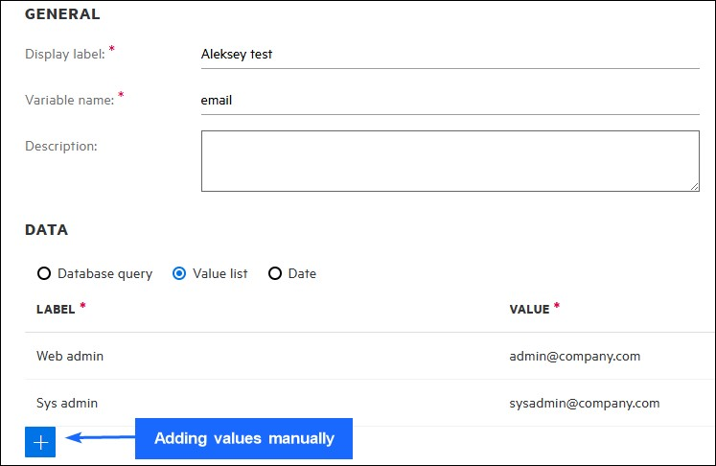
Building queries without SQL
When adding a new Predefined Query, the dialog provides two options – an SQL query editor and a Browse Database table.
The second option allows building queries without using SQL syntax.
The result varies between Flex Reports and STAKEHOLDER DASHBOARDS
For STAKEHOLDER DASHBOARDS, the resulting query will produce a single row data access with optional Time Selection or an array of results that can be attached to the group widget.
For Flex reporting, the same query will provide filtering and data shaping options.
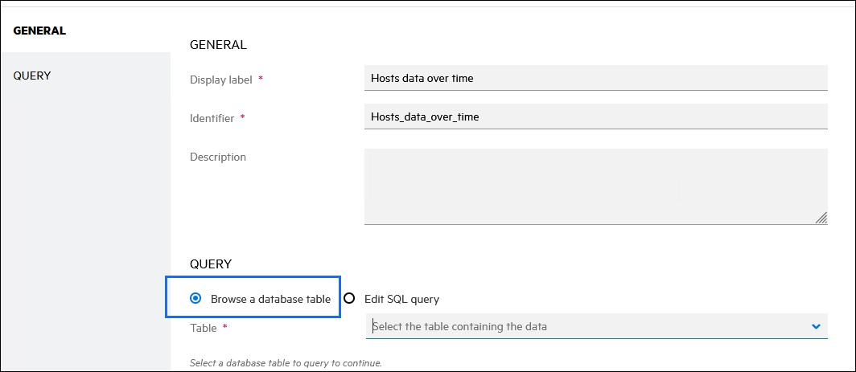
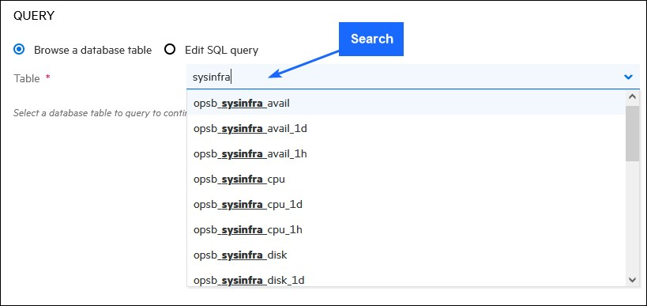
To build a query without using the SQL syntax, the very first step is to select a table. The Table drop-down list displays all tables available in the ODL Vertica cluster, and it supports search functionality.
Note that the ODL has aggregation table that can reduce the data processing demands from the Vertica cluster.

When a table is selected, the interface displays a sample of five rows, allowing you to examine the data.
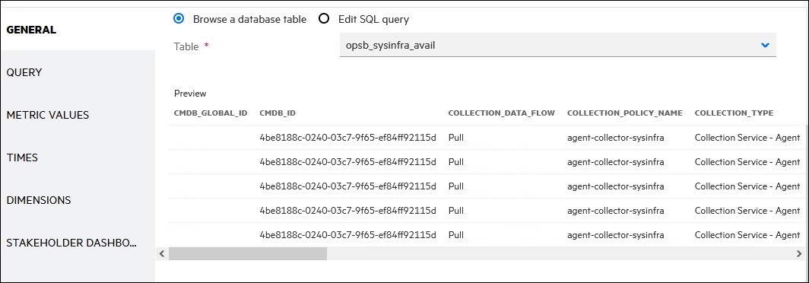
The Add Value (+) button allows you to create a dialog to select the column of the table that will be used as a filter in the report, similar to a Parameter Query.
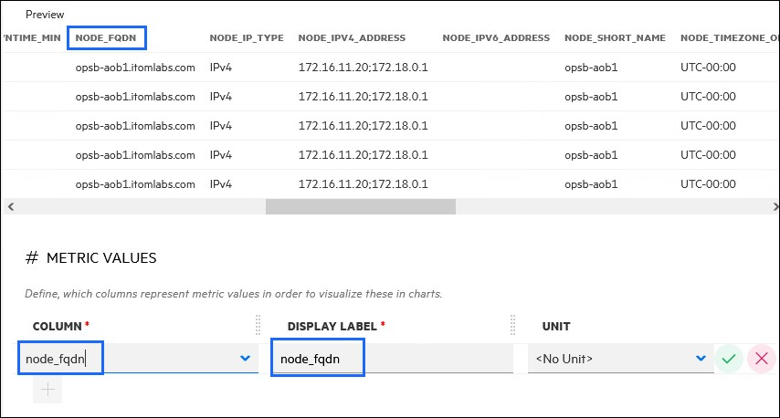
The DISPLAY LABEL column defines how the selected data is represented when you configure the reports and dashboards.
In this example, the column node_fqdn is labeled to a more user friendly name Node Address.
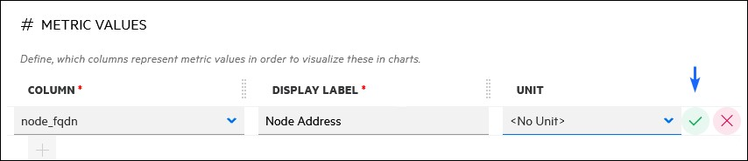
The UNIT selection determines how the data is transformed in the query result. If not used, the data will be shown as is.
You can select more columns, using the Add (+) button.
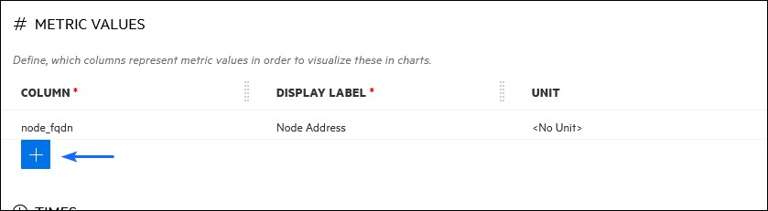
The Count unit returns an integer and the Percentage unit returns the percent in the 0-100 range (if applicable).
The selection of the unit needs to match the data type and intended use. For example, a query that returns text values but configured to show percentage will not work.
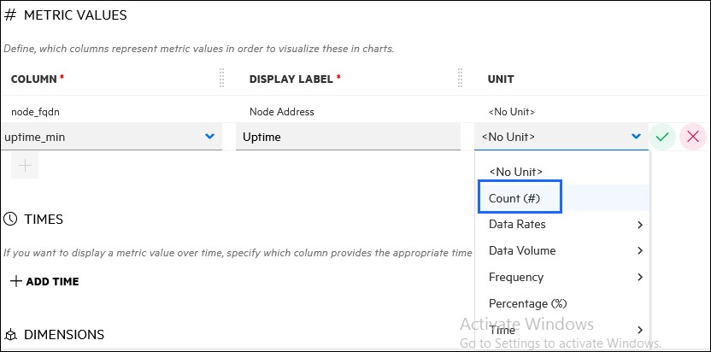
The Time Unit (Corrected the spelling error and preserved the meaning) provides a column selection that specifically refers to the time formats.
For example, a database table (The provided text uses the term 'Vertica table' which is likely a technical term and should be replaced with 'database table' for clarity.) can include the timestamp of data collection and timestamp of data entry into the Vertica cluster (The text uses the phrase 'timestamp of data collection and timestamp of data entry into the Vertica cluster' which is clear and concise.).
This feature is used for graphs and reporting for time selection in the Flex Reports and STAKEHOLDER DASHBOARDS.
Example use case: By selecting the specific time column, you will gain the option for Local Time reports.
The TIMES section can have multiple time columns selected to be used in the result. For example:
Timestamp for time range selection in the UI
Uptime for comparing servers in Bar chart widget
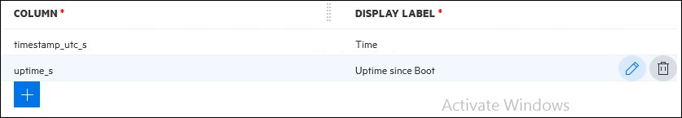
The DISPLAY LABEL works the same way as with metric columns.
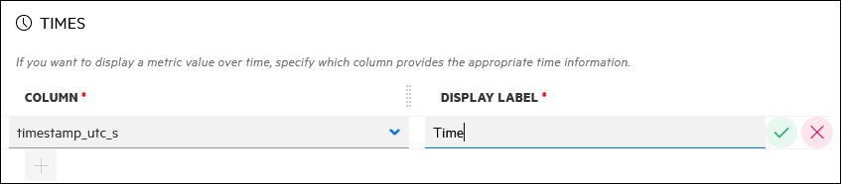
The DIMENSIONS section categorizes the content or filters out the results.
In this example, if a report gets the details of all hosts in AWS EC2, the os_type column will allow filtering out results by Operation Systems, thus narrowing down the result and expanding the dashboard usability.
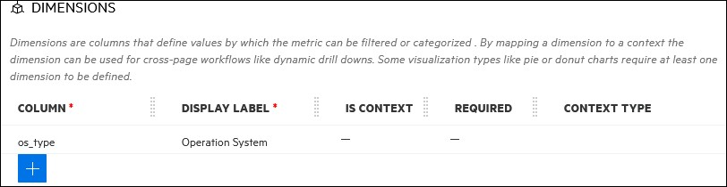
The STAKEHOLDER DASHBOARDS section provides tagging for easier search and parameterization in Stakeholder Dashboard configuration stage.
The Formats section changes the shape of the JSON output, so it could be used in a group or a normal widget.
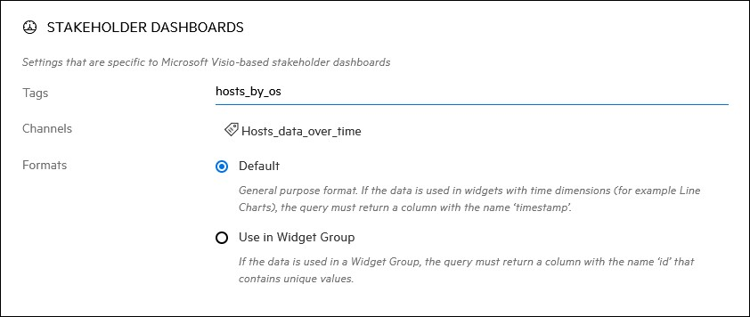
After you save the query, it becomes searchable in the list of Predefined Queries.
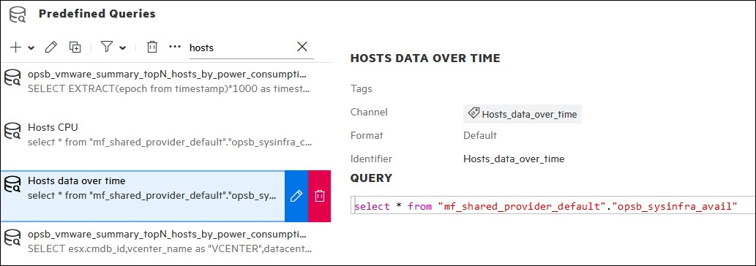
Rule-based custom data fields
In addition to database queries, you can create rule-based data fields.This is done during the Data Chanel configuration in STAKEHOLDER DASHBOARDS (at the moment, not supported in Flex Reports) The possible calculations are:
Mathematical operations (+, -, *, /, sin, cos ln, and so on)
Logical operations (=, <, >, and, or, and so on)
Functions (min, max, random, and so on.)For example:A Donut Chart displays the number of Critical, Major, and Minor values.To display the total of all three values, add them in a text value Widget within the Donut Chart: Minor + Major + Critical = ValueThe sum of all events is not available as a dedicated data field or channel.
A Donut Chart displays the number of Critical, Major, and Minor values.
To display the total of all three values, add them within a text value widget within the Donut Chart (The text value widget is used to display the total of all three values.): Minor + Major + Critical = Value
The sum of all events is not available as a dedicated data field or channel.
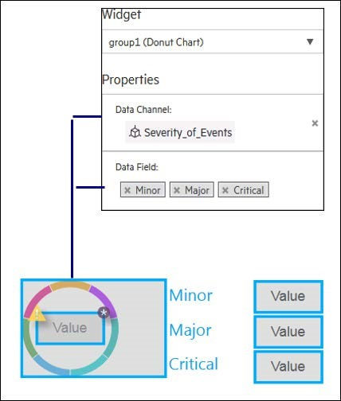
To configure the text value to show the sum of all events:
Combine the data fields that you want to use for the calculation with the equivalent operators in the Calculation Rule field.
Select the CalculatedProperty data field from the Data Field dropdown list that is generated when the Calculation Rule is created.
The Calculation Rule example is as follows: Minor + Major + Critical
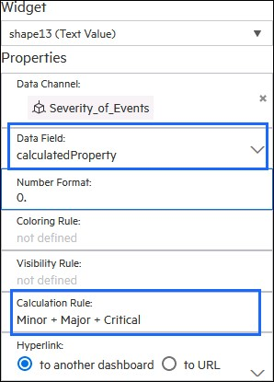
Result: the number 183, in the center of the doughnut is the sum of all three statuses
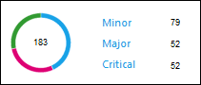
The Operator functions that are available for calculation are as follows:
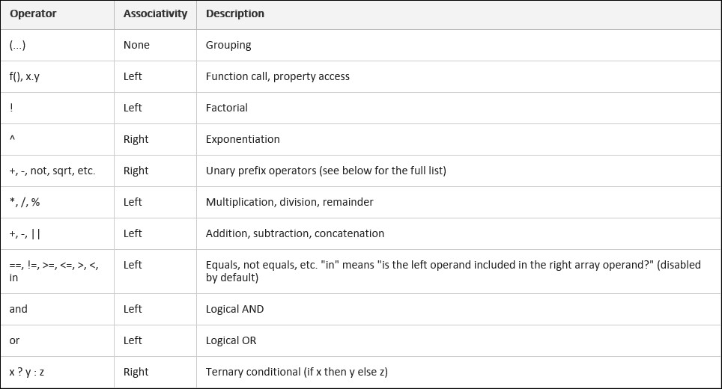
The pre-defined functions are available for calculation are as follows:
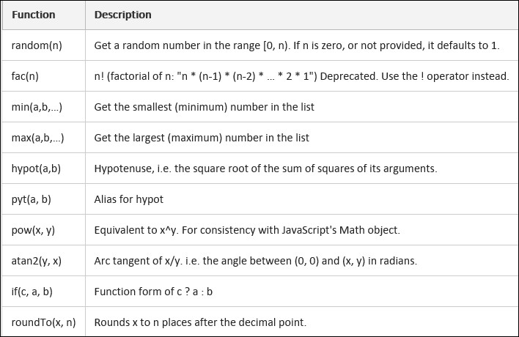
Summary
This module presented the following topics:
Configured Predefined Queries – set up system metric queries.
Configured Predefined Queries – set up parameter queries.
Explored data calculation capabilities (Corrected the phrase for clarity and accuracy.).

Oh no!
Please try again later, contact LearnExperts if the problem persists.

