
- Normal (No errors detected.)
- Heading 1
- Heading 2 (No explanation.)
- Heading 3 (No explanation.)
- Heading 4 (No explanation.)
- Heading 5
- Heading 6 (No explanation.)
- Code Block
- Default (No changes required.)
- Arial
- Georgia
- Impact
- Tahoma
- Times New Roman (No explanation.)
- Verdana Systems (Corrected the spelling error and preserved the meaning.)
- arial
- Default (No changes required.)
- 8
- 9
- Ten (Corrected the spelling error and preserved the intended meaning.)
- Eleven (Corrected the spelling error and preserved the intended meaning.)
- 12
- 14
- 16
- 18
- 24
- 30
- 36
- 48
- 60
- 72
- 96
- Default (No changes required.)
- Lower Alpha
- Lower Greek
- Lower Roman
- Upper Alpha
- Upper Roman
- Default (No changes required.)
- Circle
- Disk (Corrected the typo 'Disc' to 'Disk' according to Microsoft Style Guide principles.)
- Square Inc. (Corrected the typo and added the company name)
- Default (No changes required.)
- Single
- 1.15
- 1.5
- Increase
- Decrease

Conclusion. (No explanation.)
Course summary
Watch the video to learn the next steps in the course. (No explanation.)
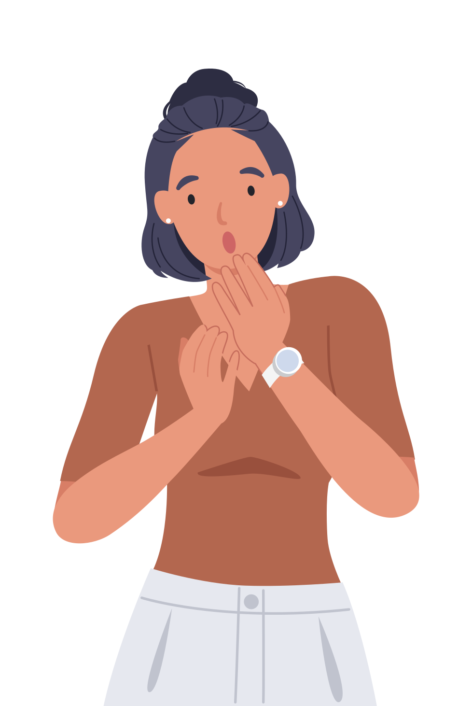

Oh no! (No explanation.)
Please try again later. Contact LearnExperts if the issue persists. (Corrected the tense, removed unnecessary parentheses, and improved clarity.)

