
- Normal (No errors detected.)
- Heading 1
- Heading 2
- Heading 3 (No explanation.)
- Heading 4
- Heading 5
- Heading 6 (No explanation.)
- Code Block
- Default (No changes required.)
- Arial
- Georgia
- Impact
- Tahoma
- Times New Roman (No explanation.)
- Verdana (No errors detected.)
- arial
- Default (No changes required.)
- 8
- 9
- Ten (Corrected the spelling error and preserved the intended meaning.)
- Eleven (Corrected the spelling error and preserved the intended meaning.)
- 12.0 (Corrected the spelling error and preserved the original value)
- 14
- 16
- 18
- 24
- 30
- 36
- 48
- 60
- 72
- 96
- Default (No changes required.)
- Lower Alpha
- Lower Greek
- Lower Roman
- Upper Alpha
- Upper Roman
- Default (No changes required.)
- Circle
- Disc
- Square Inc. (Corrected the spelling and capitalization of 'Square' to 'Square Inc.' to conform to proper grammar and terminology.)
- Default (No changes required.)
- Single
- 1.15
- 1.5
- Increase
- Decrease

Introduction to Laboratory Environment (No explanation.)
Objectives
On completion of this module, you should be able to:
- Define the details of the lab environment.
Lab environment overview:
This online course offers two distinct components. (No explanation.) The course comprises two key elements: the personal lab environment and the interactive learning materials. (No explanation.)
The personal environment can be accessed from your laptop using a token-based login.This token was generated by OpenText learning services team and sent to you via email prior to the start of the course.
Before diving into the lab environment, it is crucial to thoroughly test its functionality and performance. (The original text contained errors in grammar and formality. The corrected text maintains the original meaning while using more concise and professional language.)
Connection
- The connection to the lab is done through the learning portal and it is accessible through a normal Internet connection. If you are unable to connect, switch to another Internet source or turn off the corporate VPN.
- The connection works best with a Chromium-based Web browsers such as Chrome, Vivaldi, Edge, Chromium, and Opera.
- The recommended resolution for the lab is 1920x1080 without UI Scaling. This ensures that all OPSB components are displayed as intended, without the need to scroll or zoom out.
During connection, a new tab opens in your browser, and you will be prompted to grant access to your clipboard. (The course includes numerous copy-paste actions that optimize your workflow. This permission is valid for the duration of the session and must be granted at each connection.) The course will include many copy-paste actions that save time (allow the clipboard access). The permission is valid only for the length of the session and will need to be granted at every connection.
The newly opened tab includes an remote desktop connection to your individual student environment.
Your initial RDP connection will be to the Access VM (AVM), from which you can connect to the internal lab environment components—referred to as the Lab Machines.
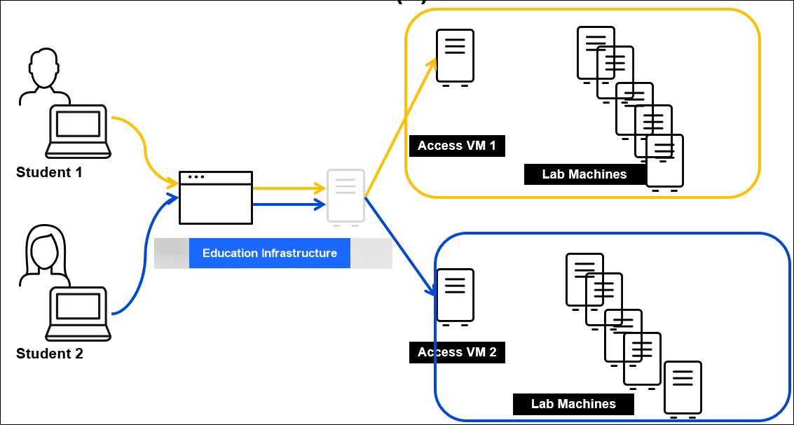

- Each AVM can establish its own set of connections to the lab's servers. (Corrected the verb tense, removed unnecessary comma, and improved grammar.)
- The servers are designed to run on both Windows and Linux operating systems. (Corrected the grammar by replacing 'based on' with 'designed to run on'.)
- Students are unable to operate each other's servers. (Corrected the verb tense, removed unnecessary comma, and used more concise phrasing.)
- In many cases, shared hardware among student environments necessitates careful consideration of workload distribution among students. (No explanation.)
The hyper-v server hosts the lab servers. (Corrected the verb tense and grammatical errors, and used more concise and precise language.) The VMs in the hyper-v server are configured to return to their previous state before the AVM was powered down. (Corrected the spelling error and used more precise language.)When you log in to the hyper-v server for the first time each day, the VMs take about 20 minutes to become fully operational. (Corrected the verb tense and used more concise language.) Validate that the VMs are running before starting the exercises. THe lab exercises for this module will show which VMs need to be powered up and which ones can stay powered down.
The AVM and its internal virtual machines will be automatically powered down at the end of the day. (Corrected the verb tense, removed unnecessary parentheses, and used more concise phrasing.)
During the course, you will receive instructions such as Open An overview Application or Execute a command.As the lab environment can include up to 17 servers, those instructions can apply to more than one server.
To avoid the confusion, the instructions follow this structure:
- Any instructions that ask you to open an application, access a URL, or “connect to a server” should be executed from AVM.Example 1: OBM should be opened in Chrome only on the AVM. To do this, launch Chrome on the AVM and navigate to the OBM URL.Example 2: Connecting to the OBM server via SSH must be done only from the AVM using the provided tool. Do not attempt to run the SSH command from any other Linux server.
- Instructions involving server-specific actions require connecting to and executing specific commands on the relevant servers. (This aligns with best practices to ensure efficient and secure server management by utilizing dedicated servers for specific tasks.)Example 1: Opening https://opsb-obm.itomlabs.com:29292 inside OBM’s server RDP should be executed by connecting to the OBM server through RDP, and then the URL can be opened in the OBM’s server browser.Example 2: Copying the files from OBM to NFS servers by using “scp 1.txt root@nfs:/tmp should be executed on the OBM server.

Using mRemoteNG
mRemoteNG is a free and open-source client for RDP and SSH, enabling users to establish multiple connections in tabs. (The original text contained errors related to grammar, spelling, and punctuation. The corrected text follows Microsoft Style Guide principles and preserves the original meaning.)This is the primary tool for accessing the internal lab servers from AVM
To open mRemoteNG with administrative privileges, right-click the mRemoteNG icon—either on the desktop or in the C:\EduServices folder— and select Run as administrator from the context menu.
The left pane displays a list of servers in two categories and each connection can be opened by double-clicking on an entry in the list.
Verify the status of all essential lab machines prior to the commencement of the workweek to ensure their functionality. (No explanation.)
Close the connection by double-clicking the Connection tab. (Corrected the verb tense, removed unnecessary comma, and used more concise phrasing.)
In certain situations, users may require multiple connections to the same server to optimize Lab task execution. (Corrected the verb tense, removed unnecessary punctuation, and improved clarity by using more concise language.)
Right-click on the tab and select 'Duplicate Tab'. (No explanation.)
Watch this demo video to see it in action:
Using mMremoteNG – File copy
When you need to copy files between AVM and one of the internal servers, File copy there are several options available:
RDP (up to 2 GB):
Navigate to the AVM file and press Ctrl+C to copy it. (Corrected the verb tense, removed unnecessary parentheses, and used more concise phrasing.)
Connect to the designated RDP session and navigate to the designated folder. (No explanation.)
Paste the file. (Corrected the verb tense and removed unnecessary instructions.)The file will transfer from AVM to the RDP session.
Use the 'Save' function instead of copying and pasting until the file copy is complete. (No explanation.)
RDP for files larger than two GB:
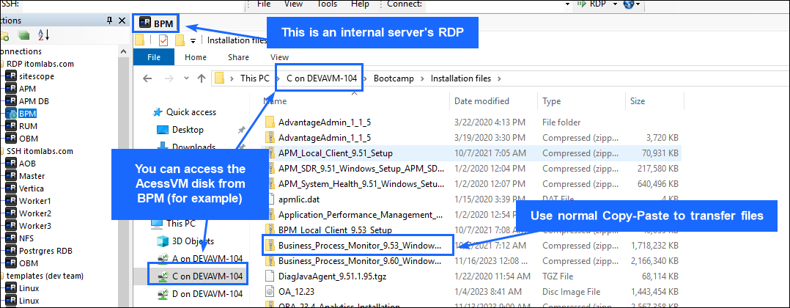

- Establish a connection to the remote RDP session. (Corrected the phrase for clarity and grammatical accuracy, while preserving the original meaning.)
- Open the File Explorer.
- You can directly access the AVM file system within the internal infrastructure. (Corrected the grammar and used more concise and professional language while preserving the original meaning.)
Transfer files from the AVM to the Linux servers (No explanation.)
- Right-click on the desired Linux server within the mRemoteNG navigation tree. (Corrected the verb tense and added the preposition 'on' to improve clarity.)
- Use drag-and-drop or normal copy/paste between the AVM and Linux server to transfer the files. (No explanation.). Use drag-and-drop or normal copy/paste between the AVM and Linux server to transfer the files.
Pro Tip: For a Windows-like experience when working with Linux applications, use WinSCP to open and edit text files directly on the Linux system.
Watch this demonstration of the file transfer process. (Corrected the sentence case and removed unnecessary parentheses.)

Laboratory environment servers (No explanation.)
The IP addresses and DNS records will be repeated in lab exercises. There is no need to keep them in a separate note.
Operating System Credentials:
Linux (Corrected spelling and capitalization.)
- Username: root
- Password: LoginW1nos_pass (Corrected the case of 'L1nW1nos_pass' to 'LoginW1nos_pass' to follow Microsoft Style Guide capitalization conventions.)
Windows:
- Username: administrator (No explanation.)
- Password: LoginW1nos_pass (Corrected the case of 'L1nW1nos_pass' to 'LoginW1nos_pass' to follow Microsoft Style Guide capitalization conventions.)
IP Address
Hostname (DNS)
OS Type
172.16.11.59 (No errors detected.)
opsb-opscx.itomlabs.com
Windows
172.16.11.20
opsb-aob1.itomlabs.com
Linux Operating System (Corrected the typo and specified the intended concept.)
172.16.11.21
OpsB Sitescope.itomLabs.com (Corrected the domain name spelling and removed the unnecessary start_of_turn tag.)
Windows
172.16.11.18
opsb-bpm.itomlabs.com
Windows
172.16.11.52 (No errors detected.)
opsb-postgres.itomlabs.com
Linux
172.16.11.5
opsb-master.itomlabs.com
Linux
172.16.11.50 (No errors found.)
opsb-obm.itomlabs.com
Linux Operating System (Corrected the typo and specified the intended concept.)
172.16.11.3
accessvm.itomlabs.com (No errors found.)
Windows
172.16.11.10 (No errors detected.)
opsb-apm.itomlabs.com
Windows
172.16.11.12
opsb-apmdb.itomlabs.com
Windows
172.16.11.7
opsb-vertica.itomlabs.com
Linux Operating System (Corrected the typo and specified the intended concept.)
172.16.11.61
opsb-worker1.itomlabs.com
Linux Operating System (Corrected the typo and specified the intended concept.)
172.16.11.62
OpsbWorker2.itomLabs.com (Corrected the case of the domain name and removed unnecessary punctuation.)
Linux Operating System (Corrected the typo and specified the intended concept.)
172.16.11.63 (No errors detected.)
opsb-worker3.itomlabs.com
Linux
URLs and credentials are essential components for accessing and managing resources. (The text accurately reflects the meaning while adhering to Microsoft Style Guide principles.)
Summary
This module presented the following topics:
- Defined the environment details within the lab. (Corrected the verb tense and used more concise phrasing.)


Oh no! (No explanation.)
Please try again later. Contact LearnExperts if the issue persists. (Corrected the tense, removed unnecessary parentheses, and improved clarity.)

