

3-6360-254-00_13. Troubleshooting
Objectives
On completion of this module, you should be able to:
- Learn how to read logs in a variety of ways.
- Learn how to use K9S.
- Learn about Grafana dashboards.
- Learn how to use tools and documentation.
- Learn the basic workflows of IDM.

OMT troubleshooting can be separated into many categories and subcategories, for example:
- Infrastructure can be split into OS management, virtualization, networking, storage, and hardware.
- Kubernetes can be separated into configuration management, versioning, resource allocation, container runtime, and internal connectivity.
- OMT and ITOM application components can be categorized with compatibility, workload, security, access control, and plain bugs.
The troubleshooting begins with the tools that allow a convenient way to look at the OMT Kubernetes components.
There are several ways to look at Kubernetes logs and pods.
Please note that the methods here are all an alternative to the kubectl logs <pod name> -n <namespace> command. [Added a period to complete the sentence.]
The first method is to use AppHub. This method is fast and easy, with additional benefit of not needing to connect to the cluster VMs. [Corrected double "the", added "to", and capitalized "VMs".]
<video>
The second method is to use the out-of-the-box Kubernetes UI. [Corrected capitalization of "Method" and added a period.]
To access, use the https://<FQDN>:5443/dashboard URL. [Added a period to complete the sentence.]
<video>

K9S
So far, instruction has guided you through using either the native Kubectl command or an R&D-provisioned alias to work with Kubernetes in the OMT cluster. [Corrected grammar "through were using" to "through using" and hyphenated "R&D-provisioned".] The CLI approach contains all possible commands and flags to complete any task in the cluster, but it is also time‑consuming and sometimes inconvenient even for simplest tasks. [Hyphenated "time-consuming".]
There are solutions dedicated to making this process more convenient. A Kubernetes browser UI is one of them, and another common tool is K9S. [Corrected subject‑verb agreement and added a comma.]
K9S is basically a visualization layer for the Kubectl command and it provides a fast and convenient way to accomplish common tasks, such as viewing pod status, listing resources, reading logs, and modifying YAML-based settings.
Full details of K9S functionality will not be covered here, but a few helpful basics are: [Pluralized "detail" to "details" for consistency.]
- There many ways to install the tool using package managers and even, as this example shows, Webi, which gets K9S with a single command.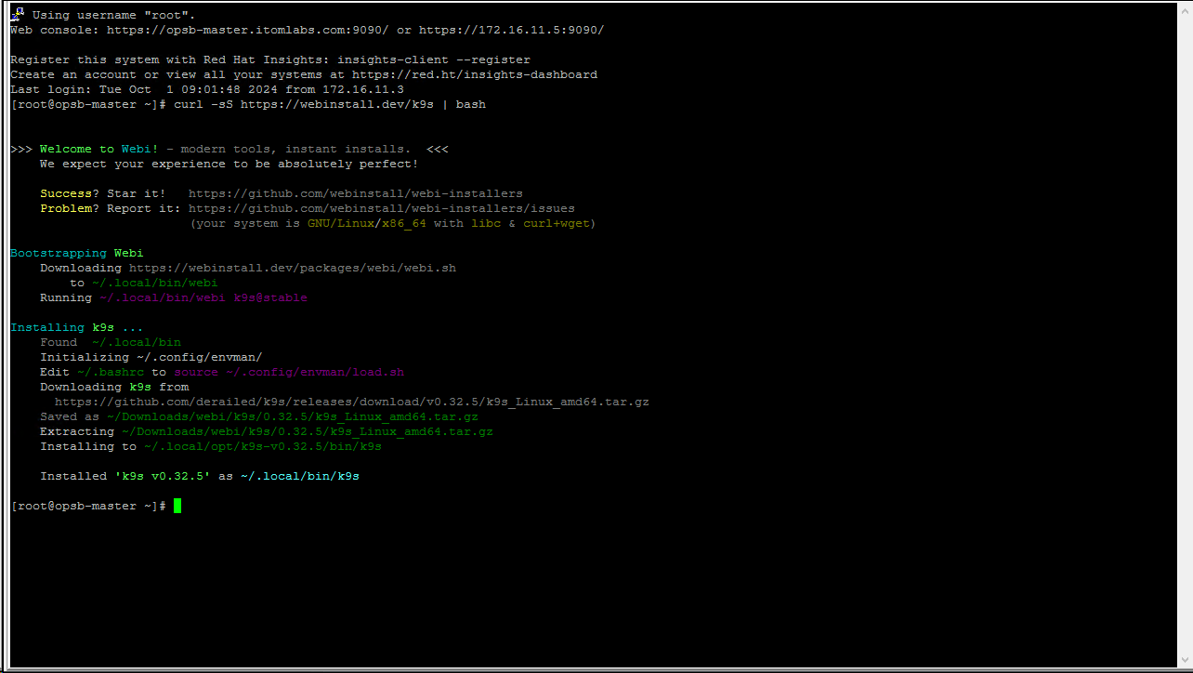
- The tool is launched from a shell using a K9S command and it opens in the last, previously used view . The example shows the first launch that views the contents of the default namespace. Until now, the default namespace was not configured, so there are no pods.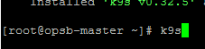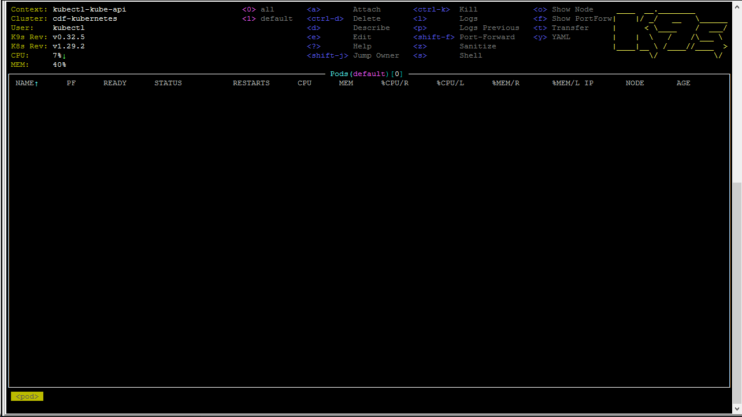
- At the top of the UI is a command that is applicable to the current view. Press 0 and the view will show all available pods.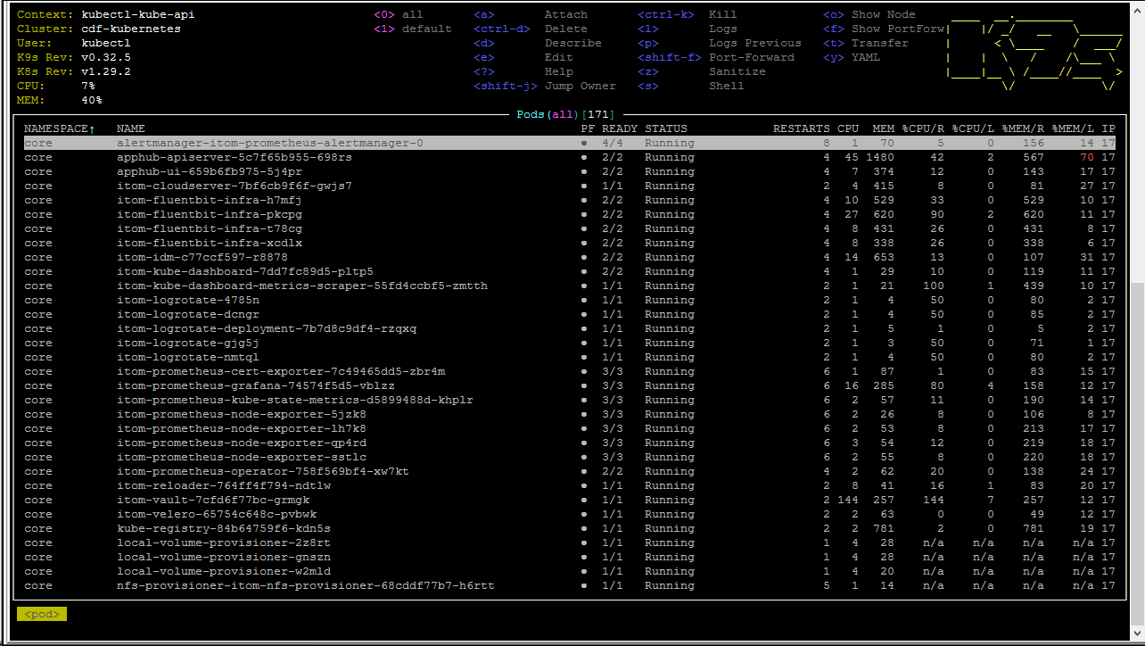
- Navigate through the view with the arrow and page up and down keys.
In this example by going down the list there are a few pods in failing state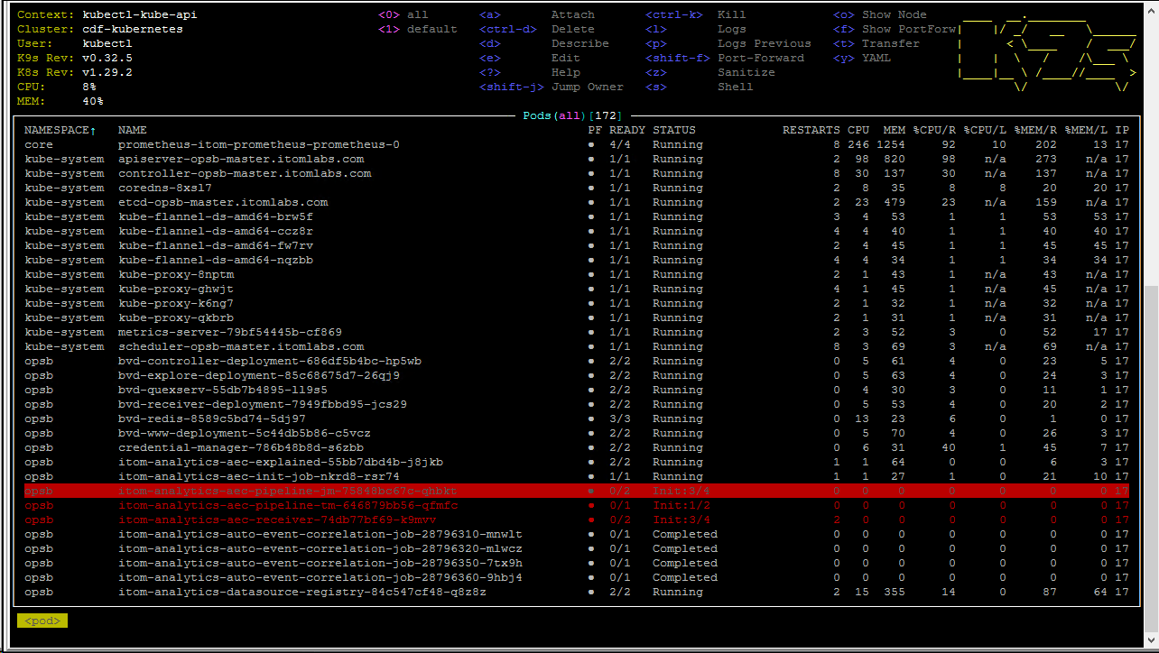
- Several operations can be performed on a selected pod: [Rephrased to active voice, changed preposition to "on" for natural phrasing, and removed the trailing non‑breaking space.]
  - Press d to show the pod description and press the Escape key to return to the previous screen.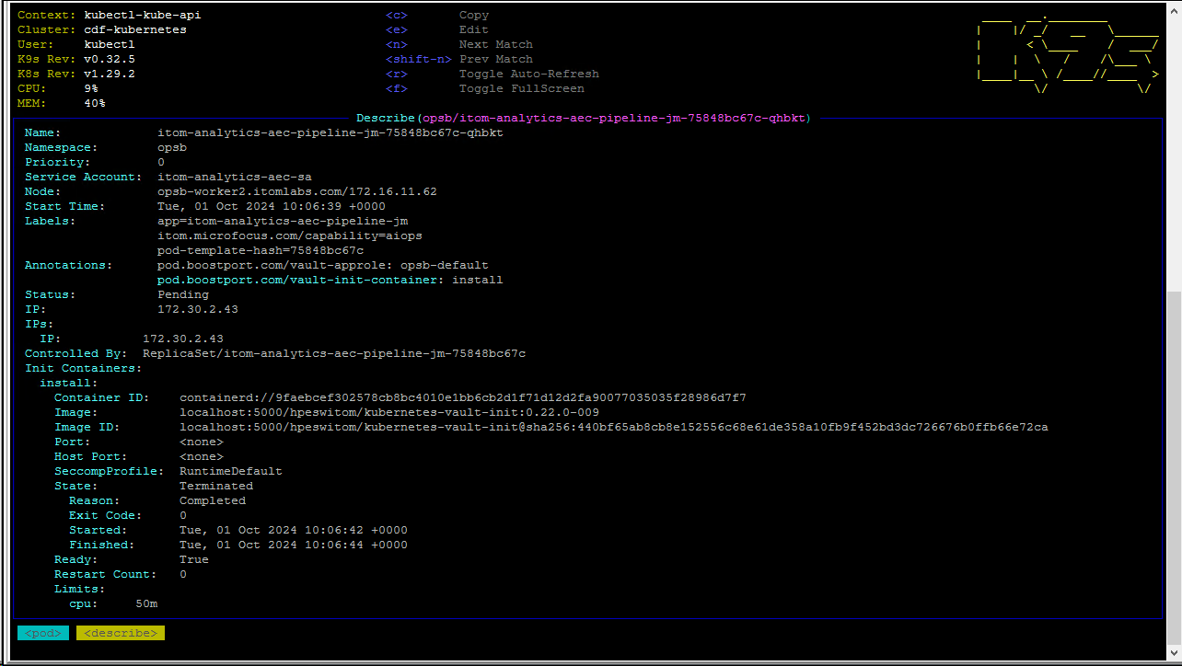
  - Press Enter to show all individual containers.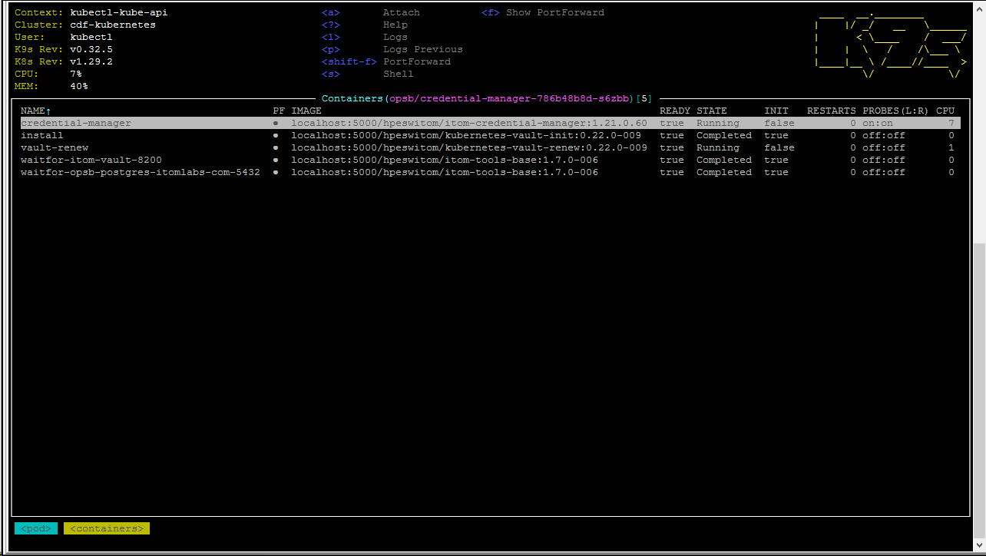
  - Press l (Small L) to show the log of the container, or in pod selection, press l to show all logs of all containers in a single stream.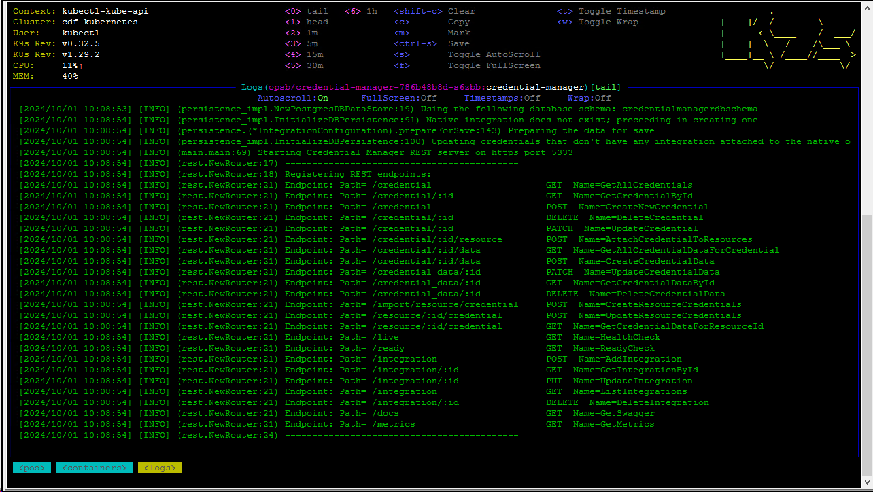
The log opens in a tail mode, and it can be manipulated to show a specific time frame using the number keys. Press s to stop tailing .When the log does not have time stamps, press the t key and K9S will add them is.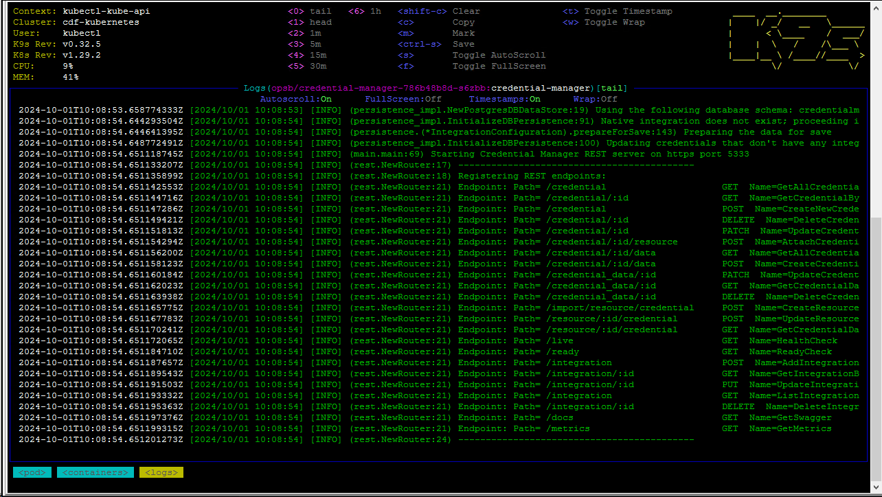
- To switch the view to other resources and use the search function, K9S employs an approach like the Vim text editing tool. For example, to switch the top services view, type colon (:), then type “services,” and press Enter.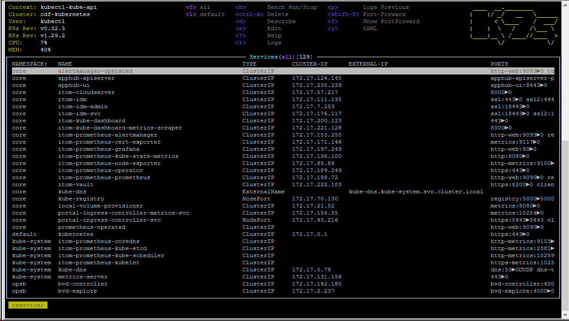To search, type back slash (/) and the text string you want to find. In this example, a search was completed for any entry with the number 5443.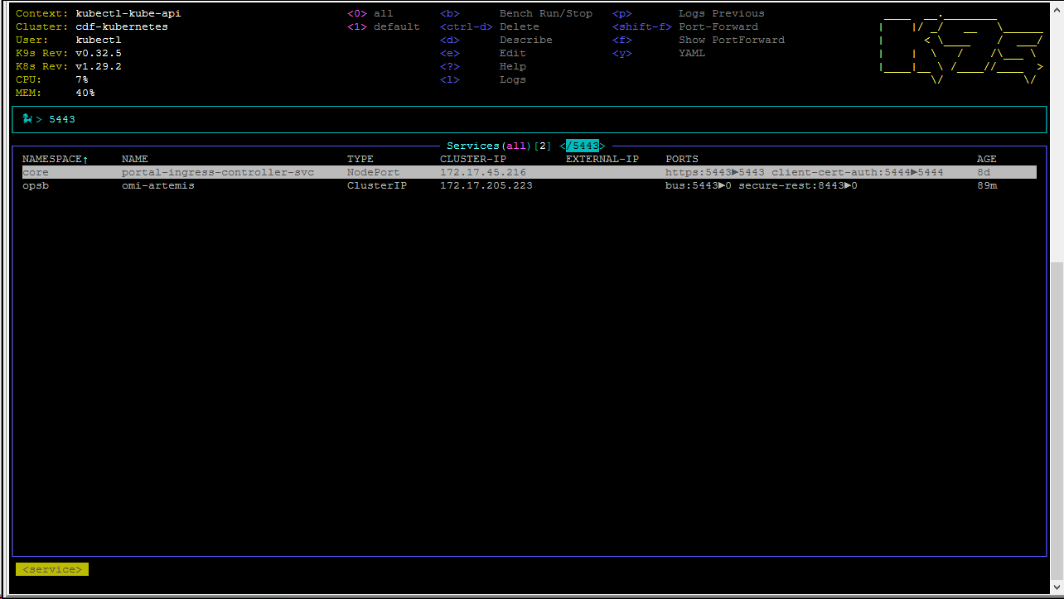
- Press the e key to edit the selected resource of any kind and it will open the YAML file for editing in the VI application. 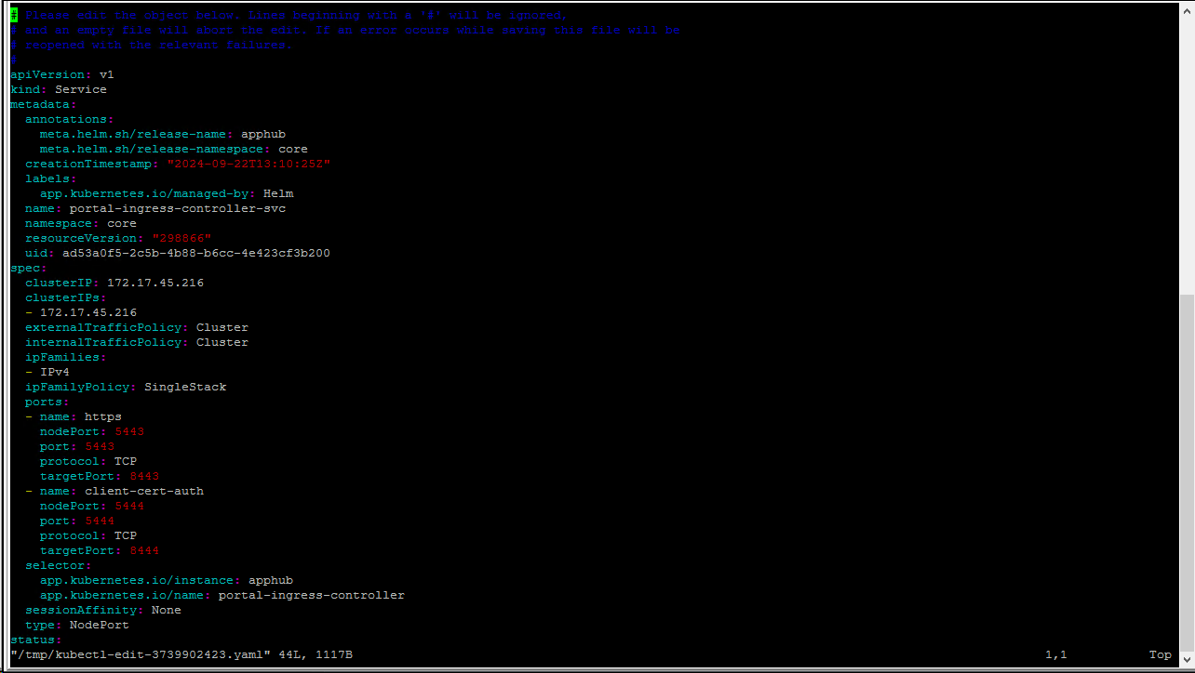After performing the required edits, the file is saved using the regular VI commands. It will also check the YAML syntax for errors and refuse to save the edits if the syntax is not correct. Once the file is saved, it will be immediately applied to the cluster configuration.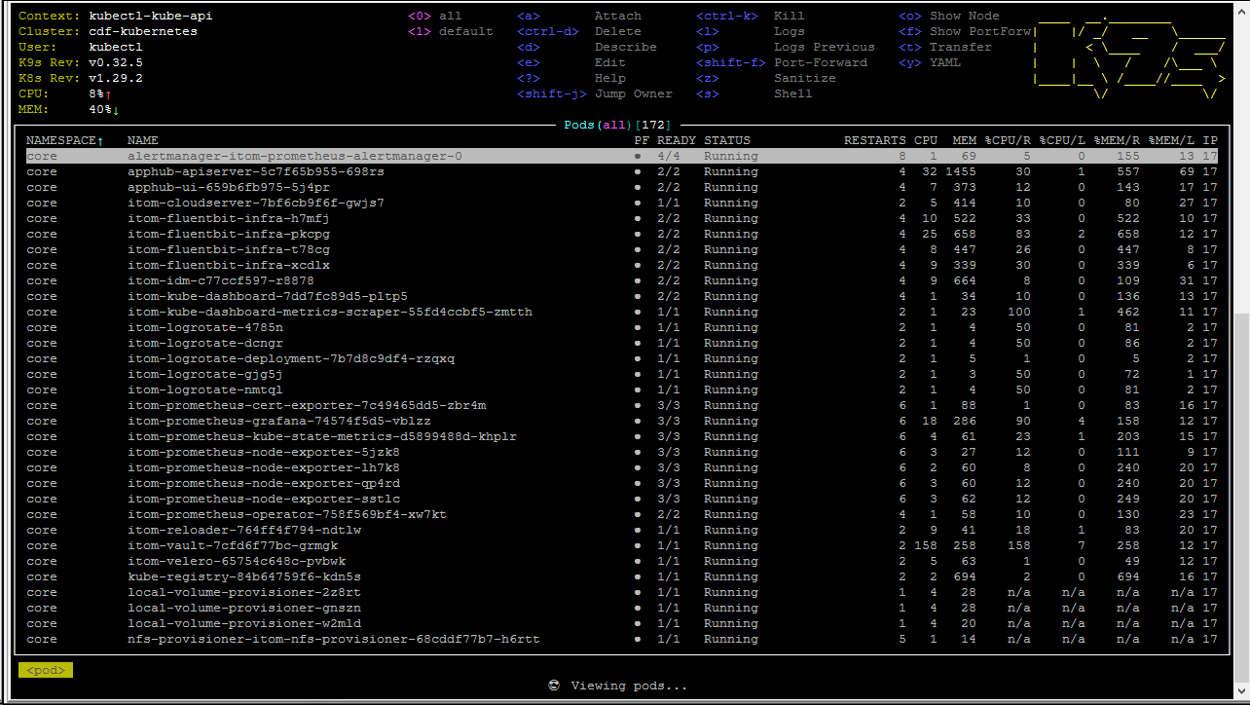
This concludes the brief K9S overview. Using this tool can shorten maintenance and troubleshooting tasks, so please explore the official documentation to learn about other features of the tool. [Removed the extra period at the end of the sentence.]

Troubleshooting pods
Three ways to navigate the Kubernetes components have been explored so far. A fourth method uses native Kubernetes CLI commands, which is part of the basic Kubernetes training. [Removed the non‑breaking space after the period.]
Now, when you learn how to navigate the components, you will see a common investigation scenario. [Removed the erroneous word "less" that made the sentence unclear.]
To troubleshoot the pods, list the pods and see the status of the pod in question.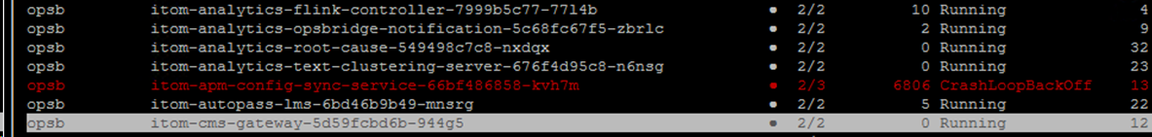
If the status does not display Completed or Running, investigate further.
Use the kubectl describe command to see the pod status in detail. [Removed trailing non‑breaking space after the period.]
The description includes the Events section at the bottom, and in most cases, it will explain why the pod status is not running.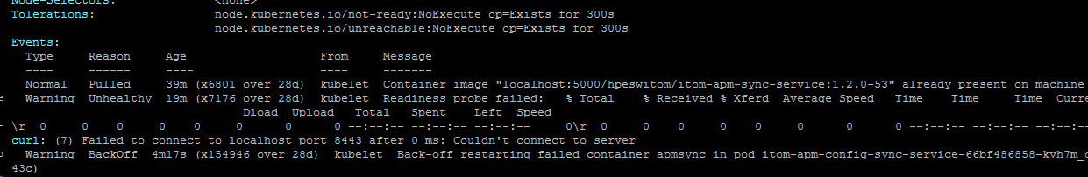
Most messages in the Events section are related to pod configuration and its relationships to other pods and Kubernetes components.
Not all issues can be examined from the Describe page, since pod failures can be related to the actual application that is hosted in the pod.
Read the log of the pod for further examination, which shows more details, including those that might be related to the root cause.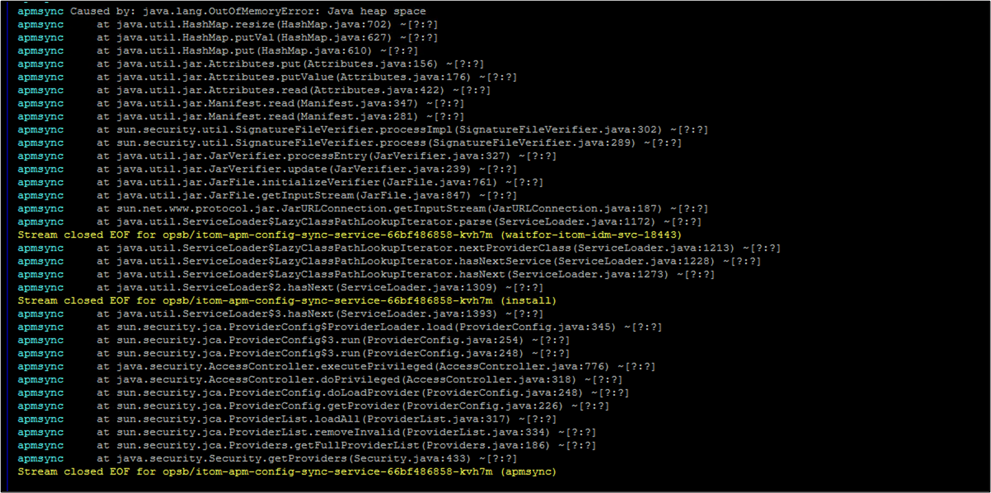

Logs
Not all logs are accessible from the kubectl command. Each container in the pod might store additional logs, which can affect the pod's health and the contents of those logs will be visible only by looking at them directly in the file system. [Replaced curly apostrophe with straight apostrophe; removed comma before "and" to avoid a comma splice; preserved meaning and technical terms.]
The logs are located in the NFS server directory, which was set up during the infrastructure preparation stages. The example shows the default location of the /VAR/VOLS/ITOM and the structure of the core and OpenText AI Operations Management deployments.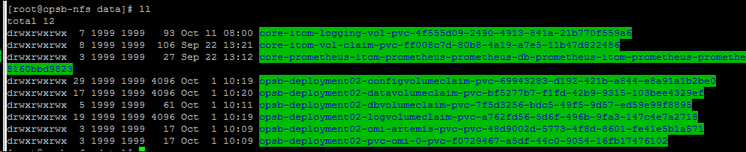
There are several types of logs: pod logs that contain data about pods and their life cycle as well as logs that are used for the applications that are contained inside the pods. As the example shows, the contents of the OpenText AI Operations Management logs are separated by capability and contain the application logs, such as OMI runtime and processing logic of UCMDB.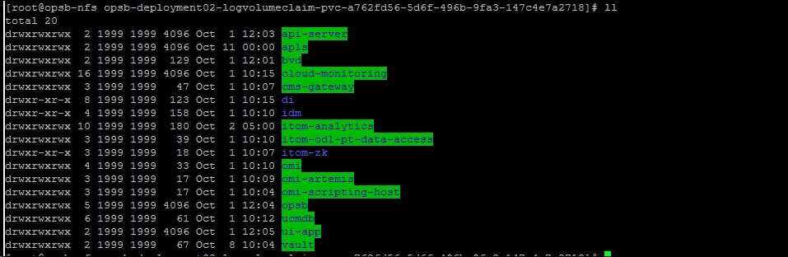
The core logging volume includes all the pod runtime logs.
Most pods will have a random hash value in their name. This is helpful because pods that migrate from node to node or are redeployed are essentially new entities. If the name is identical to all previous deployments, you will have to filter out new data from old and irrelevant data each time you try to read the logs.
To continue this example with the Stakeholder Dashboards pods, here is a list of the pods that correspond to Stakeholder Dashboards and all of them have the exact same name with a random string at the end. This is the log history of each individual Stakeholder Dashboards pod, and the operator must know the exact name of the pod in its current instance to read the currently relevant log.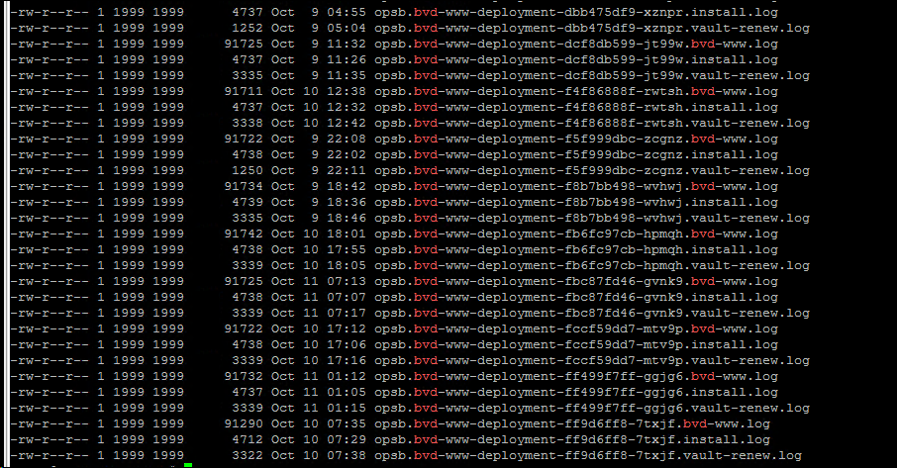
Not all pods have the random value and here is an example of OMI pod, which will log the data in the same file, even if OMI was completely replaced or updated with a new version.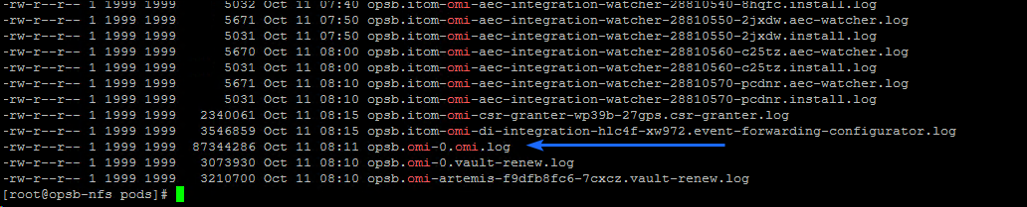
To summarize, when evaluating the logs, it is best to start with the pod status, then check the logs in Kubernetes with any tool that is convenient. If this is not sufficient, go to the NFS server to investigate further.

Summary
On completion of this module, you should have:
- Learned how to read logs in a variety of ways.
- Learned how to use K9S.
- Learned about Grafana dashboards.
- Learned how to use tools and documentation.
- Learned the basic workflows of IDM.

Test Questions [Missing initial letter 'T' in 'Test'.]

Where are additional logs stored that can reveal details about pod's health?
- In the file system
- In a separate server
- In a database
- In the cloud
Answer: a
Some containers in the pod might store additional logs in the file system.
Where are additional logs stored that can reveal details about pod's health?
- In the file system
- In a separate server
- In a database
- In the cloud
Answer: a
Why do most pods have a random hash value in their name?
- To reduce storage usage
- To distinguish new entities when pods migrate or are redeployed
- To enhance security
- To improve performance
Answer: b
Most pods have a random hash value in their name to distinguish them as new entities when they migrate from node to node or are redeployed.
Why do most pods have a random hash value in their name?
- To reduce storage usage
- To distinguish new entities when pods migrate or are redeployed
- To enhance security
- To improve performance
Answer: b
Comments

Type
All
Reviewed

Add Comment
ramarajr@opentext.com
Added 1/23/2026
"This is what I was looking for the commands discussed in previous modules. The other modules had the commands as part of the screenshot, which made it extremely tiring to read. "

apotapchuk@opentext.com
Added 1/25/2026
"the course looks different for customers. They will be able to click and see the image in full resolution, the content itself will be narrower too. This is not available in review mode"
Reply
apotapchuk@opentext.com
Added 12/4/2025
"Aleksey, need a k9s screenshot here "

apotapchuk@opentext.com
Added 2/3/2026
"hmmm, I see it attached to the step, probably a course loading issue [Capitalized the pronoun 'I'.]"
Reply
ramarajr@opentext.com
Added 1/23/2026
"Typo"

apotapchuk@opentext.com
Added 1/25/2026
"fixed [Removed trailing space.]"
Reply
ramarajr@opentext.com
Added 1/23/2026
"Need to fix the cropped area."

apotapchuk@opentext.com
Added 1/25/2026
"fixed"
Reply
Comments

Type
All
Reviewed

Add Comment
ramarajr@opentext.com
Added 1/23/2026
"This is what I was looking for the commands discussed in previous modules. The other modules had the commands as part of the screenshot, which made it extremely tiring to read. "

apotapchuk@opentext.com
Added 1/25/2026
"the course looks different for customers. They will be able to click and see the image in full resolution, the content itself will be narrower too. This is not available in review mode"
Reply
apotapchuk@opentext.com
Added 12/4/2025
"Aleksey, need a k9s screenshot here "

apotapchuk@opentext.com
Added 2/3/2026
"hmmm, I see it attached to the step, probably a course loading issue [Capitalized the pronoun 'I'.]"
Reply
ramarajr@opentext.com
Added 1/23/2026
"Typo"

apotapchuk@opentext.com
Added 1/25/2026
"fixed [Removed trailing space.]"
Reply
ramarajr@opentext.com
Added 1/23/2026
"Need to fix the cropped area."

apotapchuk@opentext.com
Added 1/25/2026
"Fixed" [Capitalized status label to match Microsoft style for labels.]
Reply


Oh no!
Please try again later. Contact LearnExperts if the problem persists. [Split run‑on sentence into two sentences for clarity.]
OK

