PROGRAMMİNG 2 PROJECT

Alperen Aydın 23040102045

Emirhan Toğuç 22040102020

GitHub

<https://github.com/alprnayd/JavaFX-ToDOList>

https://github.com/emirhantoguc/ToDoList

In our project, we attempted to create a To-do list using JavaFX where users can register and log in, application data is saved to the local drive, we can add and delete tasks, and mark added tasks as completed. We also tried to add an option to specify the difficulty level of the task when adding it.

*Task Priority:*

  Each task can be marked as Low, Medium, or Hard priority, and this is shown next to the task.

*Automatic Save & Load:*

  Adding, completing, or deleting a task is saved instantly. When the user logs in, their tasks are loaded automatically.

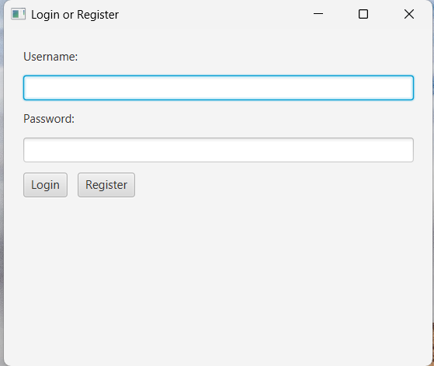 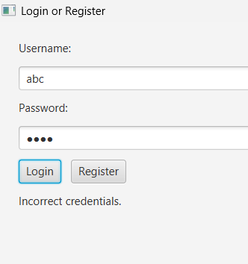

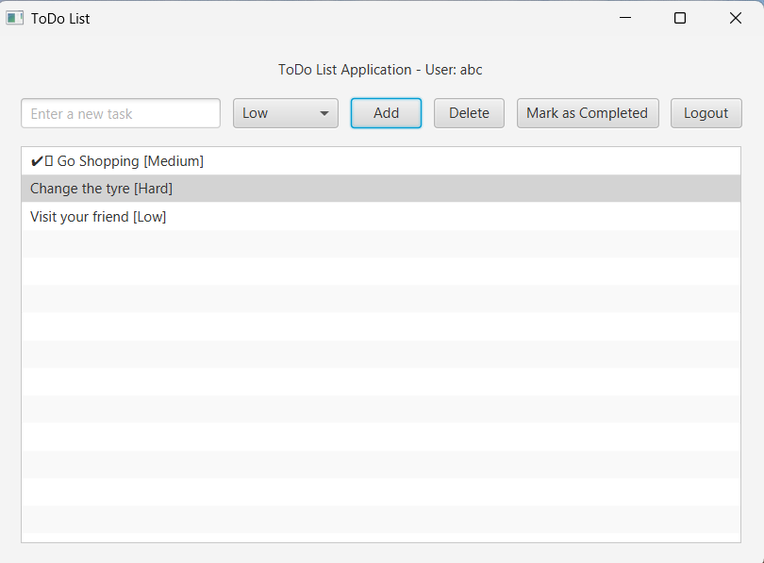 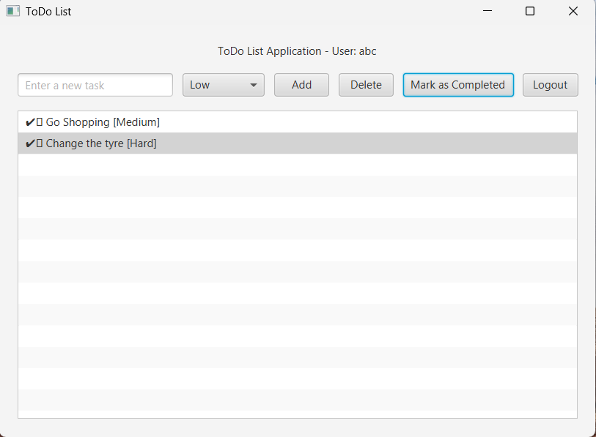

|  |  |  |
| --- | --- | --- |
| **Feature** | **Successfully realized (Yes or No)** | **Source code file names** |
| Basic functionality | Yes | Main.java, User.java  Task.java |
| Authentication | Yes | LoginDialog.java |
| File processing | Yes | Main.java |
| **Additional features (if any):** |  |  |
| İndicate Difficulty(ComboBox) | Yes | Main.java |
|  |  |  |
| ….. |  |  |
|  |  |  |