### **−**Table of Contents

* [Introduction](http://robot.cmpe.boun.edu.tr/~cmpe565/doku.php?id=mehmetalpsarkisla:assignment6#introduction)
* [Object Detection](http://robot.cmpe.boun.edu.tr/~cmpe565/doku.php?id=mehmetalpsarkisla:assignment6#object_detection)
* [Kalman Filter](http://robot.cmpe.boun.edu.tr/~cmpe565/doku.php?id=mehmetalpsarkisla:assignment6#kalman_filter)

## Introduction

In this assignment we implement Kalman Filter to predict the moving ball with 0.1m radius using pointcloud data coming from kinect sensor.

Formun Üstü

Formun Altı

## Object Detection

To detect the object first I removed the plane data from the pointcloud (using planar segmentation method given in pdf)

Initial PointCloud Data:   
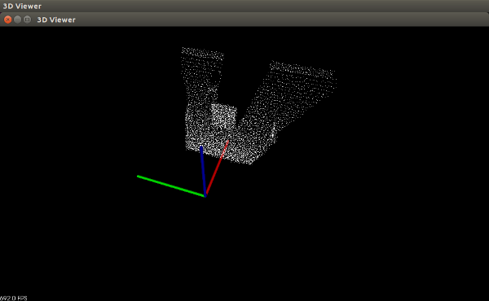

To implement the segmentation I changed pointCloud variable

//pcl::PointCloud<pcl::PointXYZ> *pointCloud = new pcl::PointCloud<pcl::PointXYZ>();

pcl::PointCloud<pcl::PointXYZ>::Ptr pointCloud(new pcl::PointCloud<pcl::PointXYZ>());

Code for planar segmentation

//plane detection

pcl::ModelCoefficients::Ptr coefficients (new pcl::ModelCoefficients);

pcl::PointIndices::Ptr inliers (new pcl::PointIndices);

// Create the segmentation object

pcl::SACSegmentation<pcl::PointXYZ> seg;

// Optional

seg.setOptimizeCoefficients (true);

// Mandatory

seg.setModelType (pcl::SACMODEL_PLANE);

seg.setMethodType (pcl::SAC_RANSAC);

seg.setDistanceThreshold (0.1);

seg.setInputCloud (pointCloud);

seg.segment (*inliers, *coefficients);

if (inliers->indices.size () == 0)

{

PCL_ERROR ("Could not estimate a planar model for the given dataset.");

}

std::cout << "Model coefficients: " << coefficients->values[0] << " "

<< coefficients->values[1] << " "

<< coefficients->values[2] << " "

<< coefficients->values[3] << std::endl;

std::cout << "Model inliers: " << inliers->indices.size () << std::endl;

Then I removed the planar indices:

//plane detection

//remove indices of plane

pcl::ExtractIndices<pcl::PointXYZ> extract;

extract.setInputCloud(pointCloud);

extract.setIndices(inliers);

extract.setNegative(true);

extract.filter(*pointCloud);

std::cout << "size after plane removal = " << pointCloud->points.size () << std::endl;

PointCloud After plane removal:   
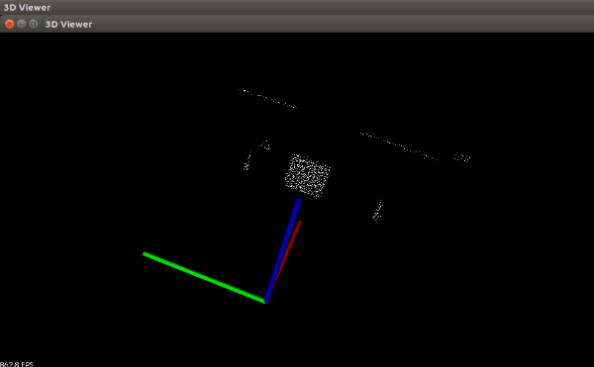

Then I limit pointcloud x axis between two walls.

//limit x axis to detect only ball

bool balloccluded = true ;

int cloudsize= 0 ;

for (int i = 0; i < pointCloud->points.size (); i++) {

if( pointCloud->points[i].x < 3.8 and pointCloud->points[i].x > 1.6){

cloudsize++ ;

balloccluded = false ;

}

}

PointCloud of Ball:   
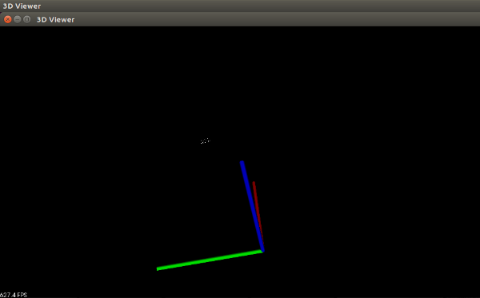

Then I avaraged the cloudpoints and transform it to world frame:

for (int i = 0; i < pointCloud->points.size (); i++) {

if( pointCloud->points[i].x < 3.8 and pointCloud->points[i].x > 1.6){

cloud->points[cloudsize].x = pointCloud->points[i].x ;

measured_x = measured_x + pointCloud->points[i].x;

cloud->points[cloudsize].y = pointCloud->points[i].y ;

measured_y = measured_y + pointCloud->points[i].y ;

cloud->points[cloudsize].z = pointCloud->points[i].z ;

cloudsize++ ;

// print point values for debugging purposes

std::cout << "p[" << i << "].x=" << pointCloud->points[i].x << " .y="

<< pointCloud->points[i].y << " .z="

<< pointCloud->points[i].z << std::endl;

}

}

if(cloudsize > 0){//turn measured data to world frame

measured_x = (measured_x / cloudsize)-1.4 ;

measured_y = (measured_y / cloudsize)+0.25 ; }

We now have x and y data of the ball location.

Formun Üstü

Formun Altı

## Kalman Filter

First Define kalman filter matrix.

State prediction:   
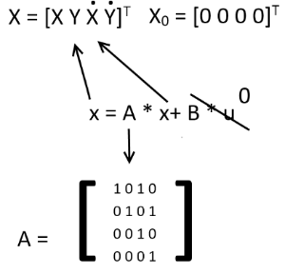

State prediction covariance:   
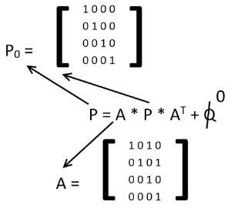

Measurement and prediction error:   
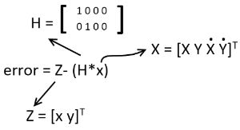

Measurement prediction covariance:   
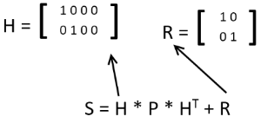

Kalman Gain calculation:   
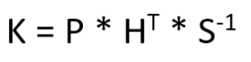

Code:   
In the code P is Ball_cov_diag   
K is Kalman_gain   
X is new_state   
error is measurement_error   
A is F_dyn

Initialization :

vector<float> new_state ; //x y xdot ydot 4x1

vector< vector<float> > Ball_cov_diag ; //P 4x4

vector< vector<float> > F_dyn ; //F 4x4

vector< vector<float> > F_dyn_t ; //F_transpose 4x4

vector< vector<float> > temp ; //temp 4x4

vector< vector<float> > H ; //temp 2x4

vector< vector<float> > H_t ; //H_t 4x2

vector<float> R_diag ; //R 1_1 2_2

vector< vector<float> > S ; //S 2x2

vector< vector<float> > Kalman_gain ; //W 4x2

vector<float> measurement_error ; //v 2x1

ros::Publisher estimatedPub_x;

ros::Publisher measuredPub_x;

ros::Publisher realPub_x;

ros::Publisher estimatedPub_y;

ros::Publisher measuredPub_y;

ros::Publisher realPub_y;

std_msgs::Float32 data_msg;

public:

StateEstimation() {//initalize matrix variables

state = 0 ;

new_state.push_back(0); //x

new_state.push_back(0);//y

//init 2 column matrix

S.push_back(new_state);//1st row

S.push_back(new_state);//2nd row

Kalman_gain.push_back(new_state);//1st row

Kalman_gain.push_back(new_state);//2nd row

Kalman_gain.push_back(new_state);//3rd row

Kalman_gain.push_back(new_state);//4th row

H_t.push_back(new_state);H_t[0][0] = 1;//1st row

H_t.push_back(new_state);H_t[1][1] = 1;//2nd row

H_t.push_back(new_state);//3rd row

H_t.push_back(new_state);//4th row

new_state.push_back(0);//xdot

new_state.push_back(0);//ydot

//init 4 column matrix

Ball_cov_diag.push_back(new_state);//1st row

Ball_cov_diag.push_back(new_state);//2nd row

Ball_cov_diag.push_back(new_state);//3rd row

Ball_cov_diag.push_back(new_state);//4th row

H.push_back(new_state);H[0][0] = 1;//1st row

H.push_back(new_state);H[1][1] = 1;//2nd row

temp.push_back(new_state);//1st row

temp.push_back(new_state);//2nd row

temp.push_back(new_state);//3rd row

temp.push_back(new_state);//4th row

F_dyn.push_back(new_state);F_dyn[0][0] = 1;F_dyn[0][2] = 1;//1st row

F_dyn.push_back(new_state);F_dyn[1][1] = 1;F_dyn[1][3] = 1;//2nd row

F_dyn.push_back(new_state);F_dyn[2][2] = 1;//3rd row

F_dyn.push_back(new_state);F_dyn[3][3] = 1;//4th row

F_dyn_t.push_back(new_state);F_dyn_t[0][0] = 1;//1st row

F_dyn_t.push_back(new_state);F_dyn_t[1][1] = 1;//2nd row

F_dyn_t.push_back(new_state);F_dyn_t[2][0] = 1;F_dyn_t[2][2] = 1;//3rd row

F_dyn_t.push_back(new_state);F_dyn_t[3][1] = 1;F_dyn_t[3][3] = 1;//4th row

Ball_cov_diag[0][0] = 1 ;Ball_cov_diag[1][1] = 1 ;Ball_cov_diag[2][2] = 1 ;Ball_cov_diag[3][3] = 1 ;

R_diag.push_back(0.1);//1_1

R_diag.push_back(0.1);//2_2

measurement_error.push_back(0.0);//v1

measurement_error.push_back(0.0);//v2

Prediction and Correction :

//time update (prediction)

new_state[0] = new_state[0] + new_state[2] ;

new_state[1] = new_state[1] + new_state[3] ;

new_state[2] = new_state[2] ;

new_state[3] = new_state[3] ;

std::cout << "Predicted x:" << new_state[0] << "y:" << new_state[1] << std::endl;

data_msg.data = new_state[0];

estimatedPub_x.publish(data_msg);

data_msg.data = new_state[1];

estimatedPub_y.publish(data_msg);

if(!balloccluded){//we can see the ball

Ball_cov_diag = matrix_product(Ball_cov_diag, F_dyn_t , 4, 4, 4 ) ;

Ball_cov_diag = matrix_product(F_dyn, Ball_cov_diag , 4, 4, 4 ) ;

//compute kalman gain

Kalman_gain = matrix_product(Ball_cov_diag, H_t , 4 , 2, 4 );//used as temp

S = matrix_product(H, Kalman_gain , 2 , 2, 4 );

S[0][0] = S[0][0] + R_diag[0] ;

S[1][1] = S[1][1] + R_diag[1] ;

Kalman_gain = matrix_product(Ball_cov_diag ,H_t , 4 , 2 , 4) ;

//inverse S

float reverse_cons = (S[0][0] * S[1][1] - S[1][0] * S[0][1]) ;

float temp_S = S[0][0] ;

S[0][0] = S[1][1] / reverse_cons ;

S[1][1] = temp_S / reverse_cons ;

S[0][1] = (-1 * S[0][1]) / reverse_cons ;

S[1][0] = (-1 * S[1][0]) / reverse_cons ; //S is not S_inv

Kalman_gain = matrix_product(Kalman_gain , S , 4 , 2 , 2);

//measurement update(corrected)

measurement_error[0] = measured_x - new_state[0] ;

measurement_error[1] = measured_y - new_state[1] ;

new_state[0] += measurement_error[0] * Kalman_gain[0][0] + measurement_error[1] * Kalman_gain[0][1] ;

new_state[1] += measurement_error[0] * Kalman_gain[1][0] + measurement_error[1] * Kalman_gain[1][1] ;

new_state[2] += measurement_error[0] * Kalman_gain[2][0] + measurement_error[1] * Kalman_gain[2][1] ;

new_state[3] += measurement_error[0] * Kalman_gain[3][0] + measurement_error[1] * Kalman_gain[3][1] ;

temp = matrix_product(Kalman_gain , H , 4 , 4 , 2);

//I - temp

temp[0][0] = 1 - temp[0][0] ;temp[0][1] =-temp[0][1];temp[0][2] =-temp[0][2];temp[0][3] =-temp[0][3];

temp[1][1] = 1 - temp[1][1] ;temp[1][0] =-temp[1][0];temp[1][2] =-temp[1][2];temp[1][3] =-temp[1][3];

temp[2][2] = 1 - temp[2][2] ;temp[2][0] =-temp[2][0];temp[2][1] =-temp[2][1];temp[2][3] =-temp[2][3];

temp[3][3] = 1 - temp[3][3] ;temp[3][0] =-temp[3][0];temp[3][1] =-temp[3][1];temp[3][2] =-temp[3][2];

Ball_cov_diag = matrix_product(temp,Ball_cov_diag,4,4,4);

std::cout << "Predict corrected x:" << new_state[0] << "y:" << new_state[1] << std::endl;

}else{//we cant see the ball

}

}

Errors:   
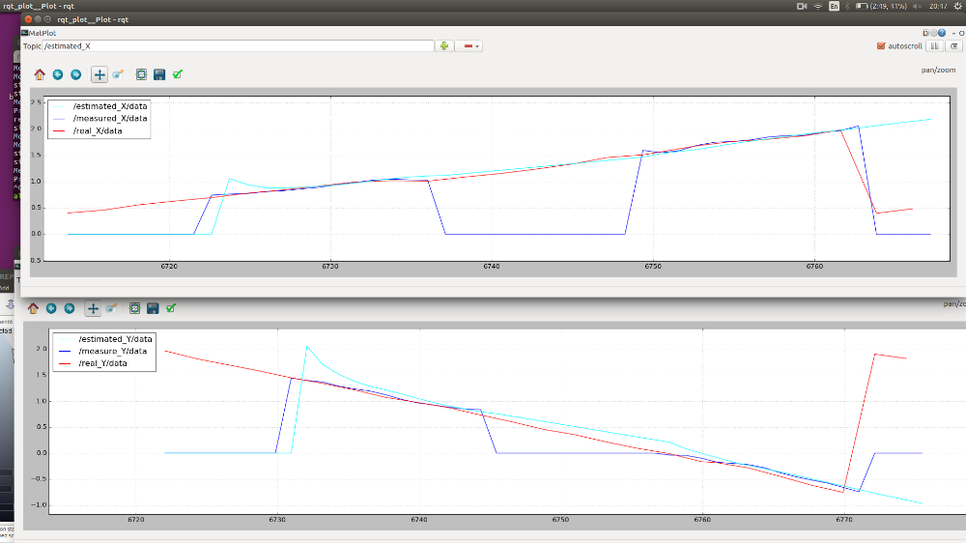

Video:

<https://youtu.be/mK0uUmk29Wg>