Alphonz George T11-03

AdvDevops Assignment 4

**Aim : To install Kubernetes**

**Theory and Outcome:**

Kubernetes is a portable, extensible, open-source platform for managing containerized workloads and services, that facilitates both declarative configuration and automation. It has a large, rapidly growing ecosystem. Kubernetes services, support, and tools are widely available. The name Kubernetes originates from Greek, meaning helmsman or pilot. K8s as an abbreviation results from counting the eight letters between the "K" and the "s". Google open- sourced the Kubernetes project in 2014. Kubernetes combines over 15 years of Google's experience running production workloads at scale with best-of-breed ideas and practices from the community.

Go to kubernetes website for installation.

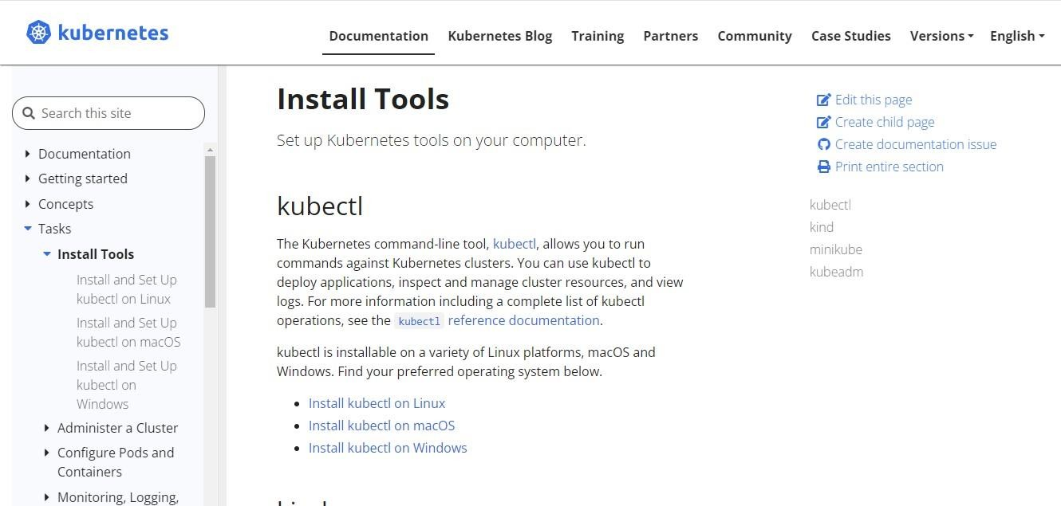

Select your appropriate OS.

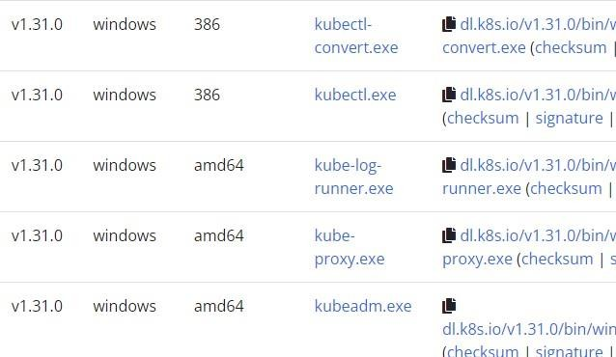

Install the Kubernetes .



Edit the path in systems environment variables

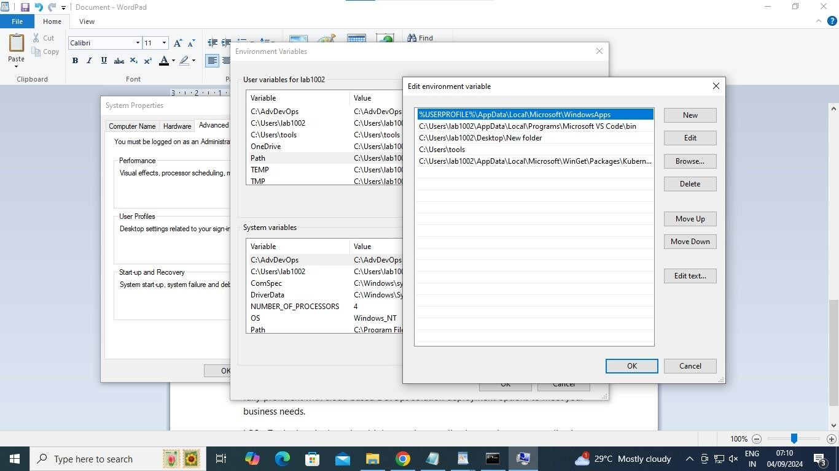

Open cmd and run and kubernetes command to check for successful installation

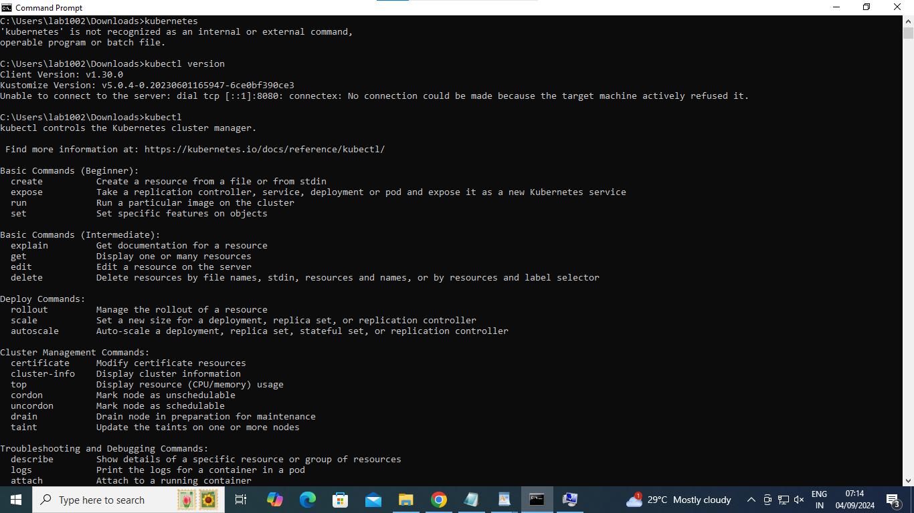

Kubernetes is successfully installed.