Alphonz George

T11-1

Assignment No. 6

**Aim**: To build, change, destroy AWS infra using Terraform

**Theory**:

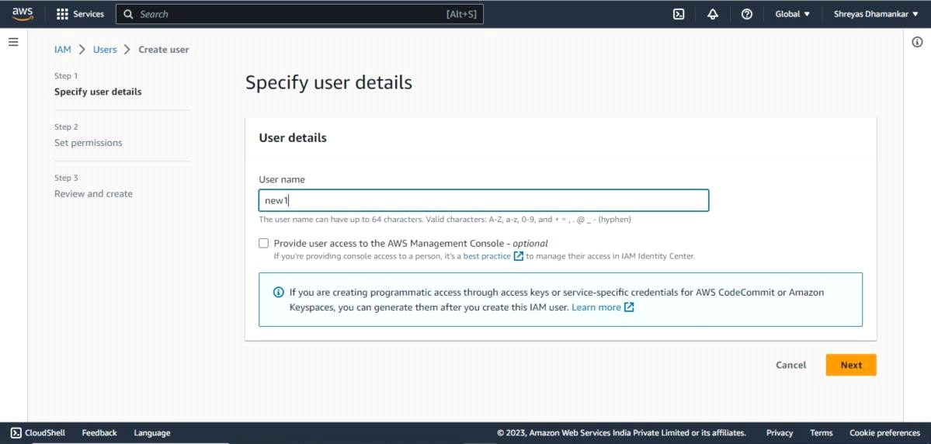

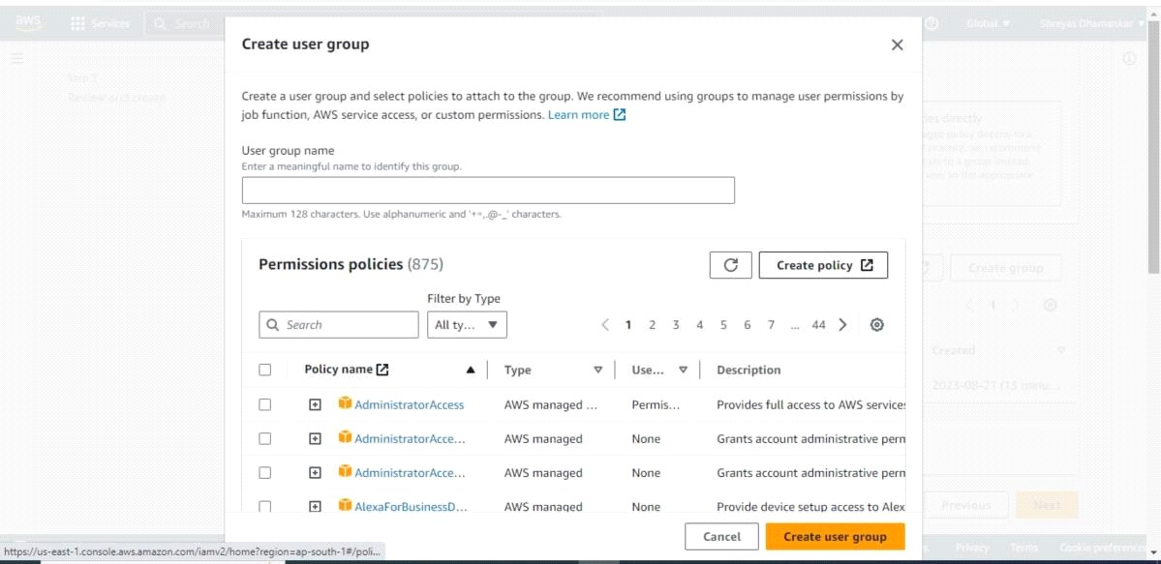add

a new user group with permission to have administrator access

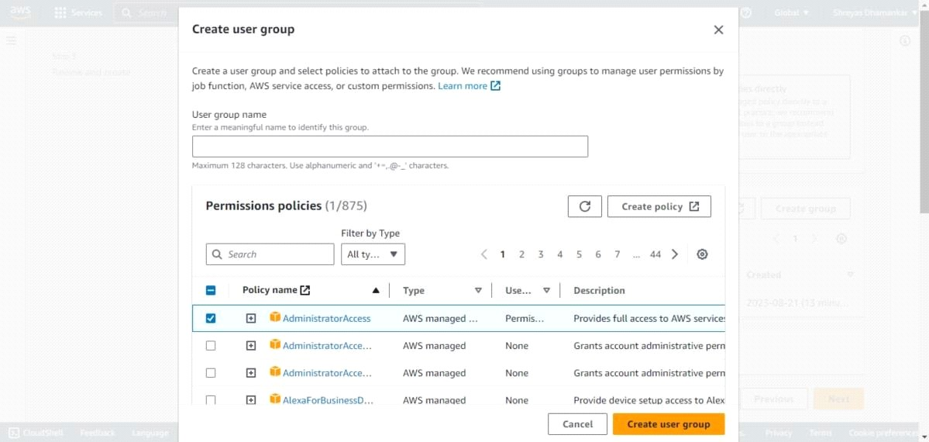

then go to user and select create new access key. after selecting select create CLI and dowload the csv.

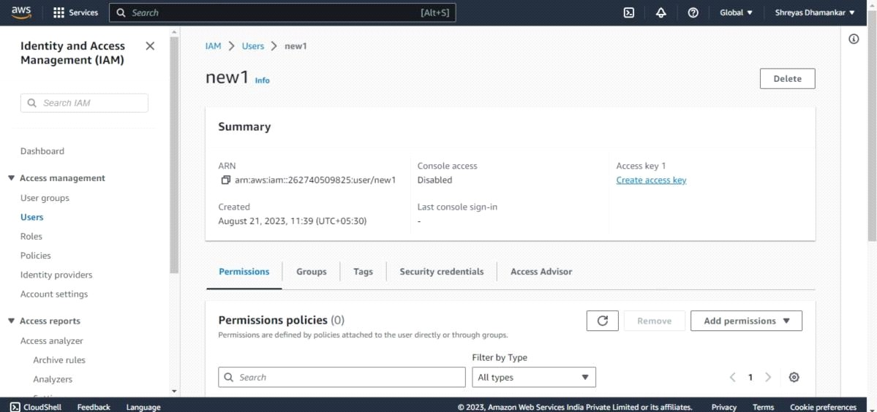

write this script and save it in Terraform Script folder. use the acces keys and secret key presentin the csv files.

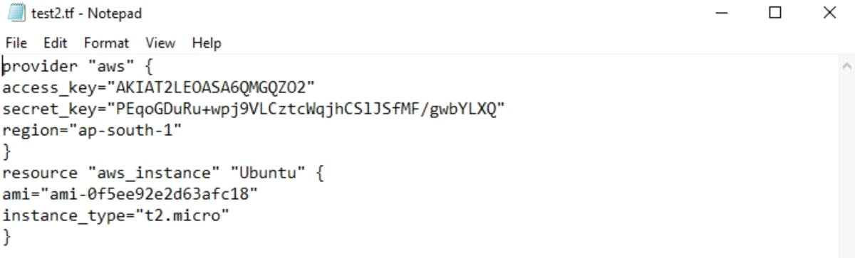

open cmd and choose the path where you have stored the script and run the following commands init,plan,apply and destroy.

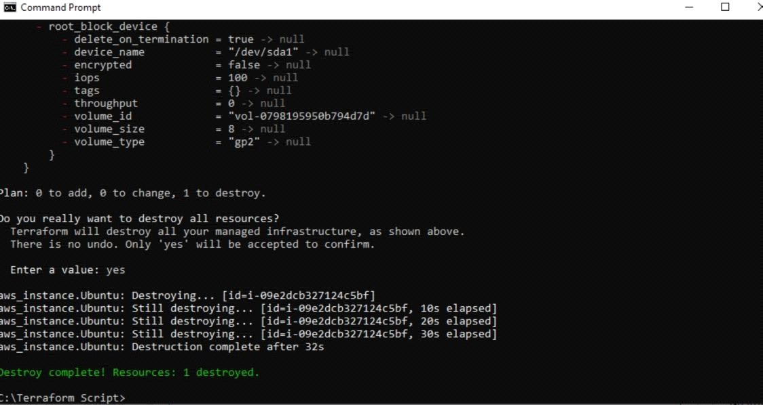

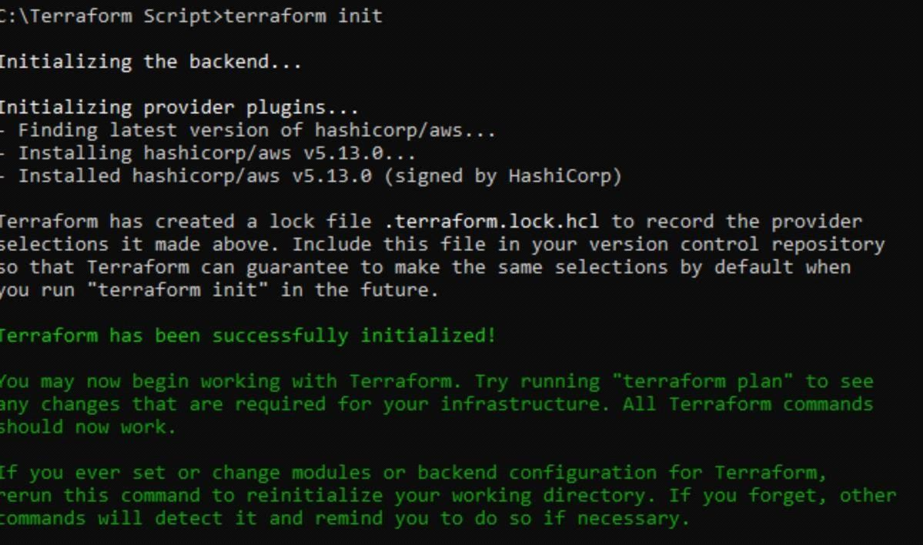

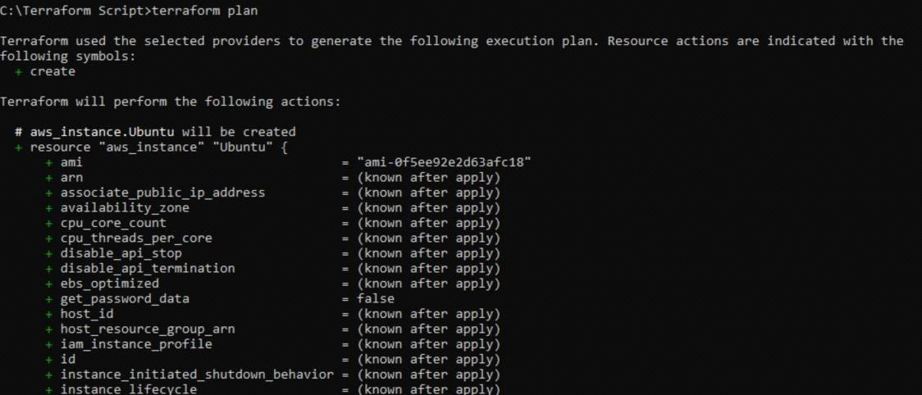

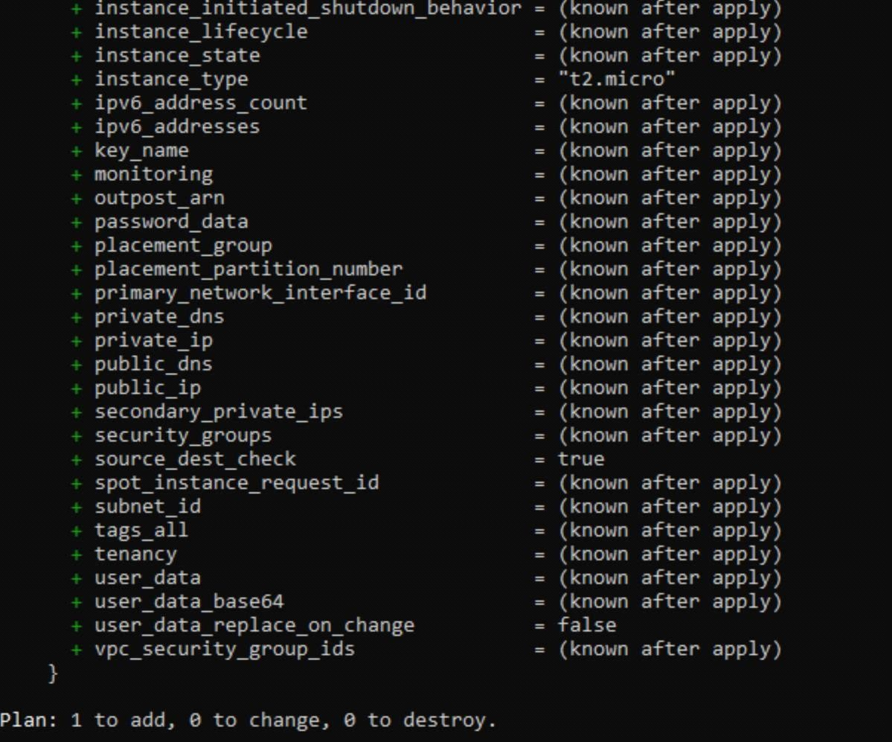

instance has been created.

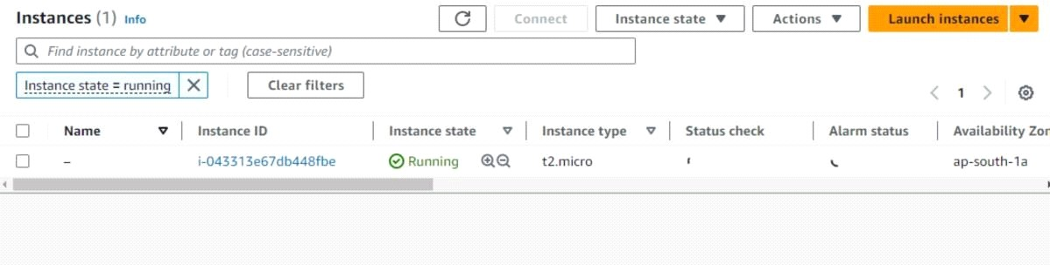

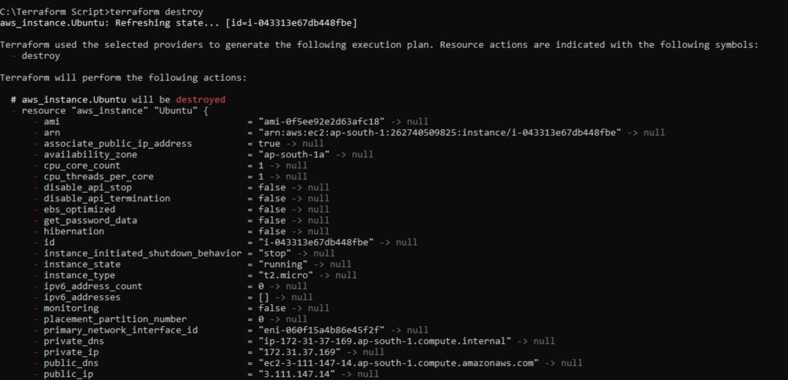

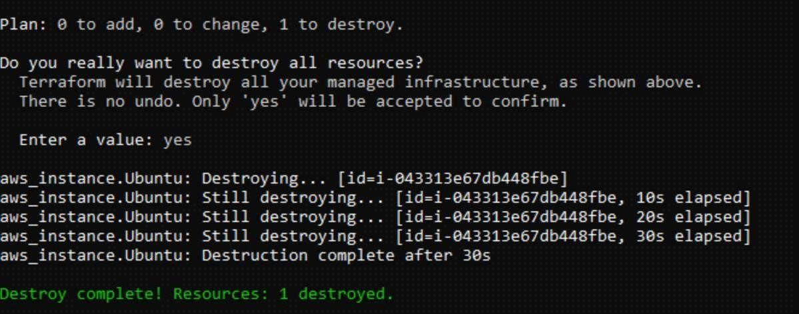

instance has been detroyed

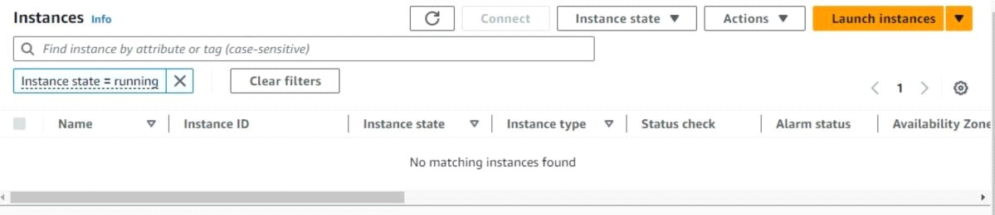

once terraform destroy command has been run and completed you can delete all security

keysand csv files and delete users and user groups.

**Conclusion:** 6

In this assignment we learnt how to install terraform and use it torun scripts.