Alphonz George

T11-03

Assignment No. 8

**Aim**: To learn how to use Lamda in order to find the ContentType of Object uploaded in S3 Bucket.

**Theory**:

# Create bucket:

create a new policy from iam dashboard;

while creating policy select json tab and paste the following code:

{

"Version": "2012-10-17",

"Statement": [

{

"Effect": "Allow", "Action": [ "logs:PutLogEvents",

"logs:CreateLogGroup", "logs:CreateLogStream"

],

"Resource": "arn:aws:logs:*:*:*"

},

{

"Effect":

"Allow",

"Action": [ "s3:GetObject"

],

"Resource": "arn:aws:s3:::*/*"

}

]

}

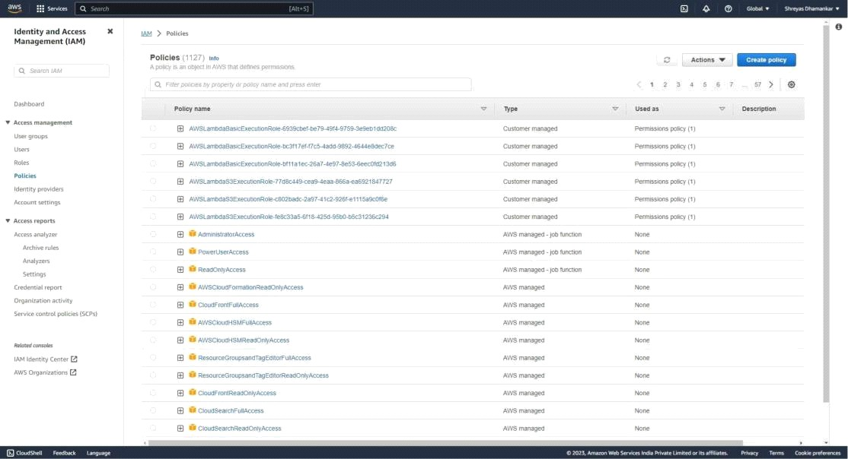

create policy and name it:

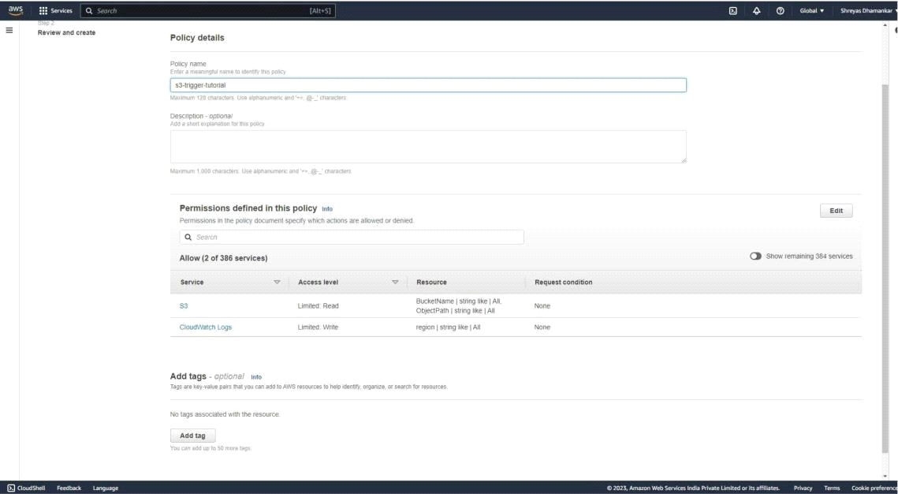

go to roles page and select create a new role

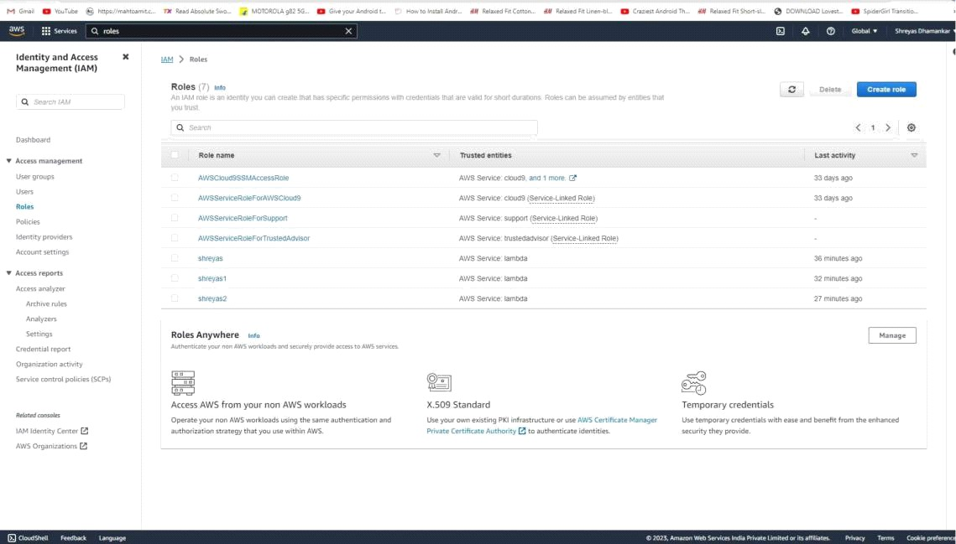

under policies for role select the policy that you have created and click next. Then name the role as follows:

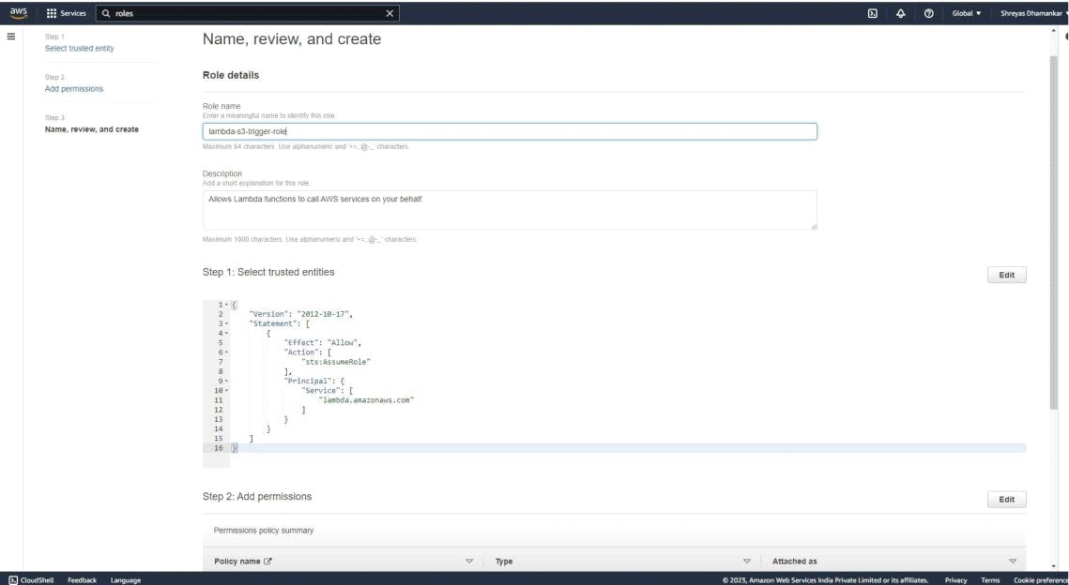

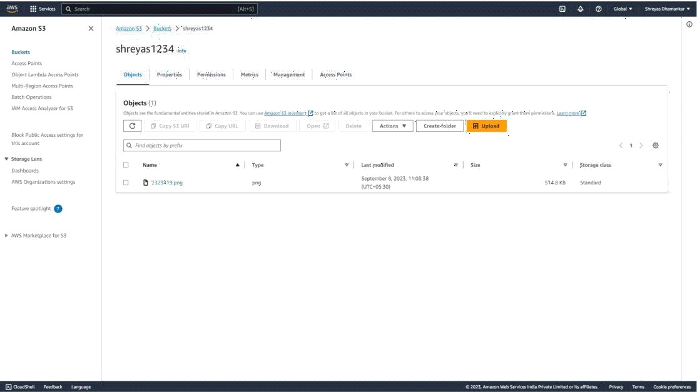Upload an image file in the S3 bucket.

Go to lamda dashboard in aws and create a new function named s3-trigger tutorial. select change execution code and choose the option use existing role. Select lambda- s3-trigger-role.

Once function is created go to code panel and paste the following code. import jso

import urllib.parse import boto3 print('Loadin

function') s3 = boto3.client('s3')

def lambda_handler(event, context):

#print("Received event: " + json.dumps(event, indent=2)) # Get the object from the event and show its content

type bucket = event['Records'][0]['s3']['bucket']['name']

key = urllib.parse.unquote_plus(event['Records'][0]['s3']['object']['key'], encoding='utf- 8') try:

response = s3.get_object(Bucket=bucket, Key=key)

print("An object : "+response['ContentType']+" has been added to S3 Bucket")

print("CONTENT TYPE: " +

response['ContentType']) return response['ContentType']

except Exception as e:

print(e)

print('Error getting object {} from bucket {}. Make sure they exist and your bucket is in the same region as this function.'.format(key, bucket))

raise e

then select deploy changes.

1

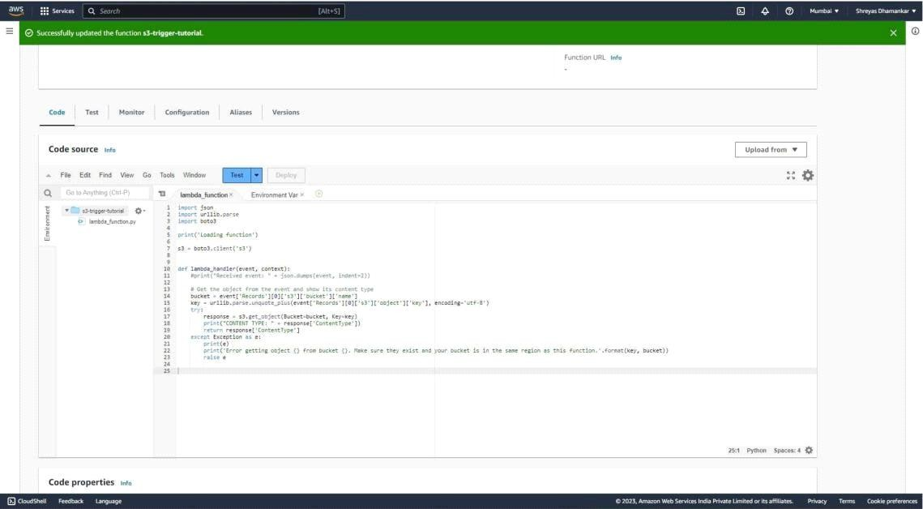

then click on test and create a new custom event named MyTestEvent.

For Template, choose S3 Put In the Event JSON, replace the following values: Replace us-east-1 with the region you created your Amazon S3 bucket in.

Replace both instances of example-bucket with the name of your own Amazon S3 bucket. Replace test%2FKey with the name of the test object you uploaded to your bucket earlier

(for example, factorial.py).

Click on save and press Test. You will see the results in Execution tab.

Check execution Tab for the CONTENT TYPE. If you have uploaded the file properly you will get the file type that you have uploaded in the S3 Bucket. Check Function logs where the line has been printed that "An Image has been Upladed to S3 Bucket".

2

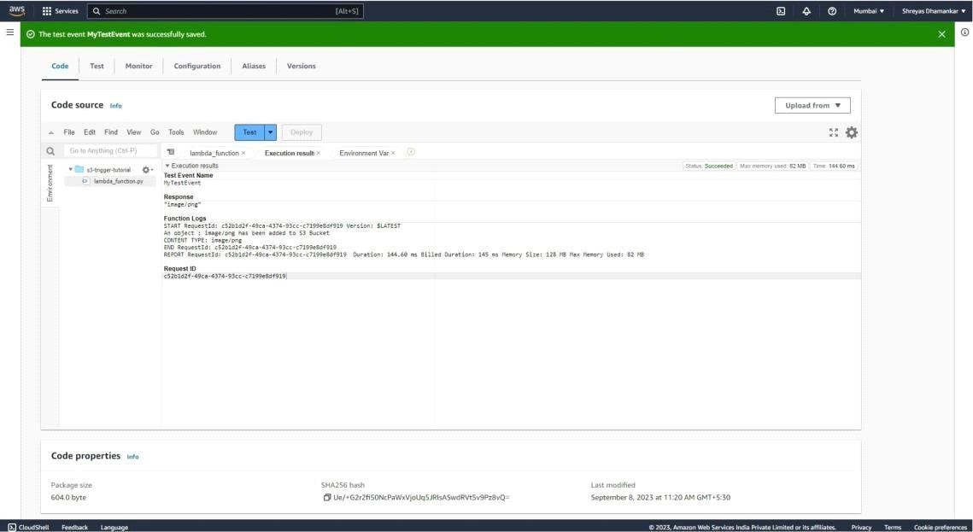

# Conclusion:

**In this assignment we learnt how to use Lambda function to log what type of object has been uploaded to S3 Bucket.**

3