Rafael UResti Vázquez

A01201440

21/04/2015

Intelligent Systems

Laboratory

Write a report using the comparisons collected by training the ANN with different parameters. Include an image of the network and the parameters used as well as the error and time it took to train each network. Write a brief reflection about what you think is happening in the different ANNs. Other interesting aspects you could include in your reflection are: Explanations as to what are ANNs good for. Where would you use them? Are they worth the effort implementing or not? What kinds of problems do they not solve?

The data used for training is the following:

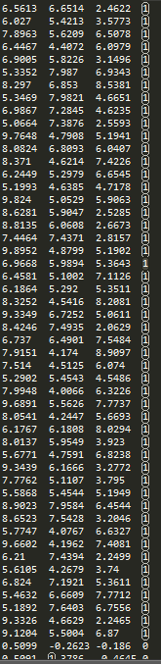 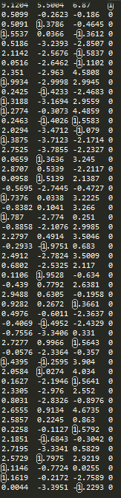

The program makes iterations till the error is equal to 0:

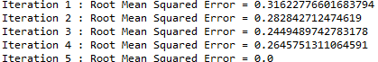

The decision boundary equation with the image of the network.



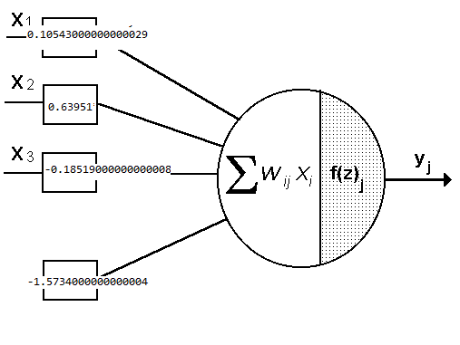

Finally the value of the program, with the decision boundary we evaluate random points, and classify it.

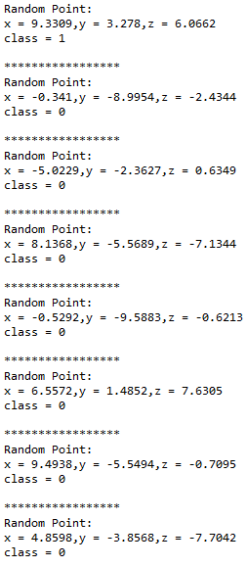

To conclude I think artificial neural networks are good for learning, auto organizing, real timing they are also very flexible in terms of the information they receive because it can have some. They do worth the effort implementing because they solve situations in a very simple way, for example I would use them in character recognition (like handwriting characters), in the stock market in order to make predictions, image recognition, basically everything related with the analysis of patterns. They problem is when we try to implement networks with a high level of parallelism because with the neurons process information in parallel while the computers do it sequentially.