How ACSOE picks a coin, and every engine that gets it there
A companion to [SYSTEM-EXPLAINED.md](SYSTEM-EXPLAINED.md). That document explains why the system exists. This one answers three practical questions — what happens when you press Activate, how one coin gets chosen out of everything Kraken lists, and what each of the twenty-three engines does — and then puts the whole thing on one page in section 5. No prior knowledge assumed.

1. What happens when you press Activate
The button lives in a small web page that runs on your own machine. Pressing it does exactly one thing:
It writes a single row into a database table that says `activate`.
That is all. The page holds no exchange keys and has no ability to place an order. It cannot buy anything even if something went badly wrong with it. This separation is deliberate: the only program that can touch money is the background program, and the only thing the button can do is leave it a note.
The background program — the daemon — wakes up once every minute, forever. Each wake-up is called a tick. At the top of every tick it reads any notes left for it. Finding your activate note, it switches its mode from idle to running and marks the note as read.
Three things are worth knowing about that moment.
Nothing happens immediately. Activating does not buy anything. It gives the system permission to start looking, and looking only happens when a 15-minute candle closes. So after you press Activate you may wait up to fifteen minutes before the system even considers a trade, and it will very likely then decide not to take one.
It was already collecting data before you pressed anything. Recording market data, building candles and watching the health of the account all happen in every mode, including idle and frozen. Activate does not switch the system on; it switches on the part that is allowed to buy. This matters because order-book and spread history cannot be recovered later, so the recorder must never be gated behind a button.
It never survives a restart. If the daemon crashes and comes back, it comes back idle, not running. Any open position is still watched and still exited normally, but nothing new is opened until a human presses Activate again. A program that quietly resumed trading after a crash it did not understand would be the wrong kind of helpful.
There are two other buttons. Freeze stops new trades while continuing to record data and manage whatever is already open. Close all is the emergency stop: it cancels every resting order and sells every open position, and it keeps retrying until both are actually done.

2. How one coin gets chosen out of the whole exchange
Here is the thing most people expect, and it is not what happens:
❌ "Score every coin on Kraken by how much it is likely to rise, sort the list, and buy the top one."
That is not the design, for two reasons. Running a model over several hundred pairs every fifteen minutes would be slow and would encourage the system to go hunting until it found something. And "most likely to rise" is the wrong question anyway — a coin that is likely to rise 0.5% is a losing trade once fees are paid.
What actually happens is an elimination funnel. The system narrows the exchange down to one plausible candidate using cheap, model-free arithmetic, and then spends all of its remaining effort trying to disprove that one candidate. The expensive thinking happens once, not hundreds of times.
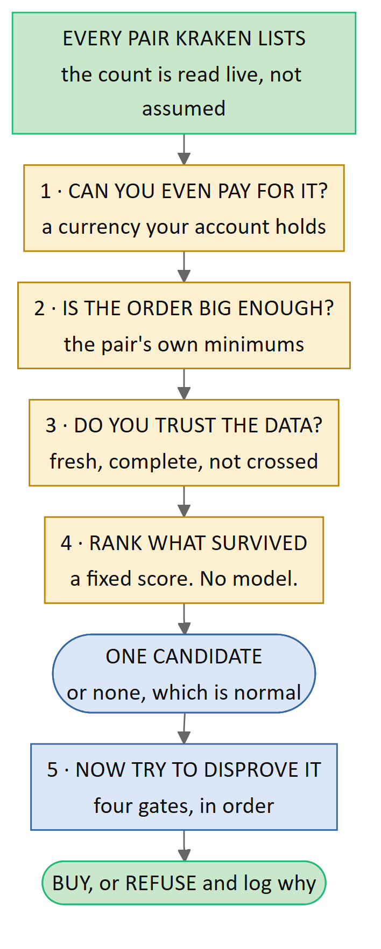
The funnel. Steps 1 to 3 are subtraction — they remove pairs you could not legally or safely trade right now. Step 4 is the only place anything is ranked, and it is ordinary arithmetic that produces the same answer every time from the same inputs. Step 5 is where the real work happens, and it happens on exactly one coin.

The steps, in plain terms
Step 1 — can you pay for it? Every Kraken pair is two things traded against each other. In SOL/USD you are buying SOL and paying in USD. If your account holds only US dollars, then a pair priced in euros is not tradable no matter how attractive it looks, because you do not hold euros. Pairs priced in another cryptocurrency — say SOL/BTC — are switched off by default for a different reason: your profit would be denominated in Bitcoin, which means you have quietly taken a second bet on Bitcoin that you never chose to take.
Step 2 — is your order big enough to be legal? Exchanges refuse orders that are too small. Each pair publishes a minimum quantity and a minimum order value, and they differ from pair to pair. The system fetches both live, and compares them against the position it would actually place. Concretely, with the current settings: a $5,000 account risking 1% per trade against a 1.5% stop-loss produces a position of about $3,333. That clears the minimum on almost everything. At a $200 account it would not, and the tradable list would collapse to a handful of pairs. The system never rounds an order up to reach a minimum. A position too small to be legal is a rejection, recorded as such.
Step 3 — do you trust the data? A pair whose latest quote is more than two minutes old, or whose candle series has a hole in it, or whose order book is crossed (the highest buyer is offering more than the lowest seller is asking — which should be impossible and means something is broken) is dropped. Not softened, not estimated. Dropped.
Step 4 — the ranking. Whatever survives is scored by a fixed formula and sorted. This is the only ranking in the system, and three things about it matter: it contains no machine learning, it produces the same answer every time from the same inputs, and nothing is allowed to override it. It is not trying to predict the future. It is picking the most promising thing to investigate.
Step 5 — the gates. The single top-ranked candidate goes through four gates in order. Any one of them can refuse, and the chain stops at the first refusal. The important one is the cost gate, which asks whether the expected move beats the real, live, measured cost of the round trip with margin to spare.

The honest answer to "which coin is best?"
Most of the time, the answer is none, and that is the system working correctly.
On roughly fourteen ticks out of fifteen no 15-minute bar has closed, so no candidate is even born. When one is born, it usually dies at the cost gate. And at a fresh account's fee tier the cost gate is unreachable by construction — the arithmetic requires an expected move of about 3.125% while the profit target is 3.00%, so nothing can clear it at all. That is not a bug that someone forgot to fix. It is the system telling you the truth about a small account's economics rather than trading anyway.
So a more accurate way to describe what Activate does is: it gives the system permission to start refusing things out loud, and to buy on the rare occasion nothing refuses.

3. Every engine, in the order it runs
The system is twenty-three components called engines. They never call each other. Each one reads what earlier engines left on a shared scratchpad, does one job, writes its own result, and stops. That is what makes the order below meaningful: it is the actual sequence, every minute.
They are grouped into four lists called chains. Numbers are names, not positions — engine 17 runs fifth, and that is deliberate.
GATE in the table means the engine can stop everything. There are seven of them.
Order | # | Engine | Chain | Gate | What it does, in plain English
1 | 1 | exchange | Guard |  | Fetches the account picture fresh: your balances, your current fee rate, and every pair's trading rules. Nothing here is remembered from last time.
2 | 2 | market_data_recorder | Guard |  | Writes every incoming market message to an append-only file. Never edits, never tidies. This is the data that cannot be bought back later.
3 | 3 | market_sensor | Guard |  | Builds 15-minute candles and the live bid/ask for every pair. Also owns the clock: it is the only thing that says "a bar just closed".
4 | 4 | data_guard | Guard | GATE | Refuses the whole minute if the data is stale, has a hole in it, or the book is crossed. Acting on a price nobody observed is how you lose money to a bug.
5 | 17 | safety | Guard | GATE | The circuit breaker on the account, not the trade: how far down from the peak, how many losses in a row, how many internal errors this hour, how long the feed has been bad. It runs every minute in every mode, because an account bleeding while every trade is rejected must still trip a breaker.
6 | 5 | feature | Opportunity |  | Computes the numbers a pair is judged on from the bar that just closed. On fourteen minutes out of fifteen it reports "nothing to do" and everything below stops here.
7 | 6 | macro_context | Opportunity |  | Reads Bitcoin and Ethereum for the overall weather. When the whole market is falling, an individual coin's signal means less.
8 | 7 | scout | Opportunity | GATE | The funnel in section 2. Builds the tradable list from live pair rules and your real balance, ranks the survivors, and emits exactly one candidate. Refuses when nothing qualifies. Contains no model.
9 | 12 | regime | Opportunity |  | Classifies the market environment: trending, choppy, or violently volatile. The same signal means different things in each.
10 | 13 | anomaly | Opportunity | GATE | Asks whether the market itself is behaving strangely — volume, spread and speed well outside anything normal. It judges the market, not the trade.
11 | 8 | prediction | Opportunity |  | The model. Predicts which of three lines the price touches first: the +3% target, the −1.5% stop, or the 12-hour timeout. It also refuses to answer at all when today's conditions look nothing like anything it was trained on.
12 | 9 | order_book | Opportunity |  | Looks at how deep the book actually is and estimates how much worse than the quoted price your order would fill — the slippage.
13 | 10 | cost | Opportunity | GATE | The heart of the system. Expected move, minus live fees, minus the live measured spread, minus estimated slippage. Trades only if what is left beats the cost again with margin.
14 | 11 | risk | Opportunity | GATE | Works out how much to buy from your total equity, then refuses if that is below the pair's minimums, more cash than you hold, or one position too many. Never rounds up to fit.
15 | 14 | adaptive_router | Opportunity |  | Chooses which trained model's opinion to trust for conditions like today's.
16 | 15 | skeptic | Opportunity | GATE | A second model whose only job is to find reasons the first one is wrong. It is trained solely on the occasions the predictor said buy, and it learns when that call failed. It can veto and can never approve.
17 | 16 | decision | Opportunity |  | Assembles the final decision and the explanation of what drove it, so the choice can be audited later.
18 | 18 | execution | Opportunity |  | Places the post-only limit buy — an order that the exchange cancels rather than let it execute at the expensive rate. It also learns how far below the market to place it.
19 | 21 | position_manager | Manage |  | Watches every open position and every resting order, every minute. Cancels an entry order that has sat unfilled past its window, and never chases the price.
20 | 22 | exit | Manage |  | Closes a position when it hits the target, the stop, or the timeout.
21 | 19 | memory | Manage |  | The single writer of the record: trades, positions, orders, the equity curve, every block, and every rejection with its reason. If it is not written down, it did not happen.
— | 20 | tournament | Offline |  | Never runs in the live loop. Ranks trained models on skill after subtracting plain market exposure, penalises the score for how many models were tried, and decides which may be promoted.
— | 23 | backtest | Offline |  | Never runs in the live loop. Replays history through these very same engines, so a backtest and a live run cannot silently disagree.

Three notes on the table that are easy to miss.
The guard chain never stops early. If data_guard refuses the minute, safety still runs. Two things can refuse at once, and both are recorded. Only the opportunity chain gets skipped.
The manage chain always runs. Recording data and watching open positions happen whether the system is idle, frozen, or blocked. Freeze stops buying; it never stops watching.
The cheap checks run before the expensive ones. Everything model-free happens first. By the time the predictor runs, the candidate has already survived the affordability filter, the data check and the anomaly check — so the expensive thinking is never spent on something that was never tradable.

4. One minute, in one picture
This is the operating cycle on its own — what happens between one tick and the next. Section 5 widens the lens to the whole system, including where the data came from and how the system learns.
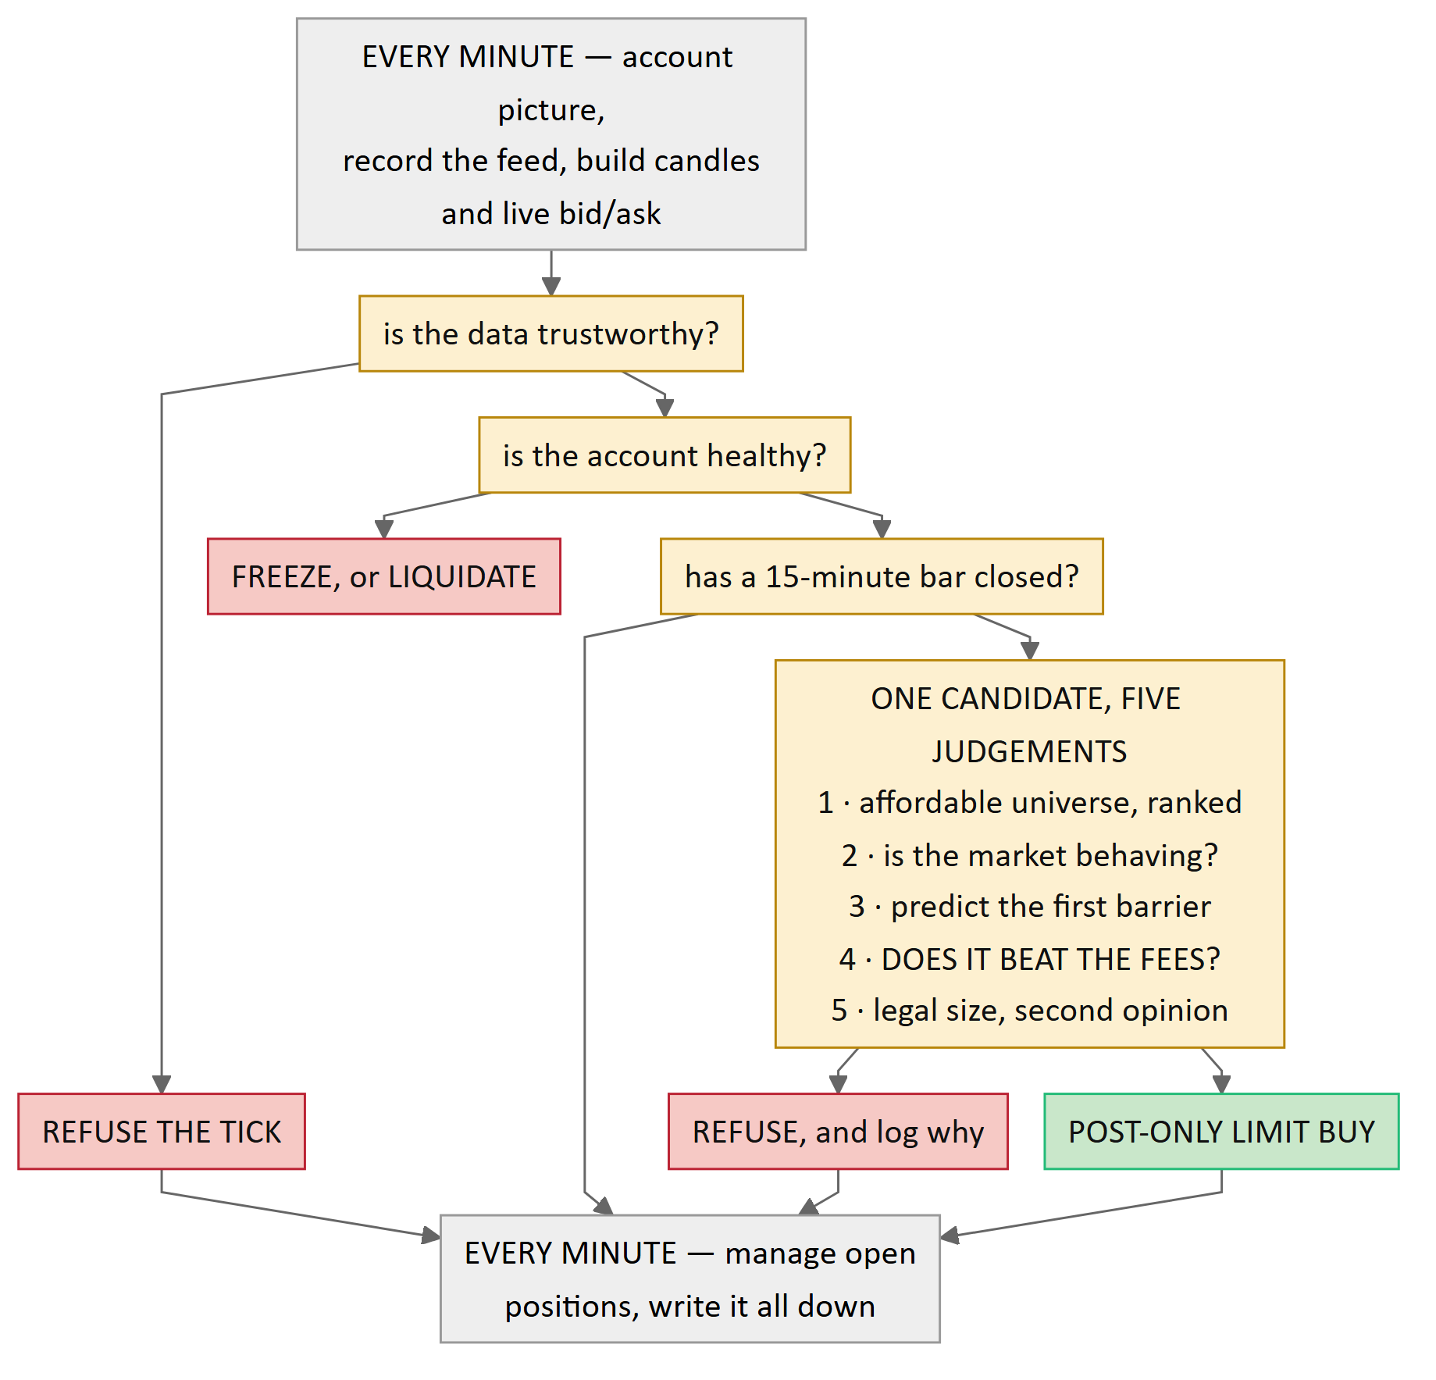
The minute loop. Amber boxes are checks; a red box is what happens when one says no, and the arrow continuing downward is what happens when it says yes. There is one path to a purchase and six ways to refuse — bad data, an unhealthy account, and one for each of the four judgement gates. The five judgements named in the amber box run in that order, and the chain stops at the first one that objects; section 3's table lists all twenty-three engines individually. On roughly fourteen minutes in fifteen no bar has closed and the flow goes straight to managing. Note what a refusal does not do: it does not stop the minute. Data is still recorded, positions are still managed, and the refusal is written down with its reason. A refusal is data.

5. The whole system on one page, A to Z
Section 4 showed one minute. This shows the entire life of the system: where the data comes from, every engine it passes through, what gets written down, how the system learns from what it wrote, and how that learning comes back round. Read it straight down.
The colours carry meaning. Blue is data arriving from outside. Amber is a gate — something that can stop the system. Red is a refusal, green the one path to a purchase. Purple marks the six things that are not standard practice, keyed ★​1 to ★​6 and explained underneath.
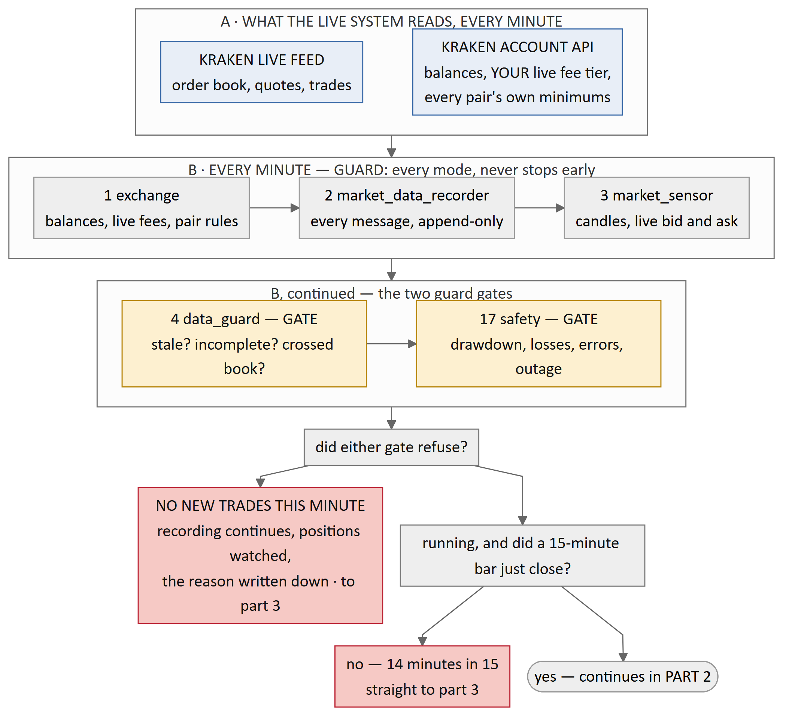
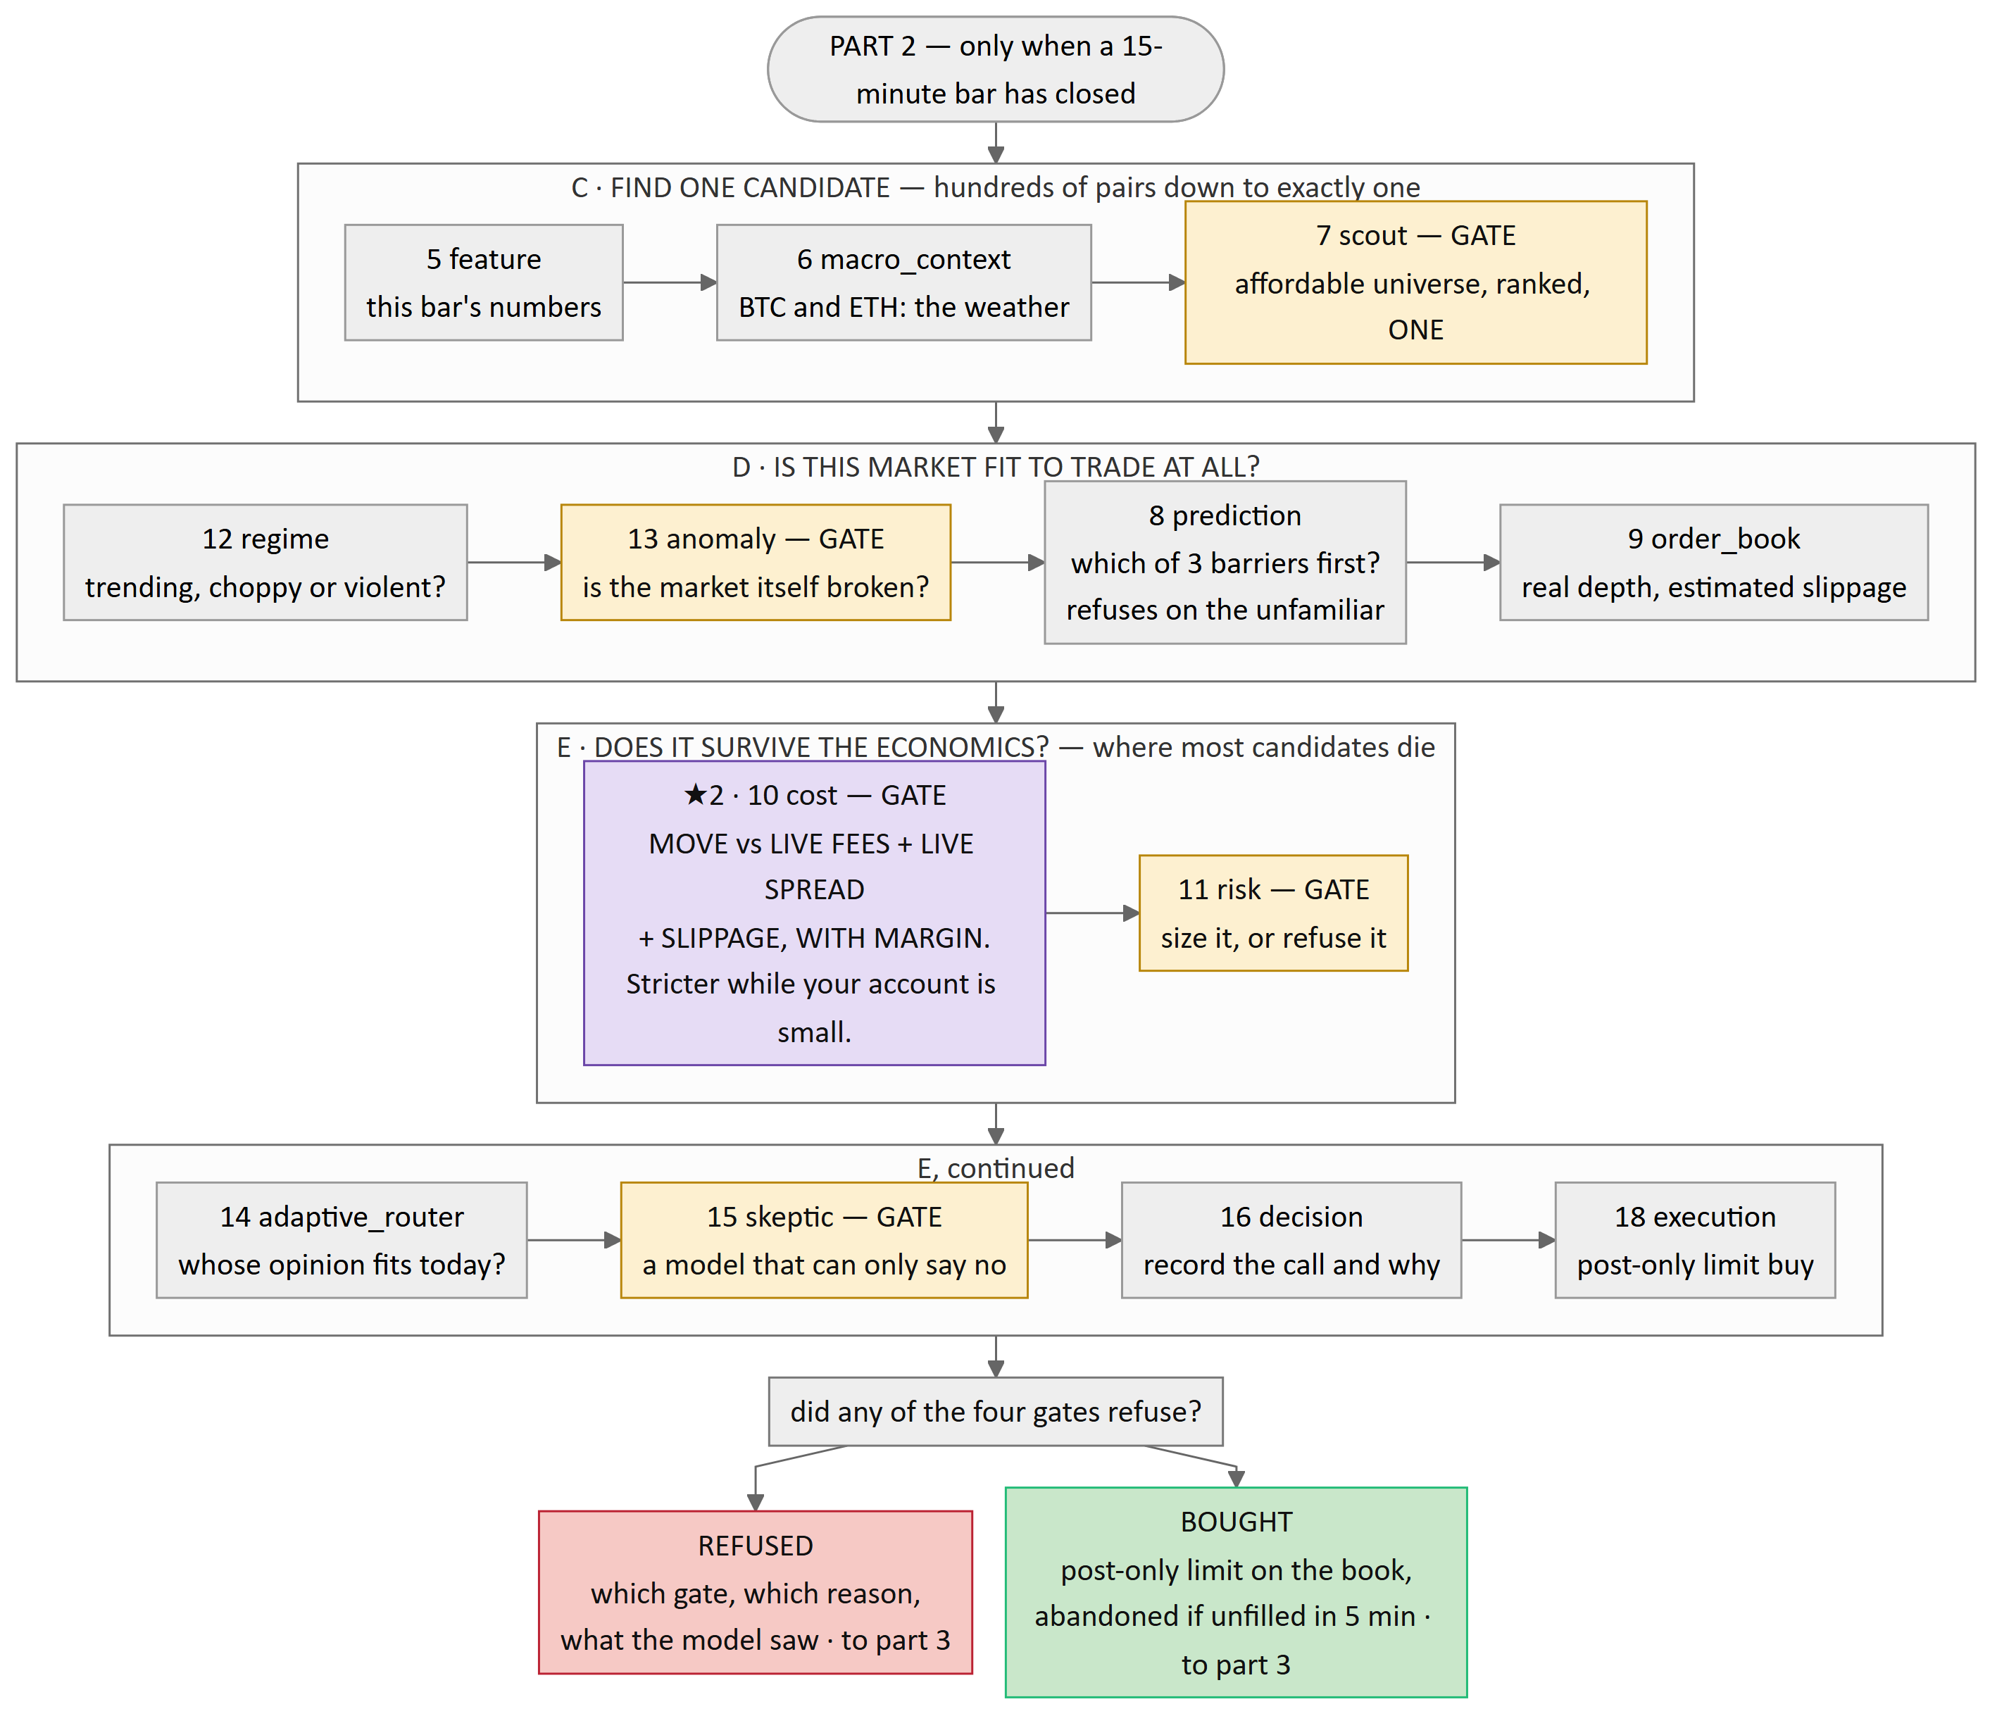
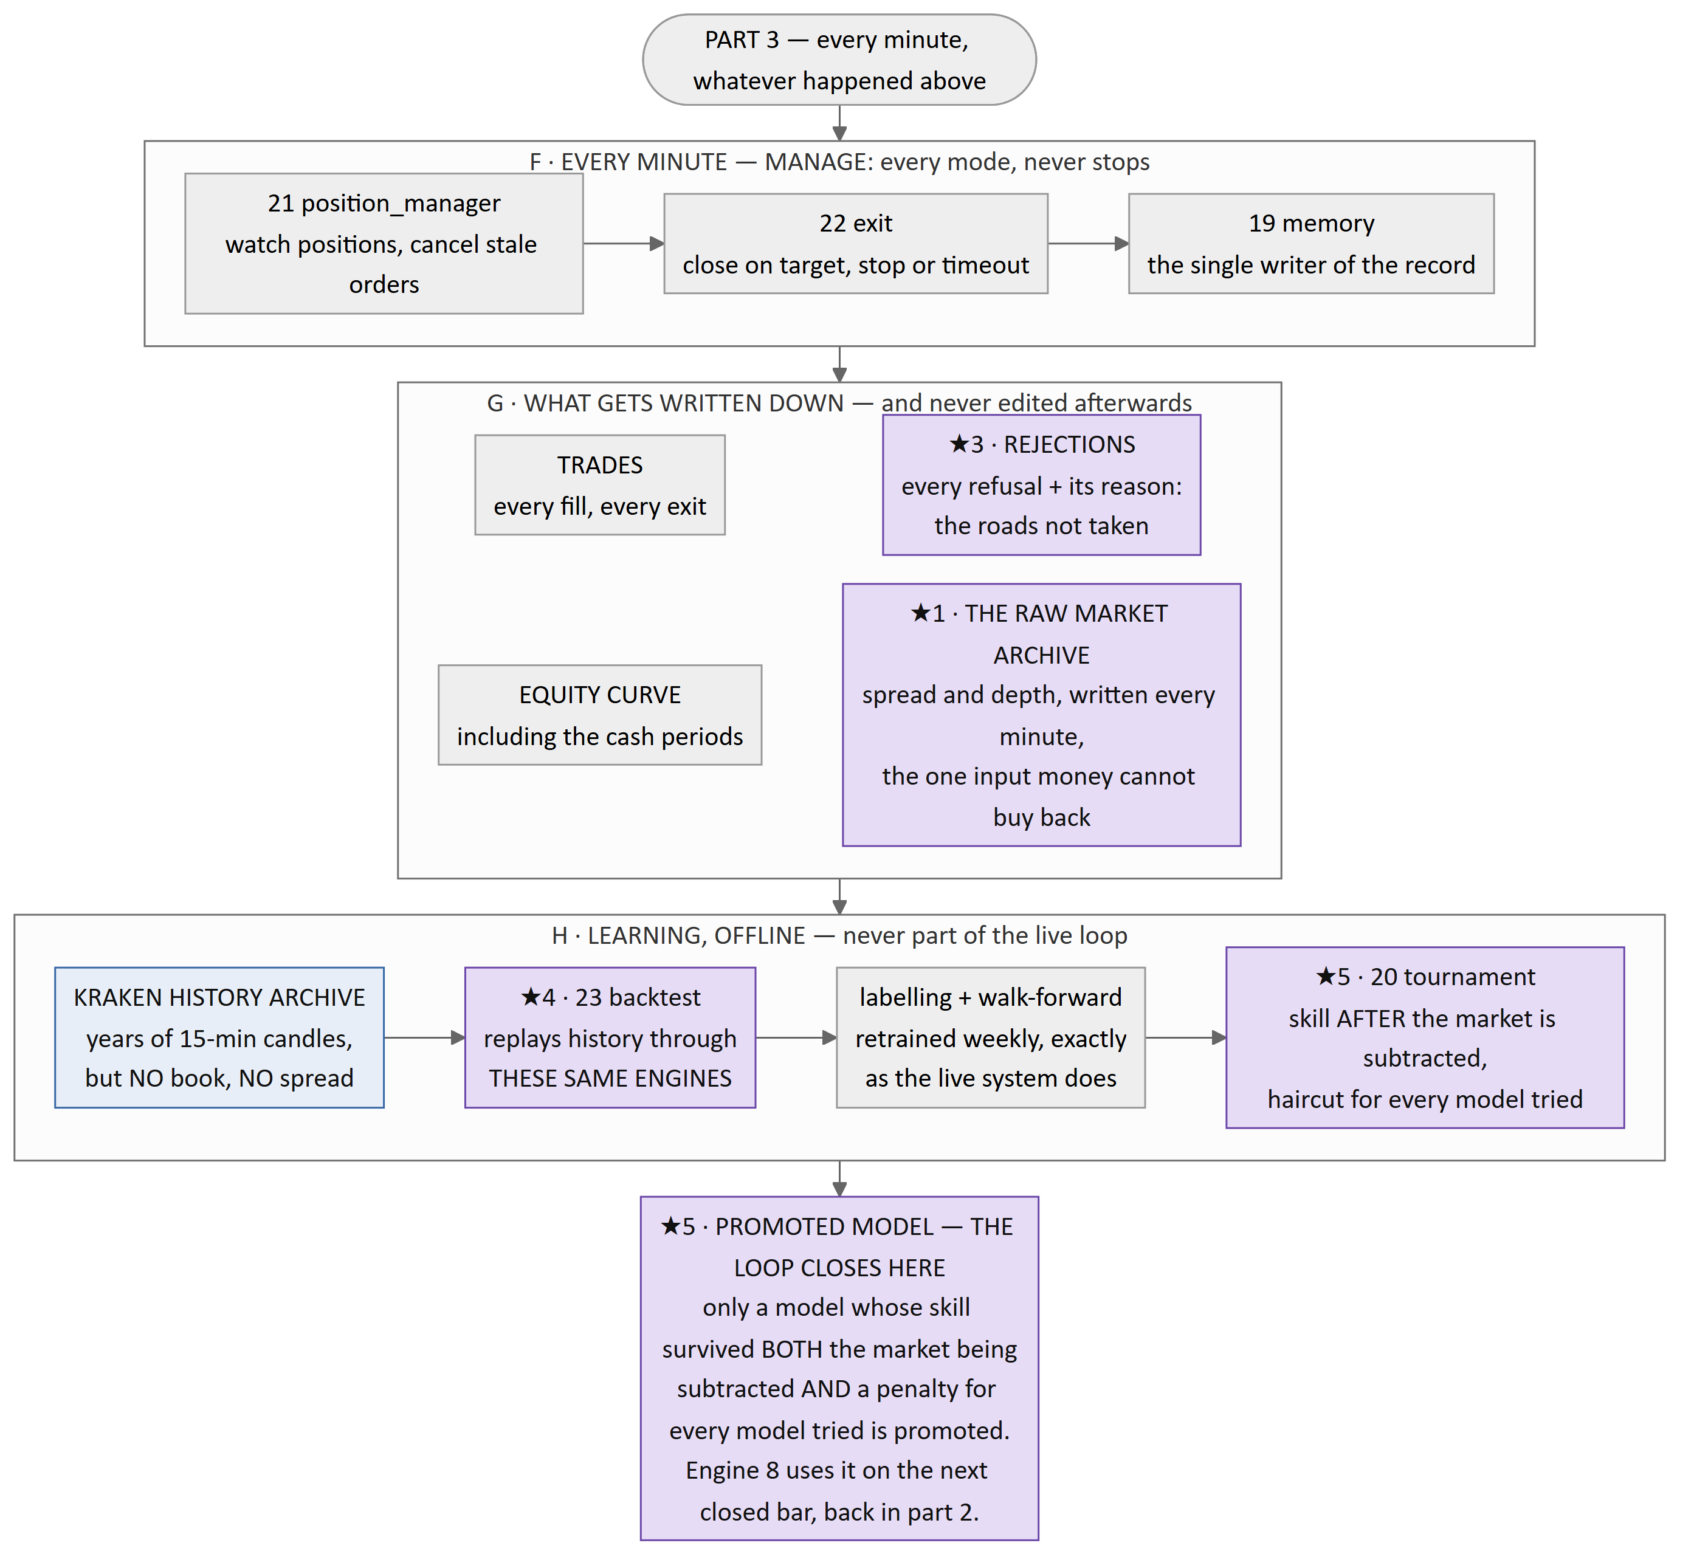
The whole system, in three parts because it will not fit legibly on one printed page. PART 1 is where the data comes from and the two checks every minute must pass. PART 2 runs only when a 15-minute bar has closed, and stops at the first objection. PART 3 runs every minute whatever happened above it — which is why a system that is refusing to trade is still recording, still watching its positions and still writing things down. Blue is data arriving from outside, amber is a gate, red a refusal, green the one path to a purchase, and purple marks the six things that are not standard practice, keyed ★1 to ★6 and explained below. The cost gate is drawn purple rather than amber because it is both a gate and the central contribution. Follow the labels: the overwhelming majority of minutes end at one of the two dead ends, and that is the system working.

What the stars mean — and why any of this is new
★​1 · The raw market archive. Kraken publishes years of price history but no bid, no ask, no spread, no order-book depth. Those exist only in the moment; nobody stores them and nobody sells them. So the system has recorded them itself, continuously, since before it could trade. A professional desk does not have this problem — it has a market-data subscription that has been running for years — so nobody has ever built the equivalent for an individual. Without it, the cost model in ★​2 cannot be tested against history at all.
★​2 · A cost gate with live inputs and an adaptive bar. Most retail tools ignore trading costs. Backtesting platforms almost universally simulate a fill at the mid-price — the midpoint between the best buyer and the best seller, a price at which nobody can actually trade. This system fetches your real fee tier before every decision, measures the real spread, estimates real slippage from real book depth, and refuses the trade unless the expected move beats all of it with margin to spare. Because the bar is computed from your live fee tier, the system is automatically stricter while your account is small and relaxes as your fees improve. That is not a setting anyone tuned.
★​3 · A record of the trades it did not take. Every system records its trades. This one records every refusal, with the gate that stopped it, the reason, and what the model was looking at. Over time that becomes a dataset of roads not taken — the only way to ever answer was it right to say no? Without it, a system that refuses everything and a system that refuses correctly look identical.
★​4 · One set of engines, not two. The backtest replays history through the very same engines the live system runs. The usual arrangement is a research codebase and a trading codebase that are meant to agree, and quietly stop agreeing. Here a backtest and a live run cannot silently disagree, because there is only one implementation to disagree with.
★​5 · Promotion on skill, after two subtractions. If Bitcoin rose 20% and your account rose 8%, you did not make 8% through skill — the market made it and your decisions cost you 12%. A model is promoted only if its performance survives subtracting that market movement, and a further penalty for how many models were tried, because the best of twenty attempts is usually the luckiest rather than the best. The benchmark is doing nothing at all.
★​6 · Nothing clever can overrule the arithmetic. Every amber box is the same idea repeated: a gate fails closed. If it errors it blocks, if it cannot reach its data it blocks, and the absence of a "no" is never read as a "yes". Nine of the twenty-three engines contain no machine learning whatsoever, and those nine are precisely the ones holding the money. A model in this system can only ever make it less willing to trade, never more.
None of the six is individually unprecedented. The contribution is that all six hold at the same time, in a system one person can run on one machine — at exactly the account size where trading costs stop being a detail and become the entire problem, and where, until now, nobody had the data to say so honestly.

6. A worked minute
Concrete, using the current settings, on a $5,000 account.
10:07 — a tick. Data is fine, the account is healthy, but no 15-minute bar closed. Everything below feature is skipped. The recorder wrote another 3,000 messages to disk; the manage chain confirmed there is nothing open. Elapsed: a few hundred milliseconds. This is what fourteen minutes out of every fifteen look like.
10:15 — a bar closed. scout filters Kraken's pairs down to those priced in USD, then to those whose minimums a $3,333 position clears, then to those with fresh and sane data. It ranks the survivors and emits one: say SOL/USD. The market is not anomalous. The predictor says the +3% target is more likely to be touched first than the −1.5% stop. The book is deep enough that slippage looks like 0.03%.
Then cost does the arithmetic. Fees at this account's tier: 0.40% to buy as a maker, 0.80% to sell as a taker. Spread right now: 0.02%. Slippage: 0.03%. Total friction 1.25%. The rule demands the expected move exceed 2.5 × friction = 3.125%, and the target barrier is 3.00%.
Refused. Written down as net_edge_below_hurdle, with every number that produced it, plus a record of what the model was looking at when it happened.
That refusal is not a wasted minute. It is a row in a dataset of roads not taken, and it is the only way anyone can ever go back and ask whether saying no was right.

7. What is running today
Because this is a live project and the document should not overstate it: engines 1, 2, 3 and 4 are built and running — the data spine and the first real gate. Engines 10 `cost`, 11 `risk` and 17 `safety` are built and tested. The remaining engines are fully specified and are the work in progress. The market recorder has been running continuously since day one, because that is the one input no amount of later effort can recover.
The system runs in simulation by default. Placing a real order requires three independent switches set at once, and any one of them missing, malformed or out of date means simulation.

